YOUTH PLAYER CODE OF CONDUCT
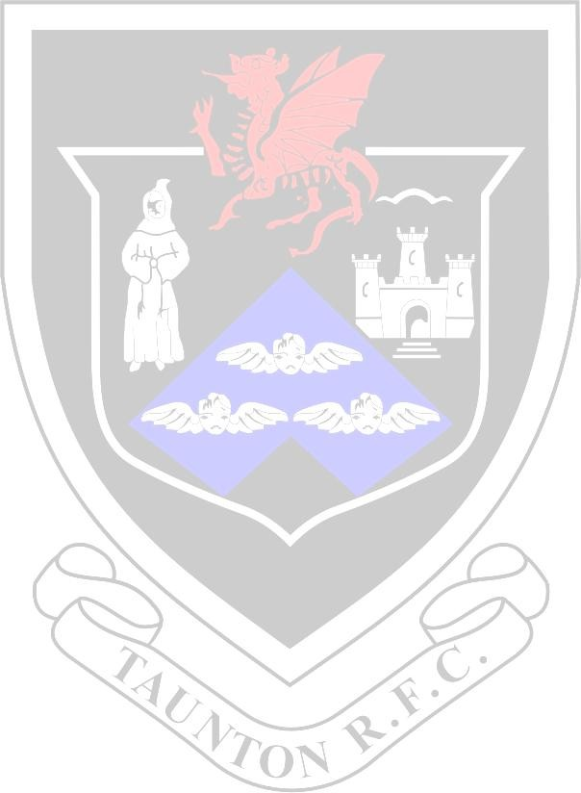
ALL TAUNTON RFC YOUTH PLAYERS MUST ADHERE TO THE CORE VALUES OF RUGBY
- TEAMWORK
- RESPECT
- ENJOYMENT
- DISCIPLINE
- SPORTSMANSHIP

- Players MUST at all times play within the rules of the game related to their age group.
- Players MUST at all times respect Match Officials and their decisions.

- Players MUST respect opponents and all other members of their team whether they win or lose.
- Players should be punctual arriving to training and games or inform their coach if they are going to be late.

- Players MUST wear suitable clothing relevant to the activity and conditions at the time.

- Players MUST NOT be negative about the club, coaches or team mates on social media, direct messages or messaging apps.
- Players ARE STRONGLY ADVISED to wear a suitable mouth guard at all times, both in training and during matches.

- U18s MUST NOT consume alcohol – this includes 0% alcoholic drinks. This has huge repercussions on your club, your coaching team, parents & yourself. It is illegal! Do not tolerate it.
- Players should not participate in any activity not in keeping with the TREDS Values or may potentially be a Safeguarding concern.

Reviewed by James Litton, Club CSO, Taunton RFC, 23/08/2026

