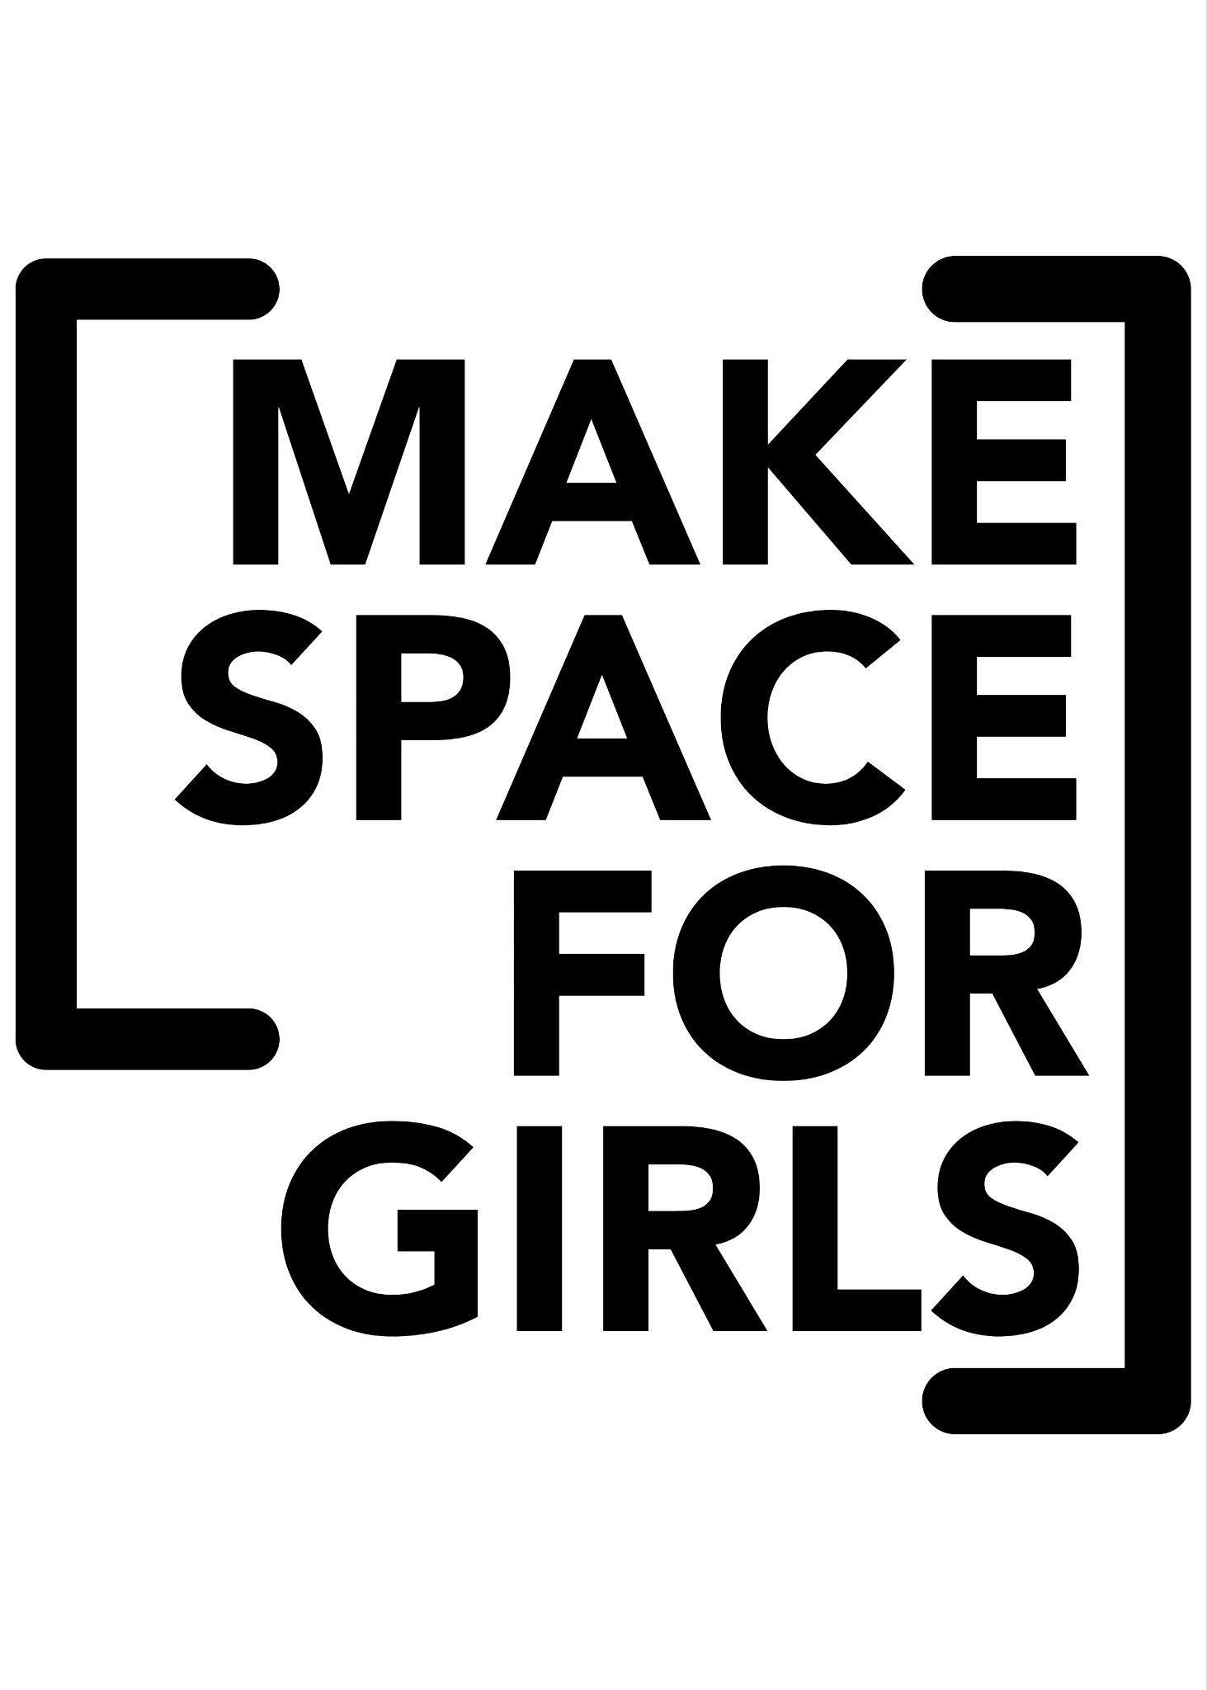

Parent/guardian consent form

Make Space for Girls - Video Project (January–April 2026)
Project Lead: Abigail Gaines
Email: abigail@makespaceforgirls.co.uk
Charity: Make Space for Girls
Website: www.makespaceforgirls.co.uk

About the project
Make Space for Girls is creating a video aimed at local councils and planners to show how parks can better meet the needs of teenage girls.
Your child is invited to join a small group of girls aged 12-18 from across the UK who will help shape and contribute to this project.
Participation will include 2–5 online meetings (early evenings) and optional creative tasks between sessions. There may also be opportunities for in-person workshops (during school holidays or weekends, if feasible).
All sessions will be led by Abigail Gaines, who is DBS-checked, safeguarding-trained, and experienced in working with young people.

Participant information
Young person’s name:
Age:
Town/City:
Parent/Guardian name:
Email of parent/guardian:
Phone number (for emergency contact):

I give consent for my child to:
Please tick all that apply - your child will be asked to complete a similar form, please make sure you’ve discussed your answers.
☐ Take part in the Make Space for Girls Video Project (January - April 2026)
☐ Attend online meetings via Zoom or Teams (supervised by DBS-checked adults)
☐ Be contacted by project staff (email only) about project activities and meetings
☐ Submit creative work (e.g. photos, drawings, short videos, written pieces)
☐ Take part in optional in-person workshops (if local and suitable)
☐ I’m aware that we can withdraw involvement at any time

Media and privacy
We may use photos, audio, or video clips created during this project in the final video or related communications (website, social media, presentations).
Please tick what you are comfortable with - you can withdraw use/change your mind at any time.
☐ My child’s face, voice, or work can be included in the public video
☐ My child’s voice only may be used (no identifiable image)
☐ My child’s work or words may be used (anonymous, no image or voice)
☐ I do not consent to any identifiable media being used publicly

Safeguarding and data protection
All data and materials will be stored securely and deleted within 12 months of project completion.
Only DBS-checked adults will supervise sessions, and no one-to-one contact will take place.
We follow the Make Space for Girls Safeguarding and Data Protection Policies, available on request.

Consent declaration
I have read and understood this information and give consent for my child to take part in this project.
I understand that participation is voluntary and can be withdrawn at any time.
Parent/Guardian signature:
Date:

Young Person Agreement

Make Space for Girls - Video Project (January–April 2026)
Hi!
We’re really glad you’re interested in helping us make this video. It’s all about making parks and public spaces better for teenage girls - places where everyone feels welcome and included.
We want to make sure you understand what you’re signing up for and feel comfortable with what we’ll be doing together.

What’s involved
You’ll take part in between 2-5 online sessions between January and April 2026. Approx 30-60 mins each.
You might:
- Share your views about parks and public spaces
- Help plan or design ideas for the video
- Create drawings, short videos, or photos
- Choose whether or not to be seen or heard in the final video
You don’t have to do anything you’re not comfortable with - there will be different ways to take part.

Our promise to you
We will:
- Listen to your ideas and respect your opinions
- Keep you safe online and in person
- Always have two adults in online sessions
- Never share your personal information without permission
- Make sure you see the video before it’s shared publicly

Your promise to us
Please agree to:
- Respect other people’s ideas and privacy
- Use kind and inclusive language
- Not share screenshots, photos or names from sessions
- Tell an adult if anything makes you uncomfortable

Media choices
Please tick what you’re happy with (you can change your mind later):
☐ I’m happy for my face and voice to be used in the video
☐ I’d prefer voice only
☐ I’d prefer my work or words to be shared, not me personally
☐ I don’t want to appear or be identified in the video

Sign to agree
By signing this form, you agree to take part safely and respectfully, and understand how your information will be used.
Your name:
Your signature:

Date:

