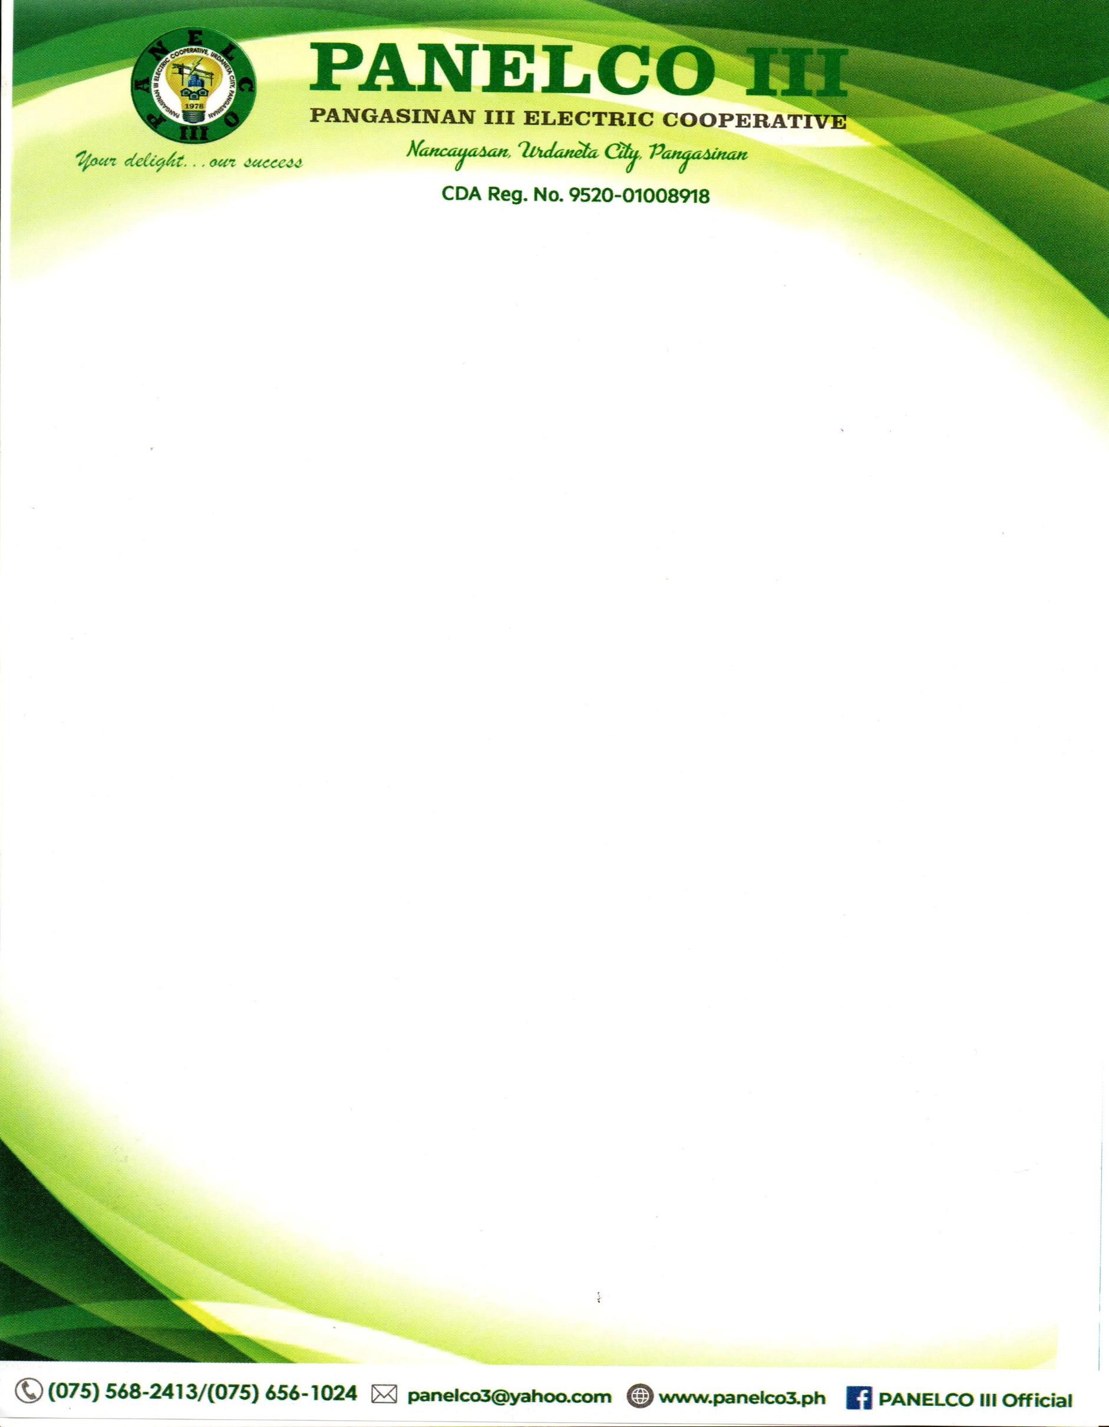

NOTICE TO THE
MEMBER CONSUMER OWNERS

This is to inform all the member consumer owners that On 11 February 2025, Pangasinan III Electric Cooperative (PANELCO III) and GNPower Dinginin Ltd. Co. (GNPD), filed their Joint Application for Approval of Emergency Power Supply Agreement (With Prayer for Confidential Treatment of Information) dated 16 January 2025, seeking the Commission’s approval of the Emergency Power Supply Agreement between PANELCO III and GNPD with prayer for confidential treatment of information and docketed as ERC Case No. 2025-040 RC.
The Energy Regulatory Commission set the virtual hearing of the said Joint Application for determination of compliance with Jurisdictional Requirements and Expository Presentation on 21 October 2025 (Tuesday) at nine o’clock in the afternoon (9:00 A.M.) via Microsoft Teams Application, and Pre-Trial Conference and Presentation of Evidence on 28 October (Tuesday) at nine o’clock in the afternoon (9:00 A.M.) via Microsoft Teams Application, as the online platform for the conduct thereof. PANELCO III has been directed to mirror the virtual hearings to be hosted by the Commission PANELCO III’s Principal Office at Brgy. Nancayasan, Urdaneta City, Pangasinan, wherein the member consumer owners may participate.

