Document Title: SciAps X-505 RoHS Specifications
Rev Date: Apr 2025
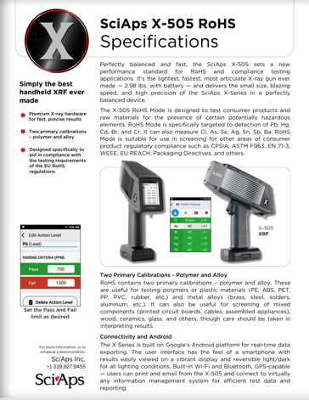
Layout Preview | English Text | Translated Text
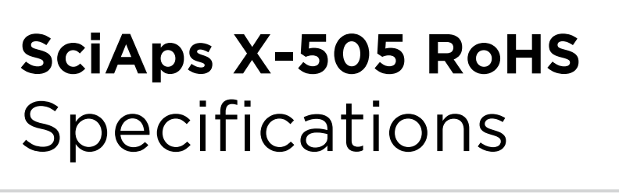 | SciAps X-505 RoHS
 | Specifications
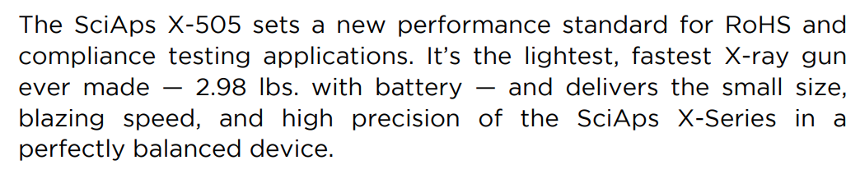 | The SciAps X-505 sets a new performance standard for RoHS and compliance testing applications. It’s the lightest, fastest X-ray gun ever made — 2.98 lbs. with battery — and delivers the small size, blazing speed, and high precision of the SciAps X-Series in a perfectly balanced device.
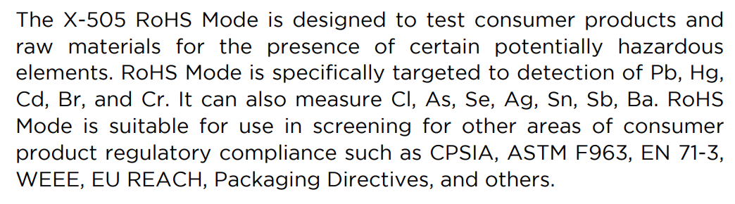 | The X-505 RoHS Mode is designed to test consumer products and raw materials for the presence of certain potentially hazardous elements. RoHS Mode is specifically targeted to detection of Pb, Hg, Cd, Br, and Cr. It can also measure Cl, As, Se, Ag, Sn, Sb, Ba. RoHS Mode is suitable for use in screening for other areas of consumer product regulatory compliance such as CPSIA, ASTM F963, EN 71-3, WEEE, EU REACH, Packaging Directives, and others.
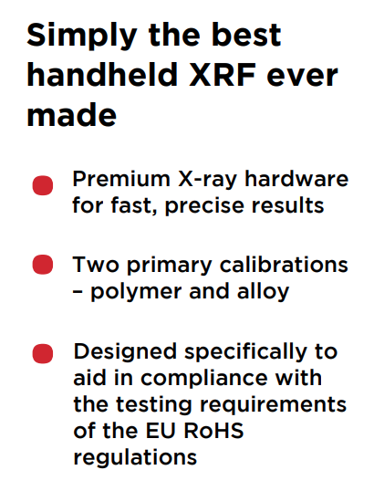 | Simply the best handheld XRF ever made
 | Premium X-ray hardware • for fast, precise results
 | Two primary calibrations • – polymer and alloy
 | Designed specifically to aid in compliance with the testing requirements of the EU RoHS regulations
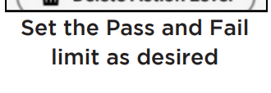 | Set the Pass and Fail limit as desired
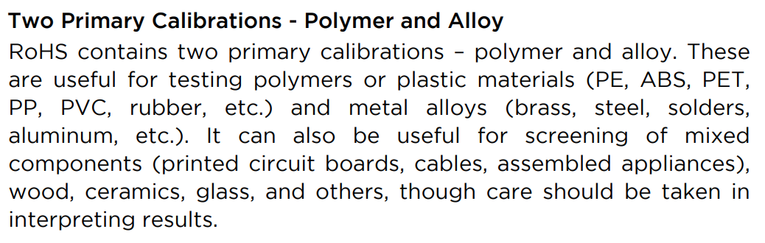 | Two Primary Calibrations - Polymer and Alloy
 | RoHS contains two primary calibrations – polymer and alloy. These are useful for testing polymers or plastic materials (PE, ABS, PET, PP, PVC, rubber, etc.) and metal alloys (brass, steel, solders, aluminum, etc.). It can also be useful for screening of mixed components (printed circuit boards, cables, assembled appliances), wood, ceramics, glass, and others, though care should be taken in interpreting results.
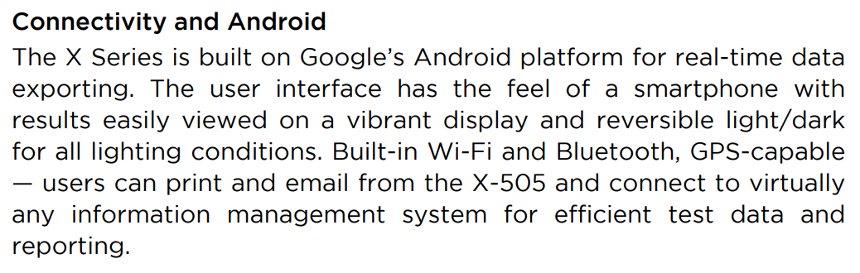 | Connectivity and Android
 | The X Series is built on Google’s Android platform for real-time data exporting. The user interface has the feel of a smartphone with results easily viewed on a vibrant display and reversible light/dark for all lighting conditions. Built-in Wi-Fi and Bluetooth, GPS-capable — users can print and email from the X-505 and connect to virtually any information management system for efficient test data and reporting.
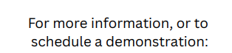 | For more information, or to schedule a demonstration:
(BACK)
 | SciAps X-505 RoHS
 | Specifications
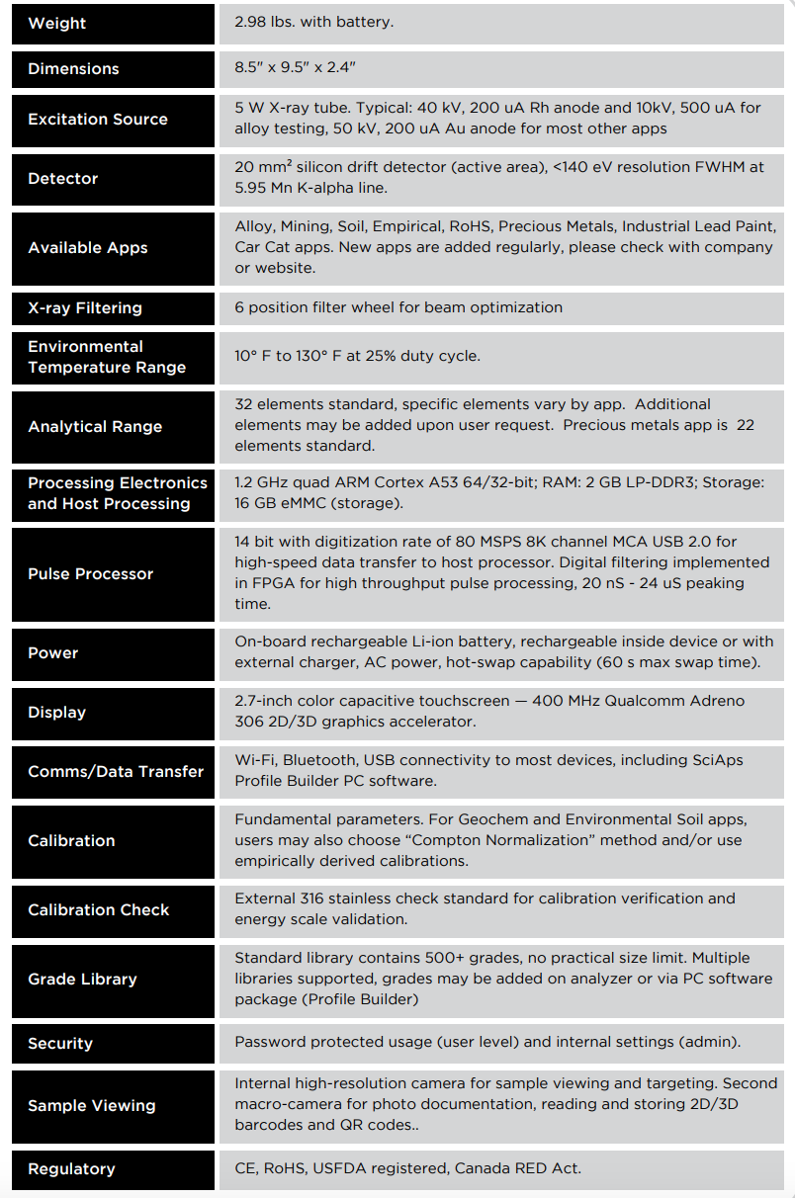 | Weight
 | 2.98 lbs. with battery.
 | Dimensions
 | 8.5" x 9.5" x 2.4"
 | Excitation Source
 | 5 W X-ray tube. Typical: 40 kV, 200 uA Rh anode and 10kV, 500 uA for alloy testing, 50 kV, 200 uA Au anode for most other apps.
 | Detector
 | 20 mm² silicon drift detector (active area), <140 eV resolution FWHM at 5.95 Mn K-alpha line.
 | Available Apps
 | Alloy, Mining, Soil, Empirical, RoHS, Precious Metals, Industrial Lead Paint, Car Cat apps. New apps are added regularly, please check with company or website.
 | X-ray Filtering
 | 6 position filter wheel for beam optimization.
 | Environmental Temperature Range
 | 10° F to 130° F at 25% duty cycle.
 | Analytical Range
 | 32 elements standard, specific elements vary by app. Additional elements may be added upon user request.
 | Processing Electronics and Host Processing
 | 1.2 GHz quad ARM Cortex A53 64/32-bit; RAM: 2 GB LP-DDR3; Storage: 16 GB eMMC (storage).
 | Pulse Processor
 | 14 bit with digitization rate of 80 MSPS 8K channel MCA USB 2.0 for high-speed data transfer to host processor. Digital filtering implemented in FPGA for high throughput pulse processing, 20 nS - 24 uS peaking time.
 | Power
 | On-board rechargeable Li-ion battery, rechargeable inside device or with external charger, AC power, hot-swap capability (60 s max swap time).
 | Display
 | 2.7-inch color capacitive touchscreen — 400 MHz Qualcomm Adreno 306 2D/3D graphics accelerator.
 | Comms/Data Transfer
 | Wi-Fi, Bluetooth, USB connectivity to most devices, including SciAps Profile Builder PC software.
 | Calibration
 | Fundamental parameters. For Geochem and Environmental Soil apps, users may also choose “Compton Normalization” method and/or use empirically derived calibrations.
 | Calibration Check
 | External 316 stainless check standard for calibration verification and energy scale validation.
 | Grade Library
 | Standard library contains 500+ grades, no practical size limit. Multiple libraries supported, grades may be added on analyzer or via PC software package (Profile Builder).
 | Security
 | Password protected usage (user level) and internal settings (admin).
 | Sample Viewing
 | high-resolution camera for sample viewing and targeting. Second macro-camera for photo documentation, reading and storing 2D/3D barcodes and QR codes.
 | Regulatory
 | CE, RoHS, USFDA registered, Canada RED Act.

