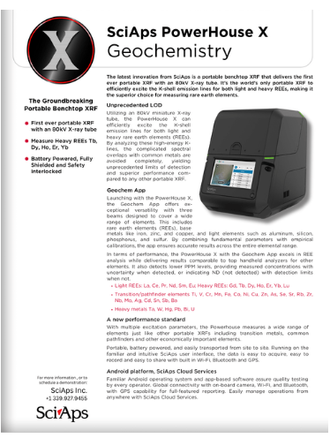
Document Title: PowerHouse X Specifications

Layout Preview | English Text | Translated Text
 | SciAps PowerHouse X
 | Geochemistry
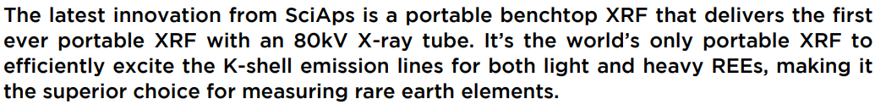 | The latest innovation from SciAps is a portable benchtop XRF that delivers the first ever portable XRF with an 80kV X-ray tube. It’s the world’s only portable XRF to efficiently excite the K-shell emission lines for both light and heavy REEs, making it the superior choice for measuring rare earth elements.
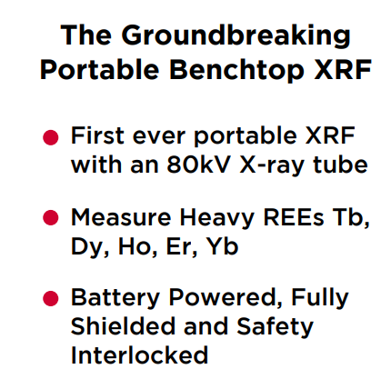 | The Groundbreaking Portable Benchtop XRF
 | First ever portable XRF with an 80kV X-ray tube.
 | Measure Heavy REEs Tb, Dy, Ho, Er, Yb
 | Battery Powered, Fully Shielded and Safety Interlocked
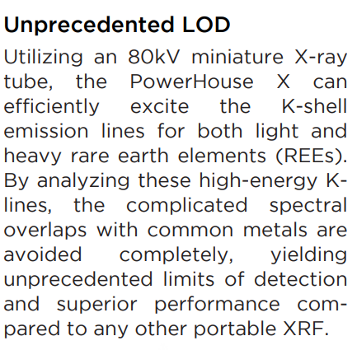 | Unprecedented LOD
 | Utilizing an 80kV miniature X-ray tube, the PowerHouse X can efficiently excite the K-shell emission lines for both light and heavy rare earth elements (REEs). By analyzing these high-energy Klines, the complicated spectral overlaps with common metals are avoided completely, yielding unprecedented limits of detection and superior performance compared to any other portable XRF
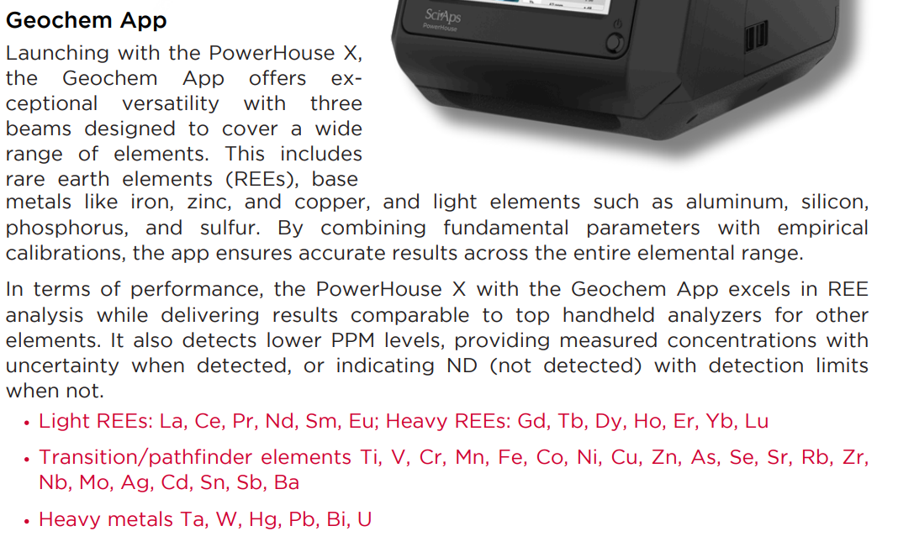 | Geochem App
 | Launching with the PowerHouse X, the Geochem App offers exceptional versatility with three beams designed to cover a wide range of elements. This includes rare earth elements (REEs), base Geochem App metals like iron, zinc, and copper, and light elements such as aluminum, silicon, phosphorus, and sulfur. By combining fundamental parameters with empirical calibrations, the app ensures accurate results across the entire elemental range.
 | In terms of performance, the PowerHouse X with the Geochem App excels in REE analysis while delivering results comparable to top handheld analyzers for other elements. It also detects lower PPM levels, providing measured concentrations with uncertainty when detected, or indicating ND (not detected) with detection limits when not.
 | Light REEs: La, Ce, Pr, Nd, Sm, Eu; Heavy REEs: Gd, Tb, Dy, Ho, Er, Yb, Lu
 | Transition/pathfinder elements Ti, V, Cr, Mn, Fe, Co, Ni, Cu, Zn, As, Se, Sr, Rb, Zr, Nb, Mo, Ag, Cd, Sn, Sb, Ba
 | Heavy metals Ta, W, Hg, Pb, Bi, U
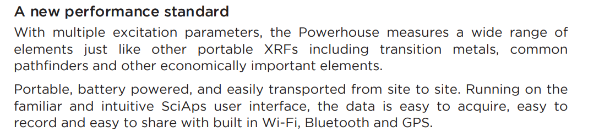 | A new performance standard
 | With multiple excitation parameters, the Powerhouse measures a wide range of elements just like other portable XRFs including transition metals, common pathfinders and other economically important elements.
 | Portable, battery powered, and easily transported from site to site. Running on the familiar and intuitive SciAps user interface, the data is easy to acquire, easy to record and easy to share with built in Wi-Fi, Bluetooth and GPS.
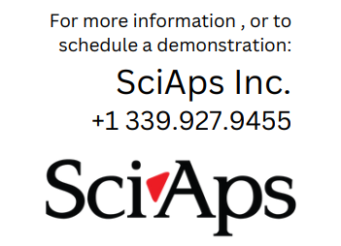 | For more information, or to schedule a demonstration:
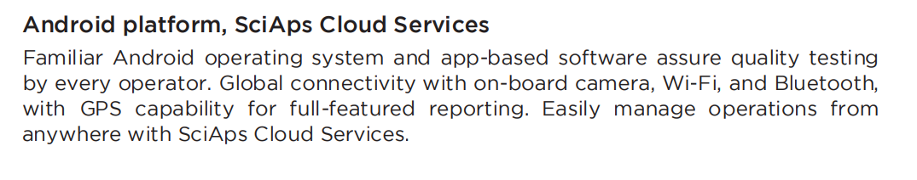 | Android platform, SciAps Cloud Services
 | Familiar Android operating system and app-based software assure quality testing by every operator. Global connectivity with on-board camera, Wi-Fi, and Bluetooth, with GPS capability for full-featured reporting. Easily manage operations from anywhere with SciAps Cloud Services.
 | SciAps PowerHouse X
 | Specifications
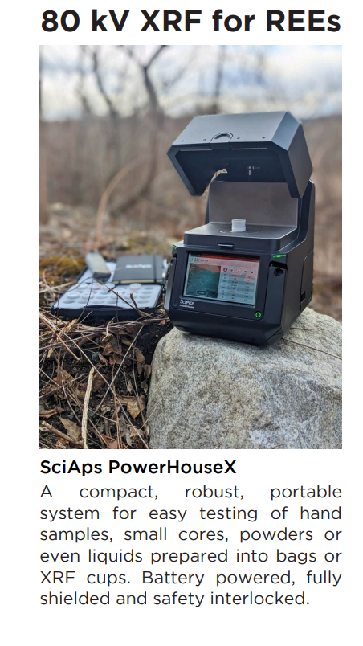 | 80 kV XRF for REEs
 | SciAps PowerHouse X
 | A compact, robust, portable system for easy testing of hand samples, small cores, powders or even liquids prepared into bags or XRF cups. Battery powered, fully shielded and safety interlocked.
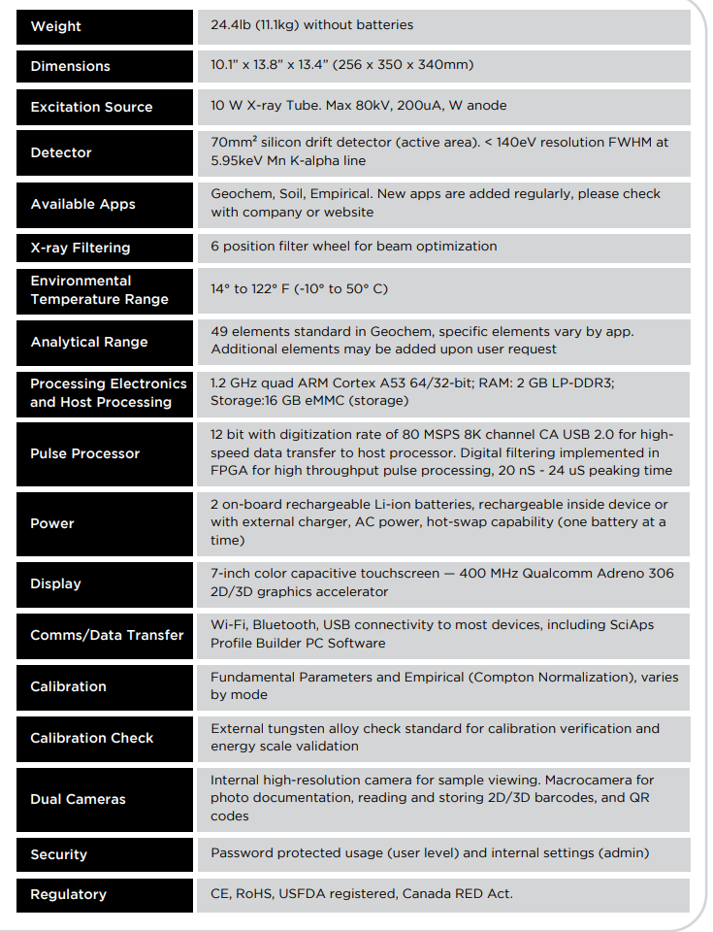 | Weight
 | 24.4lb (11.1kg) without batteries
 | Dimensions
 | 10.1” x 13.8” x 13.4” (256 x 350 x 340mm)
 | Excitation Source
 | 10 W X-ray Tube. Max 80kV, 200uA, W anode
 | Detector
 | 70mm² silicon drift detector (active area). < 140eV resolution FWHM at 5.95keV Mn K-alpha line
 | Available Apps
 | Geochem, Soil, Empirical. New apps are added regularly, please check with company or website
 | X-ray Filtering
 | 6 position filter wheel for beam optimization
 | Environmental Temperature Range
 | -10°C to 50°C (14° to 122°F) with continuous testing.
 | Analytical Range
 | 49 elements standard in Geochem, specific elements vary by app. Additional elements may be added upon user request
 | Processing Electronics and Host Processing
 | 1.2 GHz quad ARM Cortex A53 64/32-bit; RAM: 2 GB LP-DDR3; Storage:16 GB eMMC (storage)
 | Pulse Processor
 | 12 bit with digitization rate of 80 MSPS 8K channel CA USB 2.0 for high- speed data transfer to host processor. Digital filtering implemented in FPGA for high throughput pulse processing, 20 nS - 24 uS peaking time
 | Power
 | 2 on-board rechargeable Li-ion batteries, rechargeable inside device or with external charger, AC power, hot-swap capability (one battery at a time)
 | Display
 | 7-inch color capacitive touchscreen — 400 MHz Qualcomm Adreno 306 2D/3D graphics accelerator
 | Comms/Data Transfer
 | Wi-Fi, Bluetooth, USB connectivity to most devices, including SciAps Profile Builder PC software.
 | Calibration
 | Fundamental Parameters and Empirical (Compton Normalization), varies by mode
 | Calibration Check
 | External tungsten alloy check standard for calibration verification and energy scale validation
 | Sample Viewing
 | Internal high-resolution camera for sample viewing and targeting. Second macro-camera for photo documentation, reading and storing 2D/3D barcodes and QR codes.
 | Security
 | Password protected usage (user level) and internal settings (admin).
 | Regulatory
 | CE, RoHS, USFDA registered, Canada RED Act.

