Document Title: SciAps PowerHouse PMGold Karating & Precious Metals
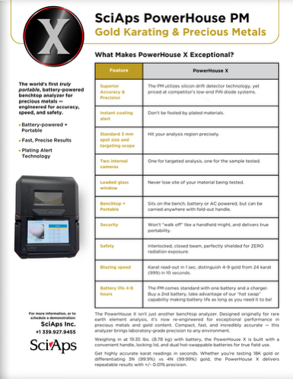
Rev Date: August 2025

Layout Preview | English Text | Translated Text
 | SciAps PowerHouse PM
 | Gold Karating & Precious Metals
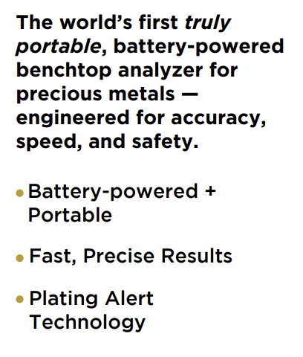 | The world’s first truly portable, battery-powered benchtop analyzer for precious metals — engineered for accuracy, speed, and safety.
 | Battery-powered + Portable
 | Fast, Precise Results
 | Plating Alert Technology
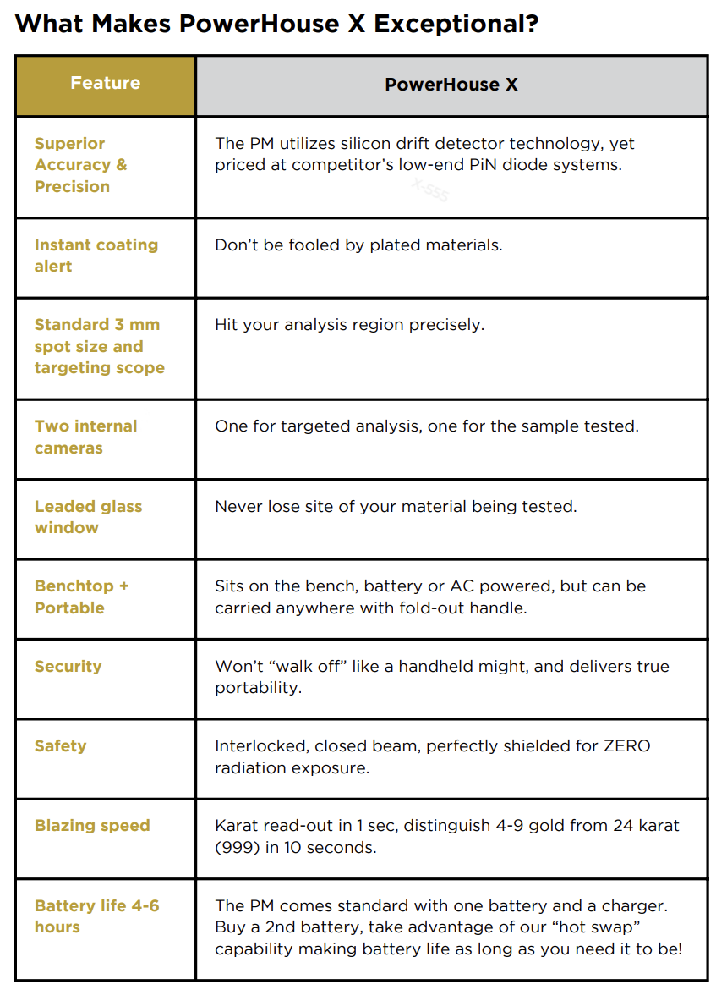 | What Makes PowerHouse X Exceptional?
 | Feature
 | PowerHouse X
 | Superior Accuracy & Precision
 | The PM utilizes silicon drift detector technology, yet priced at competitor’s low-end PiN diode systems.
 | Instant coating alert
 | Don’t be fooled by plated materials.
 | Standard 3 mm spot size and targeting scope
 | Hit your analysis region precisely.
 | Two internal cameras
 | One for targeted analysis, one for the sample tested.
 | Leaded glass window
 | Never lose sight of your material being tested.
 | Benchtop + Portable
 | Sits on the bench, battery or AC powered but can be carried anywhere with fold-out handle.
 | Security
 | Won’t “walk off” like a handheld might and delivers true portability.
 | Safety
 | Interlocked, closed beam, perfectly shielded for ZERO radiation exposure.
 | Blazing speed
 | Karat read-out in 1 sec, distinguish 4-9 gold from 24 karat (999) in 10 seconds.
 | Battery life 4-6 hours
 | The PM comes standard with one battery and a charger. Buy a 2nd battery, take advantage of our “hot swap” capability making battery life as long as you need it to be!
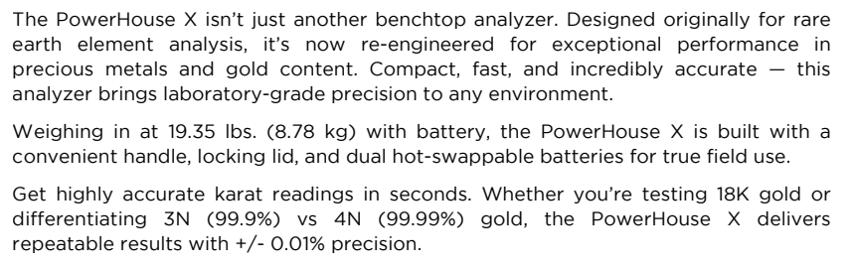 | The PowerHouse X isn’t just another benchtop analyzer. Designed originally for rare earth element analysis, it’s now re-engineered for exceptional performance in precious metals and gold content. Compact, fast, and incredibly accurate — this analyzer brings laboratory-grade precision to any environment.
 | Weighing in at 19.35 lbs. (8.78 kg) with battery, the PowerHouse X is built with a convenient handle, locking lid, and dual hot-swappable batteries for true field use.
 | Get highly accurate karat readings in seconds. Whether you’re testing 18K gold or differentiating 3N (99.9%) vs 4N (99.99%) gold, the PowerHouse X delivers repeatable results with +/- 0.01% precision.
 | For more information, or to schedule a demonstration:
[Back]
 | SciAps PowerHouse PM
 | Specifications
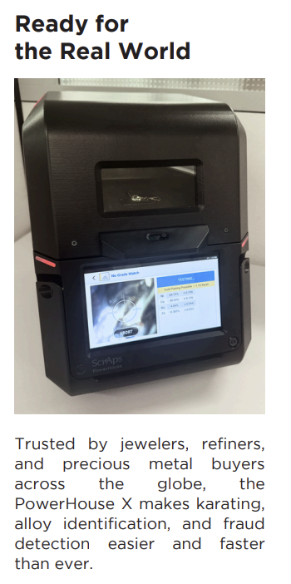 | Ready for the Real World
 | Trusted by jewelers, refiners, and precious metal buyers across the globe, the PowerHouse X makes karating, alloy identification, and fraud detection easier and faster than ever.
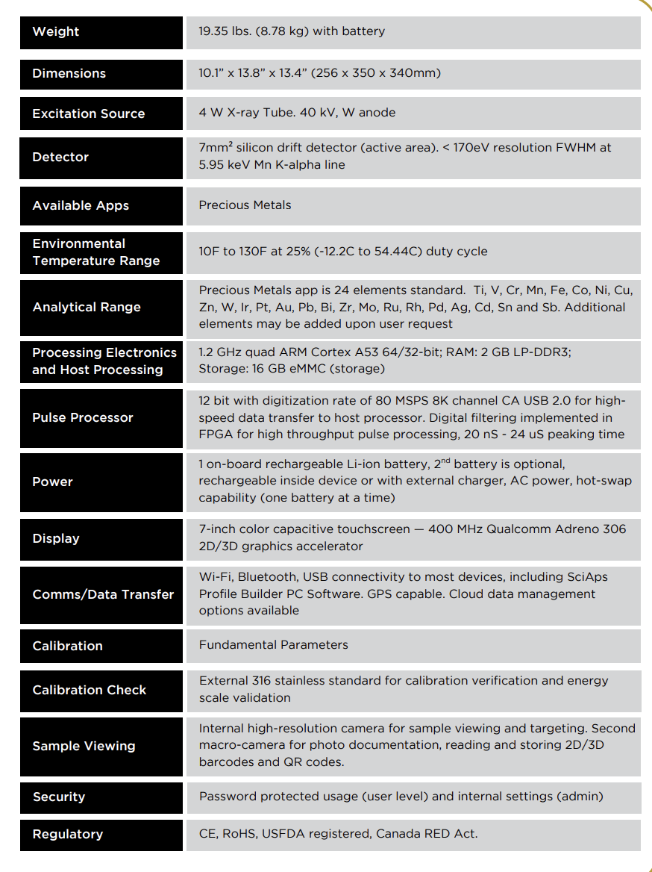 | Weight
 | 19.35 lbs. (8.78 kg) with battery
 | Dimensions
 | 10.1” x 13.8” x 13.4” (256 x 350 x 340mm)
 | Excitation Source
 | 4 W X-ray Tube. 40 kV, W anode
 | Detector
 | 7mm² silicon drift detector (active area). < 170eV resolution FWHM at 5.95 keV Mn K-alpha line
 | Available Apps
 | Precious Metals
 | Environmental Temperature Range
 | 10F to 130F at 25% (-12.2C to 54.44C) duty cycle
 | Analytical Range
 | Precious Metals app is 24 elements standard. Ti, V, Cr, Mn, Fe, Co, Ni, Cu, Zn, W, Ir, Pt, Au, Pb, Bi, Zr, Mo, Ru, Rh, Pd, Ag, Cd, Sn and Sb. Additional elements may be added upon user request
 | Processing Electronics and Host Processing
 | 1.2 GHz quad ARM Cortex A53 64/32-bit; RAM: 2 GB LP-DDR3; Storage: 16 GB eMMC (storage)
 | Pulse Processor
 | 12 bit with digitization rate of 80 MSPS 8K channel CA USB 2.0 for high- speed data transfer to host processor. Digital filtering implemented in FPGA for high throughput pulse processing, 20 nS - 24 uS peaking time
 | Power
 | 1 on-board rechargeable Li-ion battery, second battery is optional, rechargeable inside device or with external charger, AC power, hot-swap capability (one battery at a time)
 | Display
 | 7-inch color capacitive touchscreen — 400 MHz Qualcomm Adreno 306 2D/3D graphics accelerator
 | Comms/Data Transfer
 | Wi-Fi, Bluetooth, USB connectivity to most devices, including SciAps Profile Builder PC Software. GPS capable. Cloud data management options available
 | Calibration
 | Fundamental Parameters
 | Calibration Check
 | External 316 stainless standard for calibration verification and energy scale validation
 | Sample Viewing
 | Internal high-resolution camera for sample viewing and targeting. Second macro-camera for photo documentation, reading and storing 2D/3D barcodes and QR codes
 | Security
 | Password protected usage (user level) and internal settings (admin)
 | Regulatory
 | CE, RoHS, USFDA registered, Canada RED Act.
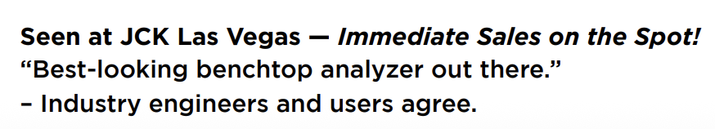 | Seen at JCK Las Vegas — Immediate Sales on the Spot! “Best-looking benchtop analyzer out there.” – Industry engineers and users agree.

