Document Title: ApNote Organic Carbon in Soils
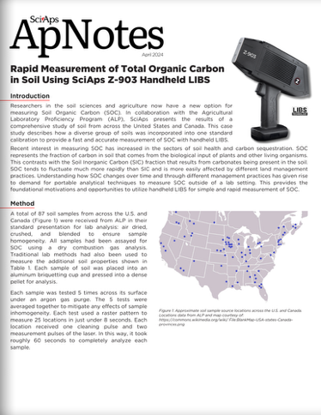
Rev Date: August 2025

Layout Preview | English Text | Translated Text
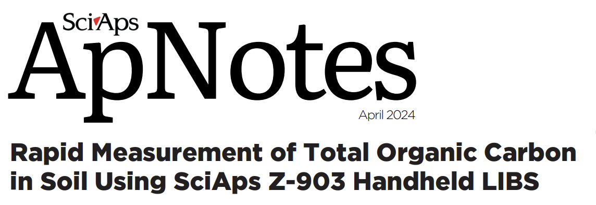 | Rapid Measurement of Total Organic Carbon in Soil Using SciAps Z-903 Handheld LIBS
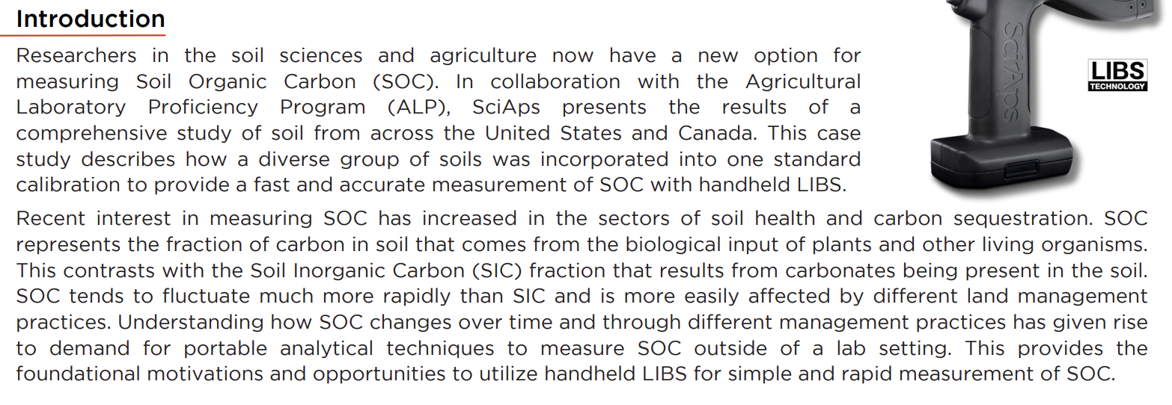 | Introduction
 | Researchers in the soil sciences and agriculture now have a new option for measuring Soil Organic Carbon (SOC). In collaboration with the Agricultural Laboratory Proficiency Program (ALP), SciAps presents the results of a comprehensive study of soil from across the United States and Canada. This case study describes how a diverse group of soils was incorporated into one standard calibration to provide a fast and accurate measurement of SOC with handheld LIBS.
 | Recent interest in measuring SOC has increased in the sectors of soil health and carbon sequestration. SOC represents the fraction of carbon in soil that comes from the biological input of plants and other living organisms. This contrasts with the Soil Inorganic Carbon (SIC) fraction that results from carbonates being present in the soil. SOC tends to fluctuate much more rapidly than SIC and is more easily affected by different land management practices. Understanding how SOC changes over time and through different management practices has given rise to demand for portable analytical techniques to measure SOC outside of a lab setting. This provides the foundational motivations and opportunities to utilize handheld LIBS for simple and rapid measurement of SOC.
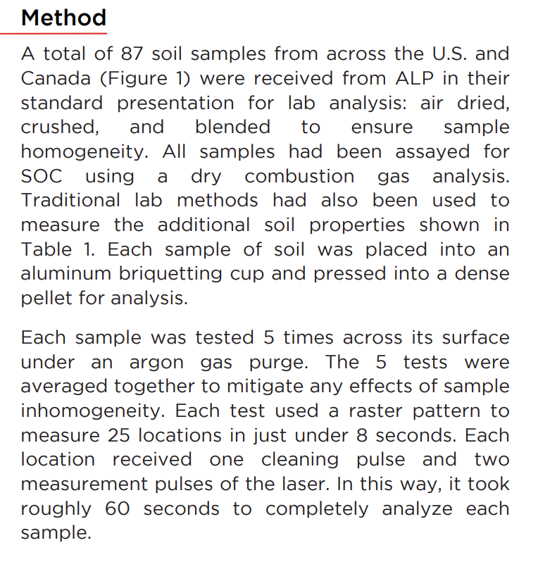 | Method
 | A total of 87 soil samples from across the U.S. and Canada (Figure 1) were received from ALP in their standard presentation for lab analysis: air dried, crushed, and blended to ensure sample homogeneity. All samples had been assayed for SOC using a dry combustion gas analysis. Traditional lab methods had also been used to measure the additional soil properties shown in Table 1. Each sample of soil was placed into an aluminum briquetting cup and pressed into a dense pellet for analysis.
 | Each sample was tested 5 times across its surface under an argon gas purge. The 5 tests were averaged together to mitigate any effects of sample inhomogeneity. Each test used a raster pattern to measure 25 locations in just under 8 seconds. Each location received one cleaning pulse and two measurement pulses of the laser. In this way, it took roughly 60 seconds to completely analyze each sample.
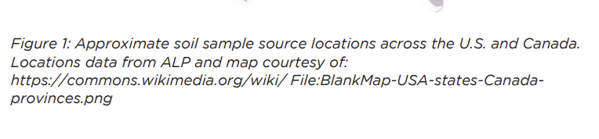 | Figure 1: Approximate soil sample source locations across the U.S. and Canada. Locations data from ALP and map courtesy of:
[BACK]
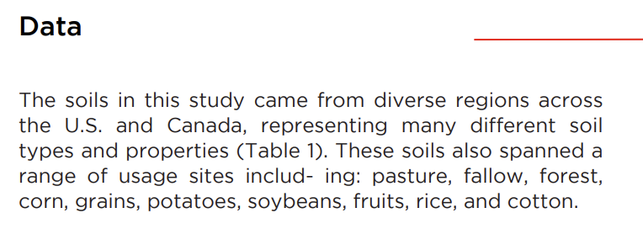 | Data
 | The soils in this study came from diverse regions across the U.S. and Canada, representing many different soil types and properties (Table 1). These soils also spanned a range of usage sites includ- ing: pasture, fallow, forest, corn, grains, potatoes, soybeans, fruits, rice, and cotton.
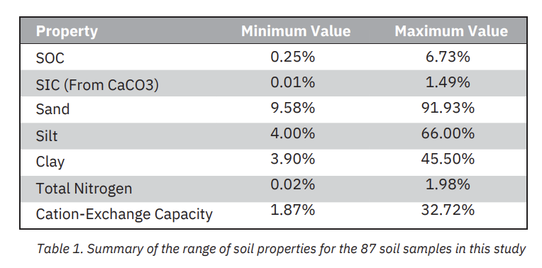 | Property
 | Minimum Value
 | Maximum Value
 | SOC
 | 0.25%
 | 6.73%
 | SIC (From CaCO3)
 | 0.01%
 | 1.49%
 | Sand
 | 9.58%
 | 91.93%
 | Silt
 | 4.00%
 | 66.00%
 | Clay
 | 3.90%
 | 45.50%
 | Total Nitrogen
 | 0.02%
 | 1.98%
 | Cation-Exchange Capacity
 | 1.87%
 | 32.72%
 | Table 1. Summary of the range of soil properties for the 87 soil samples in this study
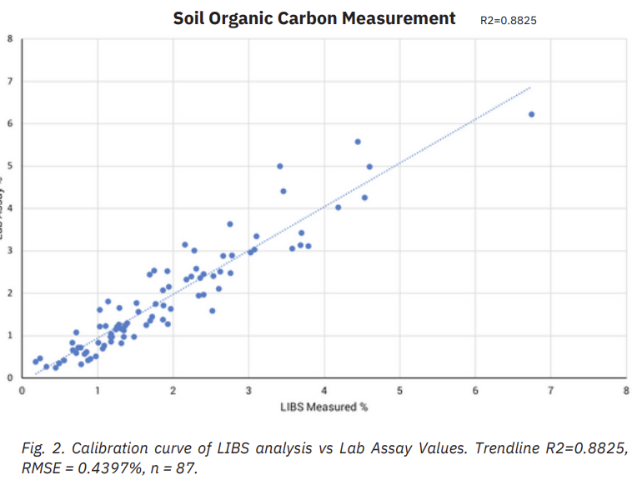 | Soil Organic Carbon Measurement R2=0.8825
 | Fig. 2. Calibration curve of LIBS analysis vs Lab Assay Values. Trendline R2=0.8825, RMSE = 0.4397%, n = 87.
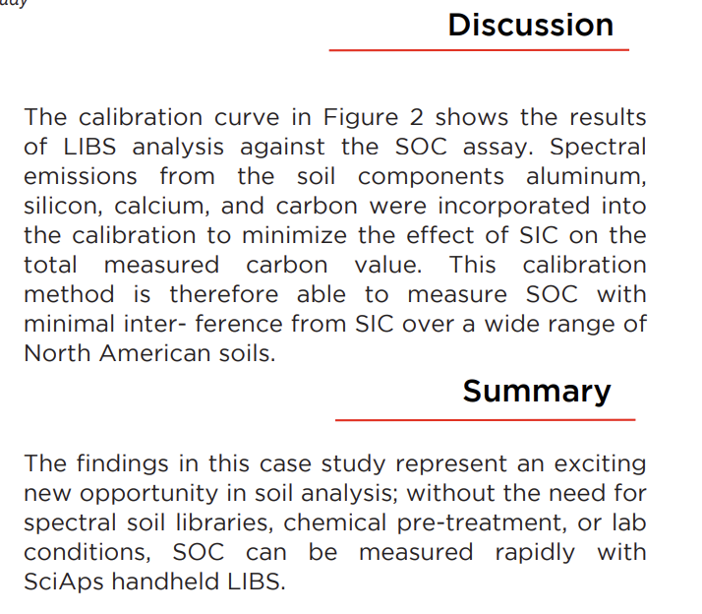 | Discussion
 | The calibration curve in Figure 2 shows the results of LIBS analysis against the SOC assay. Spectral emissions from the soil components aluminum, silicon, calcium, and carbon were incorporated into the calibration to minimize the effect of SIC on the total measured carbon value. This calibration method is therefore able to measure SOC with minimal inter- ference from SIC over a wide range of North American soils.
 | Summary
 | The findings in this case study represent an exciting new opportunity in soil analysis; without the need for spectral soil libraries, chemical pre-treatment, or lab conditions, SOC can be measured rapidly with SciAps handheld LIBS.
 | ANALYZE YOUR WORLD.

