Document Title: SciAps reveNIR Specifications
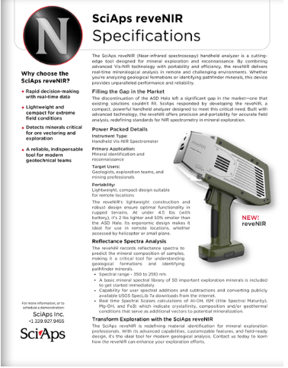
Rev Date: Aug 2025

Layout Preview | English Text | Translated Text
 | SciAps reveNIR
 | Specifications
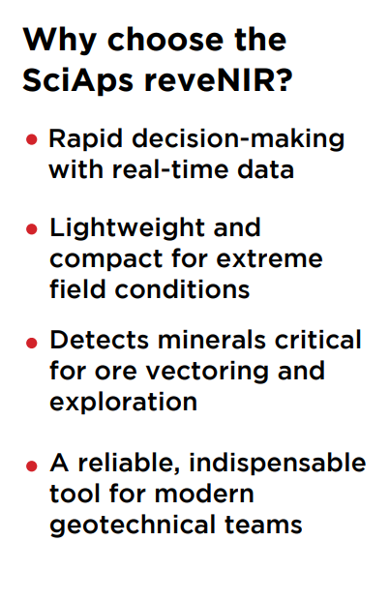 | Why choose the SciAps reveNIR?
 | Rapid decision-making with real-time data
 | Lightweight and compact for extreme field conditions
 | Detects minerals critical for ore vectoring and exploration
 | A reliable, indispensable tool for modern geotechnical teams
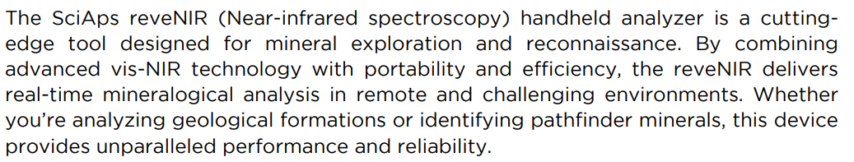 | The SciAps reveNIR (Near-infrared spectroscopy) handheld analyzer is a cutting-edge tool designed for mineral exploration and reconnaissance. By combining advanced Vis-NIR technology with portability and efficiency, the reveNIR delivers real-time mineralogical analysis in remote and challenging environments. Whether you’re analyzing geological formations or identifying pathfinder minerals, this device provides unparalleled performance and reliability.
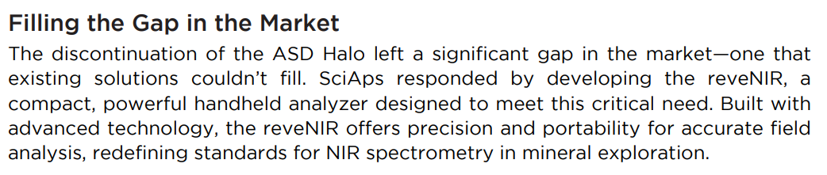 | Filling the Gap in the Market
 | The discontinuation of the ASD Halo left a significant gap in the market—one that existing solutions couldn’t fill. SciAps responded by developing the reveNIR, a compact, powerful handheld analyzer designed to meet this critical need. Built with advanced technology, the reveNIR offers precision and portability for accurate field analysis, redefining standards for NIR spectrometry in mineral exploration.
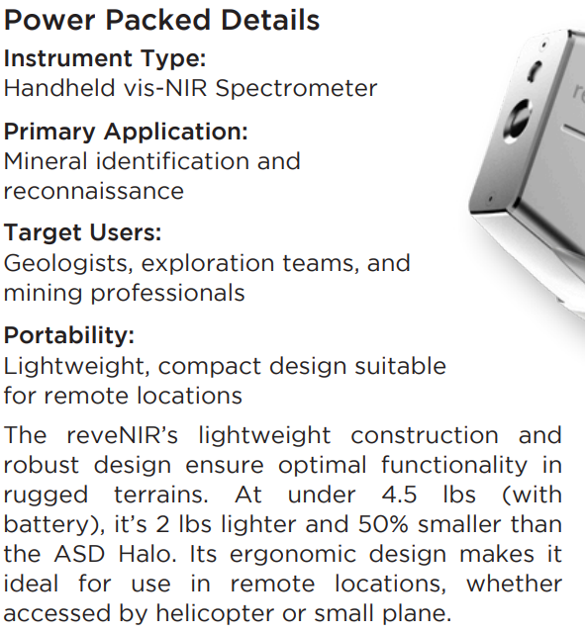 | Power Packed Details | Detalles increíbles
 | Instrument Type:
 | Handheld Vis-NIR Spectrometer
 | Primary Application:
 | Mineral identification and reconnaissance
 | Target Users:
 | Geologists, exploration teams, and mining professionals
 | Portability:
 | Lightweight, compact design suitable for remote locations.
 | The reveNIR’s lightweight construction and robust design ensure optimal functionality in rugged terrains. At under 4.5 lbs (with battery), it’s 2 lbs lighter and 50% smaller than the ASD Halo. Its ergonomic design makes it ideal for use in remote locations, whether accessed by helicopter or small plane.
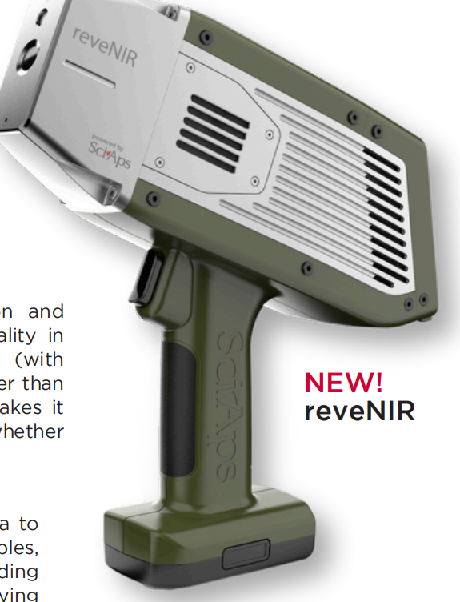 | NEW! reveNIR
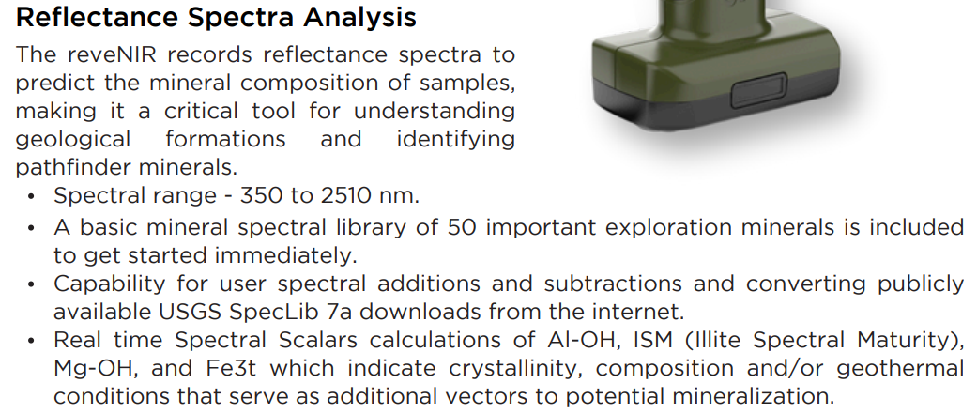 | Reflectance Spectra Analysis
 | The reveNIR records reflectance spectra to predict the mineral composition of samples, making it a critical tool for understanding geological formations and identifying pathfinder minerals.
 | Spectral range - 350 to 2500 nm.
 | A basic mineral spectral library of 100 important exploration minerals is included to get started immediately.
 | Ability to add and remove spectra from the library and converting publicly available USGS SpecLib 7a downloads from the internet.
 | Real time Spectral Scalars calculations of Al-OH, ISM (Illite Spectral Maturity), Mg-OH, and Fe3t which indicate crystallinity, composition and/or geothermal conditions that serve as additional vectors to potential mineralization.
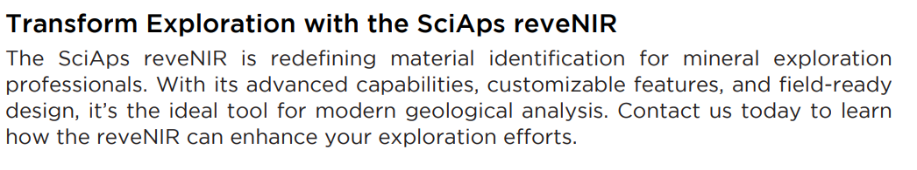 | Transform Exploration with the SciAps reveNIR
 | The SciAps reveNIR is redefining material identification for mineral exploration professionals. With its advanced capabilities, customizable features, and field-ready design, it’s the ideal tool for modern geological analysis. Contact us today to learn how the reveNIR can enhance your exploration efforts.
 | For more information, or to schedule a demonstration:
 | SciAps reveNIR
 | Specifications
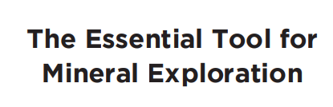 | The Essential Tool for Mineral Exploration
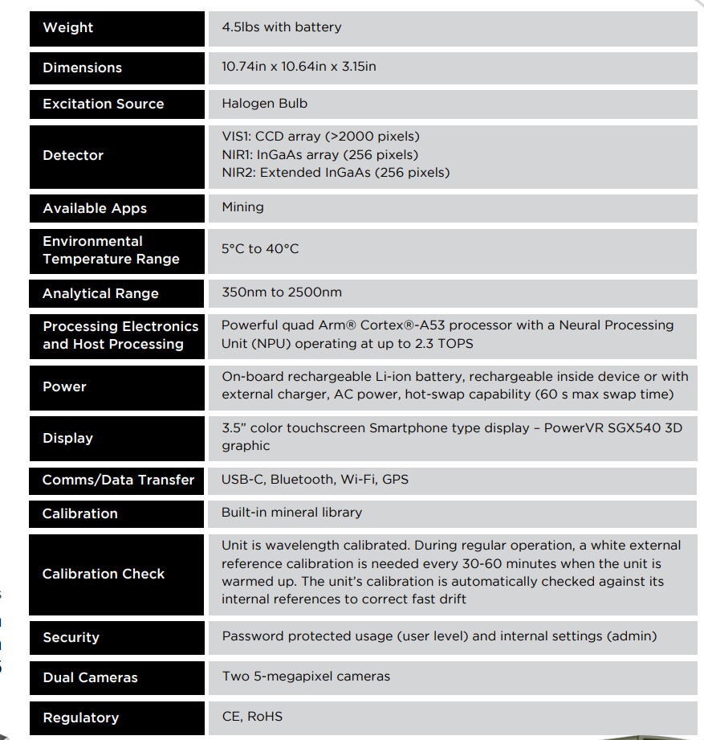 | Weight
 | 4.5lbs with battery
 | Dimensions
 | 10.74in x 10.64in x 3.15in
 | Light Source
 | Halogen Bulb
 | Detector
VNIR: CCD array (>2000 pixels)
SWIR1: InGaAs array (256 pixels)
SWIR2: Extended InGaAs (256 pixels)
 | Available Apps
 | Mining
 | Environmental Temperature Range
 | 5°C to 40°C
 | Analytical Range
 | 350nm to 2500nm
 | Processing Electronics and Host Processing
 | Powerful quad Arm® Cortex®-A53 processor with a Neural Processing Unit (NPU) operating at up to 2.3 TOPS
 | Power
 | On-board rechargeable Li-ion battery, rechargeable inside device or with external charger, AC power, hot-swap capability (60 s max swap time)
 | Display
 | 3.5” color touchscreen Smartphone type display – PowerVR SGX540 3D graphic
 | Comms/Data Transfer
 | USB-C, Bluetooth, Wi-Fi, GPS
 | Calibration
 | Built-in customizable mineral library
 | Calibration Check
 | Unit is wavelength calibrated. During regular operation, a white external reference calibration is needed every 2 hours when the unit is warmed up. The unit’s calibration is automatically checked against its internal references to correct fast drift
 | Security
 | Password protected usage (user level) and internal settings (admin)
 | Dual Cameras
 | Two 5-megapixel cameras, internal shot of the sample from the NIR FOV and external camera for macro view or barcode scanning
 | Regulatory
 | CE, RoHS
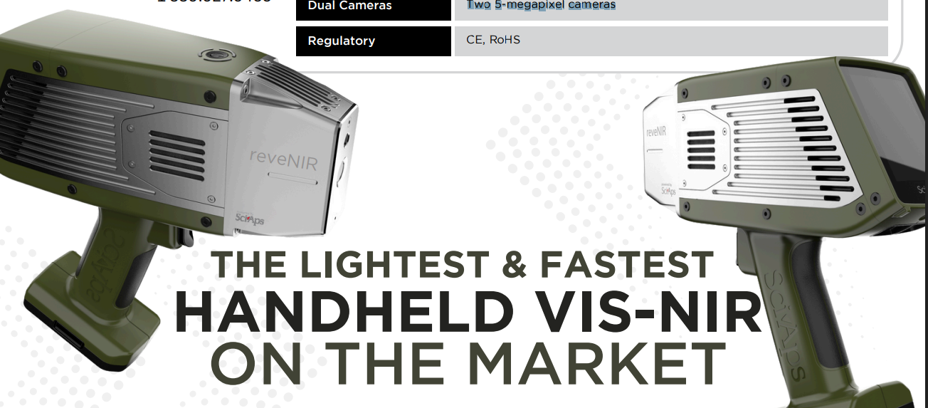 | THE LIGHTEST & FASTEST
 | HANDHELD VIS-NIR
 | ON THE MARKET

