Document Title: SciAps X-200 Alloy Specifications
Rev Date: Feb 2024
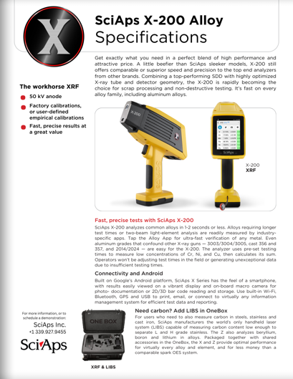
Layout Preview | English Text | Translated Text
 | SciAps X-200 Alloy
 | Specifications
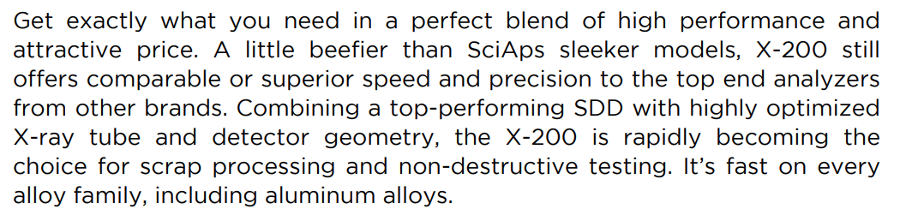 | Get exactly what you need in a perfect blend of high performance and attractive price. A little beefier than SciAps sleeker models, X-200 still offers comparable or superior speed and precision to the top end analyzers from other brands. Combining a top-performing SDD with highly optimized X-ray tube and detector geometry, the X-200 is rapidly becoming the choice for scrap processing and non-destructive testing. It’s fast on every alloy family, including aluminum alloys.
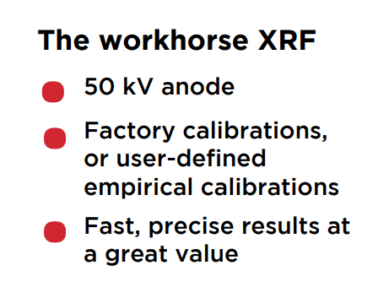 | The workhorse XRF
 | 50 kV anode
 | Factory calibrations, or user-defined empirical calibrations
 | Fast, precise results at • a great value
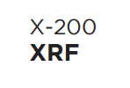 | X-200
 | XRF
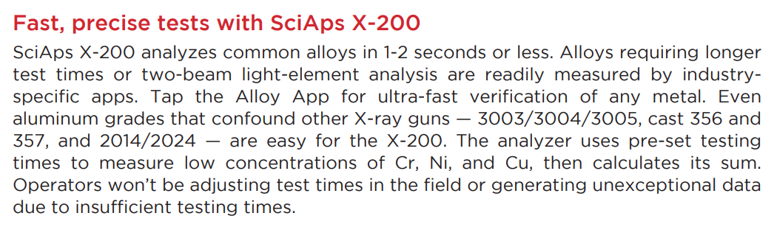 | Fast, precise tests with SciAps X-200
 | SciAps X-200 analyzes common alloys in 1-2 seconds or less. Alloys requiring longer test times or two-beam light-element analysis are readily measured by industry specific apps. Tap the Alloy App for ultra-fast verification of any metal. Even aluminum grades that confound other X-ray guns — 3003/3004/3005, cast 356 and 357, and 2014/2024 — are easy for the X-200. The analyzer uses pre-set testing times to measure low concentrations of Cr, Ni, and Cu, then calculates its sum. Operators won’t be adjusting test times in the field or generating unexceptional data due to insufficient testing times.
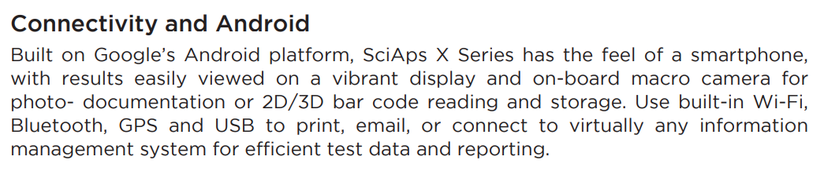 | Connectivity and Android
 | Built on Google’s Android platform, SciAps X Series has the feel of a smartphone, with results easily viewed on a vibrant display and on-board macro camera for photo- documentation or 2D/3D bar code reading and storage. With built-in Wi-Fi, Bluetooth, and USB connectivity, you can easily print, email, or transfer results to virtually any information management system. The analyzer is also GPS capable and compatible with SciAps Profile Builder PC software, ensuring fast and efficient test data handling and reporting.
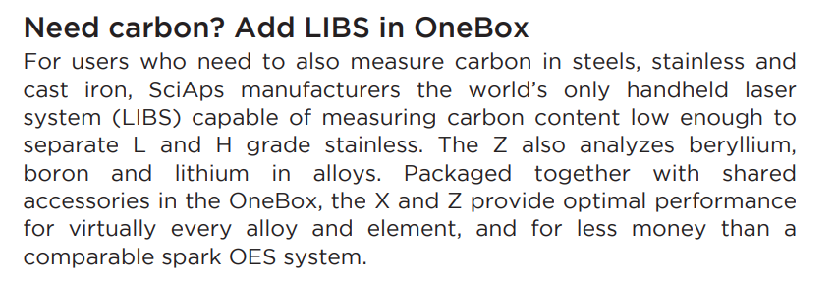 | Need carbon? Add LIBS in OneBox
 | For users who need to also measure carbon in steels, stainless and cast iron, SciAps manufacturers the world’s only handheld laser system (LIBS) capable of measuring carbon content low enough to separate L and H grade stainless. The Z also analyzes beryllium, boron and lithium in alloys. Packaged together with shared accessories in the OneBox, the X and Z provide optimal performance for virtually every alloy and element, and for less money than a comparable spark OES system.
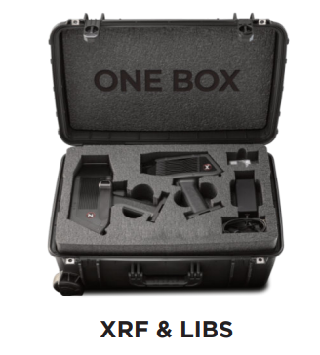 | XRF & LIBS
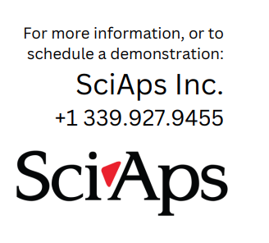 | For more information, or to schedule a demonstration:
If applicable, please add:
LOCAL COMPANY NAME
LOCAL WEBSITE
LOCAL PHONE
(BACK)
 | SciAps X-200 Alloy
 | Specifications
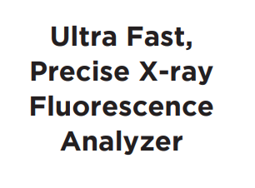 | Ultra Fast, Precise X-ray Fluorescence Analyzer
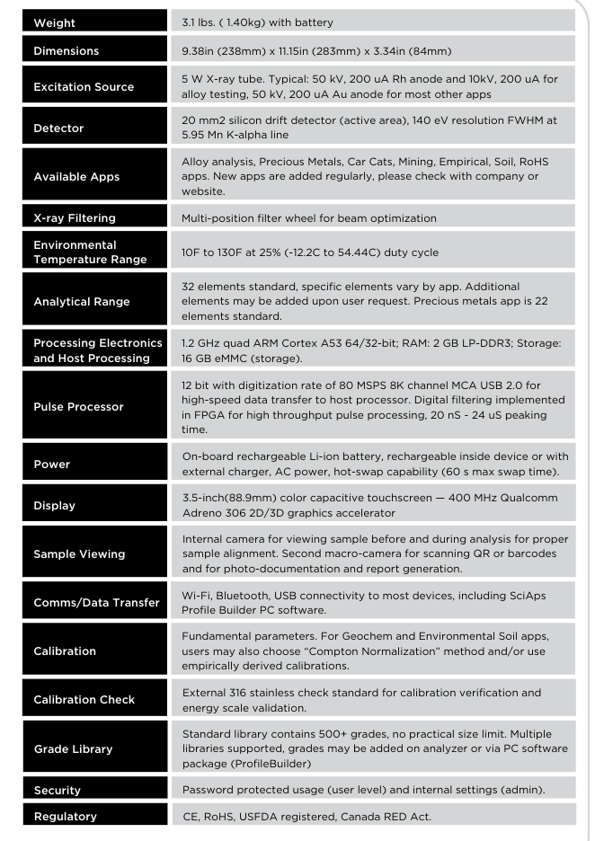 | Weight
 | 3.1 lbs. (1.40kg) with battery
 | Dimensions
 | 9.38in (238mm) x 11.15in (283mm) x 3.34in (84mm)
 | Excitation Source
 | 5 W X-ray tube. Typical: 50 kV, 200 uA Rh anode and 10kV, 200 uA for alloy testing, 50 kV, 200 uA Au anode for most other apps
 | Detector
 | 20 mm2 silicon drift detector (active area), 140 eV resolution FWHM at 5.95 Mn K-alpha line
 | Available Apps
 | Alloy analysis, Precious Metals, Car Cats, Mining, Empirical, Soil, RoHS apps. New apps are added regularly, please check with company or website.
 | X-ray Filtering
 | Multi-position filter wheel for beam optimization
 | Environmental Temperature Range
 | 10F to 130F at 25% (-12.2C to 54.44C) duty cycle
 | Analytical Range
 | 32 elements standard, specific elements vary by app. Additional elements may be added upon user request. Precious metals app is 22 elements standard.
 | Processing Electronics and Host Processing
 | 1.2 GHz quad ARM Cortex A53 64/32-bit; RAM: 2 GB LP-DDR3; Storage: 16 GB eMMC (storage).
 | Pulse Processor
 | 12 bit with digitization rate of 80 MSPS 8K channel MCA USB 2.0 for high-speed data transfer to host processor. Digital filtering implemented in FPGA for high throughput pulse processing, 20 nS - 24 uS peaking time.
 | Power
 | On-board rechargeable Li-ion battery, rechargeable inside device or with external charger, AC power, hot-swap capability (60 s max swap time).
 | Display
 | 3.5-inch(88.9mm) color capacitive touchscreen — 400 MHz Qualcomm Adreno 306 2D/3D graphics accelerator
 | Sample Viewing
 | Internal camera for viewing sample before and during analysis for proper sample alignment. Second macro-camera for scanning QR or barcodes and for photo-documentation and report generation.
 | Comms/Data Transfer
 | Wi-Fi, Bluetooth, USB connectivity to most devices, including SciAps Profile Builder PC software.
 | Calibration
 | Fundamental parameters. For Geochem and Environmental Soil apps, users may also choose “Compton Normalization” method and/or use empirically derived calibrations.
 | Calibration Check
 | External 316 stainless check standard for calibration verification and energy scale validation.
 | Grade Library
 | Standard library contains 500+ grades, no practical size limit. Multiple libraries supported, grades may be added on analyzer or via PC software package (Profile Builder)
 | Security
 | Password protected usage (user level) and internal settings (admin).
 | Regulatory
 | CE, RoHS, USFDA registered, Canada RED Act.
 | YouTube.com/SciAps
If applicable, please add:
LOCAL COMPANY NAME
LOCAL WEBSITE
LOCAL PHONE

