Document Title: SciAps PowerHouse X for REEs
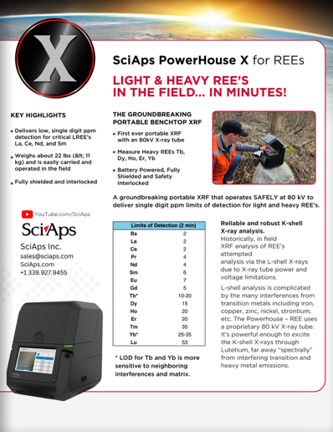
Rev Date: Aug 2025

Layout Preview | English Text | Translated Text
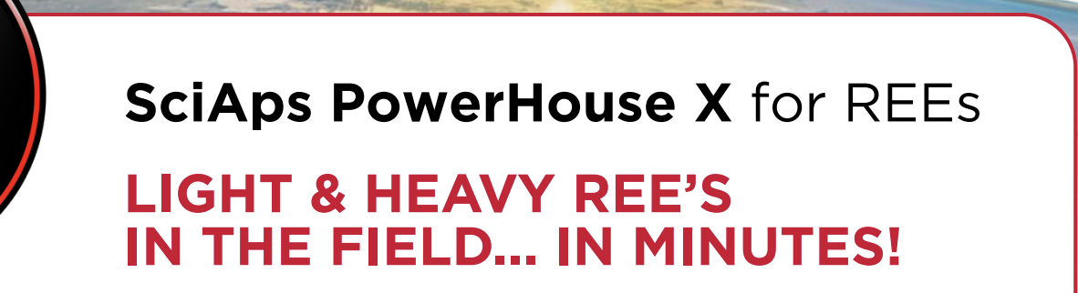 | SciAps PowerHouse X for REEs
 | LIGHT & HEAVY REE’S IN THE FIELD... IN MINUTES!
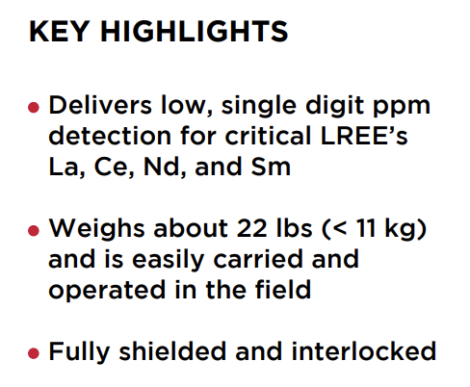 | KEY HIGHLIGHTS
 | Delivers low, single digit ppm detection for critical LREE’s La, Ce, Nd, and Sm
 | Weighs about 22 lbs (< 11 kg) and is easily carried and operated in the field
 | Fully shielded and interlocked
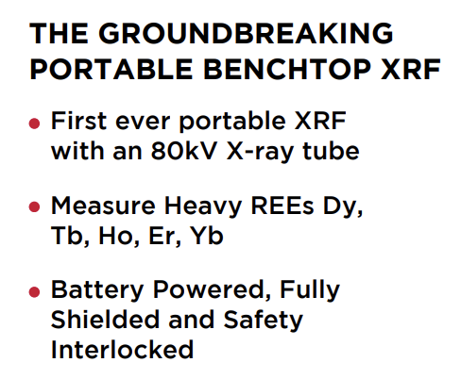 | THE GROUNDBREAKING PORTABLE BENCHTOP XRF
 | First ever portable XRF with an 80kV X-ray tube
 | Measure Heavy REEs Dy, Tb, Ho, Er, Yb
 | Battery Powered, Fully Shielded and Safety Interlocked
 | A groundbreaking portable XRF that operates SAFELY at 80 kV to deliver single digit ppm limits of detection for light and heavy REE’s.
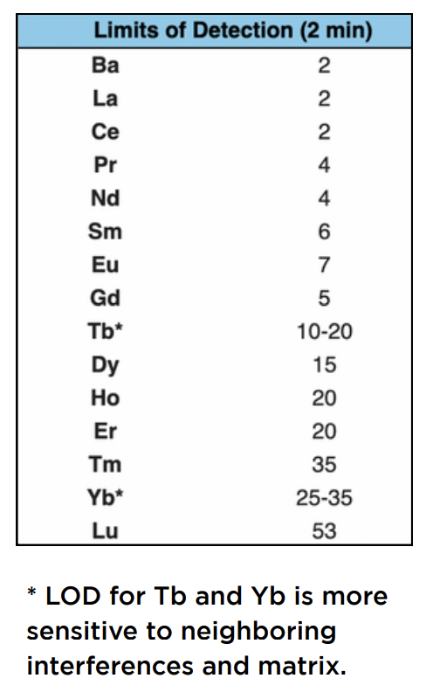 | * LOD for Tb and Yb is more sensitive to neighboring interferences and matrix.
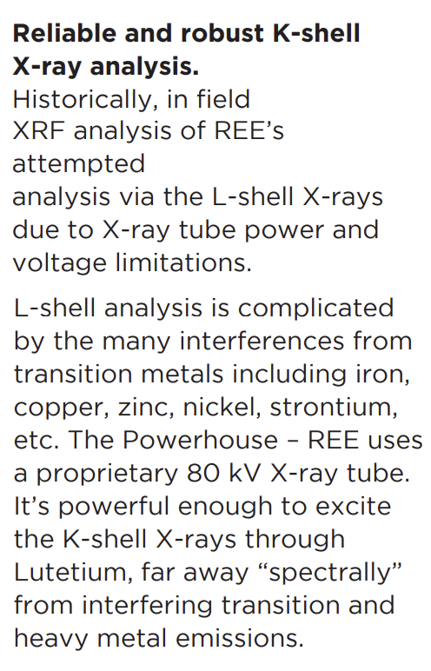 | Reliable and robust K-shell X-ray analysis.
 | Historically, in field XRF analysis of REE’s attempted analysis via the L-shell X-rays due to X-ray tube power and voltage limitations.
 | L-shell analysis is complicated by the many interferences from transition metals including iron, copper, zinc, nickel, strontium, etc. The Powerhouse – REE uses a proprietary 80 kV X-ray tube. It’s powerful enough to excite the K-shell X-rays through Lutetium, far away “spectrally” from interfering transition and heavy metal emissions.
(BACK)
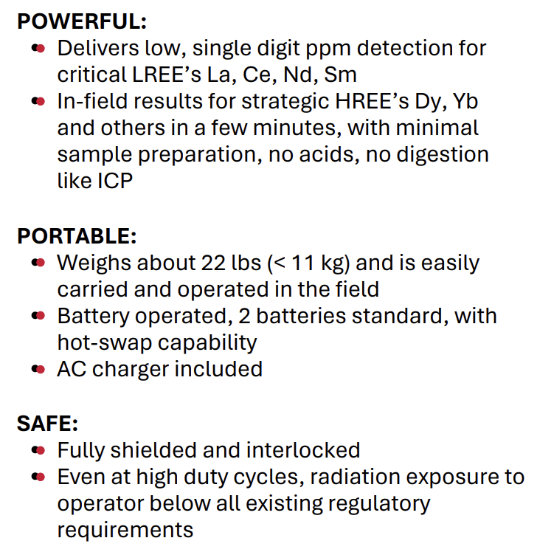 | POWERFUL:
 | Delivers low, single digit ppm detection for critical LREE’s La, Ce, Nd, Sm
 | In-field results for strategic HREE’s Dy, Yb and others in a few minutes, with minimal sample preparation, no acids, no digestion like ICP
 | PORTABLE:
 | Weighs about 22 lbs (< 11 kg) and is easily carried and operated in the field
 | Battery operated, 2 batteries standard, with hot-swap capability
 | AC charger included
 | SAFE:
 | Fully shielded and interlocked
 | Even at high duty cycles, radiation exposure to operator below all existing regulatory requirements
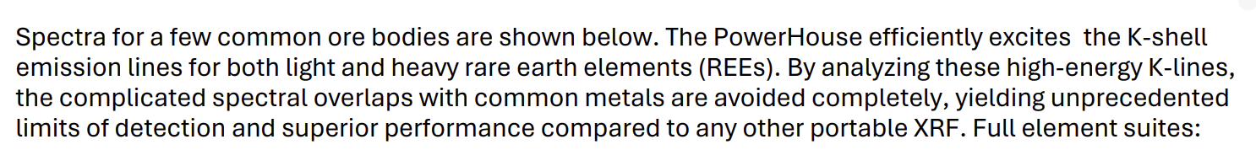 | Spectra for a few common ore bodies are shown below. The PowerHouse efficiently excites the K-shell emission lines for both light and heavy rare earth elements (REEs). By analyzing these high-energy K-lines, the complicated spectral overlaps with common metals are avoided completely, yielding unprecedented limits of detection and superior performance compared to any other portable XRF. Full element suites:
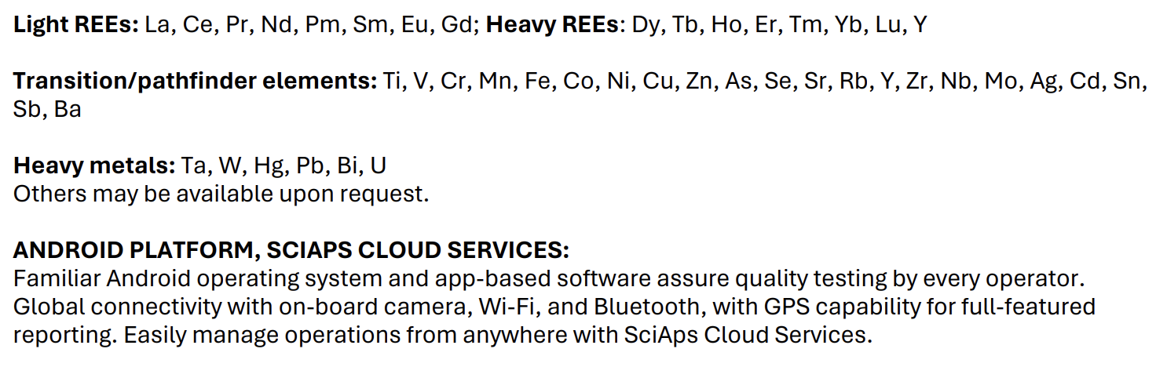 | Light REEs:
 | La, Ce, Pr, Nd, Pm, Sm, Eu, Gd;
 | Heavy REEs:
 | Dy, Tb, Ho, Er, Tm, Yb, Lu, Y
 | Transition/pathfinder elements:
 | Ti, V, Cr, Mn, Fe, Co, Ni, Cu, Zn, As, Se, Sr, Rb, Y, Zr, Nb, Mo, Ag, Cd, Sn, Sb, Ba
 | Heavy metals:
 | Ta, W, Hg, Pb, Bi, U
 | Others may be available upon request.
 | ANDROID PLATFORM, SCIAPS CLOUD SERVICES:
 | Familiar Android operating system and app-based software assure quality testing by every operator. Global connectivity with on-board camera, Wi-Fi, and Bluetooth, with GPS capability for full-featured reporting. Easily manage operations from anywhere with SciAps Cloud Services.

