Document Title: ASD FieldSpec 4 Brochure
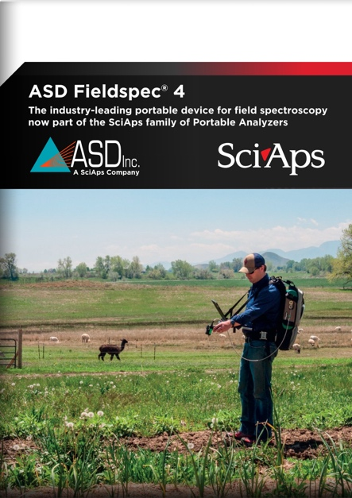
Rev Date: Sept 2025

Layout Preview | English Text | Translated Text
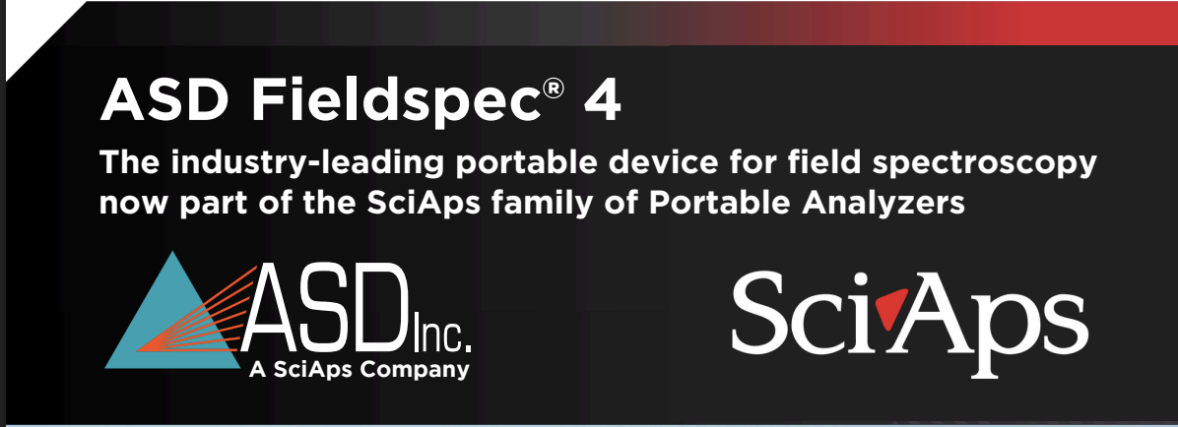 | ASD Fieldspec® 4
 | The industry-leading portable device for field spectroscopy now part of the SciAps family of Portable Analyzers
 | A SciAps Company
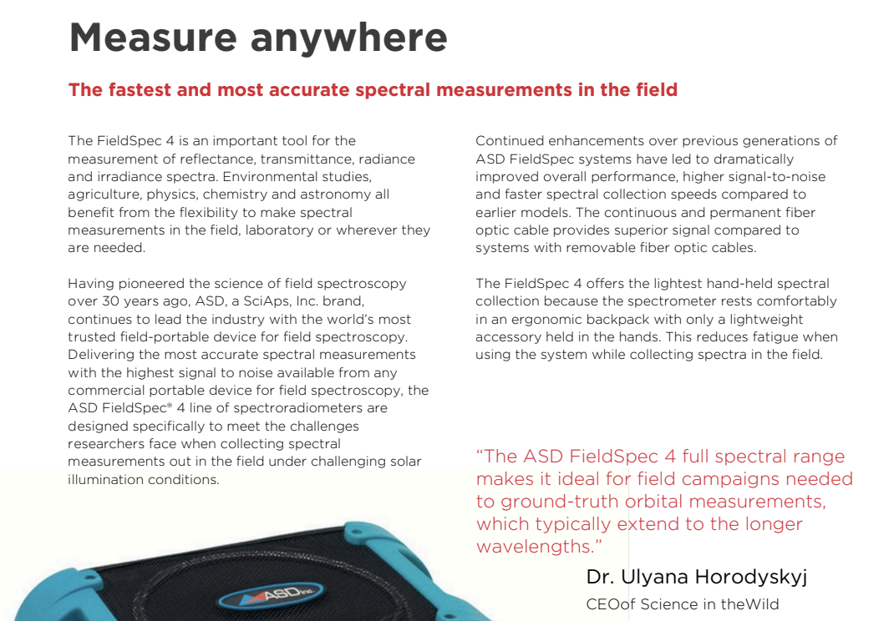 | Measure anywhere
 | The fastest and most accurate spectral measurements in the field
 | The FieldSpec 4 is an important tool for the measurement of reflectance, transmittance, radiance and irradiance spectra. Environmental studies, agriculture, physics, chemistry and astronomy all benefit from the flexibility to make spectral measurements in the field, laboratory or wherever they are needed.
 | Having pioneered the science of field spectroscopy over 30 years ago, ASD, a SciAps, Inc. brand, continues to lead the industry with the world’s most trusted field-portable device for field spectroscopy. Delivering the most accurate spectral measurements with the highest signal to noise available from any commercial portable device for field spectroscopy, the ASD FieldSpec® 4 line of spectroradiometers are designed specifically to meet the challenges researchers face when collecting spectral measurements out in the field under challenging solar illumination conditions.
 | Continued enhancements over previous generations of ASD FieldSpec systems have led to dramatically improved overall performance, higher signal-to-noise and faster spectral collection speeds compared to earlier models. The continuous and permanent fiber optic cable provides superior signal compared to systems with removable fiber optic cables.
 | The FieldSpec 4 offers the lightest hand-held spectral collection because the spectrometer rests comfortably in an ergonomic backpack with only a lightweight accessory held in the hands. This reduces fatigue when using the system while collecting spectra in the field.
 | “The ASD FieldSpec 4 full spectral range makes it ideal for field campaigns needed to ground-truth orbital measurements, which typically extend to the longer wavelengths.”
 | Dr. Ulyana Horodyskyj
 | CEOof Science in theWild
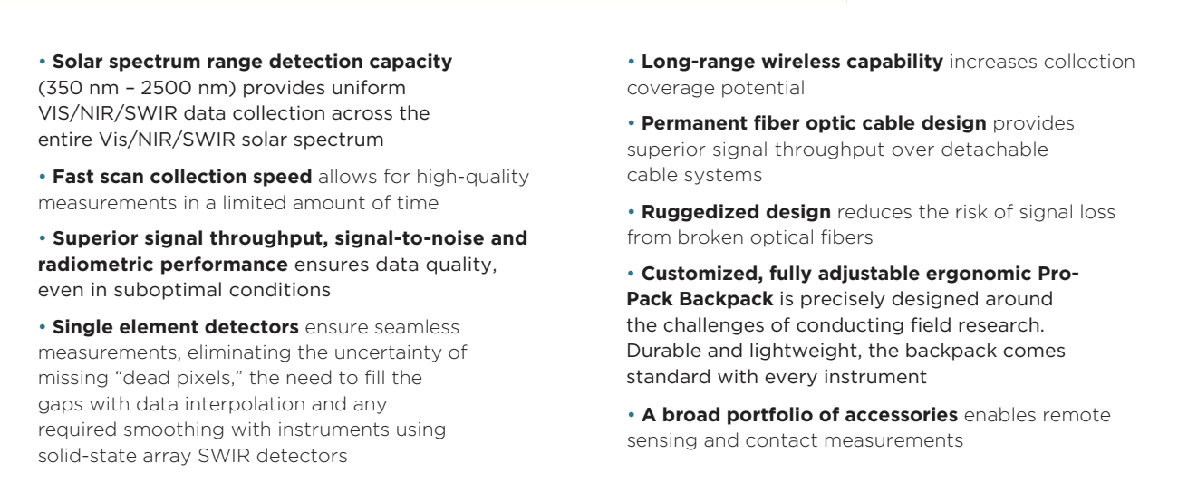 | Solar spectrum range detection capacity (350 nm – 2500 nm) provides uniform VIS/NIR/SWIR data collection across the entire Vis/NIR/SWIR solar spectrum
 | Fast scan collection speed allows for high-quality measurements in a limited amount of time
 | Superior signal throughput, signal-to-noise and radiometric performance ensures data quality, even in suboptimal conditions
 | Single element detectors ensure seamless measurements, eliminating the uncertainty of missing “dead pixels,” the need to fill the gaps with data interpolation and any required smoothing with instruments using solid-state array SWIR detectors
 | Long-range wireless capability increases collection coverage potential
 | Permanent fiber optic cable design provides superior signal throughput over detachable cable systems
 | Ruggedized design reduces the risk of signal loss from broken optical fibers
 | Customized, fully adjustable ergonomic ProPack Backpack is precisely designed around the challenges of conducting field research. Durable and lightweight, the backpack comes standard with every instrument
 | A broad portfolio of accessories enables remote sensing and contact measurements
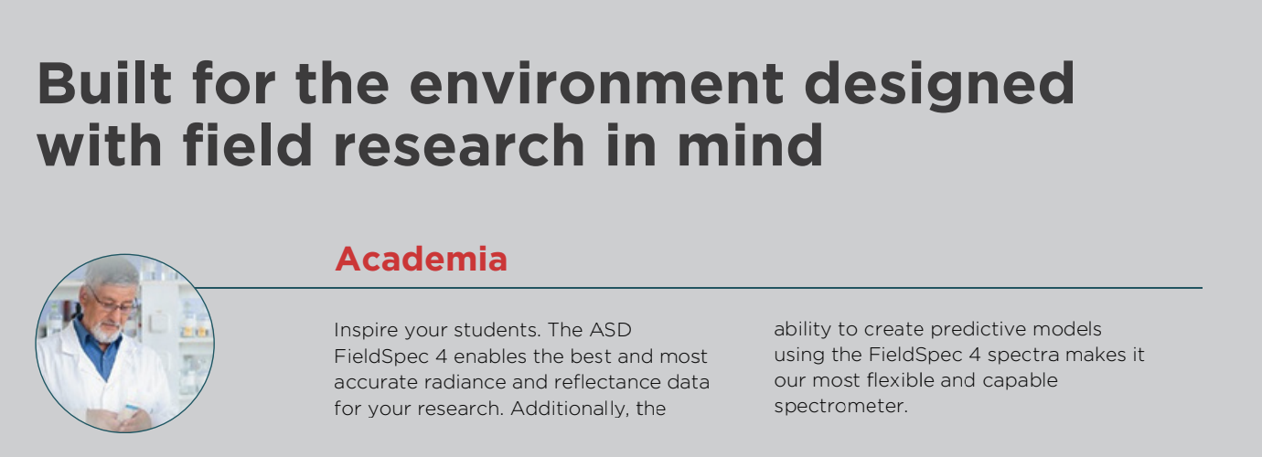 | Built for the environment designed with field research in mind
 | Academia
 | Inspire your students. The ASD FieldSpec 4 enables the best and most accurate radiance and reflectance data for your research. Additionally, the ability to create predictive models using the FieldSpec 4 spectra makes it our most flexible and capable spectrometer.
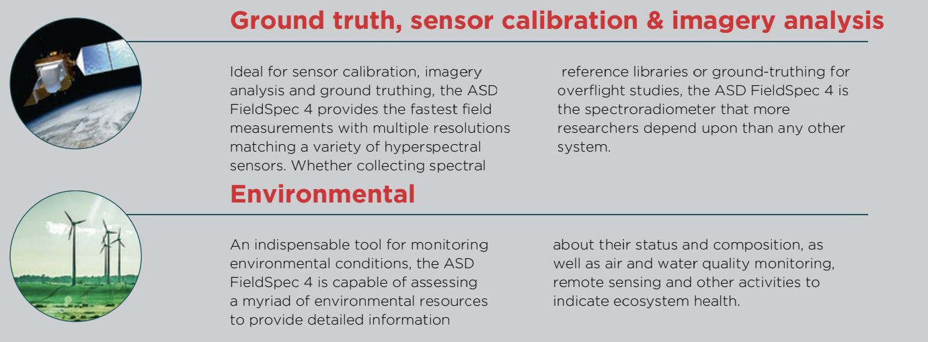 | Ground truth, sensor calibration & imagery analysis
 | Ideal for sensor calibration, imagery analysis and ground truthing, the ASD FieldSpec 4 provides the fastest field measurements with multiple resolutions matching a variety of hyperspectral sensors. Whether collecting spectral reference libraries or ground-truthing for overflight studies, the ASD FieldSpec 4 is the spectroradiometer that more researchers depend upon than any other system.
 | Environmental
 | An indispensable tool for monitoring environmental conditions, the ASD FieldSpec 4 is capable of assessing a myriad of environmental resources to provide detailed information about their status and composition, as well as air and water quality monitoring, remote sensing and other activities to indicate ecosystem health.
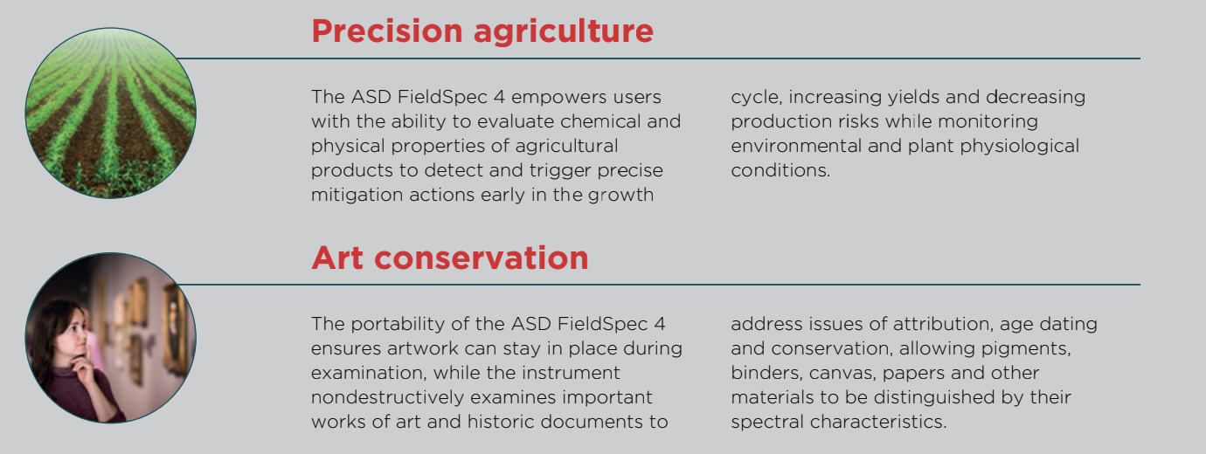 | Precision agriculture
 | The ASD FieldSpec 4 empowers users with the ability to evaluate chemical and physical properties of agricultural products to detect and trigger precise mitigation actions early in the growth cycle, increasing yields and decreasing production risks while monitoring environmental and plant physiological conditions.
 | Art conservation
 | The portability of the ASD FieldSpec 4 ensures artwork can stay in place during examination, while the instrument nondestructively examines important works of art and historic documents to address issues of attribution, age dating and conservation, allowing pigments, binders, canvas, papers and other materials to be distinguished by their spectral characteristics.
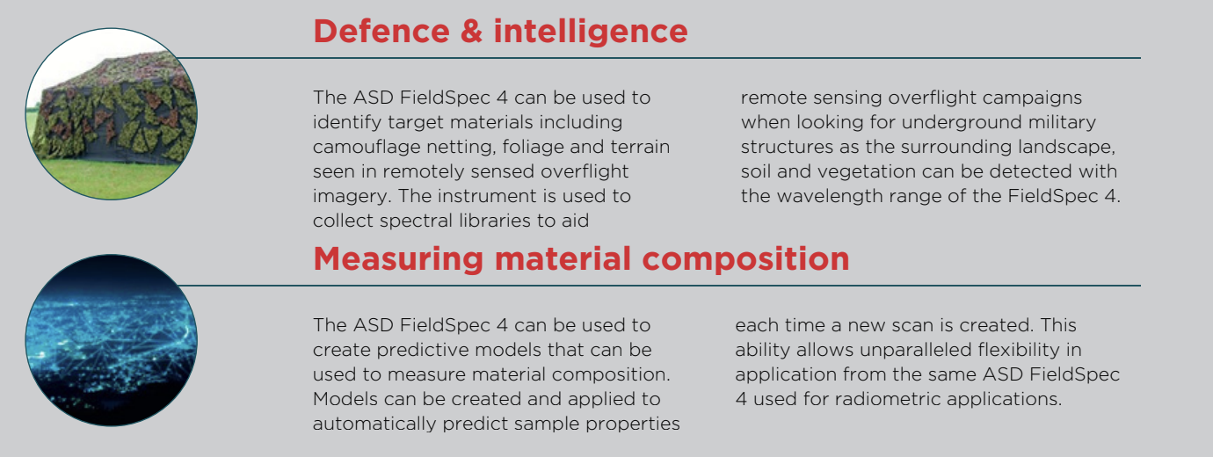 | Defence & intelligence
 | The ASD FieldSpec 4 can be used to identify target materials including camouflage netting, foliage and terrain seen in remotely sensed overflight imagery. The instrument is used to collect spectral libraries to aid remote sensing overflight campaigns when looking for underground military structures as the surrounding landscape, soil and vegetation can be detected with the wavelength range of the FieldSpec 4.
 | Measuring material composition
 | The ASD FieldSpec 4 can be used to create predictive models that can be used to measure material composition. Models can be created and applied to automatically predict sample properties each time a new scan is created. This ability allows unparalleled flexibility in application from the same ASD FieldSpec 4 used for radiometric applications.
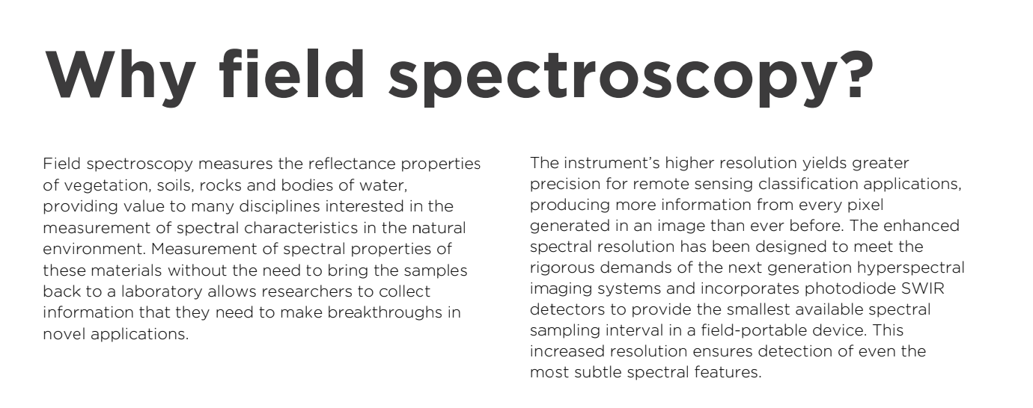 | Why field spectroscopy?
 | Field spectroscopy measures the reflectance properties of vegetation, soils, rocks and bodies of water, providing value to many disciplines interested in the measurement of spectral characteristics in the natural environment. Measurement of spectral properties of these materials without the need to bring the samples back to a laboratory allows researchers to collect information that they need to make breakthroughs in novel applications.
 | The instrument’s higher resolution yields greater precision for remote sensing classification applications, producing more information from every pixel generated in an image than ever before. The enhanced spectral resolution has been designed to meet the rigorous demands of the next generation hyperspectral imaging systems and incorporates photodiode SWIR detectors to provide the smallest available spectral sampling interval in a field-portable device. This increased resolution ensures detection of even the most subtle spectral features.
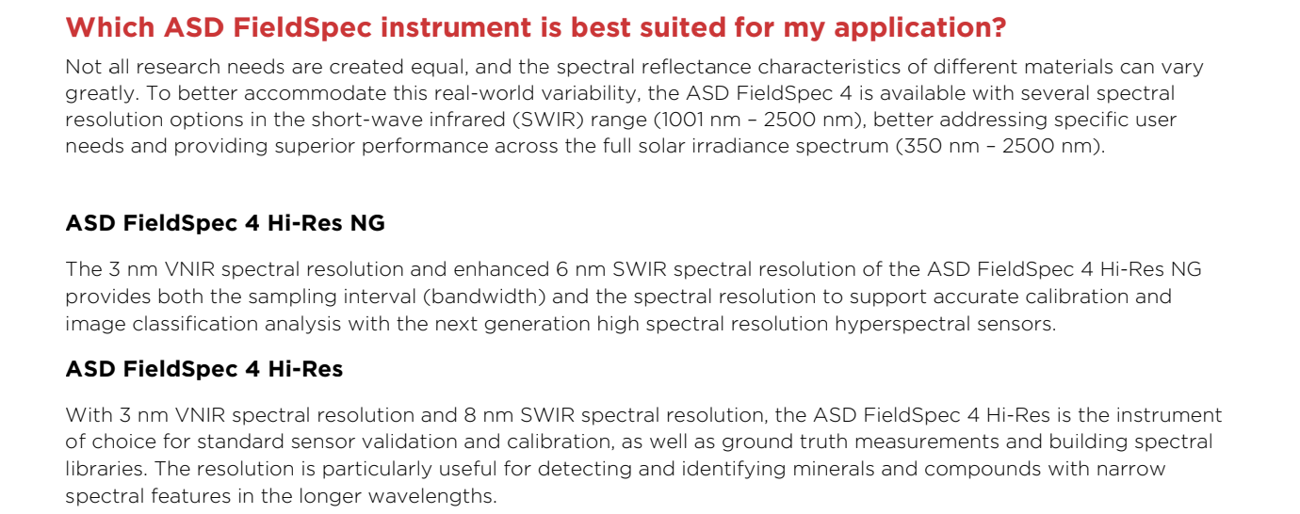 | Which ASD FieldSpec instrument is best suited for my application?
 | Not all research needs are created equal, and the spectral reflectance characteristics of different materials can vary greatly. To better accommodate this real-world variability, the ASD FieldSpec 4 is available with several spectral resolution options in the short-wave infrared (SWIR) range (1001 nm – 2500 nm), better addressing specific user needs and providing superior performance across the full solar irradiance spectrum (350 nm – 2500 nm).
 | ASD FieldSpec 4 Hi-Res NG
 | The 3 nm VNIR spectral resolution and enhanced 6 nm SWIR spectral resolution of the ASD FieldSpec 4 Hi-Res NG provides both the sampling interval (bandwidth) and the spectral resolution to support accurate calibration and image classification analysis with the next generation high spectral resolution hyperspectral sensors.
 | ASD FieldSpec 4 Hi-Res
 | With 3 nm VNIR spectral resolution and 8 nm SWIR spectral resolution, the ASD FieldSpec 4 Hi-Res is the instrument of choice for standard sensor validation and calibration, as well as ground truth measurements and building spectral libraries. The resolution is particularly useful for detecting and identifying minerals and compounds with narrow spectral features in the longer wavelengths.
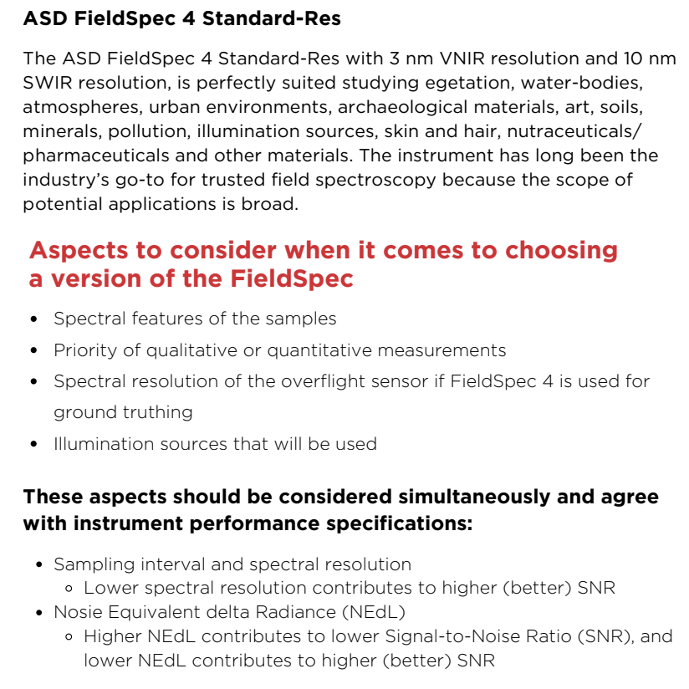 | ASD FieldSpec 4 Standard-Res
 | The ASD FieldSpec 4 Standard-Res with 3 nm VNIR resolution and 10 nm SWIR resolution, is perfectly suited studying egetation, water-bodies, atmospheres, urban environments, archaeological materials, art, soils, minerals, pollution, illumination sources, skin and hair, nutraceuticals/ pharmaceuticals and other materials. The instrument has long been the industry’s go-to for trusted field spectroscopy because the scope of potential applications is broad.
 | Aspects to consider when it comes to choosing a version of the FieldSpec
 | Spectral features of the samples
 | Priority of qualitative or quantitative measurements
 | Spectral resolution of the overflight sensor if FieldSpec 4 is used for ground truthing
 | Illumination sources that will be used
 | These aspects should be considered simultaneously and agree with instrument performance specifications:
 | Sampling interval and spectral resolution
 | Lower spectral resolution contributes to higher (better) SNR
 | Nosie Equivalent delta Radiance (NEdL)
 | Higher NEdL contributes to lower Signal-to-Noise Ratio (SNR), and lower NEdL contributes to higher (better) SNR
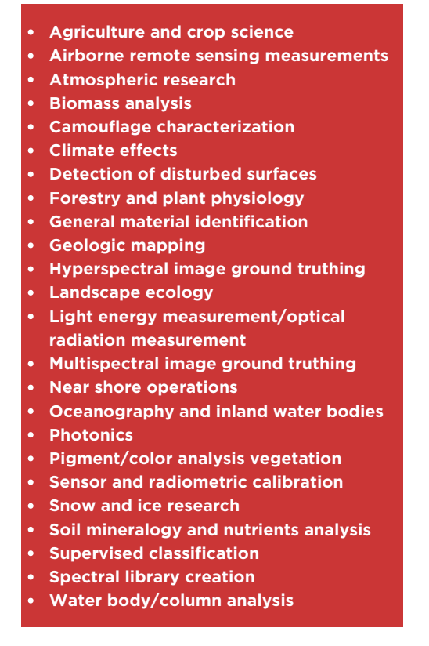 | Agriculture and crop science
 | Airborne remote sensing measurements
 | Atmospheric research
 | Biomass analysis
 | Camouflage characterization
 | Climate effects
 | Detection of disturbed surfaces
 | Forestry and plant physiology
 | General material identification
 | Geologic mapping
 | Hyperspectral image ground truthing
 | Landscape ecology
 | Light energy measurement/optical radiation measurement
 | Multispectral image ground truthing
 | Near shore operations
 | Oceanography and inland water bodies
 | Photonics
 | Pigment/color analysis vegetation
 | Sensor and radiometric calibration
 | Snow and ice research
 | Soil mineralogy and nutrients analysis
 | Supervised classification
 | Spectral library creation
 | Water body/column analysis
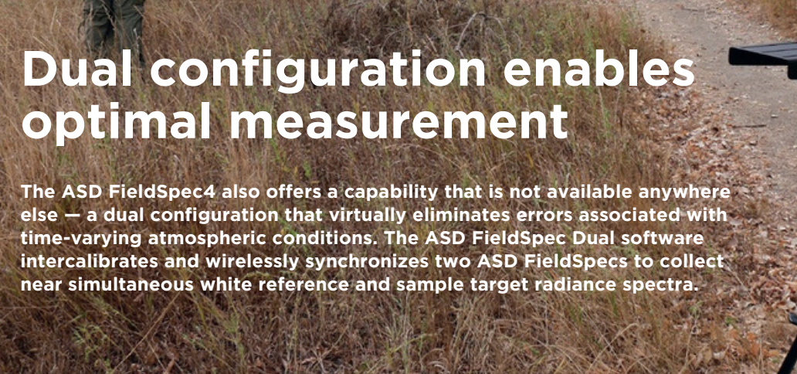 | Dual configuration enables optimal measurement
 | The ASD FieldSpec4 also offers a capability that is not available anywhere else — a dual configuration that virtually eliminates errors associated with time-varying atmospheric conditions. The ASD FieldSpec Dual software intercalibrates and wirelessly synchronizes two ASD FieldSpecs to collect near simultaneous white reference and sample target radiance spectra.
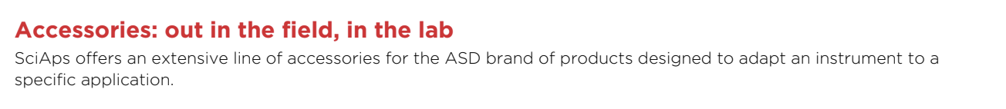 | Accessories: out in the field, in the lab
 | SciAps offers an extensive line of accessories for the ASD brand of products designed to adapt an instrument to a specific application.
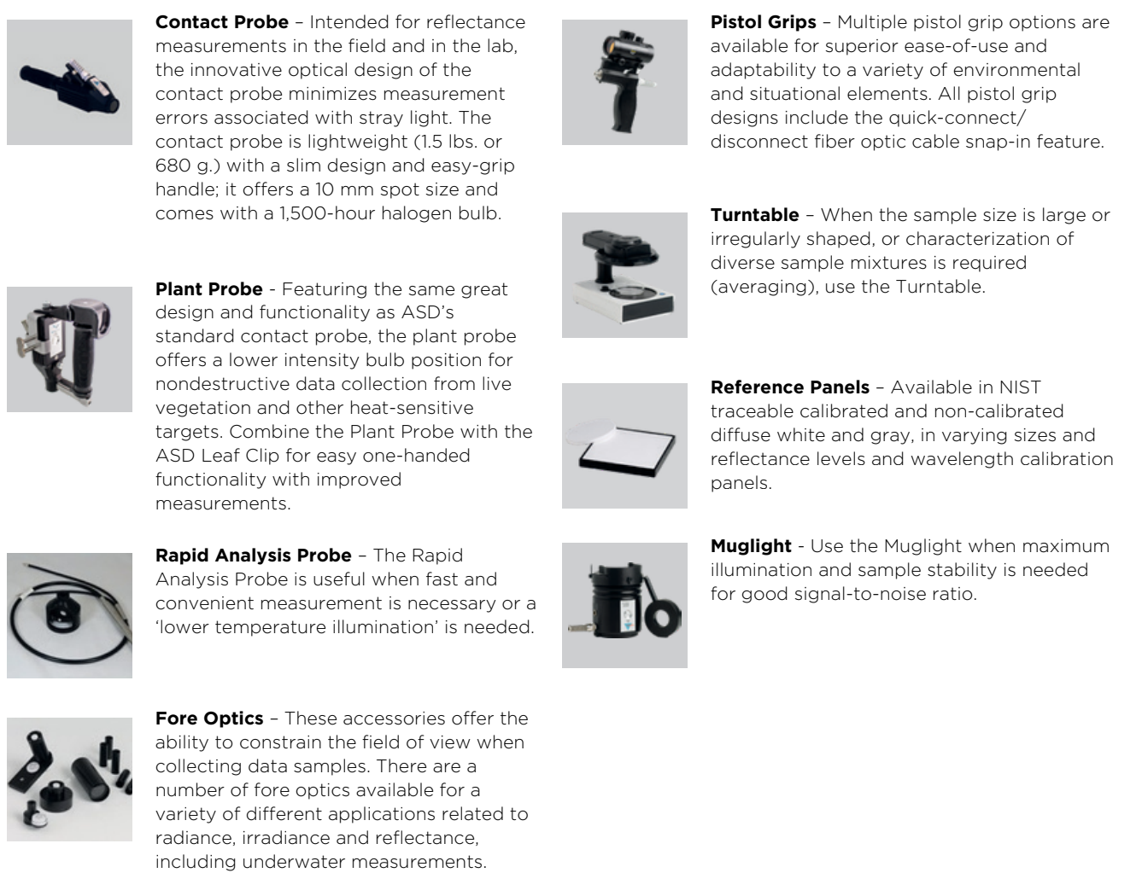 | Contact Probe – Intended for reflectance measurements in the field and in the lab, the innovative optical design of the contact probe minimizes measurement errors associated with stray light. The contact probe is lightweight (1.5 lbs. or 680 g.) with a slim design and easy-grip handle; it offers a 10 mm spot size and comes with a 1,500-hour halogen bulb.
 | Plant Probe - Featuring the same great design and functionality as ASD’s standard contact probe, the plant probe offers a lower intensity bulb position for nondestructive data collection from live vegetation and other heat-sensitive targets. Combine the Plant Probe with the ASD Leaf Clip for easy one-handed functionality with improved measurements.
 | Rapid Analysis Probe – The Rapid Analysis Probe is useful when fast and convenient measurement is necessary or a ‘lower temperature illumination’ is needed.
 | Fore Optics – These accessories offer the ability to constrain the field of view when collecting data samples. There are a number of fore optics available for a variety of different applications related to radiance, irradiance and reflectance, including underwater measurements.
 | Pistol Grips – Multiple pistol grip options are available for superior ease-of-use and adaptability to a variety of environmental and situational elements. All pistol grip designs include the quick-connect/ disconnect fiber optic cable snap-in feature.
 | Turntable – When the sample size is large or irregularly shaped, or characterization of diverse sample mixtures is required (averaging), use the Turntable.
 | Reference Panels – Available in NIST traceable calibrated and non-calibrated diffuse white and gray, in varying sizes and reflectance levels and wavelength calibration panels.
 | Muglight - Use the Muglight when maximum illumination and sample stability is needed for good signal-to-noise ratio.
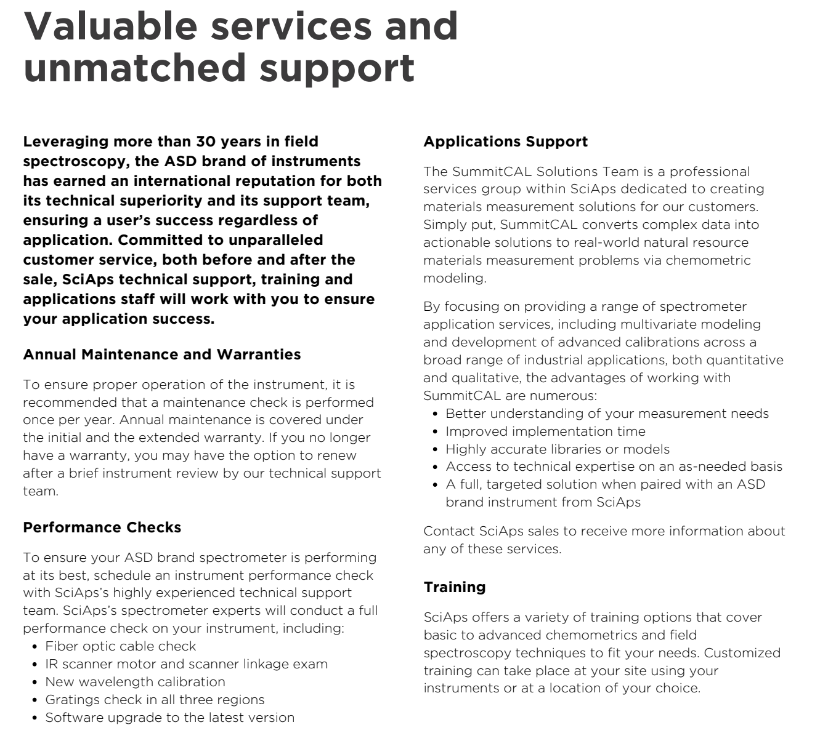 | Valuable services and unmatched support
 | Leveraging more than 30 years in field spectroscopy, the ASD brand of instruments has earned an international reputation for both its technical superiority and its support team, ensuring a user’s success regardless of application. Committed to unparalleled customer service, both before and after the sale, SciAps technical support, training and applications staff will work with you to ensure your application success.
 | Annual Maintenance and Warranties
 | To ensure proper operation of the instrument, it is recommended that a maintenance check is performed once per year. Annual maintenance is covered under the initial and the extended warranty. If you no longer have a warranty, you may have the option to renew after a brief instrument review by our technical support team.
 | Performance Checks
 | To ensure your ASD brand spectrometer is performing at its best, schedule an instrument performance check with SciAps’s highly experienced technical support team. SciAps’s spectrometer experts will conduct a full performance check on your instrument, including:
 | Fiber optic cable check
 | IR scanner motor and scanner linkage exam
 | New wavelength calibration
 | Gratings check in all three regions
 | Software upgrade to the latest version
 | Applications Support
 | The SummitCAL Solutions Team is a professional services group within SciAps dedicated to creating materials measurement solutions for our customers. Simply put, SummitCAL converts complex data into actionable solutions to real-world natural resource materials measurement problems via chemometric modeling.
 | By focusing on providing a range of spectrometer application services, including multivariate modeling and development of advanced calibrations across a broad range of industrial applications, both quantitative and qualitative, the advantages of working with SummitCAL are numerous:
 | Better understanding of your measurement needs
 | Improved implementation time
 | Highly accurate libraries or models
 | Access to technical expertise on an as-needed basis
 | A full, targeted solution when paired with an ASD brand instrument from SciAps
 | Contact SciAps sales to receive more information about any of these services.
 | Training
 | SciAps offers a variety of training options that cover basic to advanced chemometrics and field spectroscopy techniques to fit your needs. Customized training can take place at your site using your instruments or at a location of your choice.
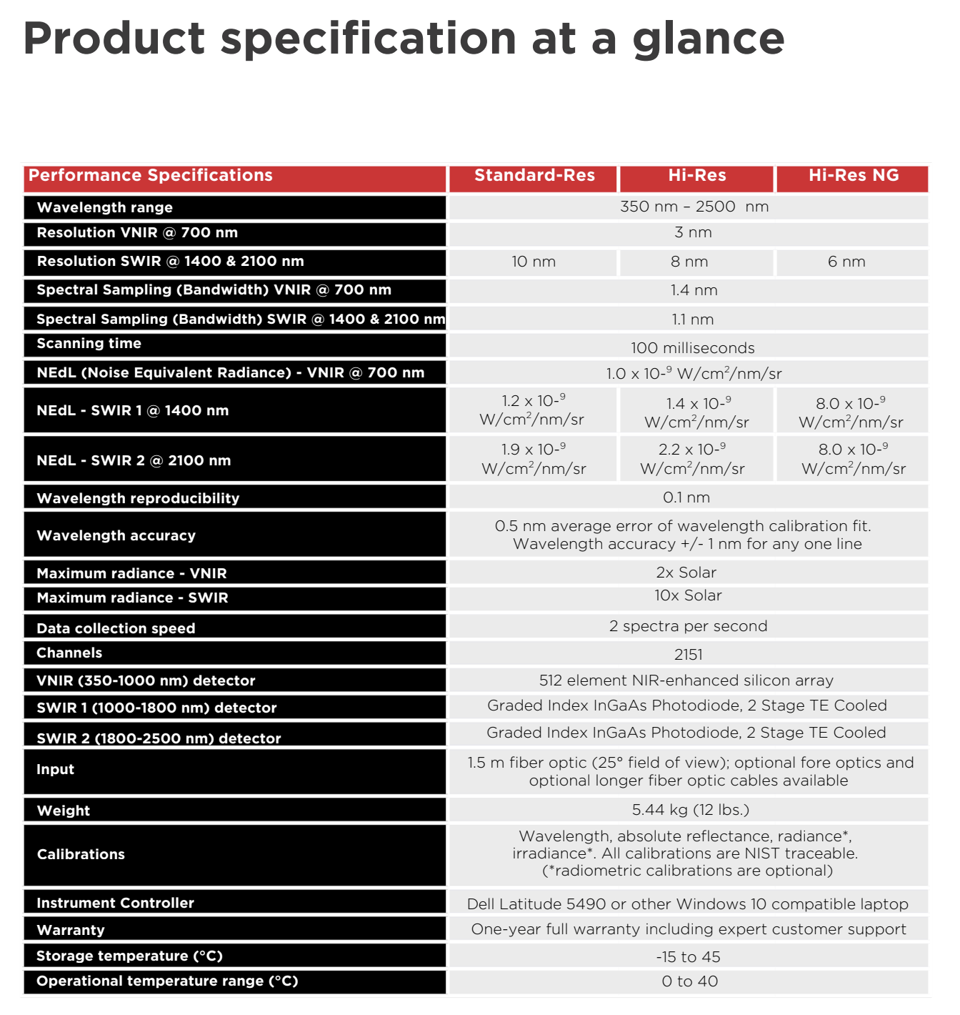 | Product specification at a glance
 | Performance Specifications
 | Standard-Res
 | Hi-Res
 | Hi-Res NG
 | Wavelength range
 | 350 nm – 2500 nm
 | Resolution VNIR @ 700 nm
 | 3 nm
 | Resolution SWIR @ 1400 & 2100 nm
 | 10 nm
 | 8 nm
 | 6 nm
 | Spectral Sampling (Bandwidth) VNIR @ 700 nm
 | 1.4 nm
 | Spectral Sampling (Bandwidth) SWIR @ 1400 & 2100 nm
 | 1.1 nm
 | Scanning time
 | 100 milliseconds
 | NEdL (Noise Equivalent Radiance) - VNIR @ 700 nm
 | 1.0 x 10- W/cm /nm/sr
 | NEdL - SWIR 1 @ 1400 nm
 | 1.2 x 10-⁹ W/cm /nm/sr
 | 1.4 x 10-⁹ W/cm /nm/sr
 | 8.0 x 10-⁹ W/cm /nm/sr
 | NEdL - SWIR 2 @ 2100 nm
 | 1.9 x 10-⁹ W/cm /nm/sr
 | 2.2 x 10-⁹ W/cm /nm/sr
 | 8.0 x 10-⁹ W/cm /nm/sr
 | Wavelength reproducibility
 | 0.1 nm
 | Wavelength accuracy
 | 0.5 nm average error of wavelength calibration fit. Wavelength accuracy +/- 1 nm for any one line
 | Maximum radiance - VNIR
 | 2x Solar
 | Maximum radiance - SWIR
 | 10x Solar
 | Data collection speed
 | 2 spectra per second
 | Channels
 | 2151
 | VNIR (350-1000 nm) detector
 | 512 element NIR-enhanced silicon array
 | SWIR 1 (1000-1800 nm) detector
 | Graded Index InGaAs Photodiode, 2 Stage TE Cooled
 | SWIR 2 (1800-2500 nm) detector
 | Graded Index InGaAs Photodiode, 2 Stage TE Cooled
 | Input
 | 1.5 m fiber optic (25° field of view); optional fore optics and optional longer fiber optic cables available
 | Weight
 | 5.44 kg (12 lbs.)
 | Calibrations
 | Wavelength, absolute reflectance, radiance* , irradiance*. All calibrations are NIST traceable. (*radiometric calibrations are optional)
 | Instrument Controller
 | Dell Latitude 5490 or other Windows 10 compatible laptop
 | Warranty
 | One-year full warranty including expert customer support
 | Storage temperature (°C)
 | -15 to 45
 | Operational temperature range (°C)
 | 0 to 40
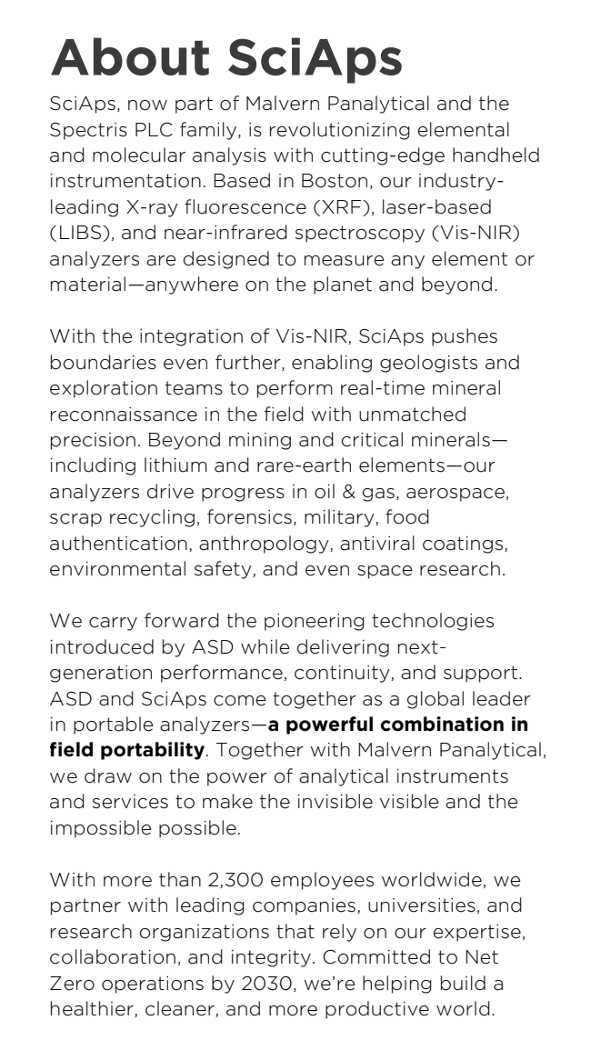 | About SciAps
 | SciAps, now part of Malvern Panalytical and the Spectris PLC family, is revolutionizing elemental and molecular analysis with cutting-edge handheld instrumentation. Based in Boston, our industryleading X-ray fluorescence (XRF), laser-based (LIBS), and near-infrared spectroscopy (Vis-NIR) analyzers are designed to measure any element or material—anywhere on the planet and beyond.
 | With the integration of Vis-NIR, SciAps pushes boundaries even further, enabling geologists and exploration teams to perform real-time mineral reconnaissance in the field with unmatched precision. Beyond mining and critical minerals— including lithium and rare-earth elements—our analyzers drive progress in oil & gas, aerospace, scrap recycling, forensics, military, food authentication, anthropology, antiviral coatings, environmental safety, and even space research.
 | We carry forward the pioneering technologies introduced by ASD while delivering nextgeneration performance, continuity, and support. ASD and SciAps come together as a global leader in portable analyzers—a powerful combination in field portability. Together with Malvern Panalytical, we draw on the power of analytical instruments and services to make the invisible visible and the impossible possible.
 | With more than 2,300 employees worldwide, we partner with leading companies, universities, and research organizations that rely on our expertise, collaboration, and integrity. Committed to Net Zero operations by 2030, we’re helping build a healthier, cleaner, and more productive world.
 | Service & Support
 | SciAps Inc. provides the global training, service and support you need to continuously drive your analytical processes at the highest level. We help you increase the return on your investment with us, and ensure that as your laboratory and analytical needs grow, we are there to support you.
 | Our worldwide team of specialists adds value to your business processes by ensuring applications expertise, rapid response and maximum instrument uptime.
 | Local and remote support
 | Full and flexible range of support agreements
 | Compliance and validation support
 | Onsite or classroom-based training courses
 | e-Learning training courses and web seminars
 | Sample and application consultancy
 | For service of ASD products, contact

