Document Title: ASD FieldSpec 4 Technical Specifications
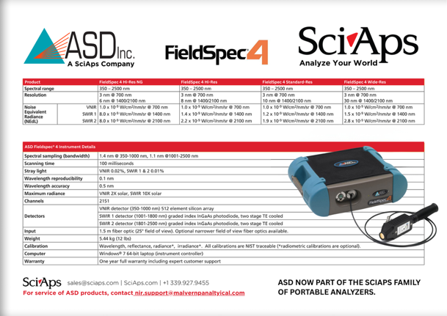
Rev Date: Sept 2025

Layout Preview | English Text | Translated Text
 | A SciAps Company
 | Analyze Your World
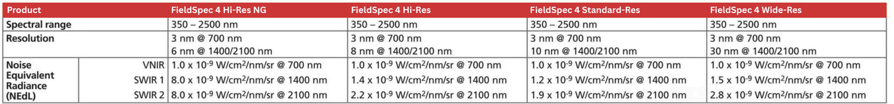 | Product
 | FieldSpec 4 Hi-Res NG
 | FieldSpec 4 Hi-Res
 | FieldSpec 4 Standard-Res
 | FieldSpec 4 Wide-Res
 | Spectral range
 | 350-2500 nm
 | 350- 2500 nm
 | 350- 2500 nm
 | 350-2500 nm
 | Resolution
3 nm @700 nm
6 nm@ 1400/2100 nm
3 nm @700 nm
8 nm@ 1400/2100 nm
3 nm@700 nm
10 nm@ 1400/2100 nm
3 nm @700 nm
30 nm@ 1400/2100 nm
Noise Equivalent
Radiance (NEdL)
VNIR SWIR 1
SWIR2
1.0 x 1o-9 W/cm2/nm/sr @ 700 nm
8.0 x 10-9 W/cm2/nm/sr@1400 nm
8.0 x 10-9 W/cm2/nm/sr@2100 nm
1.0 x 1o-9 W/cm2/nm/sr @ 700 nm
1.4 x 1o-9 W/cm2/nm/sr @ 1400 nm
2.2 x 10-9 W/cm2/nm/sr@ 2100 nm
1.0 x 10-9 W/cm2/nm/sr@700 nm
1.2 x 1o-9 W/cm2/nm/sr @ 1400 nm
1.9 x 10-9 W/cm2/nm/sr@2100 nm
1.0 x 1o-9 W/cm2/nm/sr @ 700 nm
1.5 x 1o-9 W/cm2/nm/sr @ 1400 nm
2.8 x 10-9 W/cm2/nm/sr@2100 nm
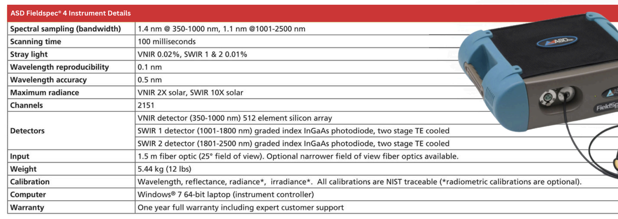 | ASD FieldSpec 4 Instrument Details
 | Spectral sampling (bandwidth)
 | 1.4 nm @350-1000 nm, 1.1 nm @1001-2500 nm
 | Scanning time
 | 100 milliseconds
 | Stray light
 | VNIR 0.02%, SWIR 1 & 2 0.01%
 | Wavelength reproducibility
 | 0.1 nm
 | Wavelength accuracy
 | 0.5 nm
 | Maximum radiance
 | VNIR 2X solar, SWIR 10X solar
 | Channels
 | 2151
 | Detectors
 | VNIR detector (350-1000 nm) 512 element silicon array
 | SWIR 1 detector (1001-1800 nm) graded index lnGaAs photodiode, two stage TE cooled
 | SWIR 2 detector (1801-2500 nm) graded index lnGaAs photodiode, two stage TE cooled
 | Input
 | 1.5 m fiber optic (25° field of view). Optional narrower field of view fiber optics available.
 | Weight
 | 5.44 kg (12 lbs)
 | Calibration
 | Wavelength, reflectance, radiance*, irradiance*. All calibrations are NIST traceable (*radiometric calibrations are optional).
 | Computer
 | Windows® 7 64-bit laptop (instrument controller)
 | Warranty
 | One year full warranty including expert customer support
 | For service of ASD products, contact
 | ASD now part of the SciAps family of portable analyzers.

