Document Title: ApNote-LIBS for Li and Al Alloys
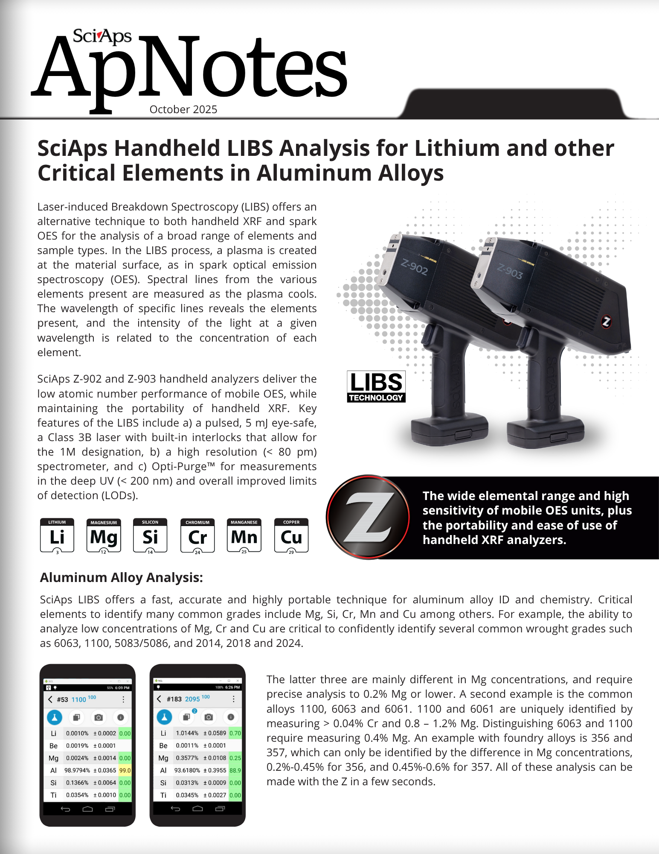
Rev Date: Oct 2025

Layout Preview | English Text | Translated Text
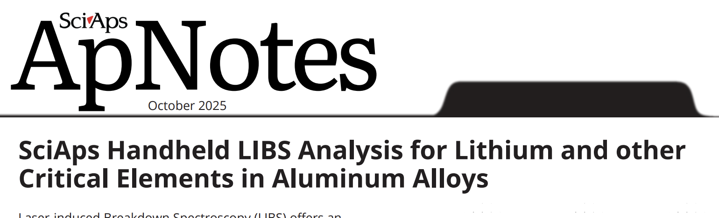 | October 2025
 | SciAps Handheld LIBS Analysis for Lithium and other Critical Elements in Aluminum Alloys
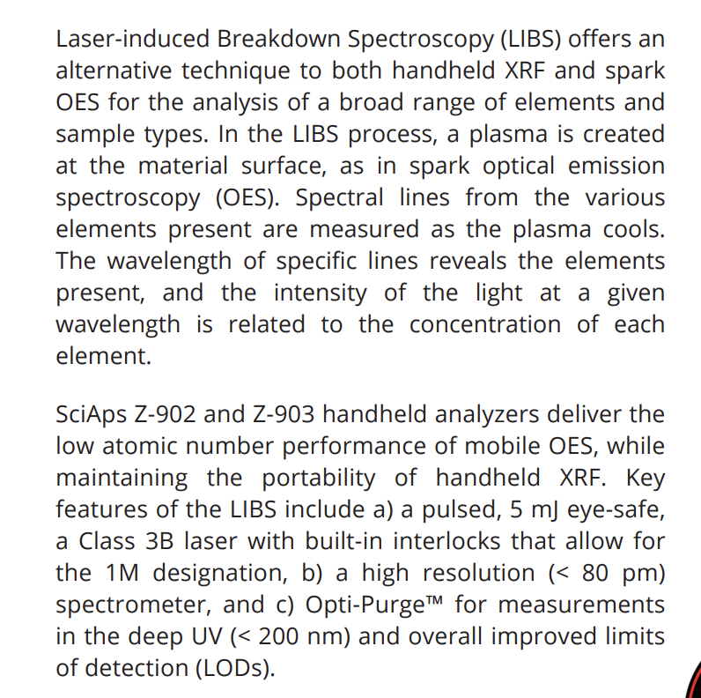 | Laser-induced Breakdown Spectroscopy (LIBS) offers an alternative technique to both handheld XRF and spark OES for the analysis of a broad range of elements and sample types. In the LIBS process, a plasma is created at the material surface, as in spark optical emission spectroscopy (OES). Spectral lines from the various elements present are measured as the plasma cools. The wavelength of specific lines reveals the elements present, and the intensity of the light at a given wavelength is related to the concentration of each element.
 | SciAps Z-902 and Z-903 handheld analyzers deliver the low atomic number performance of mobile OES, while maintaining the portability of handheld XRF. Key features of the LIBS include a) a pulsed, 5 mJ eye-safe, a Class 3B laser with built-in interlocks that allow for the 1M designation, b) a high resolution (< 80 pm) spectrometer, and c) Opti-Purge™ for measurements in the deep UV (< 200 nm) and overall improved limits of detection (LODs).
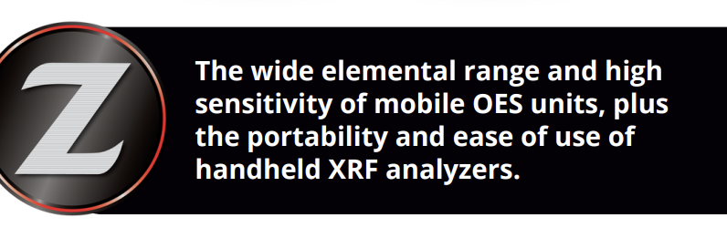 | The wide elemental range and high sensitivity of mobile OES units, plus the portability and ease of use of handheld XRF analyzers.
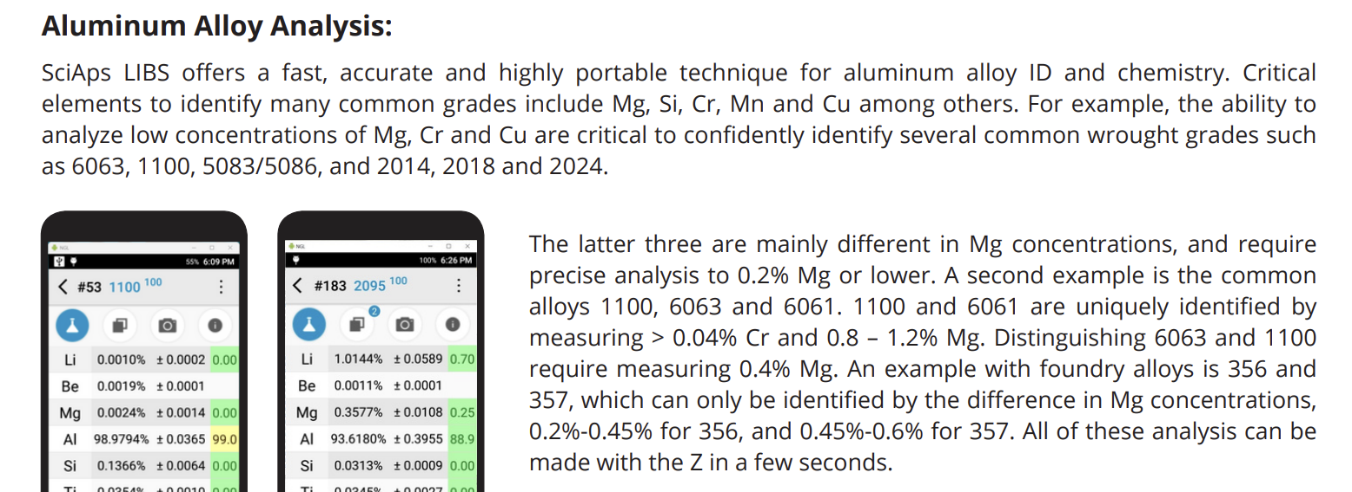 | Aluminum Alloy Analysis:
 | SciAps LIBS offers a fast, accurate and highly portable technique for aluminum alloy ID and chemistry. Critical elements to identify many common grades include Mg, Si, Cr, Mn and Cu among others. For example, the ability to analyze low concentrations of Mg, Cr and Cu are critical to confidently identify several common wrought grades such as 6063, 1100, 5083/5086, and 2014, 2018 and 2024.
 | The latter three are mainly different in Mg concentrations, and require precise analysis to 0.2% Mg or lower. A second example is the common alloys 1100, 6063 and 6061. 1100 and 6061 are uniquely identified by measuring > 0.04% Cr and 0.8 – 1.2% Mg. Distinguishing 6063 and 1100 require measuring 0.4% Mg. An example with foundry alloys is 356 and 357, which can only be identified by the difference in Mg concentrations, 0.2%-0.45% for 356, and 0.45%-0.6% for 357. All of these analysis can be made with the Z in a few seconds.
[page 2]
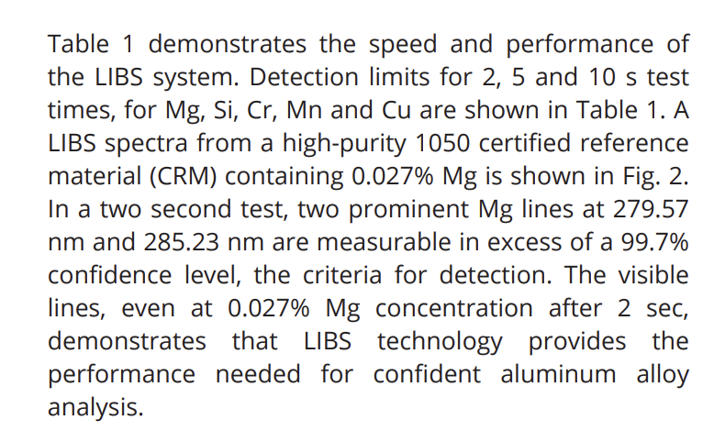 | Table 1 demonstrates the speed and performance of the LIBS system. Detection limits for 2, 5 and 10 s test times, for Mg, Si, Cr, Mn and Cu are shown in Table 1. A LIBS spectra from a high-purity 1050 certified reference material (CRM) containing 0.027% Mg is shown in Fig. 2. In a two second test, two prominent Mg lines at 279.57 nm and 285.23 nm are measurable in excess of a 99.7% confidence level, the criteria for detection. The visible lines, even at 0.027% Mg concentration after 2 sec, demonstrates that LIBS technology provides the performance needed for confident aluminum alloy analysis.
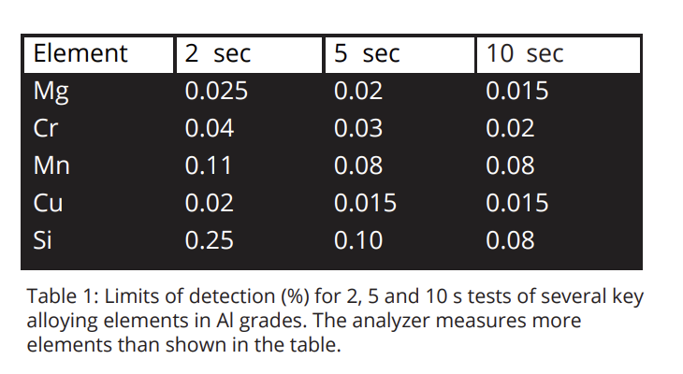 | Element
 | 2 sec
 | 5 sec
 | 10 sec
 | Mg
 | 0.025
 | 0.02
 | 0.015
 | Cr
 | 0.04
 | 0.03
 | 0.02
 | Mn
 | 0.11
 | 0.08
 | 0.08
 | Cu
 | 0.02
 | 0.015
 | 0.015
 | Si
 | 0.25
 | 0.10
 | 0.08
 | Table 1: Limits of detection (%) for 2, 5 and 10 s tests of several key alloying elements in Al grades. The analyzer measures more elements than shown in the table.
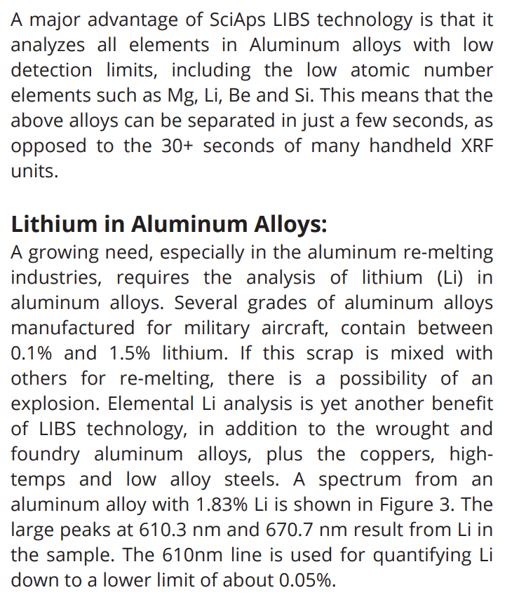 | A major advantage of SciAps LIBS technology is that it analyzes all elements in Aluminum alloys with low detection limits, including the low atomic number elements such as Mg, Li, Be and Si. This means that the above alloys can be separated in just a few seconds, as opposed to the 30+ seconds of many handheld XRF units.
 | Lithium in Aluminum Alloys:
 | A growing need, especially in the aluminum re-melting industries, requires the analysis of lithium (Li) in aluminum alloys. Several grades of aluminum alloys manufactured for military aircraft, contain between 0.1% and 1.5% lithium. If this scrap is mixed with others for re-melting, there is a possibility of an explosion. Elemental Li analysis is yet another benefit of LIBS technology, in addition to the wrought and foundry aluminum alloys, plus the coppers, hightemps and low alloy steels. A spectrum from an aluminum alloy with 1.83% Li is shown in Figure 3. The large peaks at 610.3 nm and 670.7 nm result from Li in the sample. The 610nm line is used for quantifying Li down to a lower limit of about 0.05%.
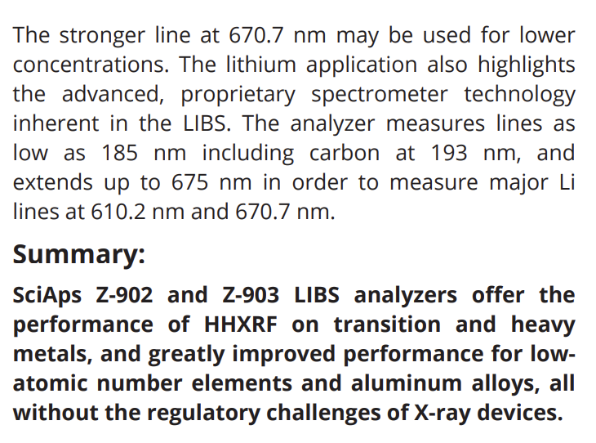 | The stronger line at 670.7 nm may be used for lower concentrations. The lithium application also highlights the advanced, proprietary spectrometer technology inherent in the LIBS. The analyzer measures lines as low as 185 nm including carbon at 193 nm, and extends up to 675 nm in order to measure major Li lines at 610.2 nm and 670.7 nm.
 | Summary:
 | SciAps Z-902 and Z-903 LIBS analyzers offer the performance of HHXRF on transition and heavy metals, and greatly improved performance for lowatomic number elements and aluminum alloys, all without the regulatory challenges of X-ray devices.
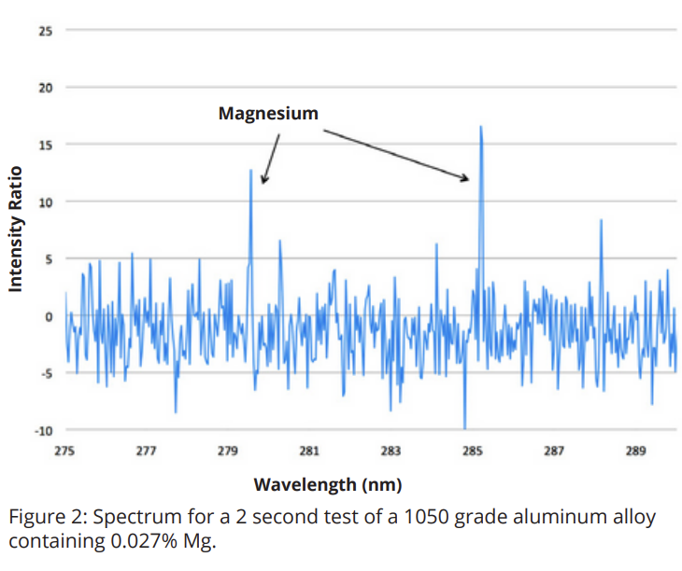 | Intensity Ratio
 | Wavelength (nm)
 | Magnesium
 | Figure 2: Spectrum for a 2 second test of a 1050 grade aluminum alloy containing 0.027% Mg.
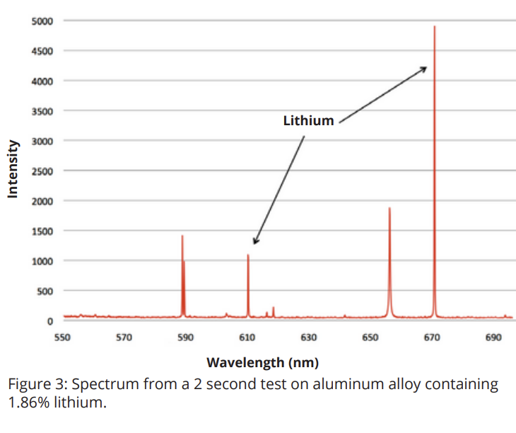 | Intensity
 | Wavelength (nm)
 | Lithium
 | Figure 3: Spectrum from a 2 second test on aluminum alloy containing 1.86% lithium.

