Document Title: Laser-Based Alloy Analysis Brochure
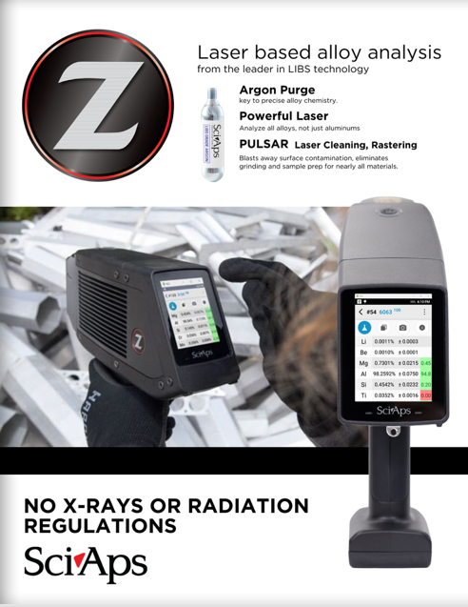
Rev Date: Nov 2025

Layout Preview | English Text | Translated Text
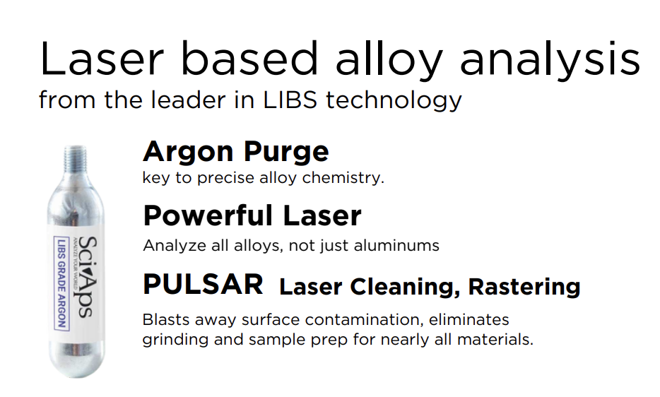 | Laser based alloy analysis
 | from the leader in LIBS technology
 | Argon Purge
 | key to precise alloy chemistry
 | Powerful Laser
 | Analyze all alloys, not just aluminums
 | PULSAR Laser Cleaning, Rastering
 | Blasts away surface contamination, eliminates grinding and sample prep for nearly all materials.
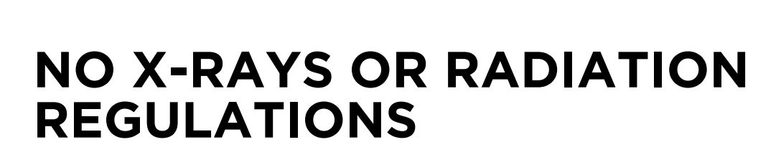 | NO X-RAYS OR RADIATION REGULATIONS
[page 2]
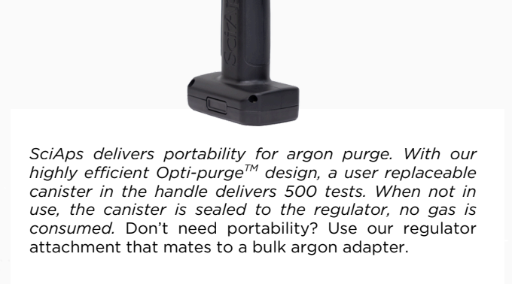 | SciAps delivers portability for argon purge. With our highly efficient Opti-purge design, a user replaceable canister in the handle delivers 500 tests. When not in use, the canister is sealed to the regulator, no gas is consumed. Don’t need portability? Use our regulator attachment that mates to a bulk argon adapter.
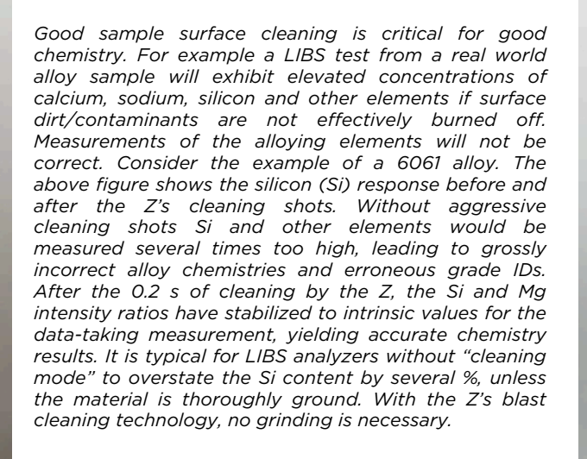 | Good sample surface cleaning is critical for good chemistry. For example a LIBS test from a real world alloy sample will exhibit elevated concentrations of calcium, sodium, silicon and other elements if surface dirt/contaminants are not effectively burned off. Measurements of the alloying elements will not be correct. Consider the example of a 6061 alloy. The above figure shows the silicon (Si) response before and after the Z’s cleaning shots. Without aggressive cleaning shots Si and other elements would be measured several times too high, leading to grossly incorrect alloy chemistries and erroneous grade IDs. After the 0.2 s of cleaning by the Z, the Si and Mg intensity ratios have stabilized to intrinsic values for the data-taking measurement, yielding accurate chemistry results. It is typical for LIBS analyzers without “cleaning mode” to overstate the Si content by several %, unless the material is thoroughly ground. With the Z’s blast cleaning technology, no grinding is necessary.
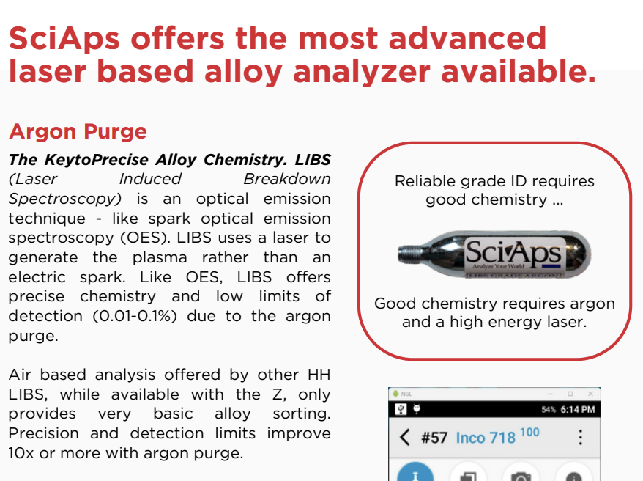 | SciAps offers the most advanced laser based alloy analyzer available.
 | Argon Purge
 | The KeytoPrecise Alloy Chemistry. LIBS (Laser Induced Breakdown Spectroscopy) is an optical emission technique - like spark optical emission spectroscopy (OES). LIBS uses a laser to generate the plasma rather than an electric spark. Like OES, LIBS offers precise chemistry and low limits of detection (0.01-0.1%) due to the argon purge.
 | Air based analysis offered by other HH LIBS, while available with the Z, only provides very basic alloy sorting. Precision and detection limits improve 10x or more with argon purge.
 | Reliable grade ID requires good chemistry ...
 | Good chemistry requires argon and a high energy laser.
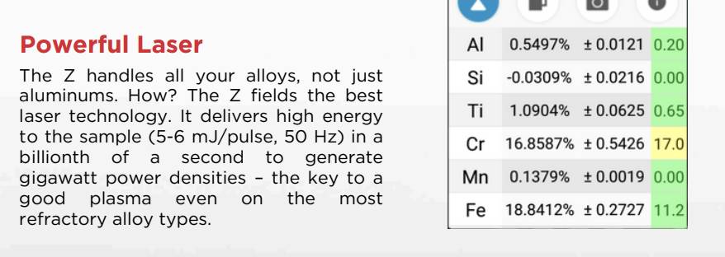 | Powerful Laser
 | The Z handles all your alloys, not just aluminums. How? The Z fields the best laser technology. It delivers high energy to the sample (5-6 mJ/pulse, 50 Hz) in a billionth of a second to generate gigawatt power densities – the key to a good plasma even on the most refractory alloy types.
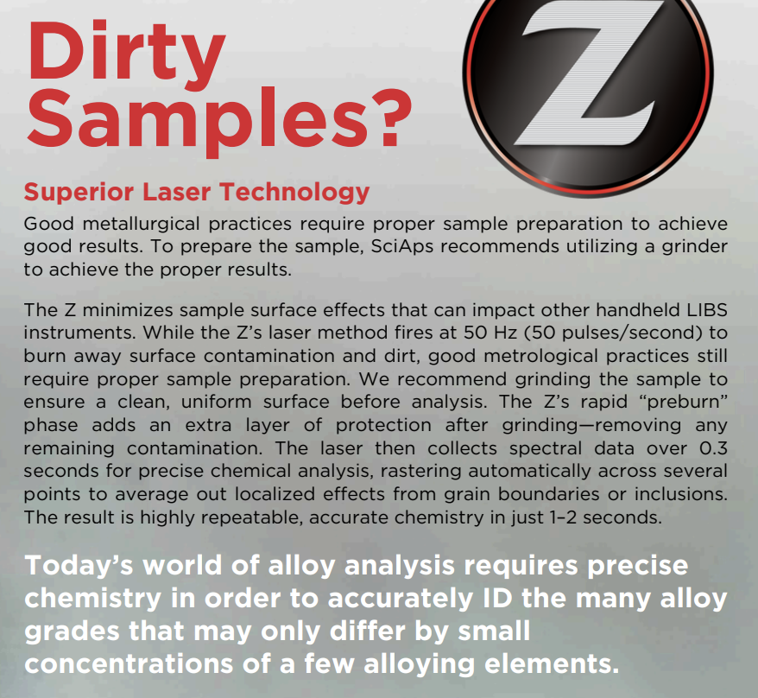 | Dirty Samples?
 | Superior Laser Technology
 | Good metallurgical practices require proper sample preparation to achieve good results. To prepare the sample, SciAps recommends utilizing a grinder to achieve the proper results.
 | The Z minimizes sample surface effects that can impact other handheld LIBS instruments. While the Z’s laser method fires at 50 Hz (50 pulses/second) to burn away surface contamination and dirt, good metrological practices still require proper sample preparation. We recommend grinding the sample to ensure a clean, uniform surface before analysis. The Z’s rapid “preburn” phase adds an extra layer of protection after grinding—removing any remaining contamination. The laser then collects spectral data over 0.3 seconds for precise chemical analysis, rastering automatically across several points to average out localized effects from grain boundaries or inclusions. The result is highly repeatable, accurate chemistry in just 1–2 seconds.
 | Today’s world of alloy analysis requires precise chemistry in order to accurately ID the many alloy grades that may only differ by small concentrations of a few alloying elements.
[page 3]
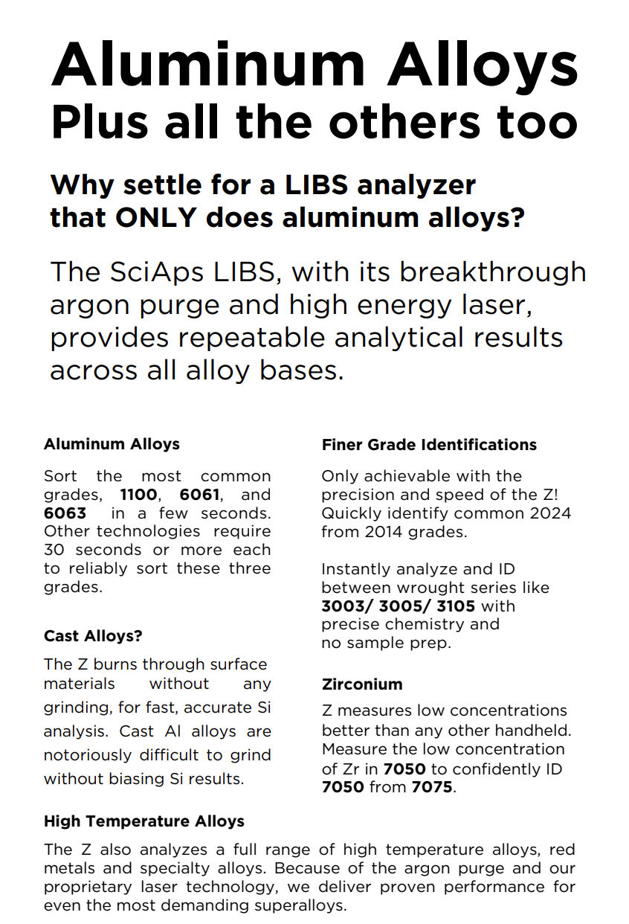 | Aluminum Alloys Plus all the others too
 | Why settle for a LIBS analyzer that ONLY does aluminum alloys?
 | The SciAps LIBS, with its breakthrough argon purge and high energy laser, provides repeatable analytical results across all alloy bases.
 | Aluminum Alloys
 | Sort the most common grades, 1100, 6061, and 6063 in a few seconds. Other technologies require 30 seconds or more each to reliably sort these three grades.
 | Cast Alloys?
 | The Z burns through surface materials without any grinding, for fast, accurate Si analysis. Cast Al alloys are notoriously difficult to grind without biasing Si results.
 | High Temperature Alloys
 | The Z also analyzes a full range of high temperature alloys, red metals and specialty alloys. Because of the argon purge and our proprietary laser technology, we deliver proven performance for even the most demanding superalloys.
 | Finer Grade Identifications
 | Only achievable with the precision and speed of the Z! Quickly identify common 2024 from 2014 grades.
 | Instantly analyze and ID between wrought series like 3003/ 3005/ 3105 with precise chemistry and no sample prep.
 | Zirconium
 | Z measures low concentrations better than any other handheld. Measure the low concentration of Zr in 7050 to confidently ID 7050 from 7075.
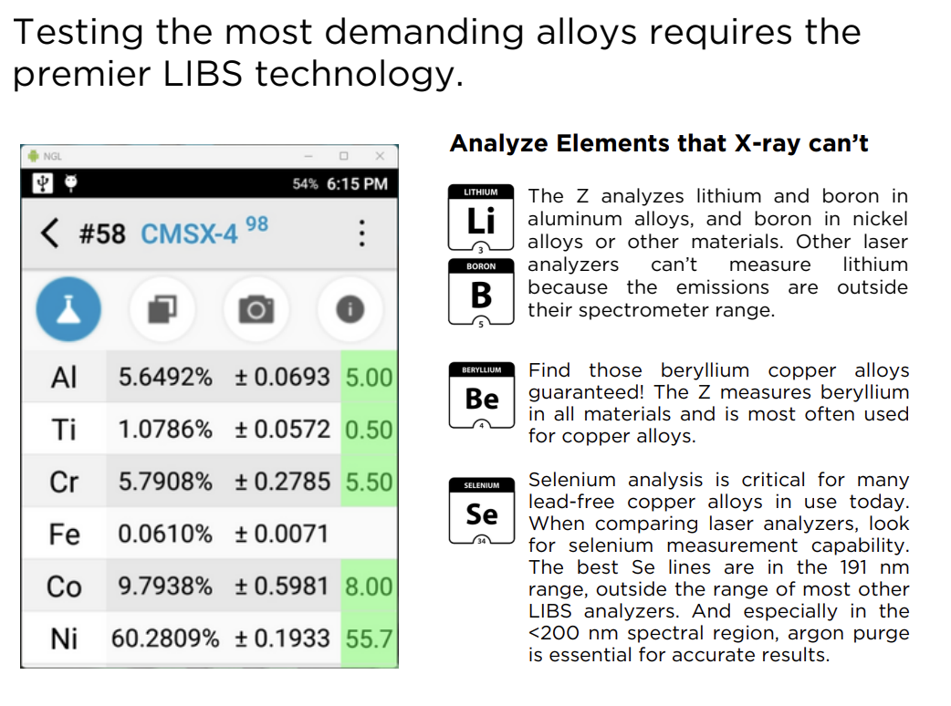 | Testing the most demanding alloys requires the premier LIBS technology.
 | Analyze Elements that X-ray can’t
 | The Z analyzes lithium and boron in aluminum alloys, and boron in nickel alloys or other materials. Other laser analyzers can’t measure lithium because the emissions are outside their spectrometer range.
 | Find those beryllium copper alloys guaranteed! The Z measures beryllium in all materials and is most often used for copper alloys
 | Selenium analysis is critical for many lead-free copper alloys in use today. When comparing laser analyzers, look for selenium measurement capability. The best Se lines are in the 191 nm range, outside the range of most other LIBS analyzers. And especially in the <200 nm spectral region, argon purge is essential for accurate results.
[page 4]
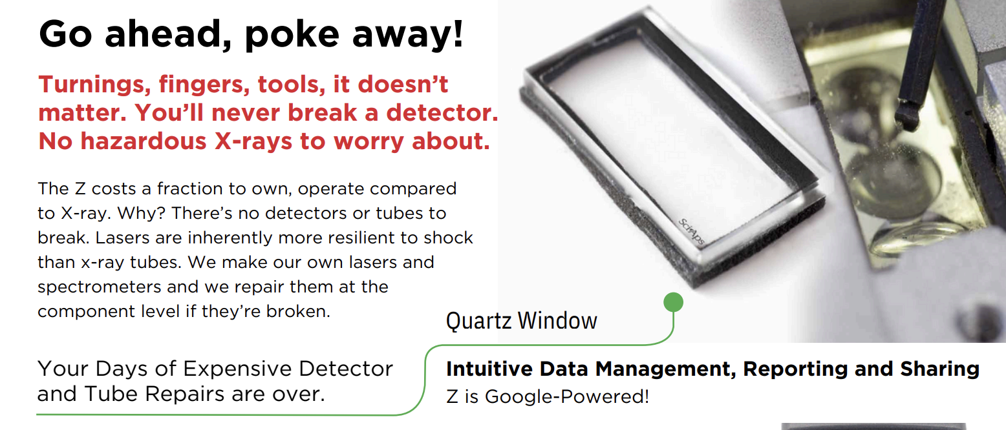 | Go ahead, poke away!
 | Turnings, fingers, tools, it doesn’t matter. You’ll never break a detector. No hazardous X-rays to worry about.
 | The Z costs a fraction to own, operate compared to X-ray. Why? There’s no detectors or tubes to break. Lasers are inherently more resilient to shock than x-ray tubes. We make our own lasers and spectrometers and we repair them at the component level if they’re broken.
 | Your Days of Expensive Detector and Tube Repairs are over.
 | Quartz Window
 | Intuitive Data Management, Reporting and Sharing
 | Z is Google-Powered!
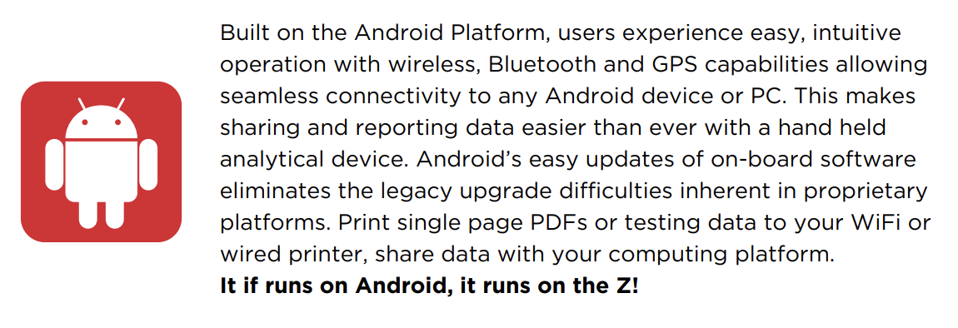 | Built on the Android Platform, users experience easy, intuitive operation with wireless, Bluetooth and GPS capabilities allowing seamless connectivity to any Android device or PC. This makes sharing and reporting data easier than ever with a hand held analytical device. Android’s easy updates of on-board software eliminates the legacy upgrade difficulties inherent in proprietary platforms. Print single page PDFs or testing data to your WiFi or wired printer, share data with your computing platform.
 | It if runs on Android, it runs on the Z!
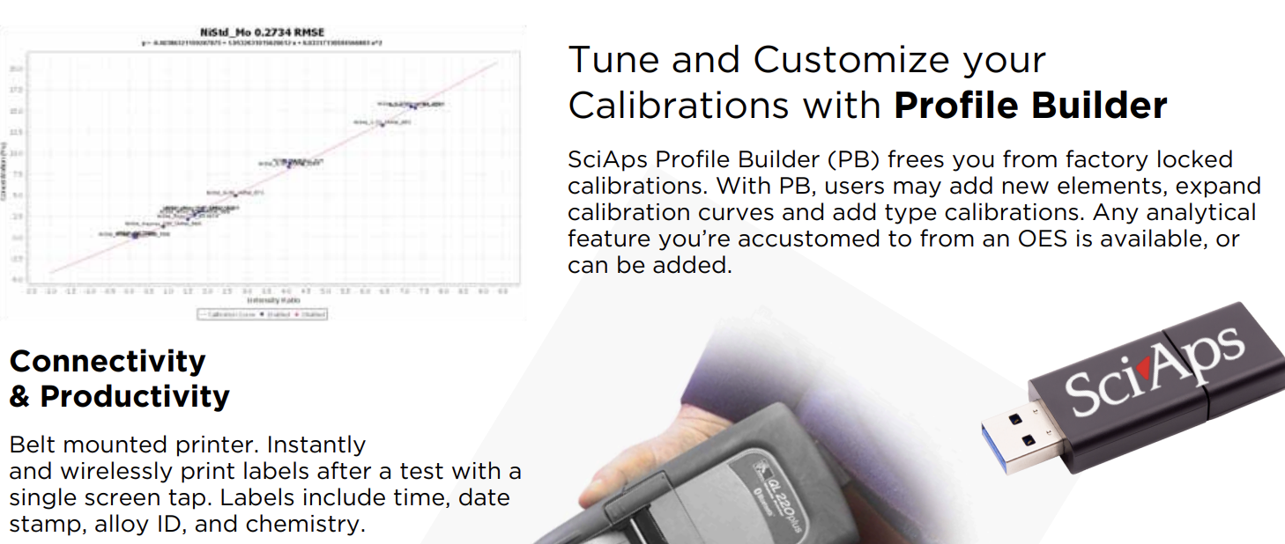 | Tune and Customize your Calibrations with Profile Builder
 | SciAps Profile Builder (PB) frees you from factory locked calibrations. With PB, users may add new elements, expand calibration curves and add type calibrations. Any analytical feature you’re accustomed to from an OES is available, or can be added.
 | Connectivity & Productivity
 | Belt mounted printer. Instantly and wirelessly print labels after a test with a single screen tap. Labels include time, date stamp, alloy ID, and chemistry.

