Document Title: ASD Mining Brochure
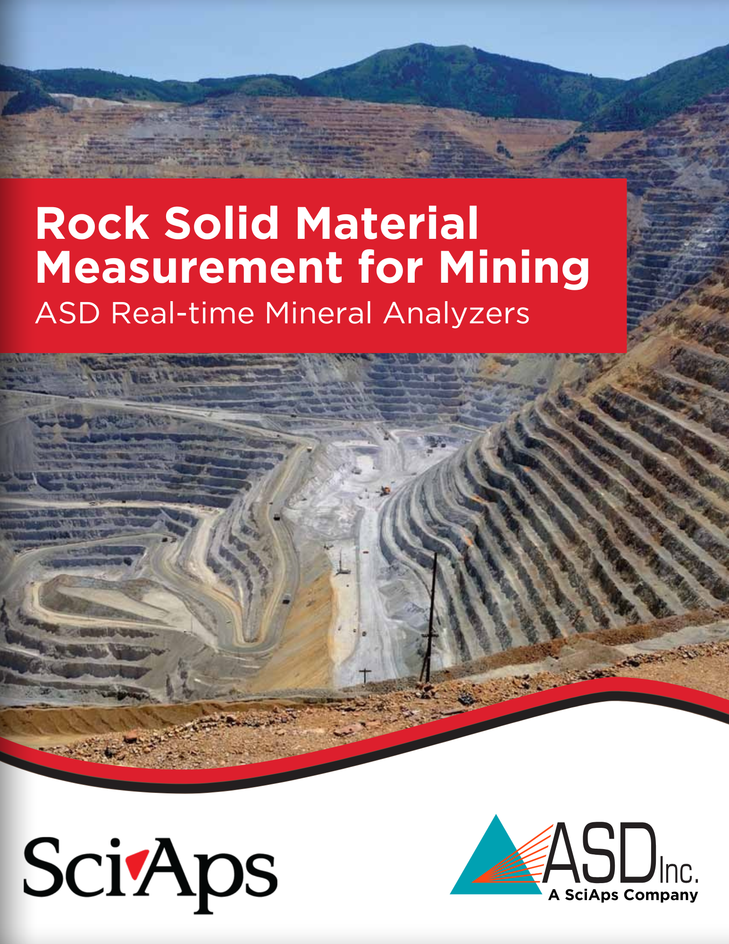
Rev Date: November 2025

Layout Preview | English Text | Translated Text
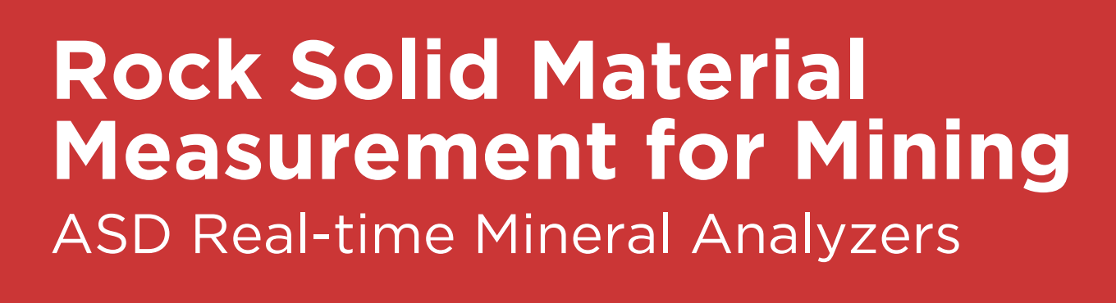 | Rock Solid Material Measurement for Mining
 | ASD Real-time Mineral Analyzers
[page 2]
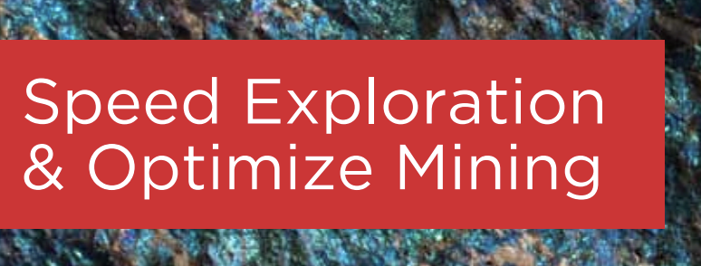 | Speed Exploration & Optimize Mining
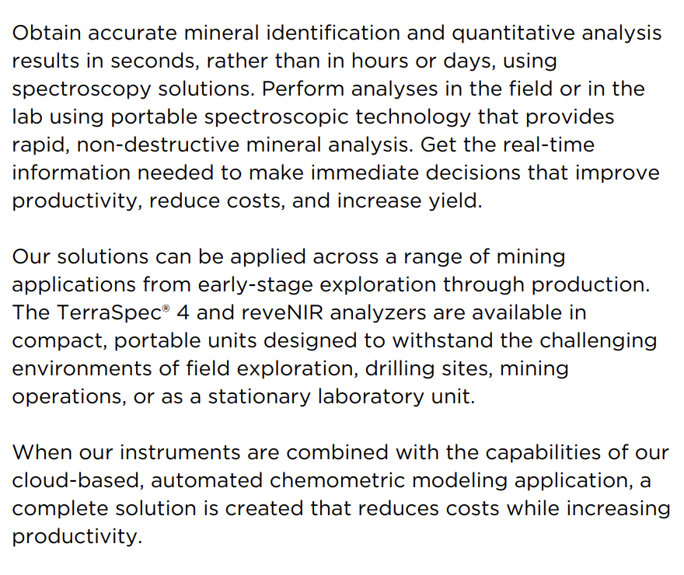 | Obtain accurate mineral identification and quantitative analysis results in seconds, rather than in hours or days, using spectroscopy solutions. Perform analyses in the field or in the lab using portable spectroscopic technology that provides rapid, non-destructive mineral analysis. Get the real-time information needed to make immediate decisions that improve productivity, reduce costs, and increase yield.
 | Our solutions can be applied across a range of mining applications from early-stage exploration through production. The TerraSpec® 4 and reveNIR analyzers are available in compact, portable units designed to withstand the challenging environments of field exploration, drilling sites, mining operations, or as a stationary laboratory unit.
 | When our instruments are combined with the capabilities of our cloud-based, automated chemometric modeling application, a complete solution is created that reduces costs while increasing productivity.
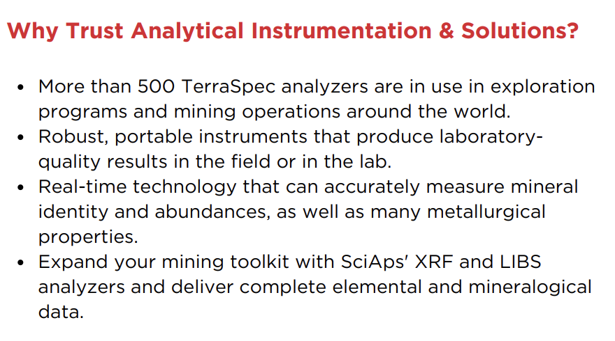 | Why Trust Analytical Instrumentation & Solutions?
 | More than 500 TerraSpec analyzers are in use in exploration programs and mining operations around the world.
 | Robust, portable instruments that produce laboratory quality results in the field or in the lab.
 | Real-time technology that can accurately measure mineral identity and abundances, as well as many metallurgical properties.
 | Expand your mining toolkit with SciAps' XRF and LIBS analyzers and deliver complete elemental and mineralogical data.
[page 3]
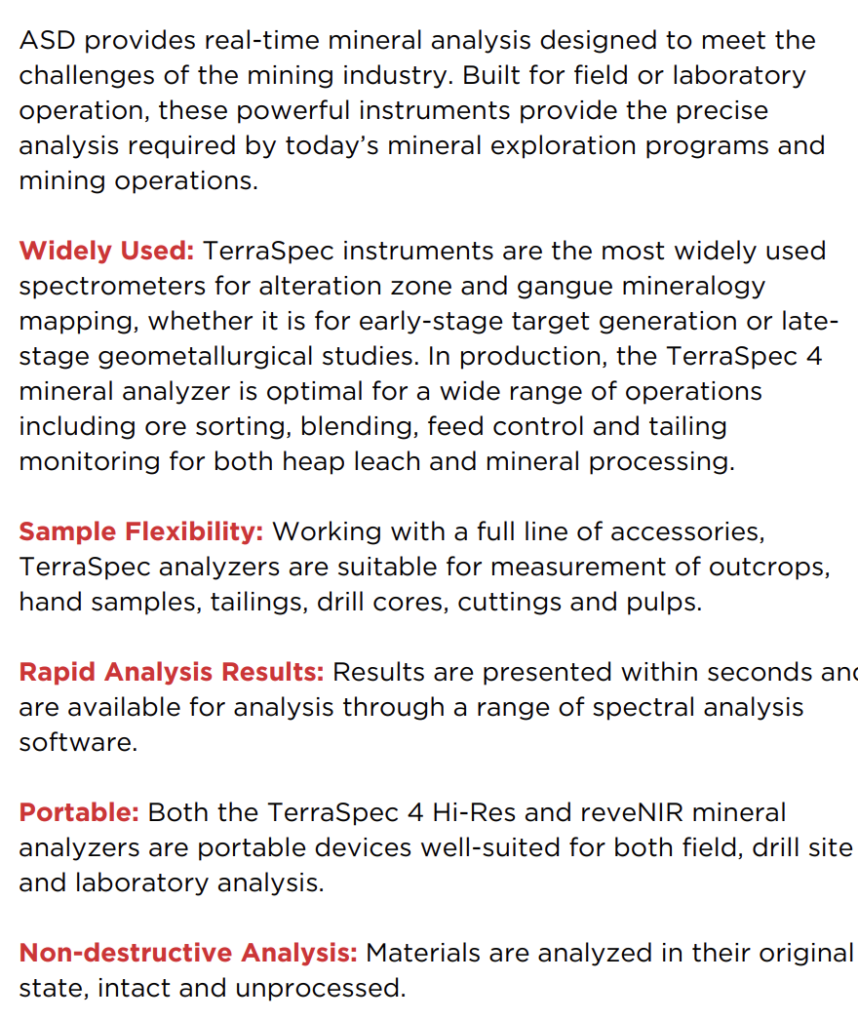 | ASD provides real-time mineral analysis designed to meet the challenges of the mining industry. Built for field or laboratory operation, these powerful instruments provide the precise analysis required by today’s mineral exploration programs and mining operations.
 | Widely Used: TerraSpec instruments are the most widely used spectrometers for alteration zone and gangue mineralogy mapping, whether it is for early-stage target generation or late-stage geometallurgical studies. In production, the TerraSpec 4 mineral analyzer is optimal for a wide range of operations including ore sorting, blending, feed control and tailing monitoring for both heap leach and mineral processing.
 | Sample Flexibility: Working with a full line of accessories, TerraSpec analyzers are suitable for measurement of outcrops, hand samples, tailings, drill cores, cuttings and pulps.
 | Rapid Analysis Results: Results are presented within seconds and are available for analysis through a range of spectral analysis software.
 | Portable: Both the TerraSpec 4 Hi-Res and reveNIR mineral analyzers are portable devices well-suited for both field, drill site and laboratory analysis.
 | Non-destructive Analysis: Materials are analyzed in their original state, intact and unprocessed.
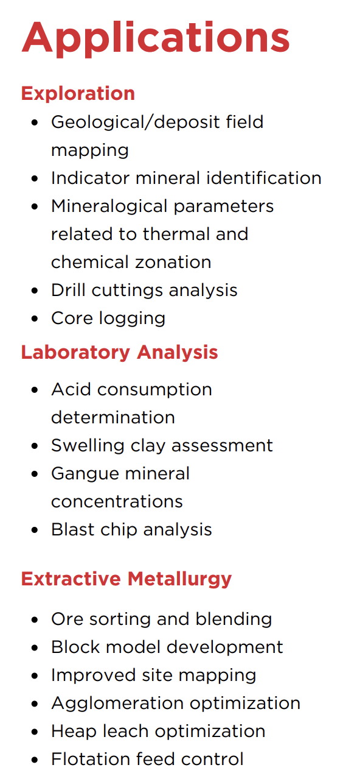 | Applications
 | Exploration
 | Geological/deposit field mapping
 | Indicator mineral identification
 | Mineralogical parameters related to thermal and chemical zonation
 | Drill cuttings analysis
 | Core logging
 | Laboratory Analysis
 | Acid consumption determination
 | Swelling clay assessment
 | Gangue mineral concentrations
 | Blast chip analysis
 | Extractive Metallurgy
 | Ore sorting and blending
 | Block model development
 | Improved site mapping
 | Agglomeration optimization
 | Heap leach optimization
 | Flotation feed control
[page 4]
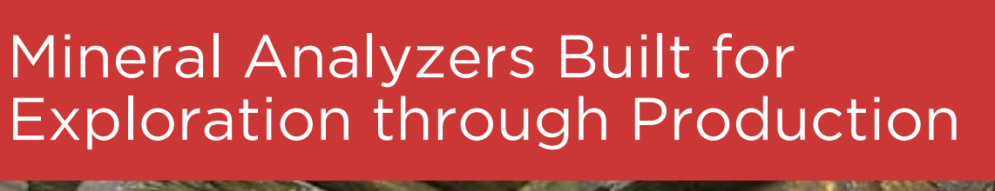 | Mineral Analyzers Built for Exploration through Production
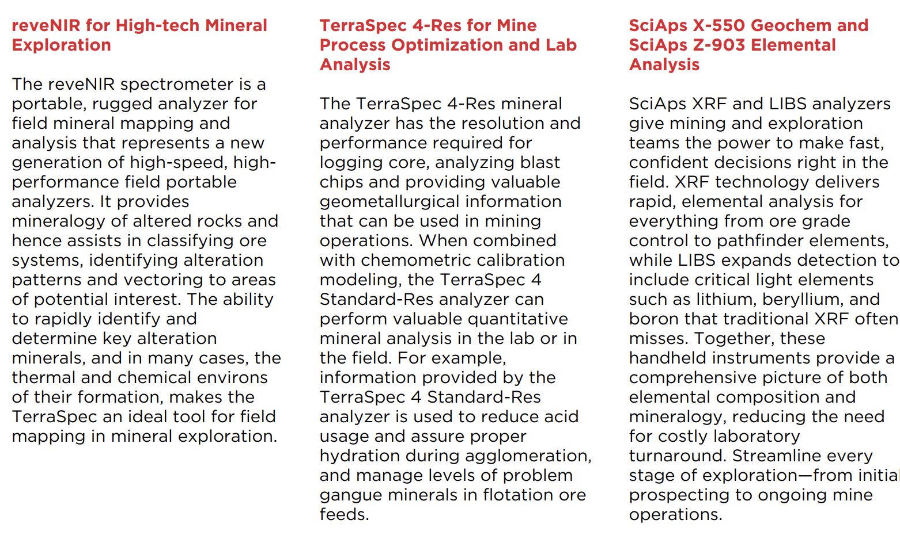 | reveNIR for High-tech Mineral Exploration
 | The reveNIR spectrometer is a portable, rugged analyzer for field mineral mapping and analysis that represents a new generation of high-speed, highperformance field portable analyzers. It provides mineralogy of altered rocks and hence assists in classifying ore systems, identifying alteration patterns and vectoring to areas of potential interest. The ability to rapidly identify and determine key alteration minerals, and in many cases, the thermal and chemical environs of their formation, makes the TerraSpec an ideal tool for field mapping in mineral exploration.
TerraSpec 4-Res for Mine Process Optimization and Lab Analysis | The TerraSpec 4-Res mineral analyzer has the resolution and performance required for logging core, analyzing blast chips and providing valuable geometallurgical information that can be used in mining operations. When combined with chemometric calibration modeling, the TerraSpec 4 Standard-Res analyzer can perform valuable quantitative mineral analysis in the lab or in the field. For example, information provided by the TerraSpec 4 Standard-Res analyzer is used to reduce acid usage and assure proper hydration during agglomeration, and manage levels of problem gangue minerals in flotation ore feeds.
SciAps X-550 Geochem and SciAps Z-903 Elemental Analysis | SciAps XRF and LIBS analyzers give mining and exploration teams the power to make fast, confident decisions right in the field. XRF technology delivers rapid, elemental analysis for everything from ore grade control to pathfinder elements, while LIBS expands detection to include critical light elements such as lithium, beryllium, and boron that traditional XRF often misses. Together, these handheld instruments provide a comprehensive picture of both elemental composition and mineralogy, reducing the need for costly laboratory turnaround. Streamline every stage of exploration—from initial prospecting to ongoing mine operations.
[page 5]
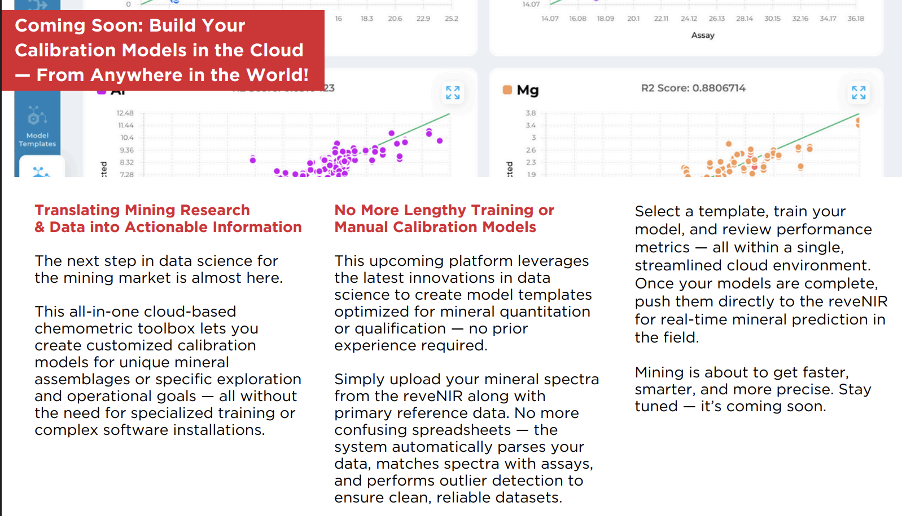 | Coming Soon: Build Your Calibration Models in the Cloud — From Anywhere in the World!
 | Translating Mining Research & Data into Actionable Information
 | The next step in data science for the mining market is almost here.
 | This all-in-one cloud-based chemometric toolbox lets you create customized calibration models for unique mineral assemblages or specific exploration and operational goals — all without the need for specialized training or complex software installations.
 | No More Lengthy Training or Manual Calibration Models
 | This upcoming platform leverages the latest innovations in data science to create model templates optimized for mineral quantitation or qualification — no prior experience required.
 | Simply upload your mineral spectra from the reveNIR along with primary reference data. No more confusing spreadsheets — the system automatically parses your data, matches spectra with assays, and performs outlier detection to ensure clean, reliable datasets.
 | Select a template, train your model, and review performance metrics — all within a single, streamlined cloud environment. Once your models are complete, push them directly to the reveNIR for real-time mineral prediction in the field.
 | Mining is about to get faster, smarter, and more precise. Stay tuned — it’s coming soon.
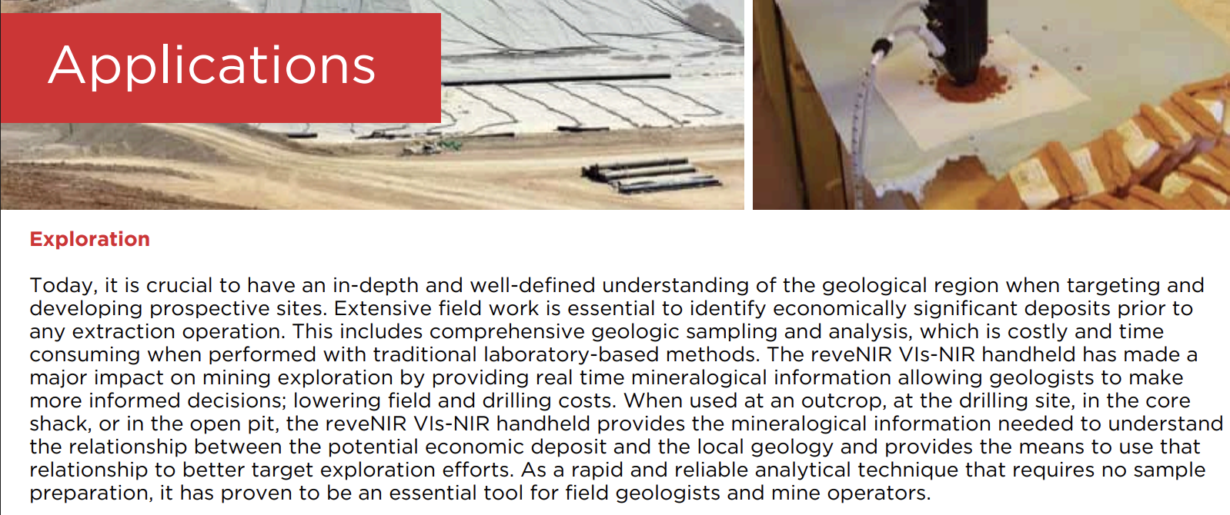 | Applications
 | Exploration
 | Today, it is crucial to have an in-depth and well-defined understanding of the geological region when targeting and developing prospective sites. Extensive field work is essential to identify economically significant deposits prior to any extraction operation. This includes comprehensive geologic sampling and analysis, which is costly and time consuming when performed with traditional laboratory-based methods. The reveNIR VIs-NIR handheld has made a major impact on mining exploration by providing real time mineralogical information allowing geologists to make more informed decisions; lowering field and drilling costs. When used at an outcrop, at the drilling site, in the core shack, or in the open pit, the reveNIR VIs-NIR handheld provides the mineralogical information needed to understand the relationship between the potential economic deposit and the local geology and provides the means to use that relationship to better target exploration efforts. As a rapid and reliable analytical technique that requires no sample preparation, it has proven to be an essential tool for field geologists and mine operators.
[page 6]
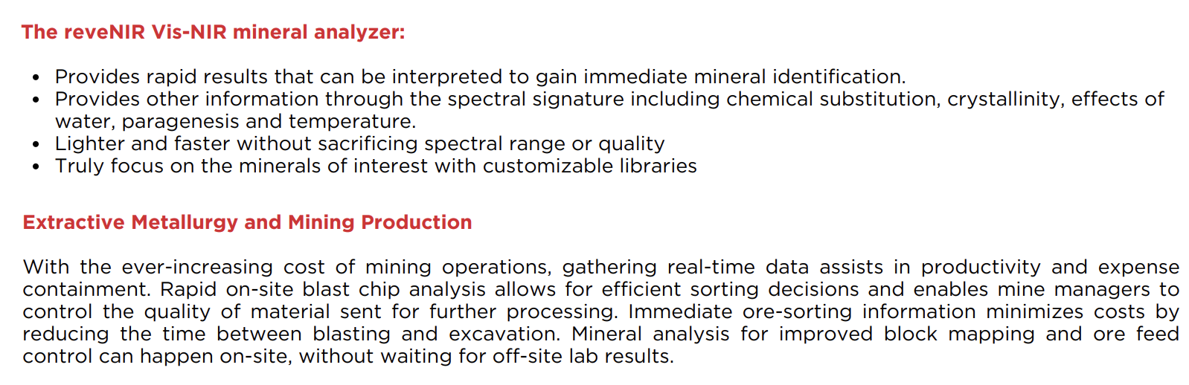 | The reveNIR Vis-NIR mineral analyzer:
 | Provides rapid results that can be interpreted to gain immediate mineral identification.
 | Provides other information through the spectral signature including chemical substitution, crystallinity, effects of water, paragenesis and temperature.
 | Lighter and faster without sacrificing spectral range or quality
 | Truly focus on the minerals of interest with customizable libraries
 | Extractive Metallurgy and Mining Production
 | With the ever-increasing cost of mining operations, gathering real-time data assists in productivity and expense containment. Rapid on-site blast chip analysis allows for efficient sorting decisions and enables mine managers to control the quality of material sent for further processing. Immediate ore-sorting information minimizes costs by reducing the time between blasting and excavation. Mineral analysis for improved block mapping and ore feed control can happen on-site, without waiting for off-site lab results.
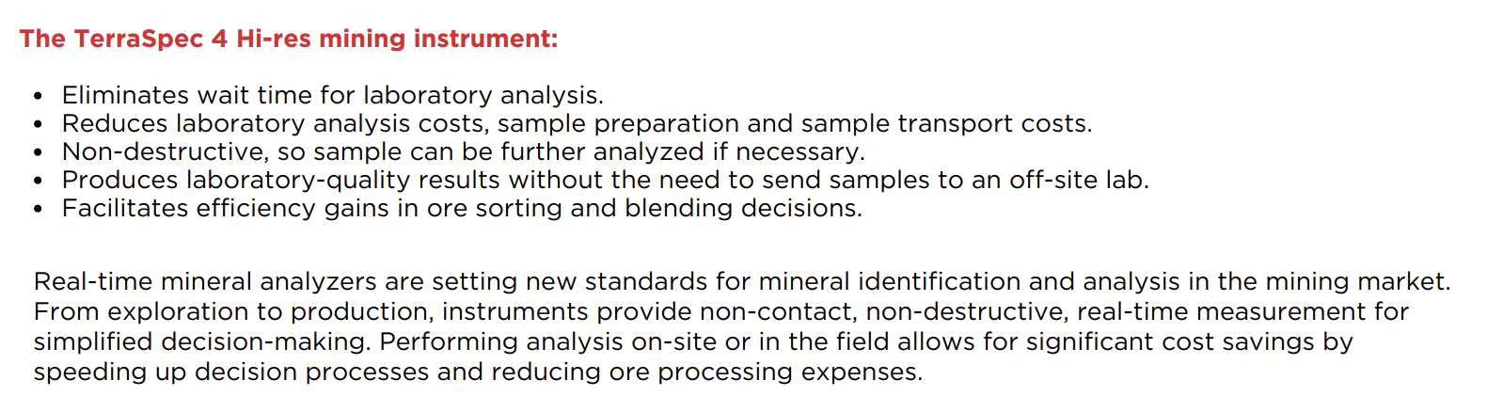 | The TerraSpec 4 Hi-res mining instrument:
 | Eliminates wait time for laboratory analysis.
 | Reduces laboratory analysis costs, sample preparation and sample transport costs.
 | Non-destructive, so sample can be further analyzed if necessary.
 | Produces laboratory-quality results without the need to send samples to an off-site lab.
 | Facilitates efficiency gains in ore sorting and blending decisions.
 | Real-time mineral analyzers are setting new standards for mineral identification and analysis in the mining market. From exploration to production, instruments provide non-contact, non-destructive, real-time measurement for simplified decision-making. Performing analysis on-site or in the field allows for significant cost savings by speeding up decision processes and reducing ore processing expenses.

