Document Title: SciAps XRF-Technology Overview
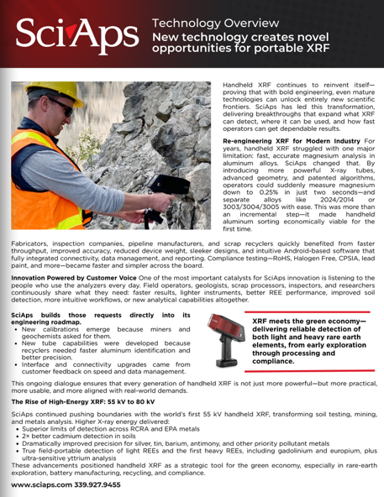
Rev Date:

Layout Preview | English Text | Translated Text
(BACK)

