Document Title: TerrSpec Halo vs. ReveNIR
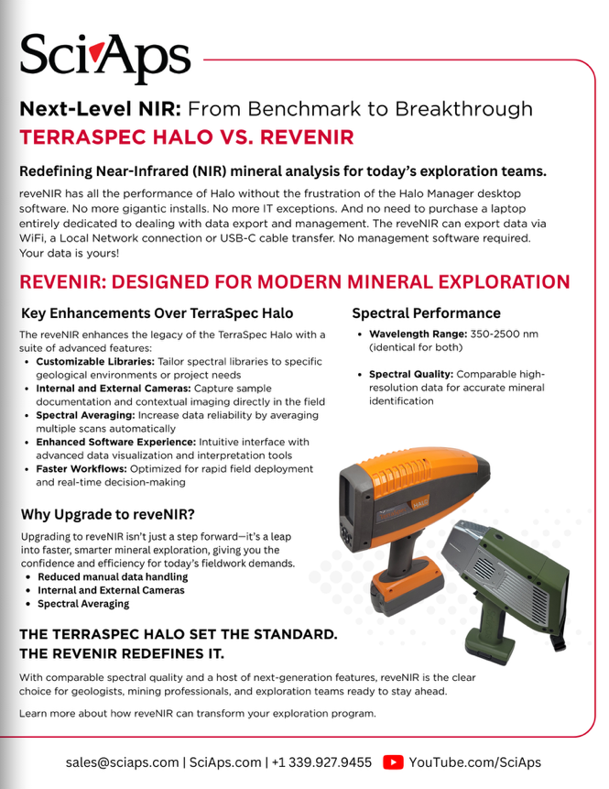
Rev Date: Sept 2025

Layout Preview | English Text | Translated Text
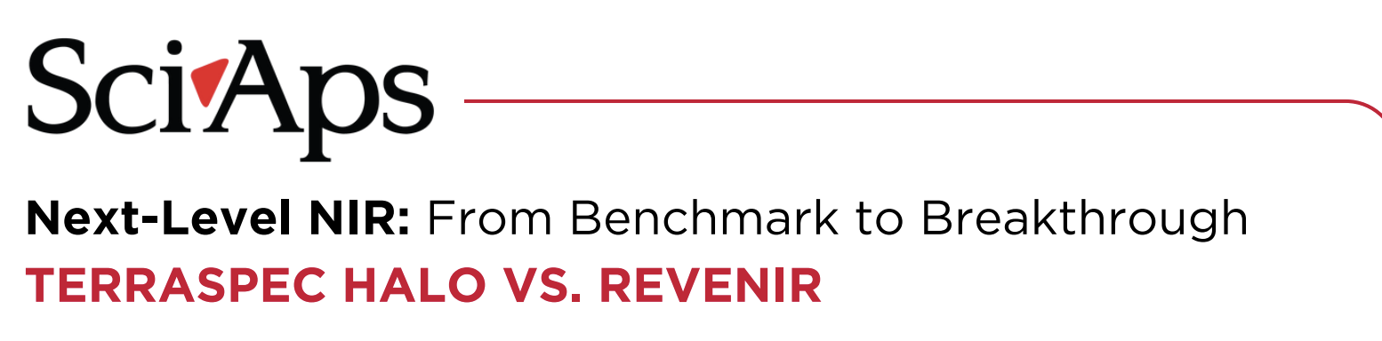 | Next-Level NIR: From Benchmark to Breakthrough
 | TERRASPEC HALO VS. REVENIR
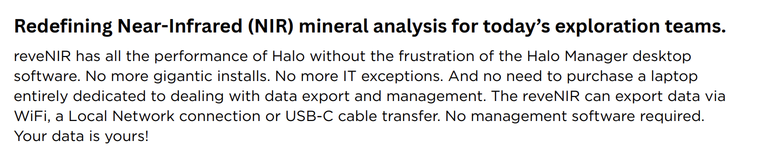 | Redefining Near-Infrared (NIR) mineral analysis for today’s exploration teams.
 | reveNIR has all the performance of Halo without the frustration of the Halo Manager desktop software. No more gigantic installs. No more IT exceptions. And no need to purchase a laptop entirely dedicated to dealing with data export and management. The reveNIR can export data via WiFi, a Local Network connection or USB-C cable transfer. No management software required. Your data is yours!
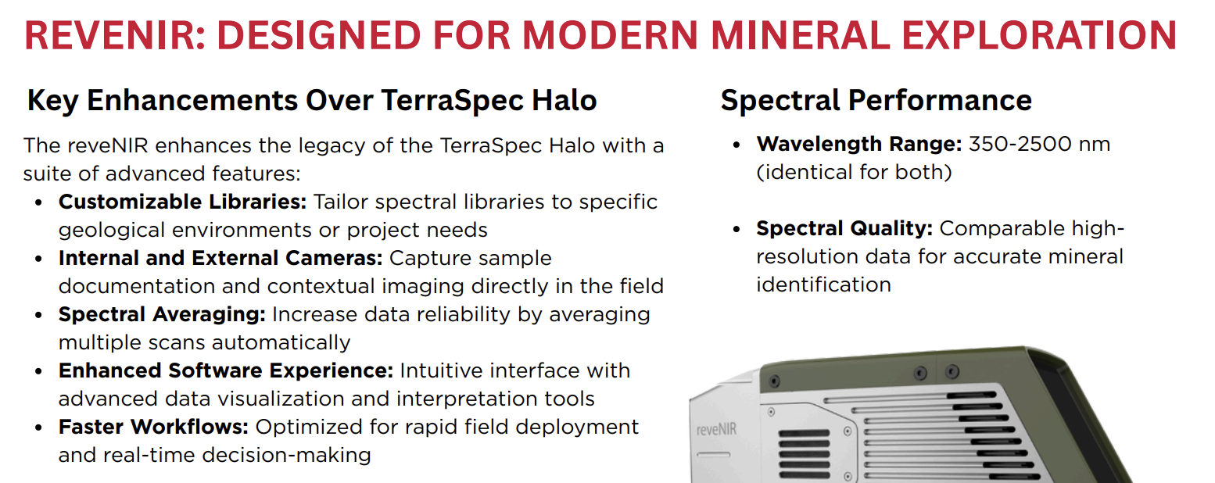 | REVENIR: DESIGNED FOR MODERN MINERAL EXPLORATION
 | Key Enhancements Over TerraSpec Halo
 | The reveNIR enhances the legacy of the TerraSpec Halo with a suite of advanced features:
 | Customizable Libraries: Tailor spectral libraries to specific geological environments or project needs
 | Internal and External Cameras: Capture sample documentation and contextual imaging directly in the field
 | Spectral Averaging: Increase data reliability by averaging multiple scans automatically
 | Enhanced Software Experience: Intuitive interface with advanced data visualization and interpretation tools
 | Faster Workflows: Optimized for rapid field deployment and real-time decision-making
 | Spectral Performance
 | Wavelength Range: 350-2500 nm (identical for both)
 | Spectral Quality: Comparable highresolution data for accurate mineral identification
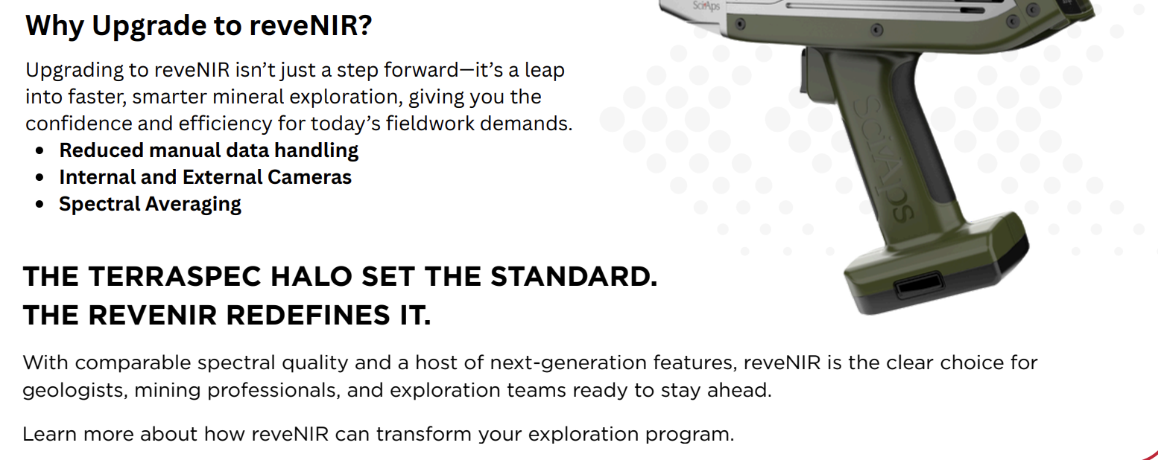 | Why Upgrade to reveNIR?
 | Upgrading to reveNIR isn’t just a step forward—it’s a leap into faster, smarter mineral exploration, giving you the confidence and efficiency for today’s fieldwork demands.
 | Reduced manual data handling
 | Internal and External Cameras
 | Spectral Averaging
 | THE TERRASPEC HALO SET THE STANDARD.
 | THE REVENIR REDEFINES IT.
 | With comparable spectral quality and a host of next-generation features, reveNIR is the clear choice for geologists, mining professionals, and exploration teams ready to stay ahead.
 | Learn more about how reveNIR can transform your exploration program.
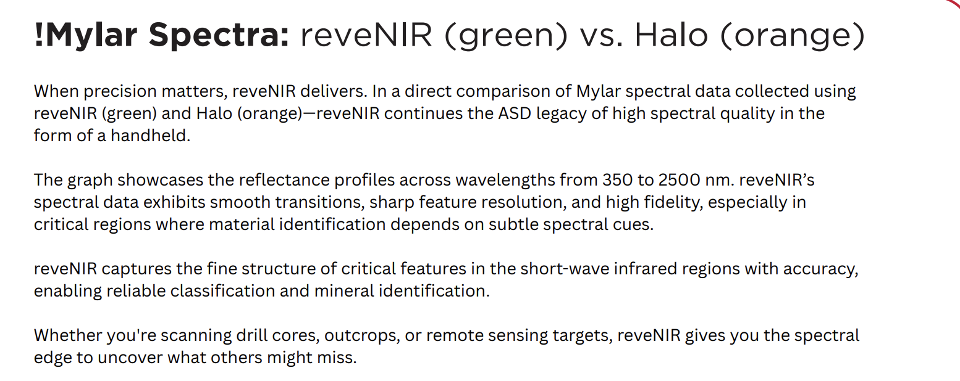 | !Mylar Spectra: reveNIR (green) vs. Halo (orange)
 | When precision matters, reveNIR delivers. In a direct comparison of Mylar spectral data collected using reveNIR (green) and Halo (orange)—reveNIR continues the ASD legacy of high spectral quality in the form of a handheld.
 | The graph showcases the reflectance profiles across wavelengths from 350 to 2500 nm. reveNIR’s spectral data exhibits smooth transitions, sharp feature resolution, and high fidelity, especially in critical regions where material identification depends on subtle spectral cues.
 | reveNIR captures the fine structure of critical features in the short-wave infrared regions with accuracy, enabling reliable classification and mineral identification.
 | Whether you're scanning drill cores, outcrops, or remote sensing targets, reveNIR gives you the spectral edge to uncover what others might miss.
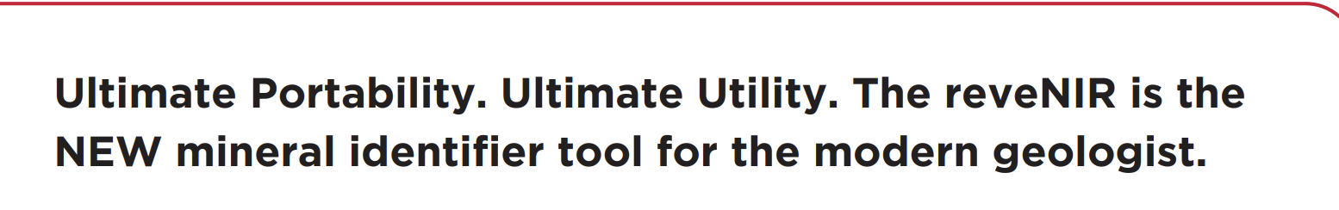 | Ultimate Portability. Ultimate Utility. The reveNIR is the NEW mineral identifier tool for the modern geologist.
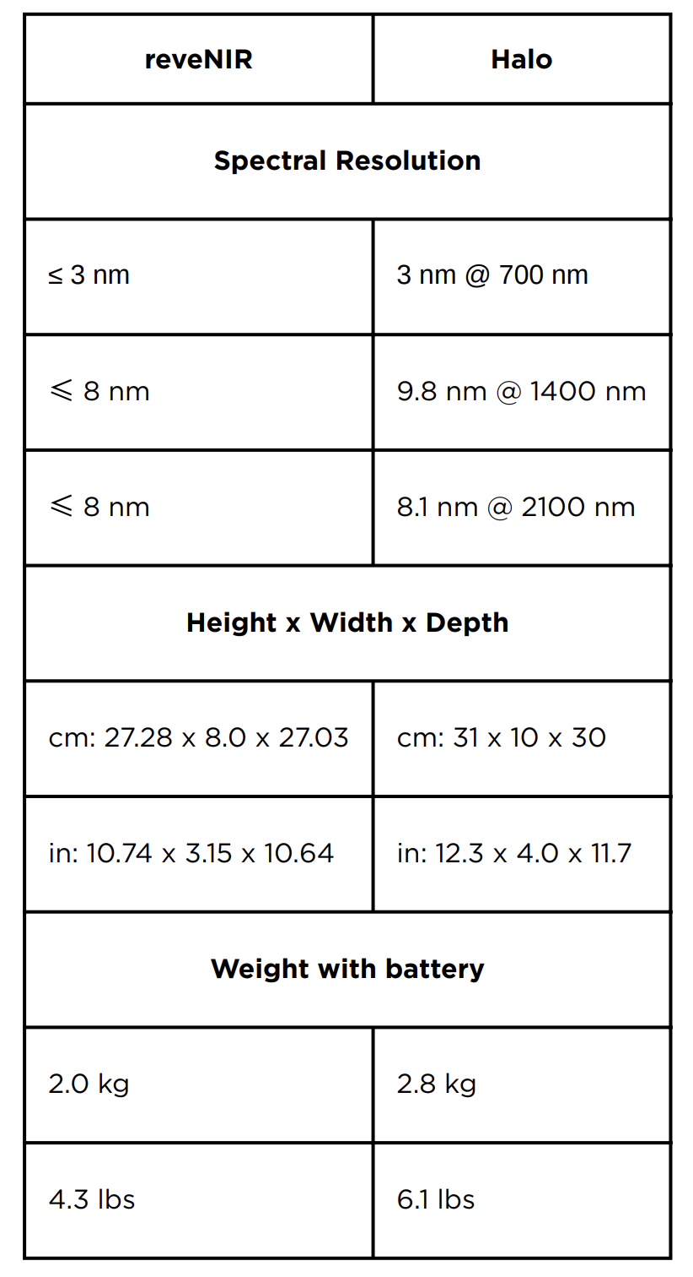 | reveNIR
 | Halo
 | Spectral Resolution
 | ≤ 3 nm
 | 3 nm @ 700 nm
 | ≤ 8 nm
 | 9.8 nm @ 1400 nm
 | ≤ 8 nm
 | 8.1 nm @ 2100 nm
 | Height x Width x Depth
 | cm: 27.28 x 8.0 x 27.03
 | cm: 31 x 10 x 30
 | in: 10.74 x 3.15 x 10.64
 | in: 12.3 x 4.0 x 11.7
 | Weight with battery
 | 2.0 kg
 | 2.8 kg
 | 4.3 lbs
 | 6.1 lbs
 | Shared Strengths | ReveNIR Advantages
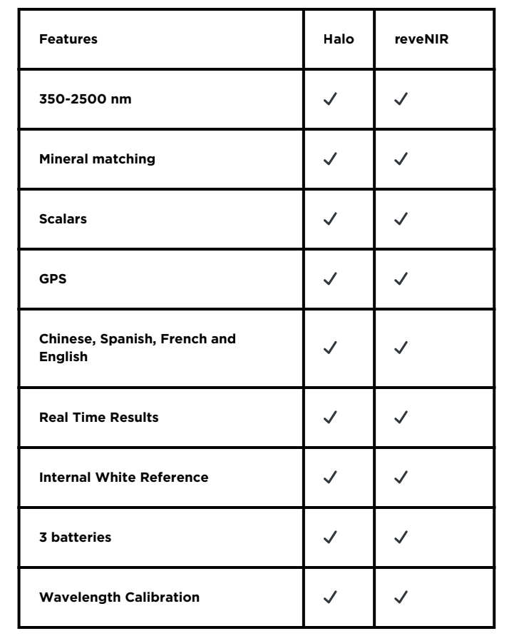 | Features
 | Halo
 | reveNIR
 | 350-2500 nm
 | Mineral matching
 | Scalars
 | GPS
 | Chinese, Spanish, French and English
 | Real Time Results
 | Internal White Reference
 | 3 batteries
 | Wavelength Calibration
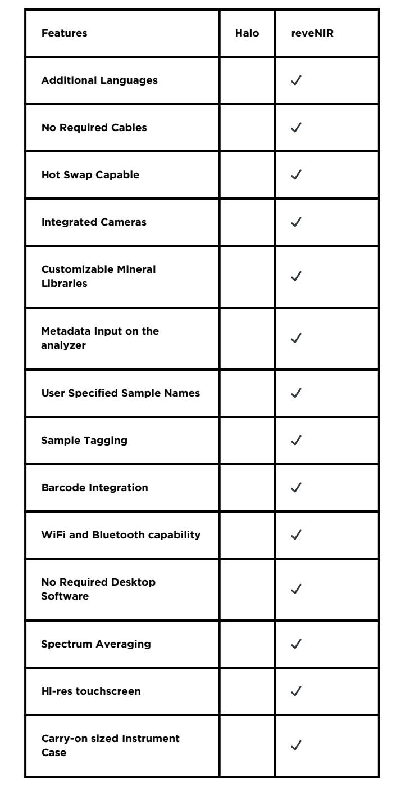 | Additional Languages
 | No Required Cables
 | Hot Swap Capable
 | Integrated Cameras
 | Customizable Mineral Libraries
 | Metadata Input on the analyzer
 | User Specified Sample Names
 | Sample Tagging
 | Barcode Integration
 | WiFi and Bluetooth capability
 | No Required Desktop Software
 | Spectrum Averaging
 | Hi-res touchscreen
 | Carry-on sized Instrument Case

