Document Title: FieldSpec 4 vs reveNIR Comparison Chart
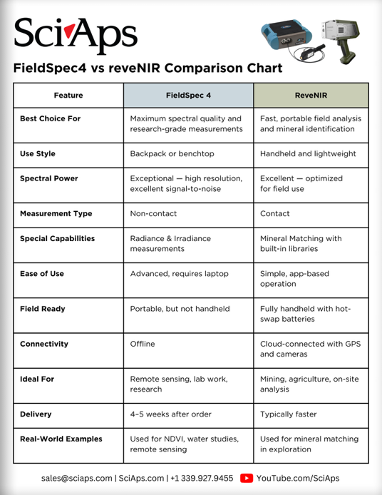
Rev Date: Dec 2025

Layout Preview | English Text | Translated Text
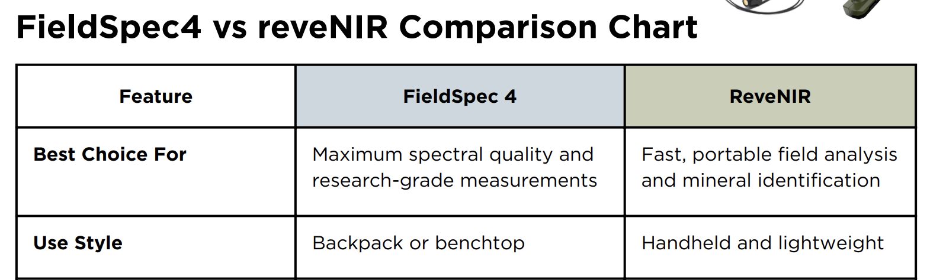 | FieldSpec4 vs reveNIR Comparison Chart
 | Feature
 | FieldSpec 4
 | ReveNIR
 | Best Choice For
 | Maximum spectral quality and research-grade measurements
 | Fast, portable field analysis and mineral identification
 | Use Style
 | Backpack or benchtop
 | Handheld and lightweight
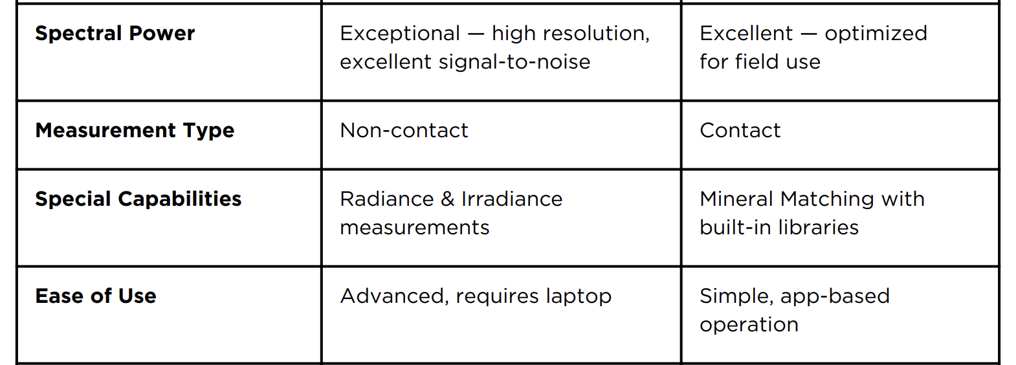 | Spectral Power
 | Exceptional — high resolution, excellent signal-to-noise
 | Excellent — optimized for field use
 | Measurement Type
 | Non-contact
 | Contact
 | Special Capabilities
 | Radiance & Irradiance measurements
 | Mineral Matching with built-in libraries
 | Ease of Use
 | Advanced, requires laptop
 | Simple, app-based operation
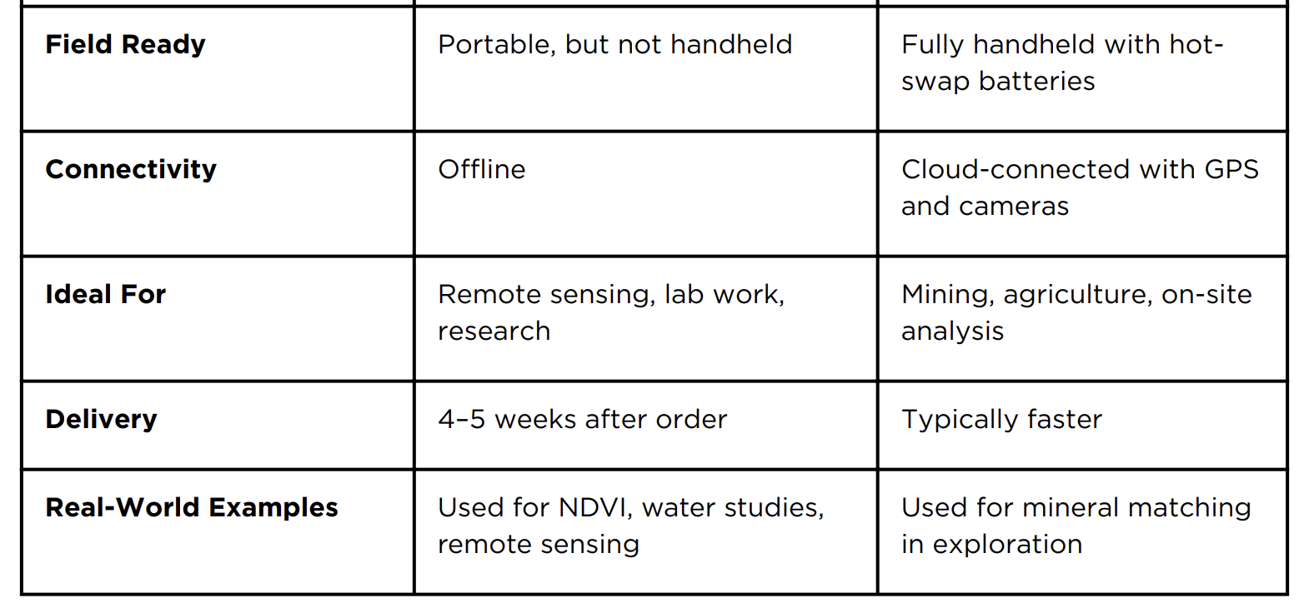 | Field Ready
 | Portable, but not handheld
 | Fully handheld with hotswap batteries
 | Connectivity
 | Offline
 | Cloud-connected with GPS and cameras
 | Ideal For
 | Remote sensing, lab work, research
 | Mining, agriculture, on-site analysis
 | Delivery
 | 4–5 weeks after order
 | Typically faster
 | Real-World Examples
 | Used for NDVI, water studies, remote sensing
 | Used for mineral matching in exploration
[BACK]
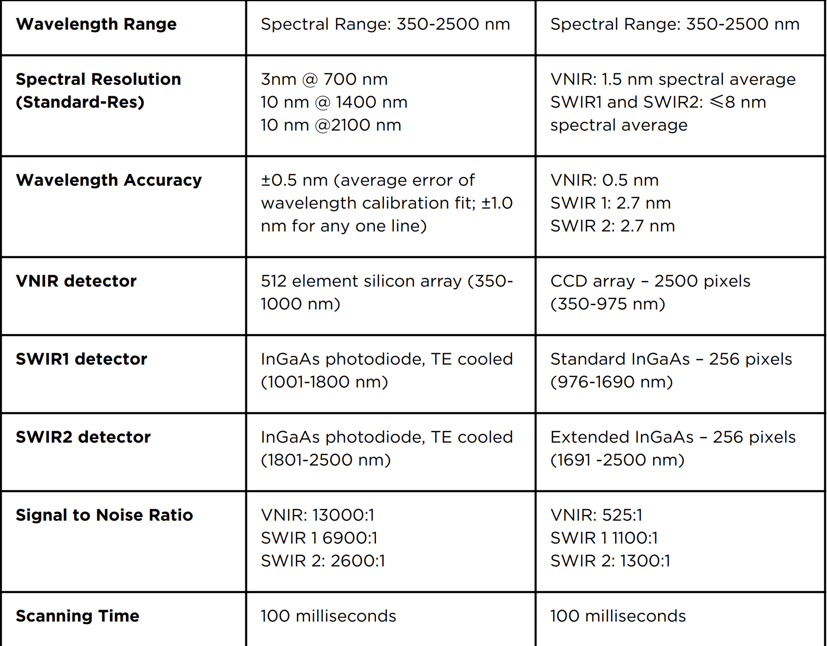 | Wavelength Range
 | Spectral Range: 350-2500 nm
 | Spectral Range: 350-2500 nm
 | Spectral Resolution (Standard-Res)
3nm @ 700 nm
10 nm @ 1400 nm
10 nm @2100 nm
VNIR: 1.5 nm spectral average
SWIR1 and SWIR2: ≤8 nm spectral average
 | Wavelength Accuracy
 | ±0.5 nm (average error of wavelength calibration fit; ±1.0 nm for any one line)
VNIR: 0.5 nm
SWIR 1: 2.7 nm
SWIR 2: 2.7 nm
 | VNIR detector
 | 512 element silicon array (350- 1000 nm)
 | CCD array – 2500 pixels (350-975 nm)
 | SWIR1 detector
 | InGaAs photodiode, TE cooled (1001-1800 nm)
 | Standard InGaAs – 256 pixels (976-1690 nm)
 | SWIR2 detector
 | InGaAs photodiode, TE cooled (1801-2500 nm)
 | Extended InGaAs – 256 pixels (1691 -2500 nm)
 | Signal to Noise Ratio
VNIR: 13000:1
SWIR 1 6900:1
SWIR 2: 2600:1
VNIR: 525:1
SWIR 1 1100:1
SWIR 2: 1300:1
 | Scanning Time
 | 100 milliseconds
 | 100 milliseconds

