Document Title: SciAps PowerHouse for PM Specifications
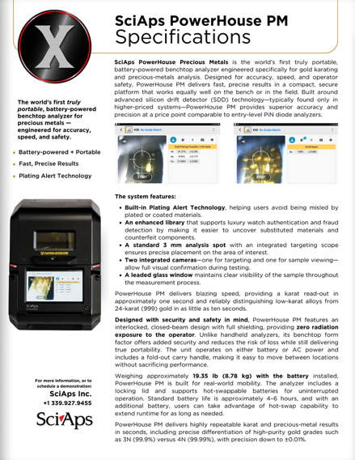
Rev Date: Feb 2026

Layout Preview | English Text | Translated Text
 | SciAps PowerHouse PM
 | Specifications
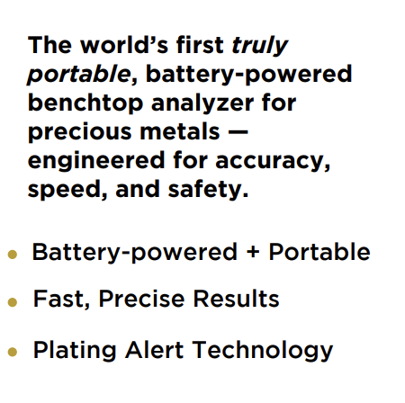 | The world’s first truly portable, battery-powered benchtop analyzer for precious metals — engineered for accuracy, speed, and safety.
 | Battery-powered + Portable
 | Fast, Precise Results
 | Plating Alert Technology
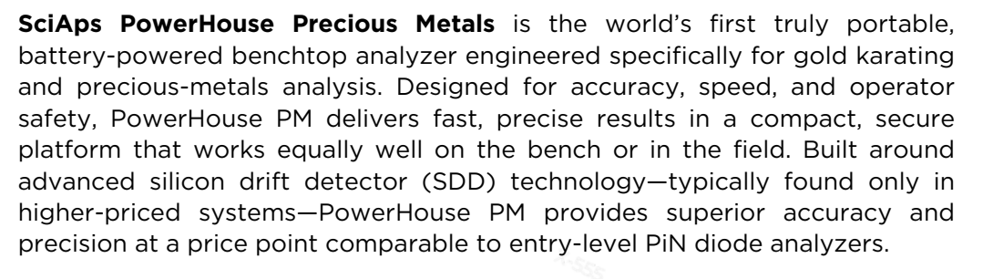 | SciAps PowerHouse Precious Metals is the world’s first truly portable, battery-powered benchtop analyzer engineered specifically for gold karating and precious-metals analysis. Designed for accuracy, speed, and operator safety, PowerHouse PM delivers fast, precise results in a compact, secure platform that works equally well on the bench or in the field. Built around advanced silicon drift detector (SDD) technology—typically found only in higher-priced systems—PowerHouse PM provides superior accuracy and precision at a price point comparable to entry-level PiN diode analyzers.
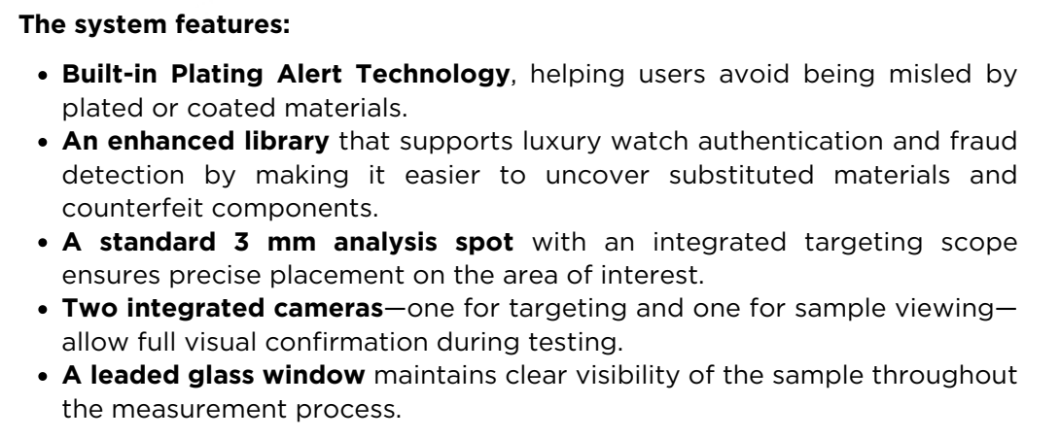 | The system features:
 | Built-in Plating Alert Technology, helping users avoid being misled by plated or coated materials.
 | An enhanced library that supports luxury watch authentication and fraud detection by making it easier to uncover substituted materials and counterfeit components.
 | A standard 3 mm analysis spot with an integrated targeting scope ensures precise placement on the area of interest.
 | Two integrated cameras—one for targeting and one for sample viewing— allow full visual confirmation during testing.
 | A leaded glass window maintains clear visibility of the sample throughout the measurement process.
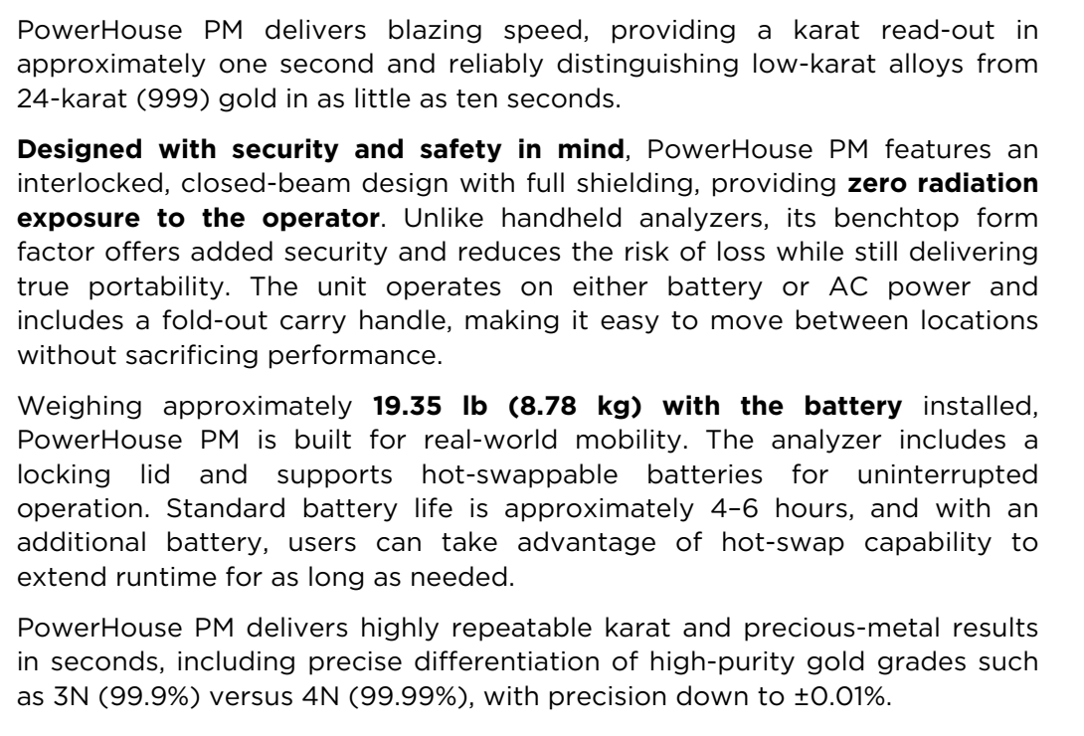 | PowerHouse PM delivers blazing speed, providing a karat read-out in approximately one second and reliably distinguishing low-karat alloys from 24-karat (999) gold in as little as ten seconds.
 | Designed with security and safety in mind, PowerHouse PM features an interlocked, closed-beam design with full shielding, providing zero radiation exposure to the operator. Unlike handheld analyzers, its benchtop form factor offers added security and reduces the risk of loss while still delivering true portability. The unit operates on either battery or AC power and includes a fold-out carry handle, making it easy to move between locations without sacrificing performance.
 | Weighing approximately 19.35 lbs. (8.78 kg) with the battery installed, PowerHouse PM is built for real-world mobility. The analyzer includes a locking lid and supports hot-swappable batteries for uninterrupted operation. Standard battery life is approximately 4–6 hours, and with an additional battery, users can take advantage of hot-swap capability to extend runtime for as long as needed.
 | PowerHouse PM delivers highly repeatable karat and precious-metal results in seconds, including precise differentiation of high-purity gold grades such as 3N (99.9%) versus 4N (99.99%), with precision down to ±0.01%.
 | For more information, or to schedule a demonstration:
(BACK)
 | SciAps PowerHouse PM
 | Specifications
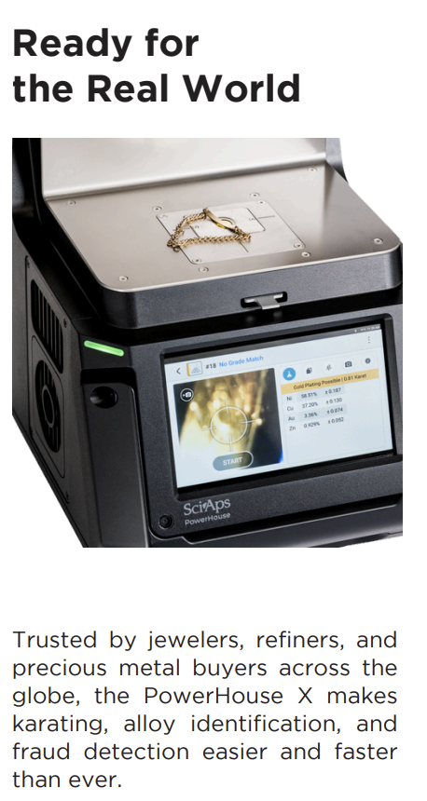 | Ready for the Real World
 | Trusted by jewelers, refiners, and precious metal buyers across the globe, the PowerHouse X makes karating, alloy identification, and fraud detection easier and faster than ever.
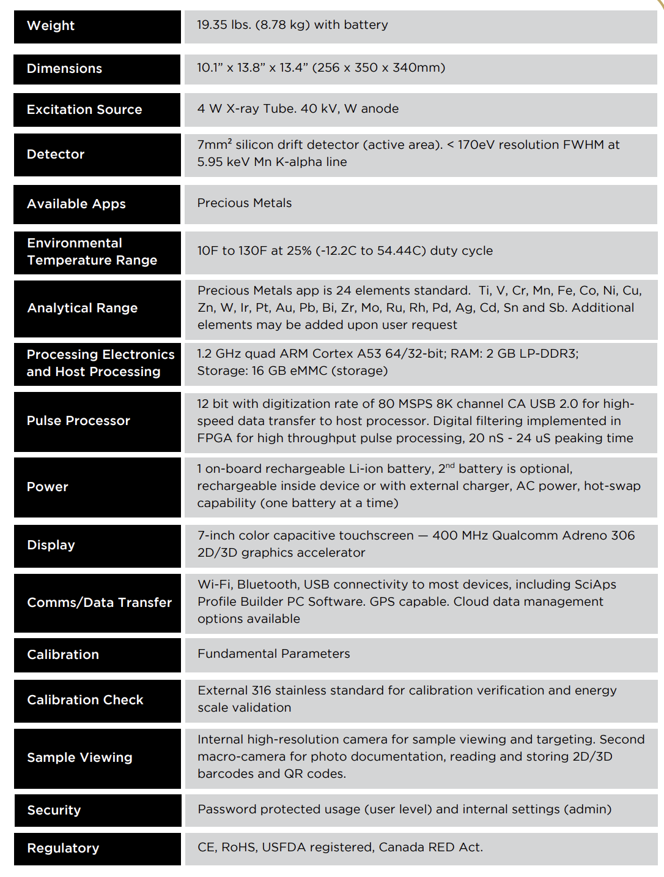 | Weight
 | 19.35 lbs. (8.78 kg) with battery
 | Dimensions
 | 10.1” x 13.8” x 13.4” (256 x 350 x 340mm)
 | Excitation Source
 | 4 W X-ray Tube. 40 kV, W anode
 | Detector
 | 7mm² silicon drift detector (active area). < 170eV resolution FWHM at 5.95 keV Mn K-alpha line
 | Available Apps
 | Precious Metals
 | Environmental Temperature Range
 | 10F to 130F at 25% (-12.2C to 54.44C) duty cycle
 | Analytical Range
 | Precious Metals app is 24 elements standard. Ti, V, Cr, Mn, Fe, Co, Ni, Cu, Zn, W, Ir, Pt, Au, Pb, Bi, Zr, Mo, Ru, Rh, Pd, Ag, Cd, Sn and Sb. Additional elements may be added upon request
 | Processing Electronics and Host Processing
 | 1.2 GHz quad ARM Cortex A53 64/32-bit; RAM: 2 GB LP-DDR3; Storage: 16 GB eMMC (storage)
 | Pulse Processor
 | 12 bit with digitization rate of 80 MSPS 8K channel CA USB 2.0 for highspeed data transfer to host processor. Digital filtering implemented in FPGA for high throughput pulse processing, 20 nS - 24 uS peaking time
 | Power
 | 1 on-board rechargeable Li-ion battery, 2nd battery is optional, rechargeable inside device or with external charger, AC power, hot-swap capability (one battery at a time)
 | Display
 | 7-inch color capacitive touchscreen — 400 MHz Qualcomm Adreno 306 2D/3D graphics accelerator
 | Comms/Data Transfer
 | Wi-Fi, Bluetooth, USB connectivity to most devices, including SciAps Profile Builder PC Software. GPS capable. Cloud data management options available
 | Calibration
 | Fundamental Parameters
 | Calibration Check
 | External 316 stainless standard for calibration verification and energy scale validation
 | Sample Viewing
 | Internal high-resolution camera for sample viewing and targeting. Second macro-camera for photo documentation, reading and storing 2D/3D barcodes and QR codes.
 | Security
 | Password protected usage (user level) and internal settings (admin)
 | Regulatory
 | CE, RoHS, USFDA registered, Canada RED Act.
 | Seen at JCK Las Vegas — Immediate Sales on the Spot!
 | “Best-looking benchtop analyzer out there.”
 | – Industry engineers and users agree.

