Document Title: ApNote DPT Protecting XRF Detectors
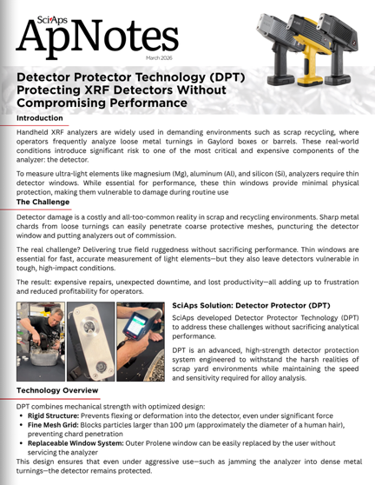
Rev Date: March 2026

Layout Preview | English Text | Translated Text
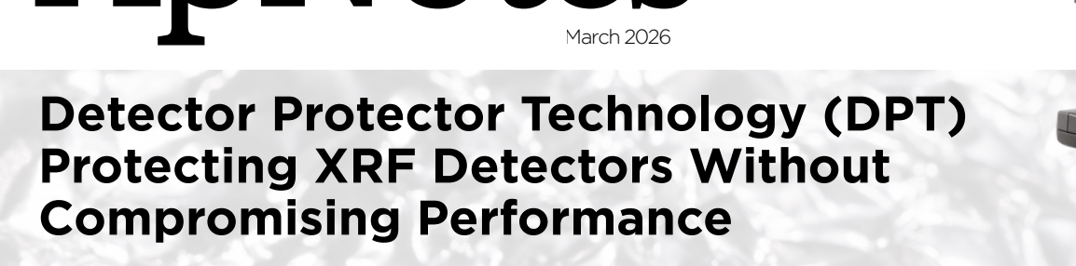 | March 2026
 | Detector Protector Technology (DPT) Protecting XRF Detectors Without Compromising Performance
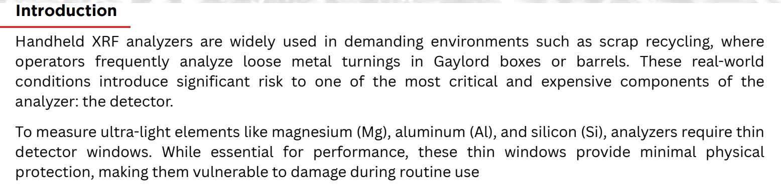 | Introduction
 | Handheld XRF analyzers are widely used in demanding environments such as scrap recycling, where operators frequently analyze loose metal turnings in Gaylord boxes or barrels. These real-world conditions introduce significant risk to one of the most critical and expensive components of the analyzer: the detector.
 | To measure ultra-light elements like magnesium (Mg), aluminum (Al), and silicon (Si), analyzers require thin detector windows. While essential for performance, these thin windows provide minimal physical protection, making them vulnerable to damage during routine use.
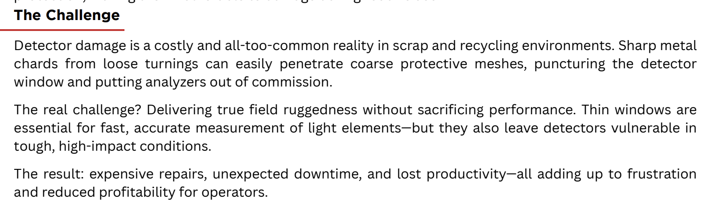 | The Challenge
 | Detector damage is a costly and all-too-common reality in scrap and recycling environments. Sharp metal chards from loose turnings can easily penetrate coarse protective meshes, puncturing the detector window and putting analyzers out of commission.
 | The real challenge? Delivering true field ruggedness without sacrificing performance. Thin windows are essential for fast, accurate measurement of light elements—but they also leave detectors vulnerable in tough, high-impact conditions.
 | The result: expensive repairs, unexpected downtime, and lost productivity—all adding up to frustration and reduced profitability for operators.
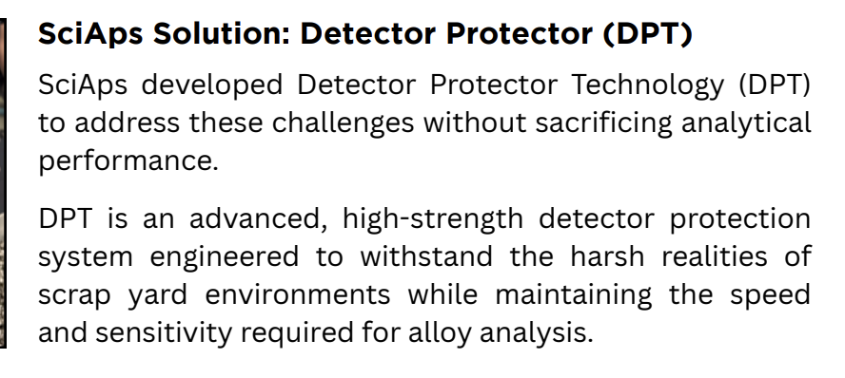 | SciAps Solution: Detector Protector (DPT)
 | SciAps developed Detector Protector Technology (DPT) to address these challenges without sacrificing analytical performance.
 | DPT is an advanced, high-strength detector protection system engineered to withstand the harsh realities of scrap yard environments while maintaining the speed and sensitivity required for alloy analysis.
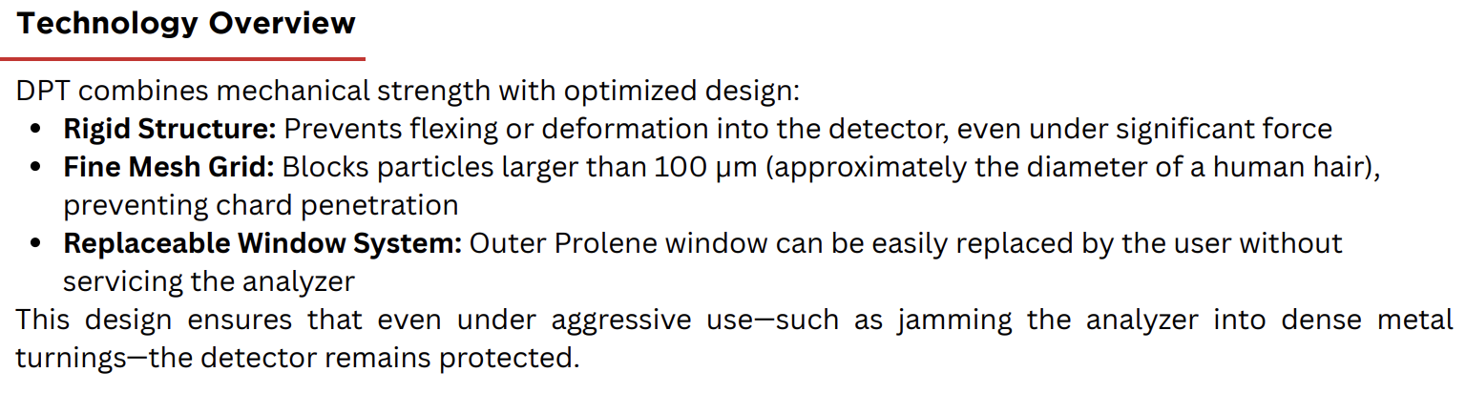 | Technology Overview
 | DPT combines mechanical strength with optimized design:
 | Rigid Structure: Prevents flexing or deformation into the detector, even under significant force
 | Fine Mesh Grid: Blocks particles larger than 100 µm (approximately the diameter of a human hair), preventing chard penetration
 | Replaceable Window System: Outer Prolene window can be easily replaced by the user without servicing the analyzer
 | This design ensures that even under aggressive use—such as jamming the analyzer into dense metal turnings—the detector remains protected.
(BACK)
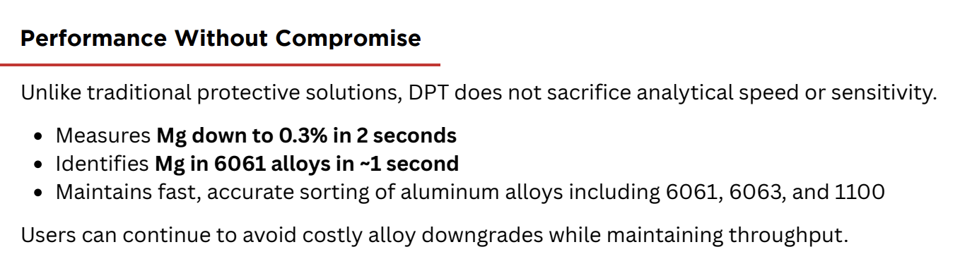 | Performance Without Compromise
 | Unlike traditional protective solutions, DPT does not sacrifice analytical speed or sensitivity.
 | Measures Mg down to 0.3% in 2 seconds
 | Identifies Mg in 6061 alloys in ~1 second
 | Maintains fast, accurate sorting of aluminum alloys including 6061, 6063, and 1100
 | Users can continue to avoid costly alloy downgrades while maintaining throughput.
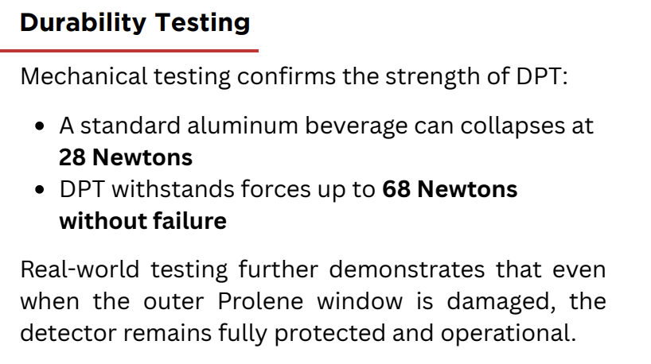 | Durability Testing
 | Mechanical testing confirms the strength of DPT:
 | A standard aluminum beverage can collapses at 28 Newtons
 | DPT withstands forces up to 68 Newtons without failure
 | Real-world testing further demonstrates that even when the outer Prolene window is damaged, the detector remains fully protected and operational.
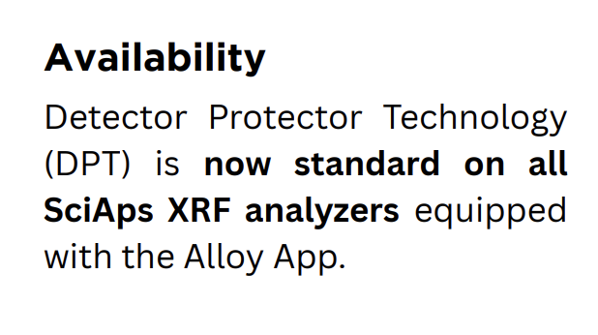 | Availability
 | Detector Protector Technology (DPT) is now standard on all SciAps XRF analyzers equipped with the Alloy App.
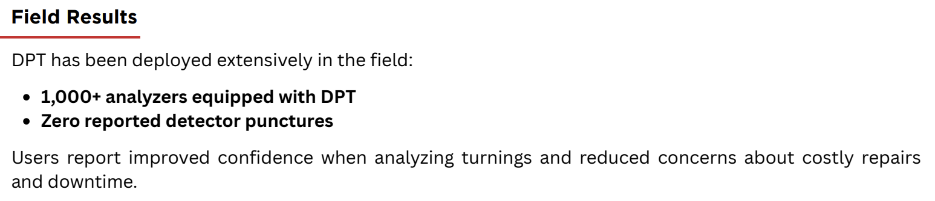 | Field Results
 | DPT has been deployed extensively in the field:
 | 1,000+ analyzers equipped with DPT
 | Zero reported detector punctures
 | Users report improved confidence when analyzing turnings and reduced concerns about costly repairs and downtime.
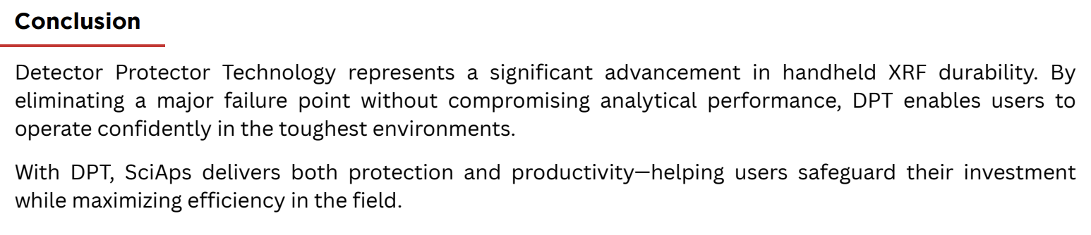 | Conclusion
 | Detector Protector Technology represents a significant advancement in handheld XRF durability. By eliminating a major failure point without compromising analytical performance, DPT enables users to operate confidently in the toughest environments.
 | With DPT, SciAps delivers both protection and productivity—helping users safeguard their investment while maximizing efficiency in the field.

