Document Title: Rock Solid Material Measurement for Mining
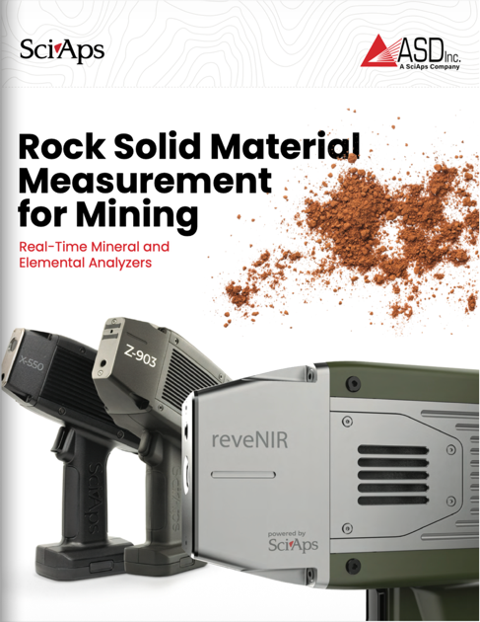
Rev Date: March 2026

Layout Preview | English Text | Translated Text
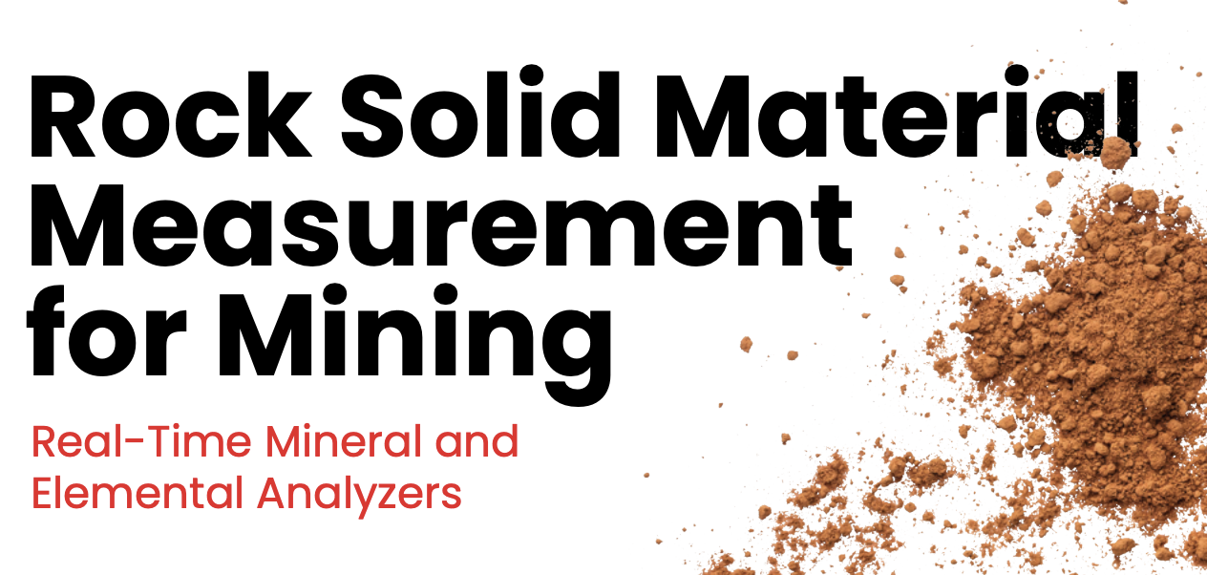 | Rock Solid Material Measurement for Mining
 | Real-Time Mineral and Elemental Analyzers
[page 2]
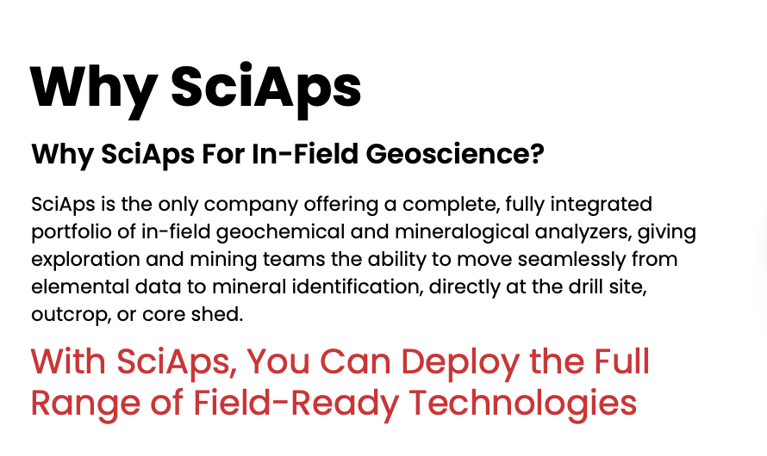 | Why SciAps
 | Why SciAps for In-Field Geoscience?
 | SciAps is the only company offering a complete, fully integrated portfolio of in-field geochemical and mineralogical analyzers, giving exploration and mining teams the ability to move seamlessly from elemental data to mineral identification, directly at the drill site, outcrop, or core shed.
 | With SciAps, You Can Deploy the Full Range of Field-Ready Technologies
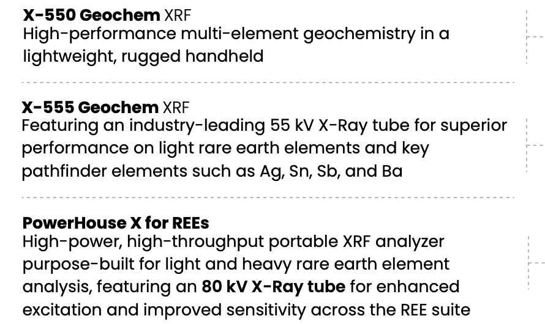 | X-550 Geochem XRF
 | High-performance multi-element geochemistry in a lightweight, rugged handheld
 | X-555 Geochem XRF
 | Featuring an industry-leading 55 kV X-Ray tube for superior performance on light rare earth elements and key pathfinder elements such as Ag, Sn, Sb, and Ba
 | PowerHouse X for REEs
 | High-power, high-throughput portable XRF analyzer purpose-built for light and heavy rare earth element analysis, featuring an 80 kV X-Ray tube for enhanced excitation and improved sensitivity across the REE suite
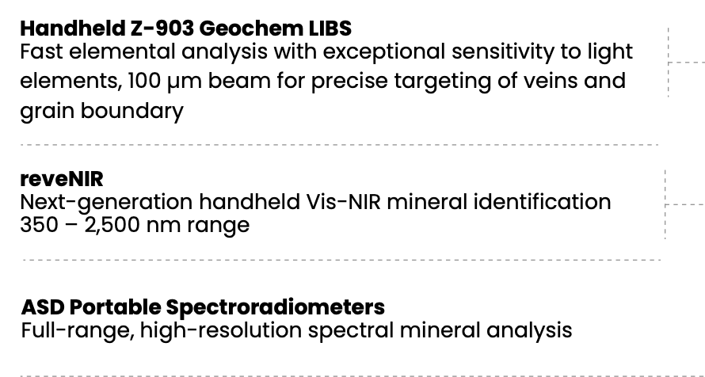 | Handheld Z-903 Geochem LIBS
 | Fast elemental analysis with exceptional sensitivity to light elements, 100 µm beam for precise targeting of veins and grain boundary
 | reveNIR
 | Next-generation handheld Vis-NIR mineral identification 350 – 2,500 nm range
 | ASD Portable Spectroradiometers
 | Full-range, high-resolution spectral mineral analysis
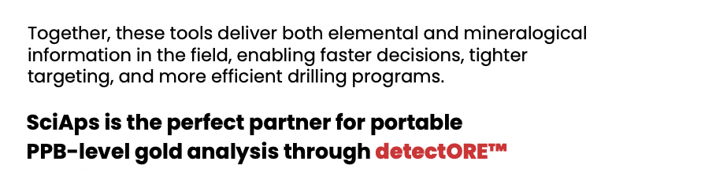 | Together, these tools deliver both elemental and mineralogical information in the field, enabling faster decisions, tighter targeting, and more efficient drilling programs.
 | SciAps is the perfect partner for portable PPB-level gold analysis through detectORE™
[page 3]
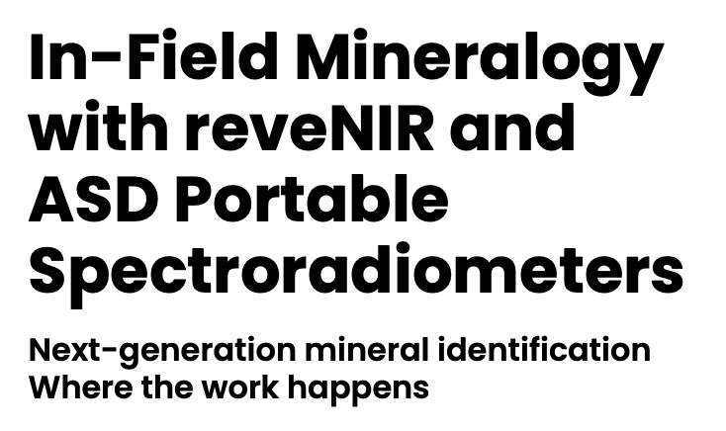 | In-Field Mineralogy with reveNIR and ASD Portable Spectroradiometers
 | Next-generation mineral identification Where the work happens
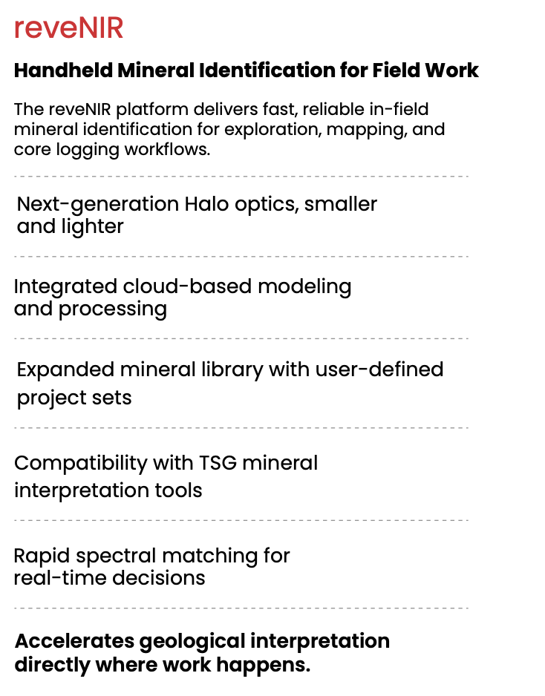 | reveNIR
 | Handheld Mineral Identification for Field Work
 | The reveNIR platform delivers fast, reliable in-field mineral identification for exploration, mapping, and core logging workflows.
 | Next-generation Halo optics, smaller and lighter
 | Integrated cloud-based modeling and processing
 | Expanded mineral library with user-defined project sets
 | Compatibility with TSG mineral interpretation tools
 | Rapid spectral matching for real-time decisions
 | Accelerates geological interpretation directly where work happens.
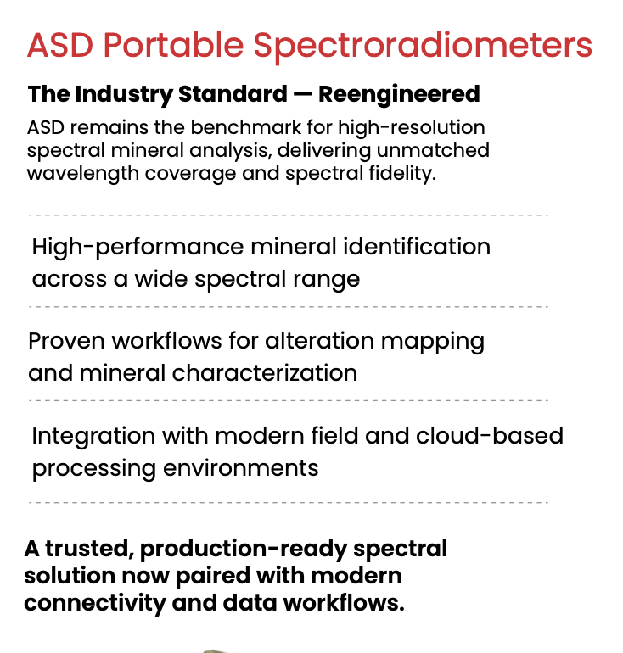 | ASD Portable Spectroradiometers
 | The Industry Standard — Reengineered
 | ASD remains the benchmark for high-resolution spectral mineral analysis, delivering unmatched wavelength coverage and spectral fidelity.
 | High-performance mineral identification across a wide spectral range
 | Proven workflows for alteration mapping and mineral characterization
 | Integration with modern field and cloud-based processing environments
 | A trusted, production-ready spectral solution now paired with modern connectivity and data workflows.
[page 4]
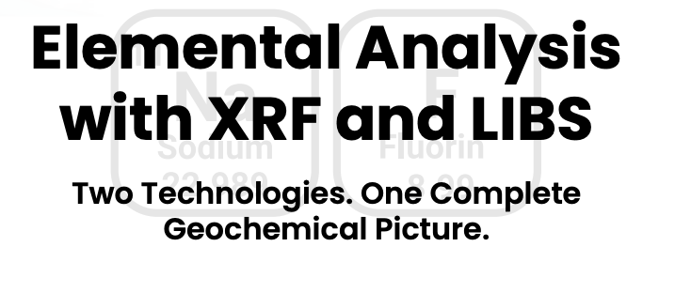 | Elemental Analysis with XRF and LIBS
 | Two Technologies. One Complete Geochemical Picture.
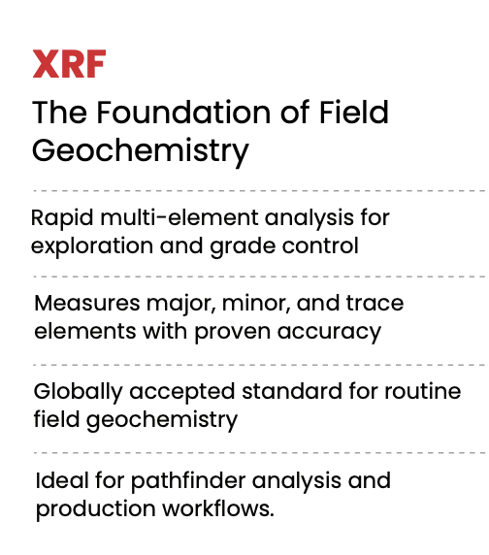 | XRF
 | The Foundation of Field Geochemistry
 | Rapid multi-element analysis for exploration and grade control
 | Measures major, minor, and trace elements with proven accuracy
 | Globally accepted standard for routine field geochemistry
 | Ideal for pathfinder analysis and production workflows.
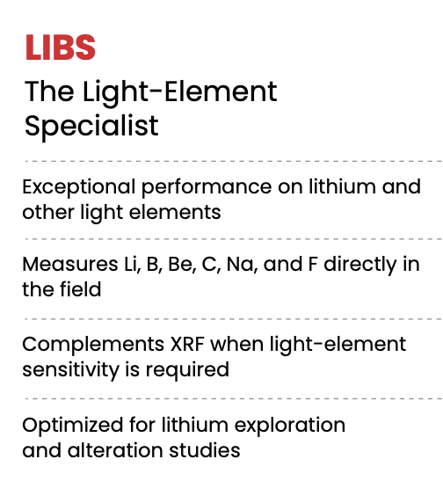 | LIBS
 | The Light-Element Specialist
 | Exceptional performance on lithium and other light elements
 | Measures Li, B, Be, C, Na, and F directly in the field
 | Complements XRF when light-element sensitivity is required
 | Optimized for lithium exploration and alteration studies
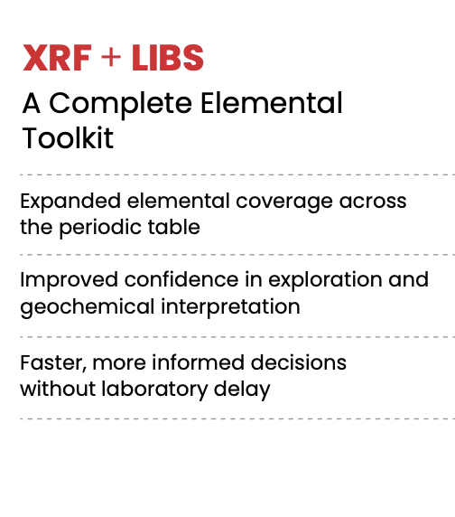 | XRF + LIBS
 | A Complete Elemental Toolkit
 | Expanded elemental coverage across the periodic table
 | Improved confidence in exploration and geochemical interpretation
 | Faster, more informed decisions without laboratory delay
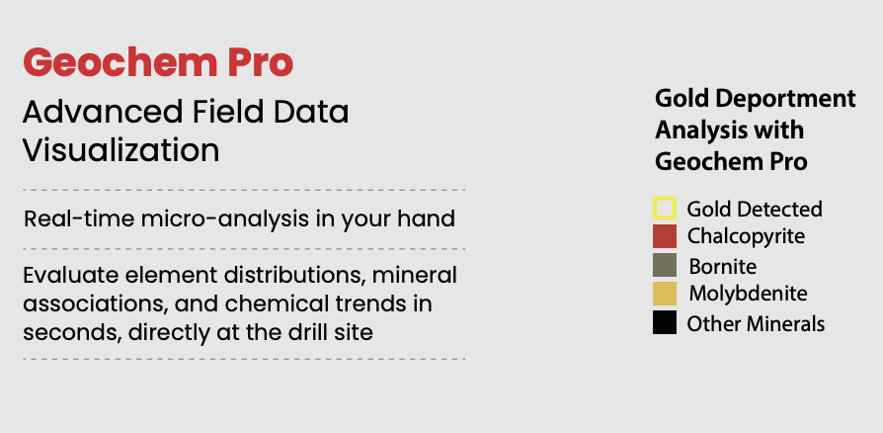 | Geochem Pro
 | Advanced Field Data Visualization
 | Real-time micro-analysis in your hand
 | Evaluate element distributions, mineral associations, and chemical trends in seconds, directly at the drill site
 | Gold Deportment Analysis with Geochem Pro
 | Gold Detected
 | Chalcopyrite
 | Bornite
 | Molybdenite
 | Other Minerals
[page 5]
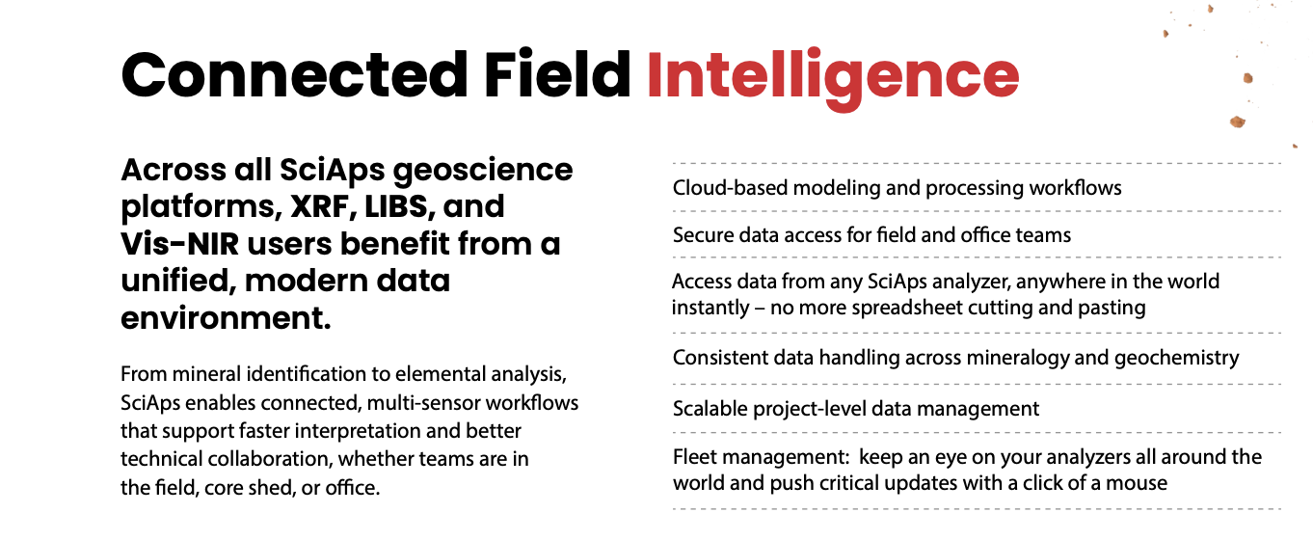 | Connected Field Intelligence
 | Across all SciAps geoscience platforms, XRF, LIBS, and Vis-NIR users benefit from a unified, modern data environment.
 | From mineral identication to elemental analysis, SciAps enables connected, multi-sensor workflows that support faster interpretation and better technical collaboration, whether teams are in the field, core shed, or office.
 | Cloud-based modeling and processing work-ows
 | Secure data access for field and office teams
 | Access data from any SciAps analyzer, anywhere in the world instantly – no more spreadsheet cutting and pasting
 | Consistent data handling across mineralogy and geochemistry
 | Scalable project-level data management
 | Fleet management: keep an eye on your analyzers all around the world and push critical updates with a click of a mouse
[page 6]
 | Multi-Sensor Workflows for Modern Core Logging
 | One Platform. Multiple Sensors. Better Ore Body Knowledge
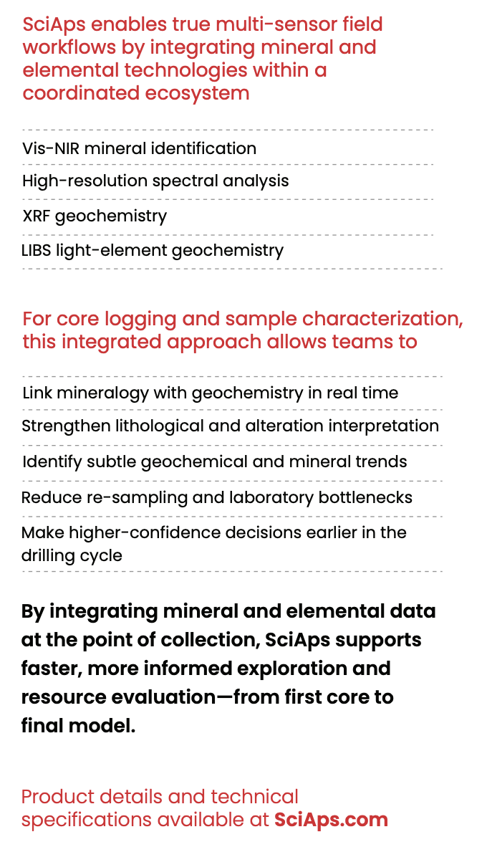 | SciAps enables true multi-sensor field workflows by integrating mineral and elemental technologies within a coordinated ecosystem
 | Vis-NIR mineral identification
 | High-resolution spectral analysis
 | XRF geochemistry
 | LIBS light-element geochemistry
 | For core logging and sample characterization, this integrated approach allows teams to
 | Link mineralogy with geochemistry in real time
 | Strengthen lithological and alteration interpretation
 | Identify subtle geochemical and mineral trends
 | Reduce re-sampling and laboratory bottlenecks
 | Make higher-confidence decisions earlier in the drilling cycle
 | By integrating mineral and elemental data at the point of collection, SciAps supports faster, more informed exploration and resource evaluation—from first core to final model.
 | Product details and technical specifications available at SciAps.com
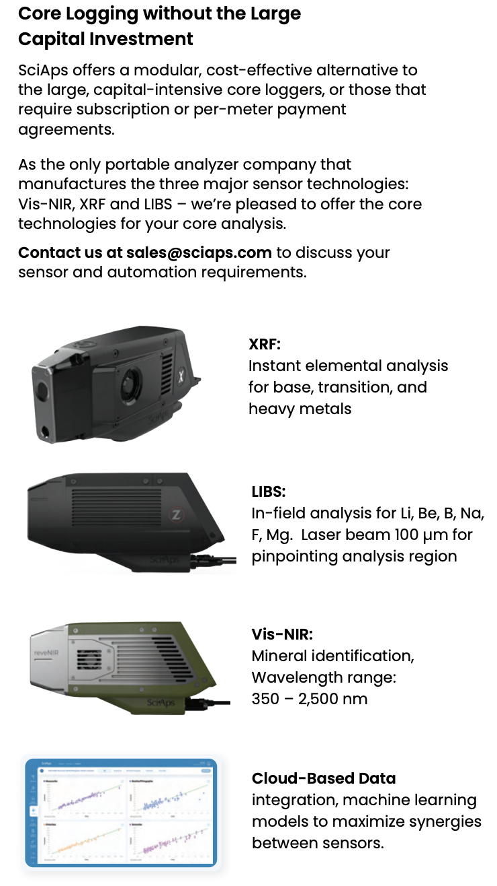 | Core Logging without the Large Capital Investment
 | SciAps offers a modular, cost-effective alternative to the large, capital-intensive core loggers, or those that require subscription or per-meter payment agreements.
 | As the only portable analyzer company that manufactures the three major sensor technologies: Vis-NIR, XRF and LIBS – we’re pleased to offer the core technologies for your core analysis.
 | Contact us at sales@sciaps.com to discuss your sensor and automation requirements.
 | XRF
 | Instant elemental analysis for base, transition, and heavy metals
 | LIBS
 | In-field analysis for Li, Be, B, Na, F, Mg. Laser beam 100 µm for pinpointing analysis region
 | Vis-NIR
 | Mineral identification, Wavelength range: 350 – 2,500 nm
 | Cloud-Based Data
 | integration, machine learning models to maximize synergies between sensors.

