Document Title: SciAps Scrap Processing Brochure
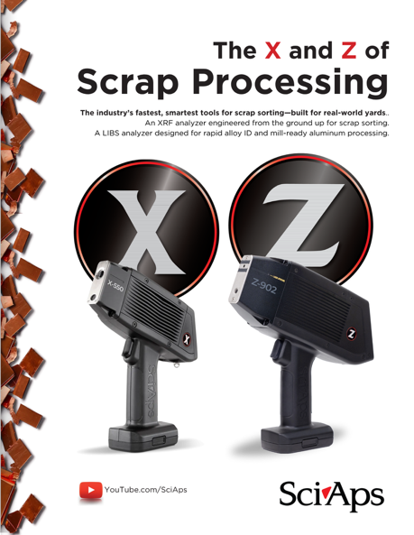
Rev Date: April 2026

Layout Preview | English Text | Translated Text
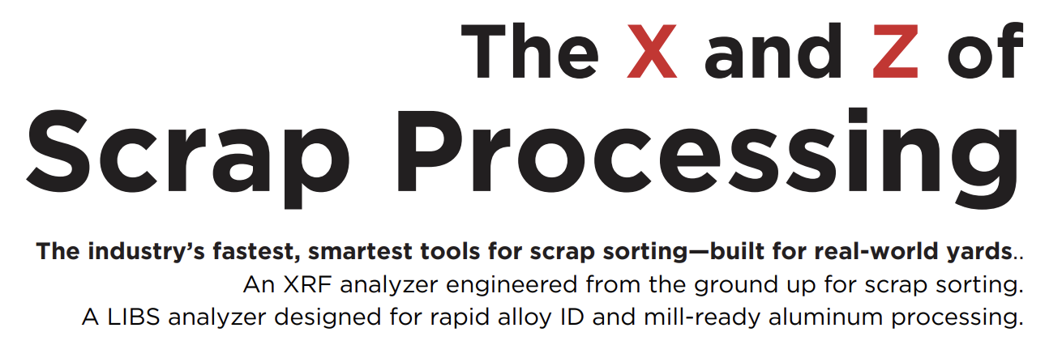 | The X and Z of
 | Scrap Processing
 | The industry’s fastest, smartest tools for scrap sorting—built for real-world yards.
 | An XRF analyzer engineered from the ground up for scrap sorting.
 | A LIBS analyzer designed for rapid alloy ID and mill-ready aluminum processing.
[page 2]
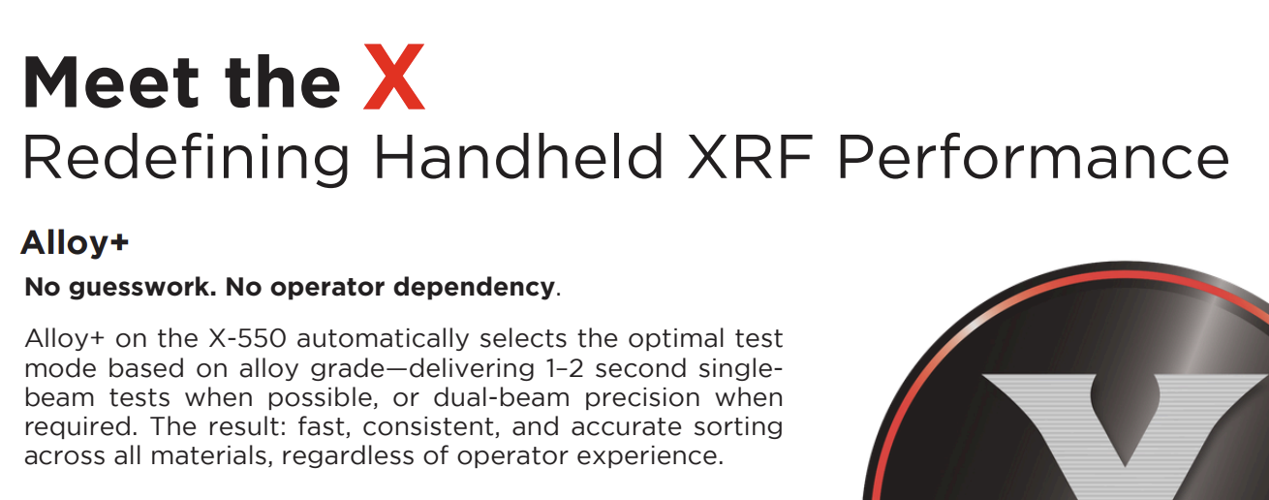 | Meet the X
 | Redefining Handheld XRF Performance
 | Alloy+
 | No guesswork. No operator dependency.
 | Alloy+ on the X-550 automatically selects the optimal test mode based on alloy grade—delivering 1–2 second single-beam tests when possible, or dual-beam precision when required. The result: fast, consistent, and accurate sorting across all materials, regardless of operator experience.
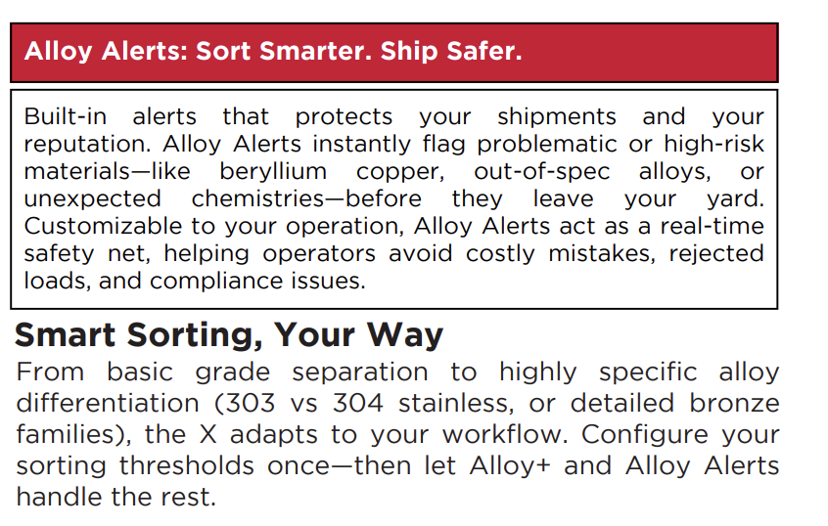 | Alloy Alerts: Sort Smarter. Ship Safer.
 | Built-in alerts that protect your shipments and your reputation. Alloy Alerts instantly flag problematic or high-risk materials—like beryllium copper, out-of-spec alloys, or unexpected chemistries—before they leave your yard. Customizable to your operation, Alloy Alerts act as a real-time safety net, helping operators avoid costly mistakes, rejected loads, and compliance issues.
 | Smart Sorting, Your Way
 | From basic grade separation to highly specific alloy differentiation (303 vs 304 stainless, or detailed bronze families), the X adapts to your workflow. Configure your sorting thresholds once—then let Alloy+ and Alloy Alerts handle the rest.
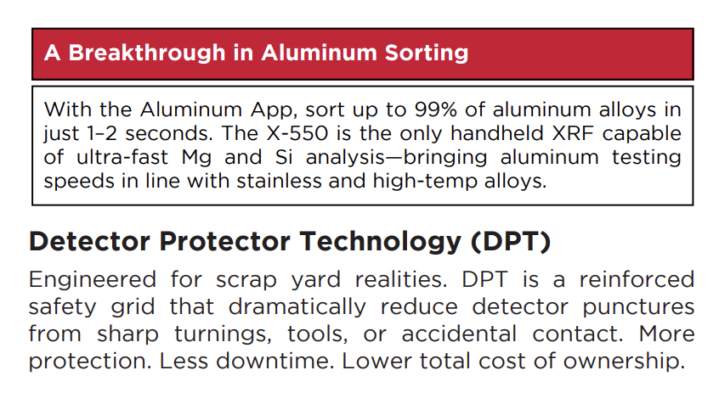 | A Breakthrough in Aluminum Sorting
 | With the Aluminum App, sort up to 99% of aluminum alloys in just 1–2 seconds. The X-550 is the only handheld XRF capable of ultra-fast Mg and Si analysis—bringing aluminum testing speeds in line with stainless and high-temp alloys.
 | Detector Protector Technology (DPT)
 | Engineered for scrap yard realities. DPT is a reinforced safety grid that dramatically reduce detector punctures from sharp turnings, tools, or accidental contact. More protection. Less downtime. Lower total cost of ownership.
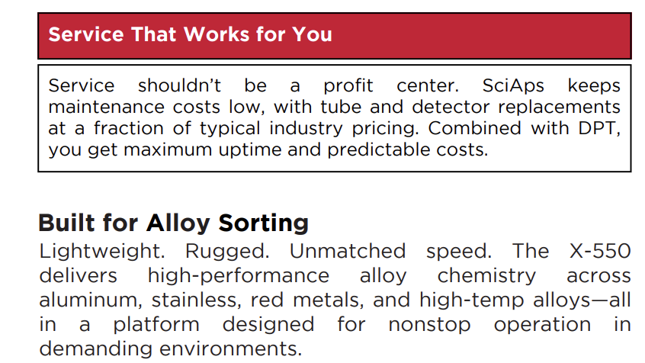 | Service That Works for You
 | Service shouldn’t be a profit center. SciAps keeps maintenance costs low, with tube and detector replacements at a fraction of typical industry pricing. Combined with DPT, you get maximum uptime and predictable costs.
 | Built for Alloy Sorting
 | Lightweight. Rugged. Unmatched speed. The X-550 delivers high-performance alloy chemistry across aluminum, stainless, red metals, and high-temp alloys—all in a platform designed for nonstop operation in demanding environments.
[page 3]
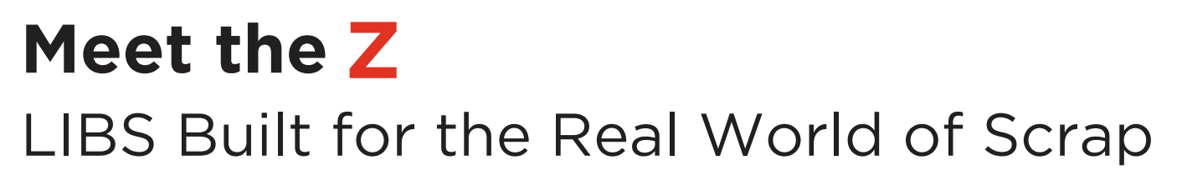 | Meet the Z
 | LIBS Built for the Real World of Scrap
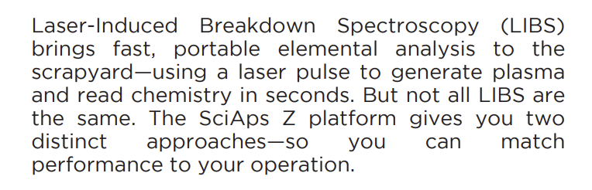 | Laser-Induced Breakdown Spectroscopy (LIBS) brings fast, portable elemental analysis to the scrapyard—using a laser pulse to generate plasma and read chemistry in seconds. But not all LIBS are the same. The SciAps Z platform gives you two distinct approaches—so you can match performance to your operation.
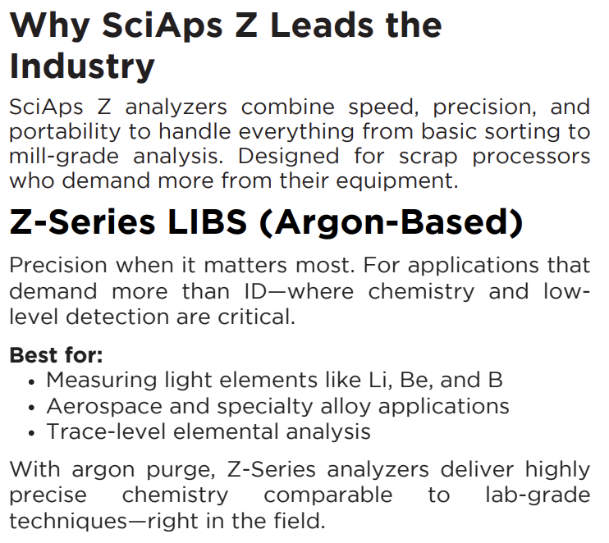 | Why SciAps Z Leads the Industry
 | SciAps Z analyzers combine speed, precision, and portability to handle everything from basic sorting to mill-grade analysis. Designed for scrap processors who demand more from their equipment.
 | Z-Series LIBS (Argon-Based)
 | Precision when it matters most. For applications that demand more than ID—where chemistry and low-level detection are critical.
 | Best for:
 | Measuring light elements like Li, Be, and B
 | Aerospace and specialty alloy applications
 | Trace-level elemental analysis
 | With argon purge, Z-Series analyzers deliver highly precise chemistry comparable to lab-grade techniques—right in the field.
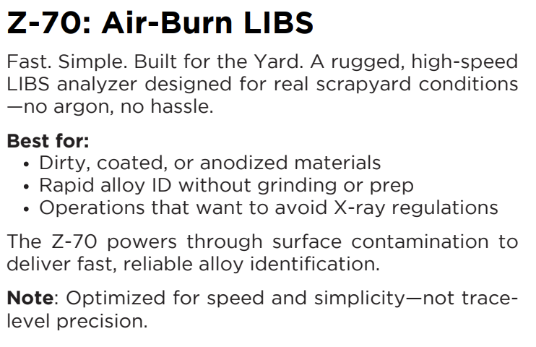 | Z-70: Air-Burn LIBS
 | Fast. Simple. Built for the Yard. A rugged, high-speed LIBS analyzer designed for real scrapyard conditions —no argon, no hassle.
 | Best for:
 | Dirty, coated, or anodized materials
 | Rapid alloy ID without grinding or prep
 | Operations that want to avoid X-ray regulations
 | The Z-70 powers through surface contamination to deliver fast, reliable alloy identification.
 | Note: Optimized for speed and simplicity—not trace-level precision.
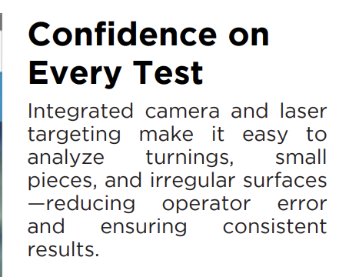 | Confidence on Every Test
 | Integrated camera and laser targeting make it easy to analyze turnings, small pieces, and irregular surfaces —reducing operator error and ensuring consistent results.
[page 4]
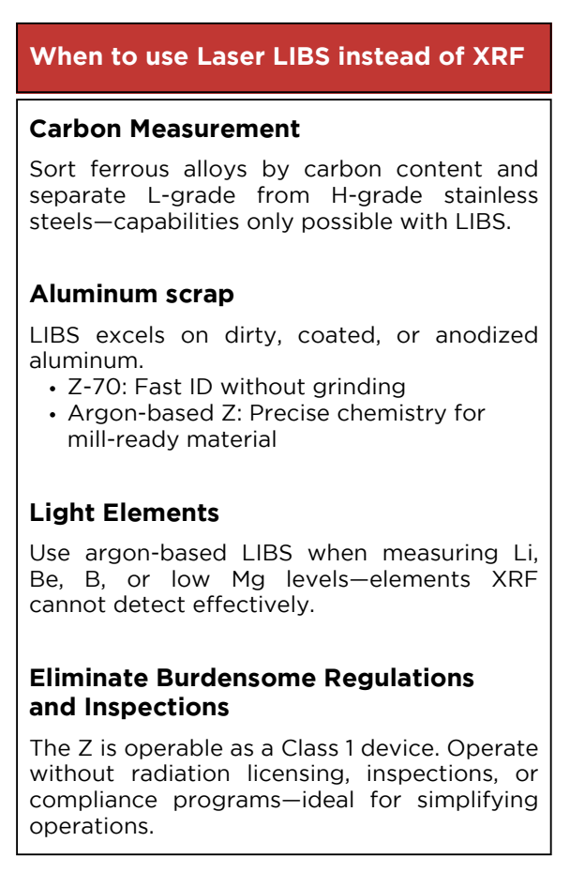 | When to use Laser LIBS instead of XRF
 | Carbon Measurement
 | Sort ferrous alloys by carbon content and separate L-grade from H-grade stainless steels—capabilities only possible with LIBS.
 | Aluminum scrap
 | LIBS excels on dirty, coated, or anodized aluminum.
 | Z-70: Fast ID without grinding
 | Argon-based Z: Precise chemistry for mill-ready material
 | Light Elements
 | Use argon-based LIBS when measuring Li, Be, B, or low Mg levels—elements XRF cannot detect effectively.
 | Eliminate Burdensome Regulations and Inspections
 | The Z is operable as a Class 1 device. Operate without radiation licensing, inspections, or compliance programs—ideal for simplifying operations.
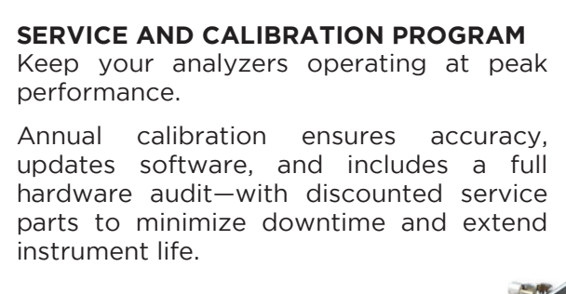 | SERVICE AND CALIBRATION PROGRAM
 | Keep your analyzers operating at peak performance.
 | Annual calibration ensures accuracy, updates software, and includes a full hardware audit—with discounted service parts to minimize downtime and extend instrument life.
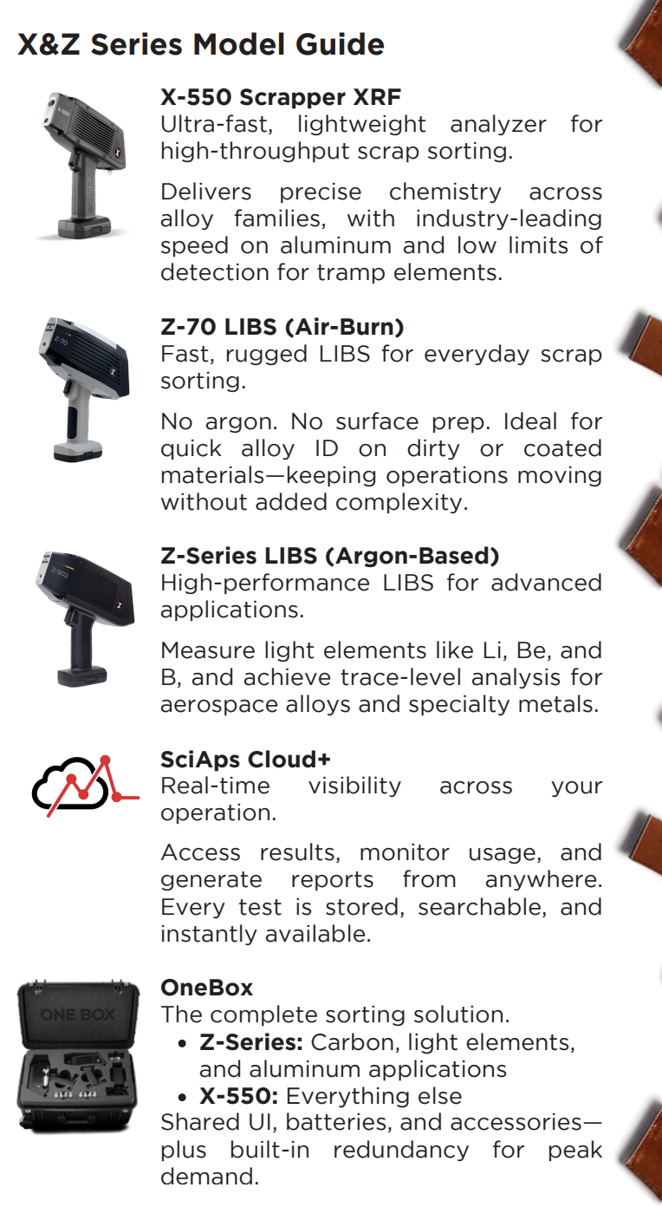 | X&Z Series Model Guide
 | X-550 Scrapper XRF
 | Ultra-fast, lightweight analyzer for high-throughput scrap sorting.
 | Delivers precise chemistry across alloy families, with industry-leading speed on aluminum and low limits of detection for tramp elements.
 | Z-70 LIBS (Air-Burn)
 | Fast, rugged LIBS for everyday scrap sorting.
 | No argon. No surface prep. Ideal for quick alloy ID on dirty or coated materials—keeping operations moving without added complexity.
 | Z-Series LIBS (Argon-Based)
 | High-performance LIBS for advanced applications.
 | Measure light elements like Li, Be, and B, and achieve trace-level analysis for aerospace alloys and specialty metals.
 | SciAps Cloud+
 | Real-time visibility across your operation.
 | Access results, monitor usage, and generate reports from anywhere. Every test is stored, searchable, and instantly available.
 | OneBox
 | The complete sorting solution.
 | Z-Series: Carbon, light elements, and aluminum applications
 | X-550: Everything else
 | Shared UI, batteries, and accessories— plus built-in redundancy for peak demand.

