Document Title: SciAps Z-902 Alloy Specifications
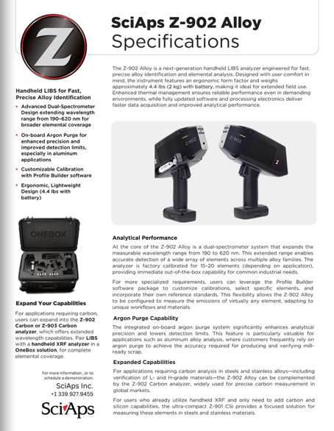
Rev Date:

Layout Preview | English Text | Translated Text
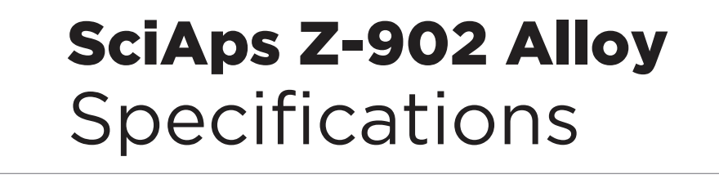 | SciAps Z-902 Alloy
 | Specifications
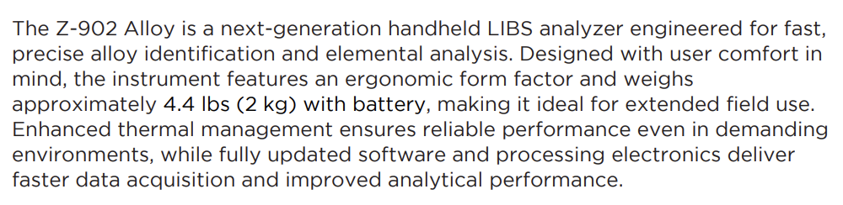 | The Z-902 Alloy is a next-generation handheld LIBS analyzer engineered for fast, precise alloy identification and elemental analysis. Designed with user comfort in mind, the instrument features an ergonomic form factor and weighs approximately 4.4 lbs (2 kg) with battery, making it ideal for extended field use. Enhanced thermal management ensures reliable performance even in demanding environments, while fully updated software and processing electronics deliver faster data acquisition and improved analytical performance.
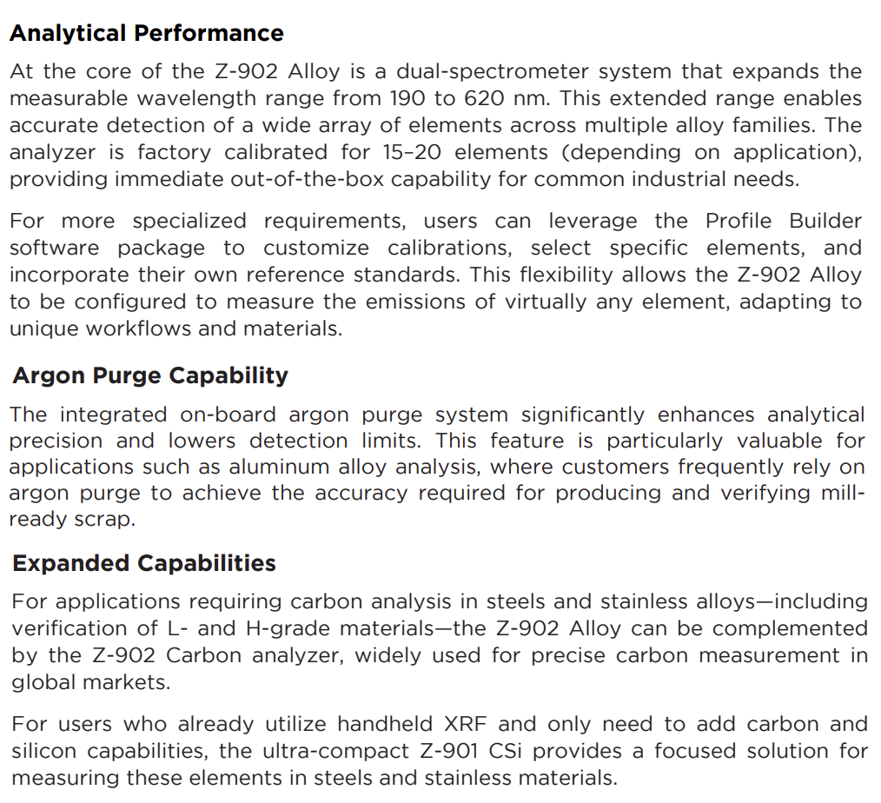 | Analytical Performance
 | At the core of the Z-902 Alloy is a dual-spectrometer system that expands the measurable wavelength range from 190 to 620 nm. This extended range enables accurate detection of a wide array of elements across multiple alloy families. The analyzer is factory calibrated for 15–20 elements (depending on application), providing immediate out-of-the-box capability for common industrial needs.
 | For more specialized requirements, users can leverage the Profile Builder software package to customize calibrations, select specific elements, and incorporate their own reference standards. This flexibility allows the Z-902 Alloy to be configured to measure the emissions of virtually any element, adapting to unique workflows and materials.
 | Argon Purge Capability
 | The integrated on-board argon purge system significantly enhances analytical precision and lowers detection limits. This feature is particularly valuable for applications such as aluminum alloy analysis, where customers frequently rely on argon purge to achieve the accuracy required for producing and verifying mill-ready scrap.
 | Expanded Capabilities
 | For applications requiring carbon analysis in steels and stainless alloys—including verification of L- and H-grade materials—the Z-902 Alloy can be complemented by the Z-902 Carbon analyzer, widely used for precise carbon measurement in global markets.
 | For users who already utilize handheld XRF and only need to add carbon and silicon capabilities, the ultra-compact Z-901 CSi provides a focused solution for measuring these elements in steels and stainless materials.
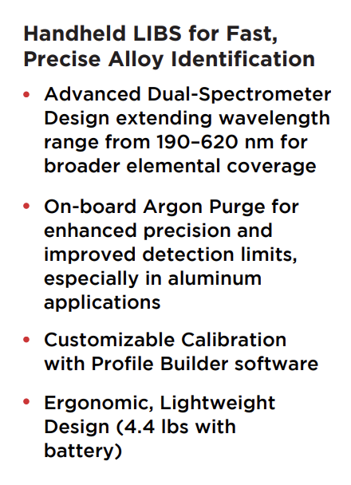 | Handheld LIBS for Fast, Precise Alloy Identification
 | Advanced Dual-Spectrometer Design extending wavelength range from 190–620 nm for broader elemental coverage
 | On-board Argon Purge for enhanced precision and improved detection limits, especially in aluminum applications
 | Customizable Calibration with Profile Builder software
 | Ergonomic, Lightweight Design (4.4 lbs with battery)
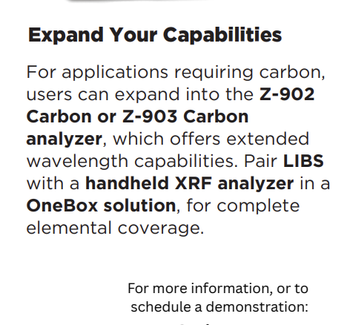 | Expand Your Capabilities
 | For applications requiring carbon, users can expand into the Z-902 Carbon or Z-903 Carbon analyzer, which offers extended wavelength capabilities. Pair LIBS with a handheld XRF analyzer in a OneBox solution, for complete elemental coverage.
 | For more information, or to schedule a demonstration:
(BACK)
 | SciAps Z-902 Alloy
 | Specifications
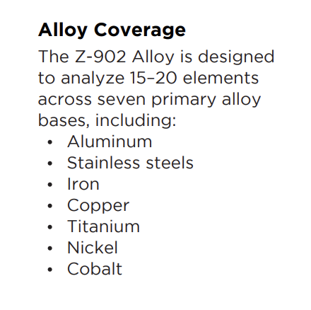 | Alloy Coverage
 | The Z-902 Alloy is designed to analyze 15–20 elements across seven primary alloy bases, including:
 | Aluminum
 | Stainless steels
 | Iron
 | Copper
 | Titanium
 | Nickel
 | Cobalt
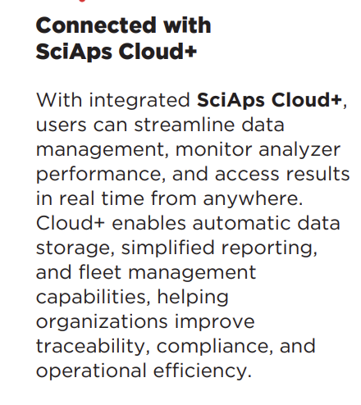 | Connected with SciAps Cloud+
 | With integrated SciAps Cloud+, users can streamline data management, monitor analyzer performance, and access results in real time from anywhere. Cloud+ enables automatic data storage, simplified reporting, and fleet management capabilities, helping organizations improve traceability, compliance, and operational efficiency.
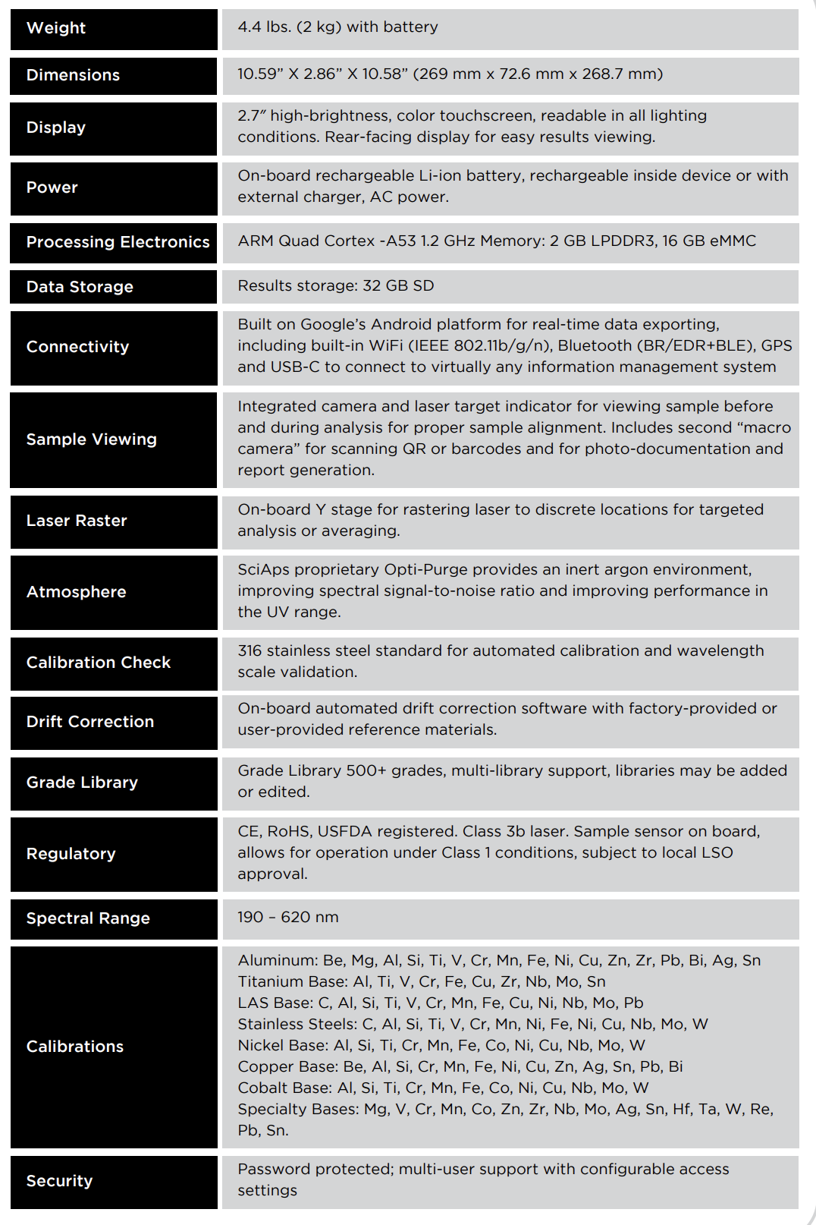 | Weight
 | 4.4 lbs. (2 kg) with battery
 | Dimensions
 | 10.59” X 2.86” X 10.58” (269 mm x 72.6 mm x 268.7 mm)
 | Display
 | 2.7″ high-brightness, color touchscreen, readable in all lighting conditions. Rear-facing display for easy results viewing.
 | Power
 | On-board rechargeable Li-ion battery, rechargeable inside device or with external charger, AC power.
 | Processing Electronics
 | ARM Quad Cortex -A53 1.2 GHz Memory: 2 GB LPDDR3, 16 GB eMMC
 | Data Storage
 | Results storage: 32 GB SD
 | Connectivity
 | Built on Google’s Android platform for real-time data exporting, including built-in WiFi (IEEE 802.11b/g/n), Bluetooth (BR/EDR+BLE), GPS and USB-C to connect to virtually any information management system
 | Sample Viewing
 | Integrated camera and laser target indicator for viewing sample before and during analysis for proper sample alignment. Includes second “macro camera” for scanning QR or barcodes and for photo-documentation and report generation.
 | Laser Raster
 | On-board Y stage for rastering laser to discrete locations for targeted analysis or averaging.
 | Atmosphere
 | SciAps proprietary Opti-Purge provides an inert argon environment, improving spectral signal-to-noise ratio and improving performance in the UV range.
 | Calibration Check
 | 316 stainless steel standard for automated calibration and wavelength scale validation.
 | Drift Correction
 | On-board automated drift correction software with factory-provided or user-provided reference materials.
 | Grade Library
 | Grade Library 500+ grades, multi-library support, libraries may be added or edited.
 | Regulatory
 | CE, RoHS, USFDA registered. Class 3b laser. Sample sensor on board, allows for operation under Class 1 conditions, subject to local LSO approval.
 | Spectral Range
 | 190 – 620 nm
 | Calibrations
 | Aluminum: Be, Mg, Al, Si, Ti, V, Cr, Mn, Fe, Ni, Cu, Zn, Zr, Pb, Bi, Ag, Sn Titanium Base: Al, Ti, V, Cr, Fe, Cu, Zr, Nb, Mo, Sn LAS Base: C, Al, Si, Ti, V, Cr, Mn, Fe, Cu, Ni, Nb, Mo, Pb Stainless Steels: C, Al, Si, Ti, V, Cr, Mn, Ni, Fe, Ni, Cu, Nb, Mo, W Nickel Base: Al, Si, Ti, Cr, Mn, Fe, Co, Ni, Cu, Nb, Mo, W Copper Base: Be, Al, Si, Cr, Mn, Fe, Ni, Cu, Zn, Ag, Sn, Pb, Bi Cobalt Base: Al, Si, Ti, Cr, Mn, Fe, Co, Ni, Cu, Nb, Mo, W Specialty Bases: Mg, V, Cr, Mn, Co, Zn, Zr, Nb, Mo, Ag, Sn, Hf, Ta, W, Re, Pb, Sn.
 | Security
 | Password protected; multi-user support with configurable access settings

