Document Title: SciAps Z-903 Carbon Specifications
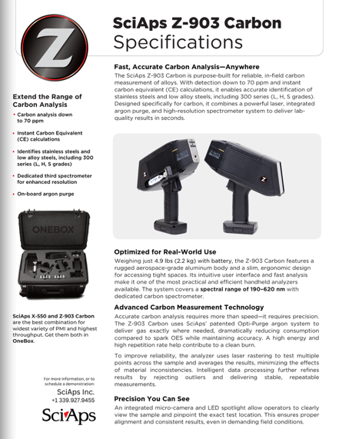
Rev Date: May 2026

Layout Preview | English Text | Translated Text
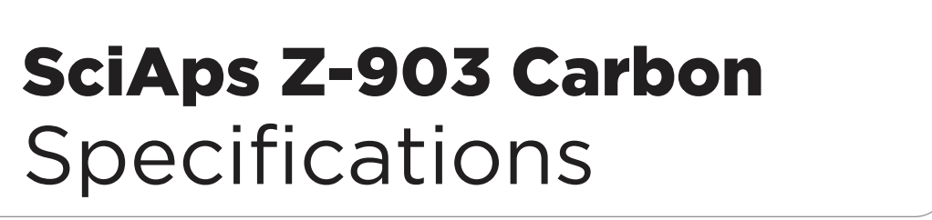 | SciAps Z-903 Carbon
 | Specifications
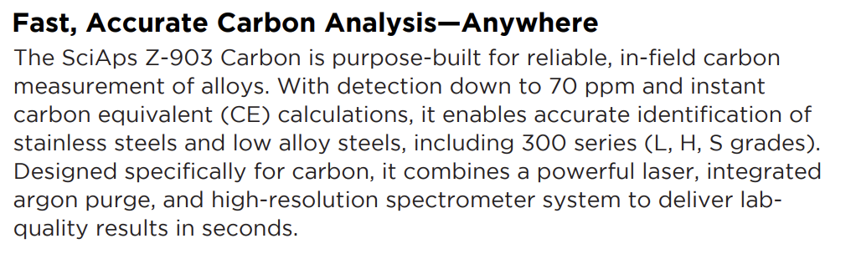 | Fast, Accurate Carbon Analysis—Anywhere
 | The SciAps Z-903 Carbon is purpose-built for reliable, in-field carbon measurement of alloys. With detection down to 70 ppm and instant carbon equivalent (CE) calculations, it enables accurate identification of stainless steels and low alloy steels, including 300 series (L, H, S grades). Designed specifically for carbon, it combines a powerful laser, integrated argon purge, and high-resolution spectrometer system to deliver labquality results in seconds.
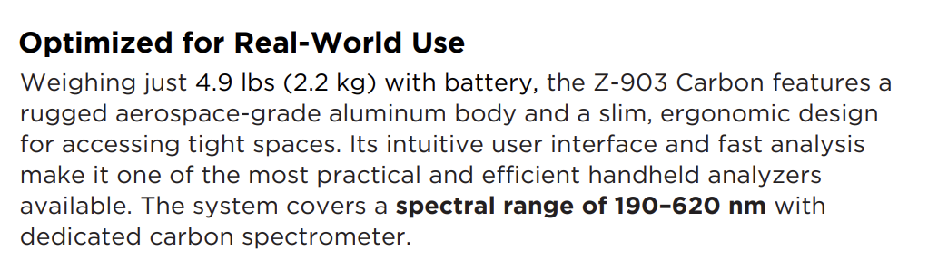 | Optimized for Real-World Use
 | Weighing just 4.9 lbs (2.2 kg) with battery, the Z-903 Carbon features a rugged aerospace-grade aluminum body and a slim, ergonomic design for accessing tight spaces. Its intuitive user interface and fast analysis make it one of the most practical and efficient handheld analyzers available. The system covers a spectral range of 190–620 nm with dedicated carbon spectrometer.
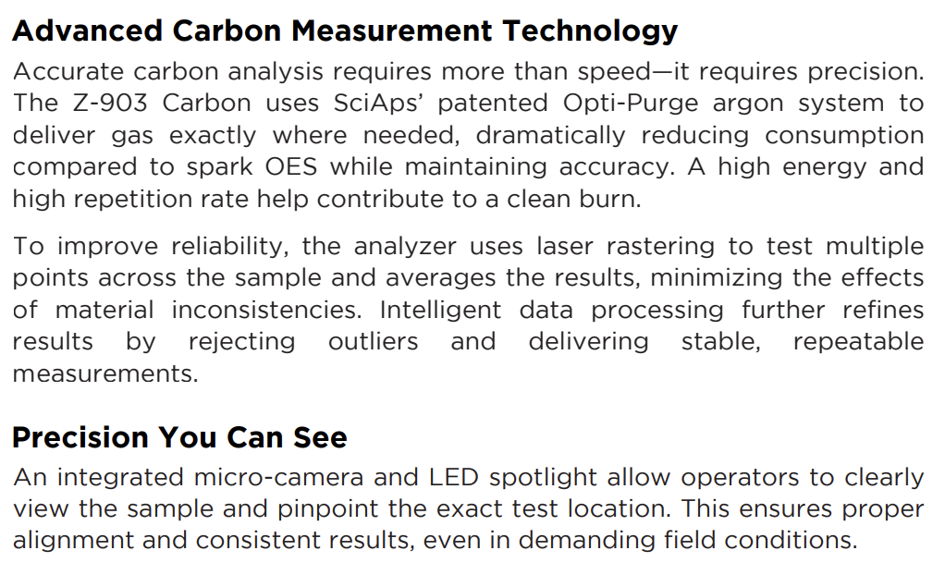 | Advanced Carbon Measurement Technology
 | Accurate carbon analysis requires more than speed—it requires precision. The Z-903 Carbon uses SciAps’ patented Opti-Purge argon system to deliver gas exactly where needed, dramatically reducing consumption compared to spark OES while maintaining accuracy. A high energy and high repetition rate help contribute to a clean burn.
 | To improve reliability, the analyzer uses laser rastering to test multiple points across the sample and averages the results, minimizing the effects of material inconsistencies. Intelligent data processing further refines results by rejecting outliers and delivering stable, repeatable measurements.
 | Precision You Can See
 | An integrated micro-camera and LED spotlight allow operators to clearly view the sample and pinpoint the exact test location. This ensures proper alignment and consistent results, even in demanding field conditions.
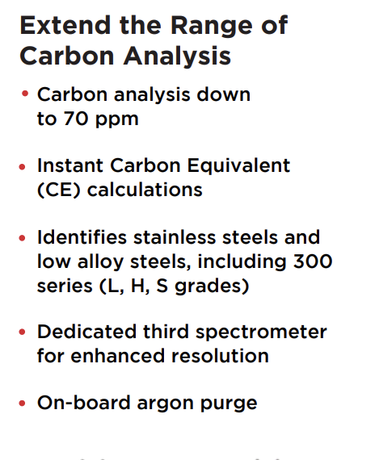 | Extend the Range of Carbon Analysis
 | Carbon analysis down to 70 ppm
 | Instant Carbon Equivalent (CE) calculations
 | Identifies stainless steels and low alloy steels, including 300 series (L, H, S grades)
 | Dedicated third spectrometer for enhanced resolution
 | On-board argon purge
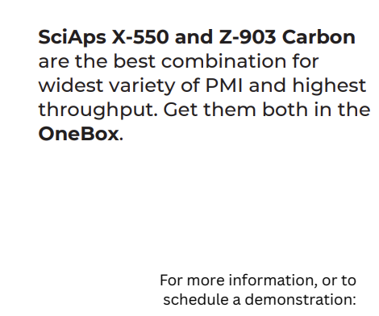 | SciAps X-550 and Z-903 Carbon are the best combination for widest variety of PMI and highest throughput. Get them both in the OneBox.
 | For more information, or to schedule a demonstration:
(BACK)
 | SciAps Z-903 Carbon
 | Specifications
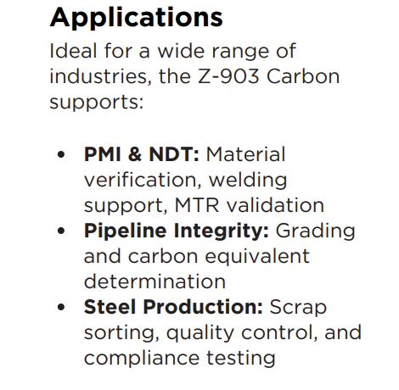 | Applications
 | Ideal for a wide range of industries, the Z-903 Carbon supports:
 | PMI & NDT: Material verification, welding support, MTR validation
 | Pipeline Integrity: Grading and carbon equivalent determination
 | Steel Production: Scrap sorting, quality control, and compliance testing
 | Connected with SciAps Cloud+
 | With integrated SciAps Cloud+, users can streamline data management, monitor analyzer performance, and access results in real time from anywhere. Cloud+ enables automatic data storage, simplified reporting, and fleet management capabilities, helping organizations improve traceability, compliance, and operational efficiency.
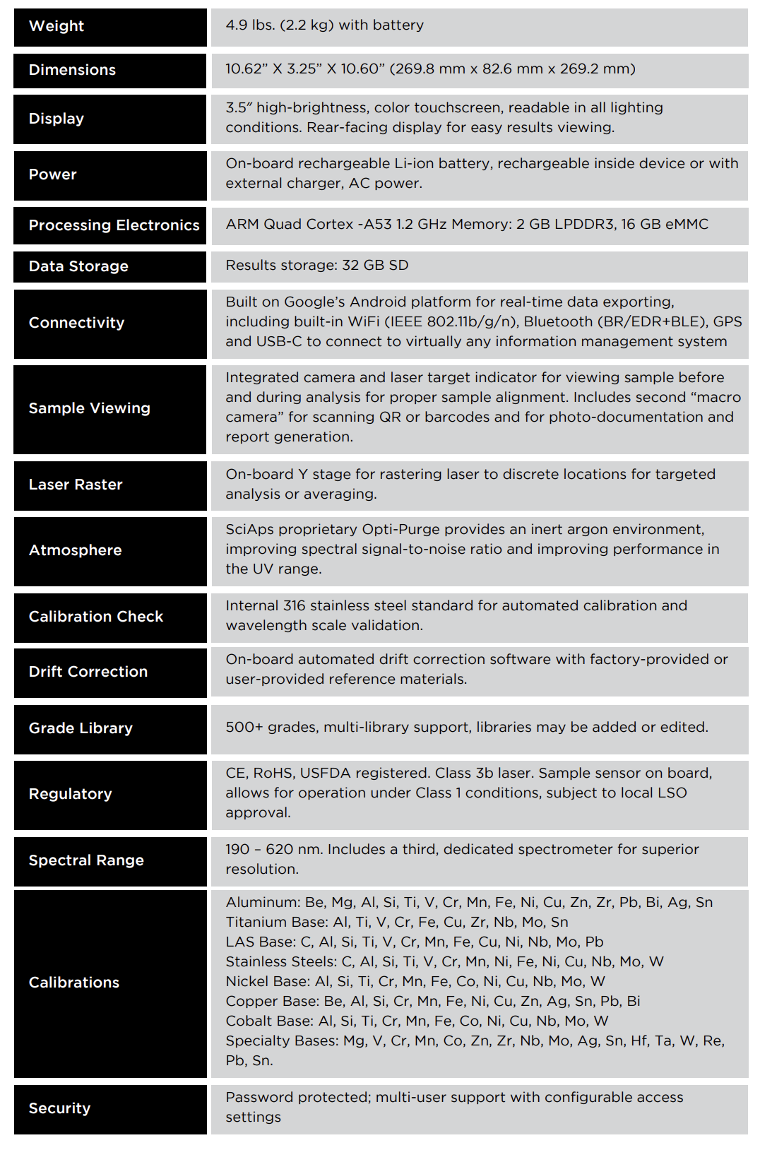 | Weight
 | 4.9 lbs. (2.2 kg) with battery
 | Dimensions
 | 10.62” X 3.25” X 10.60” (269.8 mm x 82.6 mm x 269.2 mm)
 | Display
 | 3.5″ high-brightness, color touchscreen, readable in all lighting conditions. Rear-facing display for easy results viewing.
 | Power
 | On-board rechargeable Li-ion battery, rechargeable inside device or with external charger, AC power.
 | Processing Electronics
 | ARM Quad Cortex -A53 1.2 GHz Memory: 2 GB LPDDR3, 16 GB eMMC
 | Data Storage
 | Results storage: 32 GB SD
 | Connectivity
 | Built on Google’s Android platform for real-time data exporting, including built-in WiFi (IEEE 802.11b/g/n), Bluetooth (BR/EDR+BLE), GPS and USB-C to connect to virtually any information management system
 | Sample Viewing
 | Integrated camera and laser target indicator for viewing sample before and during analysis for proper sample alignment. Includes second “macro camera” for scanning QR or barcodes and for photo-documentation and report generation.
 | Laser Raster
 | On-board Y stage for rastering laser to discrete locations for targeted analysis or averaging.
 | Atmosphere
 | SciAps proprietary Opti-Purge provides an inert argon environment, improving spectral signal-to-noise ratio and improving performance in the UV range.
 | Calibration Check
 | Internal 316 stainless steel standard for automated calibration and wavelength scale validation.
 | Drift Correction
 | On-board automated drift correction software with factory-provided or user-provided reference materials.
 | Grade Library
 | 500+ grades, multi-library support, libraries may be added or edited.
 | Regulatory
 | CE, RoHS, USFDA registered. Class 3b laser. Sample sensor on board, allows for operation under Class 1 conditions, subject to local LSO approval.
 | Spectral Range
 | 190 – 620 nm. Includes a third, dedicated spectrometer for superior resolution.
 | Calibrations
Aluminum: Be, Mg, Al, Si, Ti, V, Cr, Mn, Fe, Ni, Cu, Zn, Zr, Pb, Bi, Ag, Sn
Titanium Base: Al, Ti, V, Cr, Fe, Cu, Zr, Nb, Mo, Sn
LAS Base: C, Al, Si, Ti, V, Cr, Mn, Fe, Cu, Ni, Nb, Mo, Pb
Stainless Steels: C, Al, Si, Ti, V, Cr, Mn, Ni, Fe, Ni, Cu, Nb, Mo, W
Nickel Base: Al, Si, Ti, Cr, Mn, Fe, Co, Ni, Cu, Nb, Mo, W
Copper Base: Be, Al, Si, Cr, Mn, Fe, Ni, Cu, Zn, Ag, Sn, Pb, Bi
Cobalt Base: Al, Si, Ti, Cr, Mn, Fe, Co, Ni, Cu, Nb, Mo, W
Specialty Bases: Mg, V, Cr, Mn, Co, Zn, Zr, Nb, Mo, Ag, Sn, Hf, Ta, W, Re, Pb, Sn.
 | Security
 | Password protected; multi-user support with configurable access settings

