Document Title: ApNote Sample Preparation for Carbon Analysis
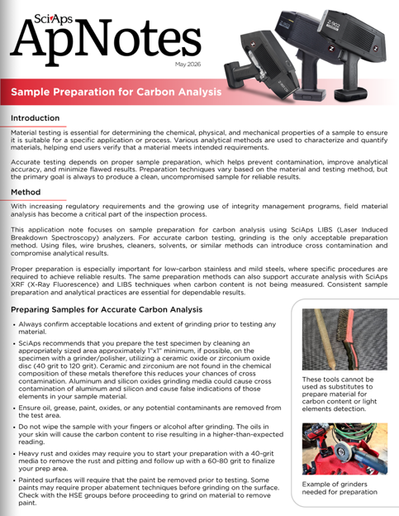
Rev Date: May 2026

Layout Preview | English Text | Translated Text
 | May 2026
 | Sample Preparation for Carbon Analysis
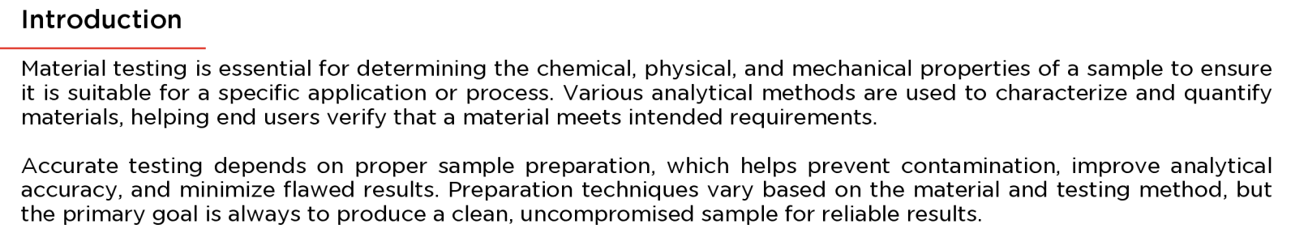 | Introduction
 | Material testing is essential for determining the chemical, physical, and mechanical properties of a sample to ensure it is suitable for a specific application or process. Various analytical methods are used to characterize and quantify materials, helping end users verify that a material meets intended requirements.
 | Accurate testing depends on proper sample preparation, which helps prevent contamination, improve analytical accuracy, and minimize flawed results. Preparation techniques vary based on the material and testing method, but the primary goal is always to produce a clean, uncompromised sample for reliable results.
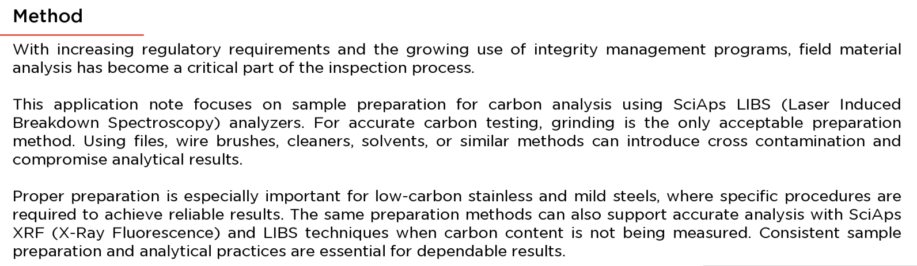 | Method
 | With increasing regulatory requirements and the growing use of integrity management programs, field material analysis has become a critical part of the inspection process.
 | This application note focuses on sample preparation for carbon analysis using SciAps LIBS (Laser Induced Breakdown Spectroscopy) analyzers. For accurate carbon testing, grinding is the only acceptable preparation method. Using files, wire brushes, cleaners, solvents, or similar methods can introduce cross contamination and compromise analytical results.
 | Proper preparation is especially important for low-carbon stainless and mild steels, where specific procedures are required to achieve reliable results. The same preparation methods can also support accurate analysis with SciAps XRF (X-Ray Fluorescence) and LIBS techniques when carbon content is not being measured. Consistent sample preparation and analytical practices are essential for dependable results.
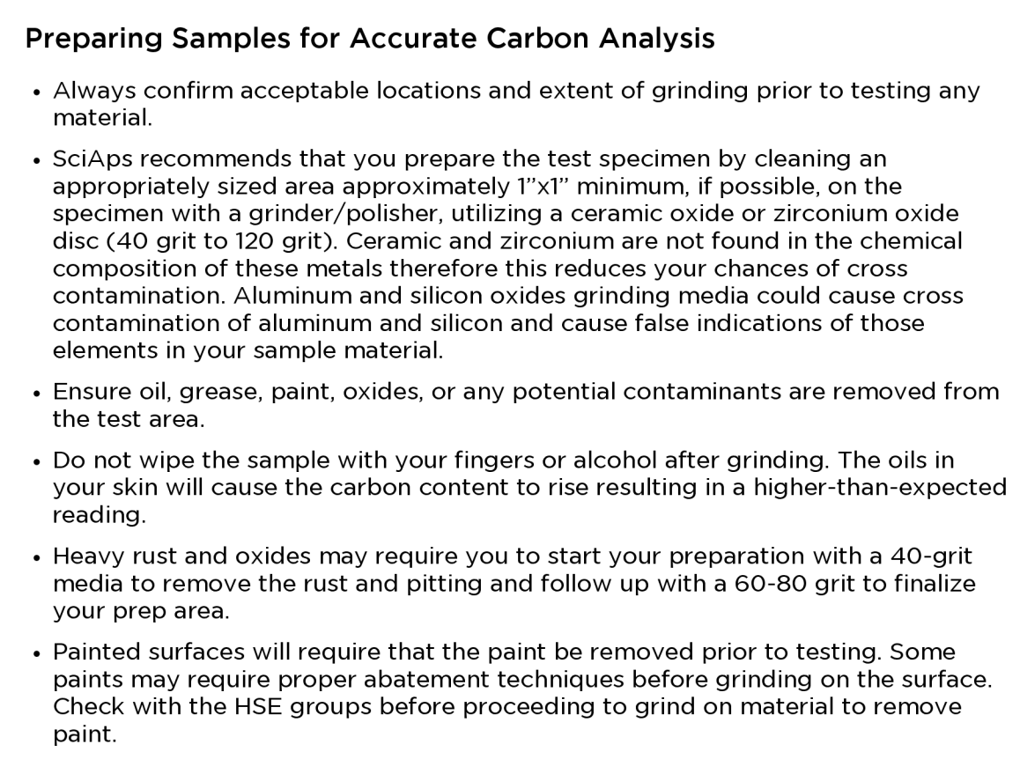 | Preparing Samples for Accurate Carbon Analysis
 | Always confirm acceptable locations and extent of grinding prior to testing any material.
 | SciAps recommends that you prepare the test specimen by cleaning an appropriately sized area approximately 1"x1" minimum, if possible, on the specimen with a grinder/polisher, utilizing a ceramic oxide or zirconium oxide disc (40 grit to 120 grit). Ceramic and zirconium are not found in the chemical composition of these metals therefore this reduces your chances of cross contamination. Aluminum and silicon oxides grinding media could cause cross contamination of aluminum and silicon and cause false indications of those elements in your sample material.
 | Ensure oil, grease, paint, oxides, or any potential contaminants are removed from the test area.
 | Do not wipe the sample with your fingers or alcohol after grinding. The oils in your skin will cause the carbon content to rise resulting in a higher-than-expected reading.
 | Heavy rust and oxides may require you to start your preparation with a 40-grit media to remove the rust and pitting and follow up with a 60-80 grit to finalize your prep area.
 | Painted surfaces will require that the paint be removed prior to testing. Some paints may require proper abatement techniques before grinding on the surface. Check with the HSE groups before proceeding to grind on material to remove paint.
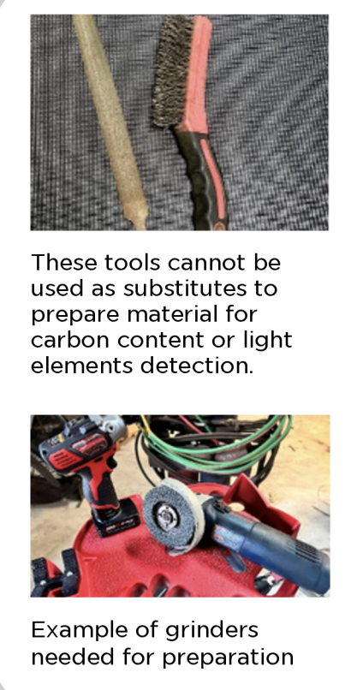 | These tools cannot be used as substitutes to prepare material for carbon content or light elements detection.
 | Example of grinders needed for preparation
(BACK)
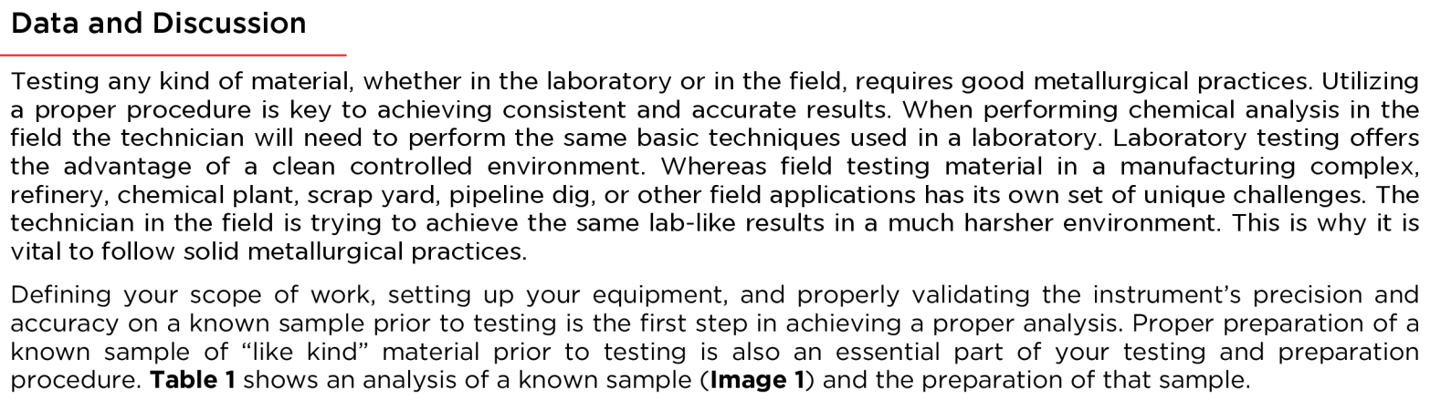 | Data and Discussion
 | Testing any kind of material, whether in the laboratory or in the field, requires good metallurgical practices. Utilizing a proper procedure is key to achieving consistent and accurate results. When performing chemical analysis in the field the technician will need to perform the same basic techniques used in a laboratory. Laboratory testing offers the advantage of a clean controlled environment. Whereas field testing material in a manufacturing complex, refinery, chemical plant, scrap yard, pipeline dig, or other field applications has its own set of unique challenges. The technician in the field is trying to achieve the same lab-like results in a much harsher environment. This is why it is vital to follow solid metallurgical practices.
 | Defining your scope of work, setting up your equipment, and properly validating the instrument's precision and accuracy on a known sample prior to testing is the first step in achieving a proper analysis. Proper preparation of a known sample of "like kind" material prior to testing is also an essential part of your testing and preparation procedure. Table 1 shows an analysis of a known sample (Image 1) and the preparation of that sample.
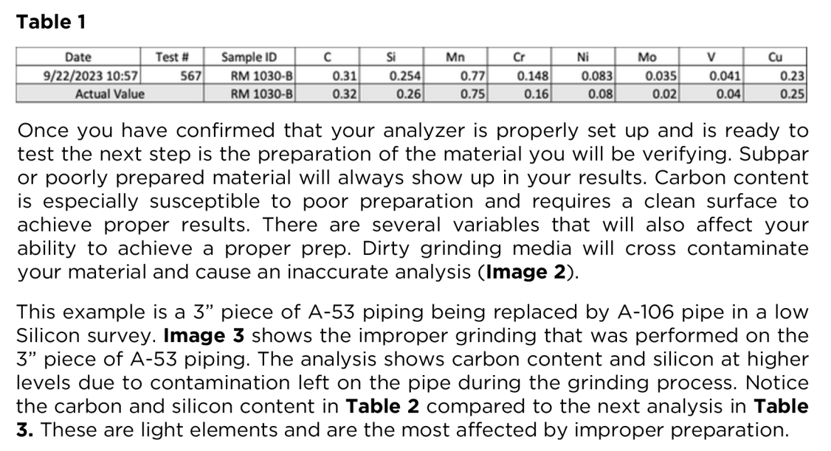 | Table 1
 | Date
 | Test #
 | Sample ID
 | Actual Value
 | Once you have confirmed that your analyzer is properly set up and is ready to test the next step is the preparation of the material you will be verifying. Subpar or poorly prepared material will always show up in your results. Carbon content is especially susceptible to poor preparation and requires a clean surface to achieve proper results. There are several variables that will also affect your ability to achieve a proper prep. Dirty grinding media will cross contaminate your material and cause an inaccurate analysis (Image 2).
 | This example is a 3" piece of A-53 piping being replaced by A-106 pipe in a low Silicon survey. Image 3 shows the improper grinding that was performed on the 3" piece of A-53 piping. The analysis shows carbon content and silicon at higher levels due to contamination left on the pipe during the grinding process. Notice the carbon and silicon content in Table 2 compared to the next analysis in Table 3. These are light elements and are the most affected by improper preparation.
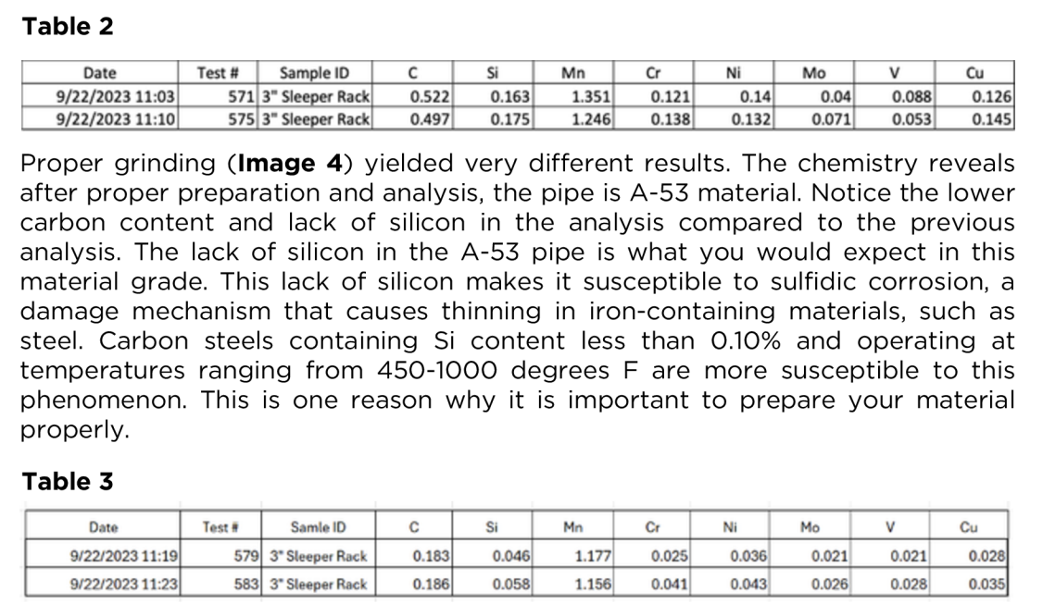 | Table 2
 | Date
 | Test #
 | Sample ID
 | Sleeper Rack
 | Proper grinding (Image 4) yielded very different results. The chemistry reveals after proper preparation and analysis, the pipe is A-53 material. Notice the lower carbon content and lack of silicon in the analysis compared to the previous analysis. The lack of silicon in the A-53 pipe is what you would expect in this material grade. This lack of silicon makes it susceptible to sulfidic corrosion, a damage mechanism that causes thinning in iron-containing materials, such as steel. Carbon steels containing Si content less than 0.10% and operating at temperatures ranging from 450-1000 degrees F are more susceptible to this phenomenon. This is one reason why it is important to prepare your material properly.
 | Table 3
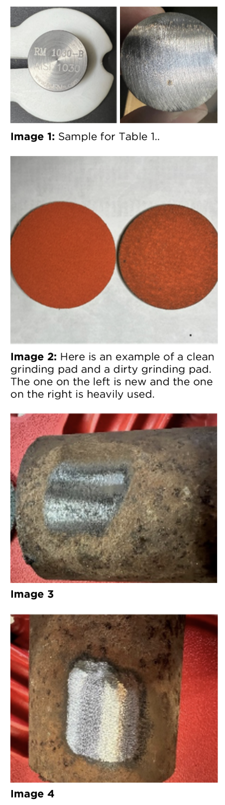 | Image 1: Sample for Table 1.
 | Image 2: Here is an example of a clean grinding pad and a dirty grinding pad. The one on the left is new and the one on the right is heavily used.
 | Image 3
 | Image 4

