Document Title: ApNote Cloud+ for Agriculture
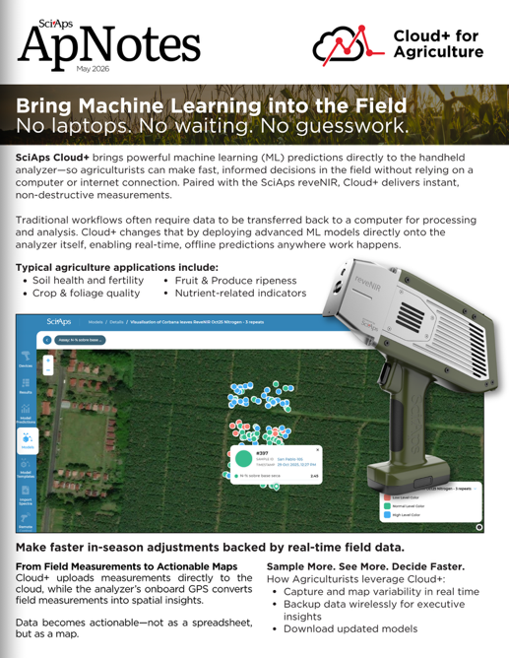
Rev Date: June 2026

Layout Preview | English Text | Translated Text
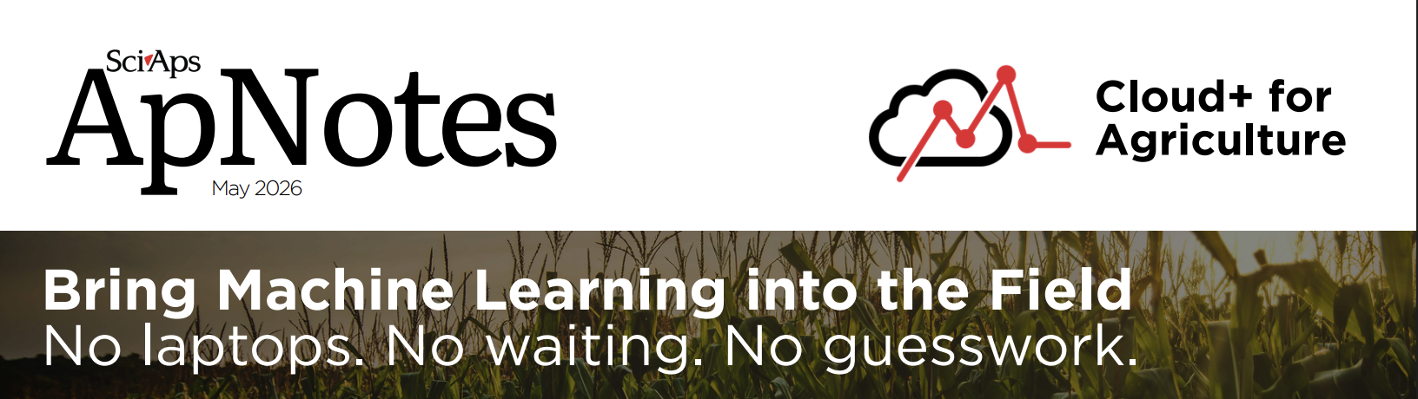 | May 2026
 | Cloud+ for Agriculture
 | Bring Machine Learning into the Field
 | No laptops. No waiting. No guesswork.
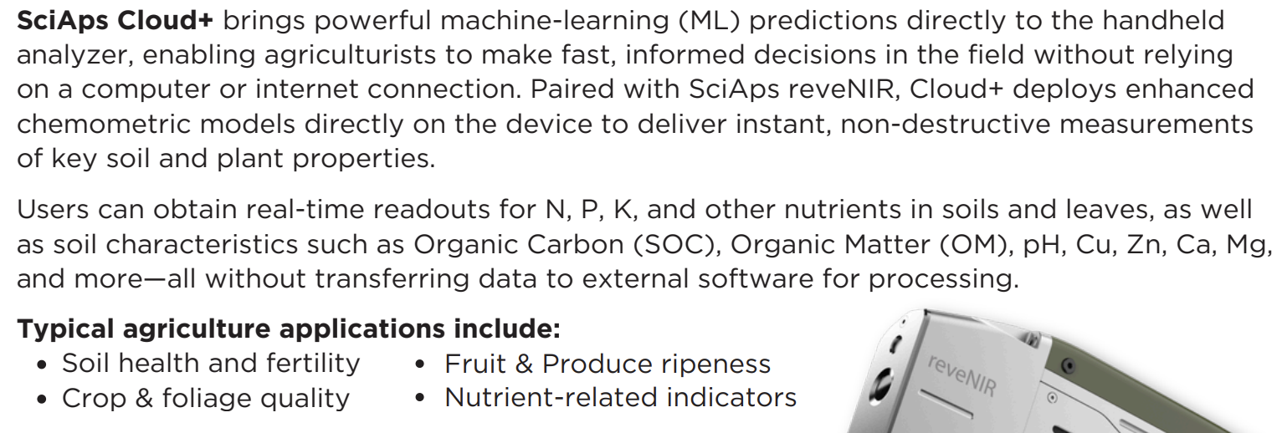 | SciAps Cloud+ brings powerful machine-learning (ML) predictions directly to the handheld analyzer, enabling agriculturists to make fast, informed decisions in the field without relying on a computer or internet connection. Paired with SciAps reveNIR, Cloud+ deploys enhanced chemometric models directly on the device to deliver instant, non-destructive measurements of key soil and plant properties.
 | Users can obtain real-time readouts for N, P, K, and other nutrients in soils and leaves, as well as soil characteristics such as Organic Carbon (SOC), Organic Matter (OM), pH, Cu, Zn, Ca, Mg, and more—all without transferring data to external software for processing.
 | Typical agriculture applications include:
 | Soil health and fertility
 | Crop & foliage quality
 | Fruit & Produce ripeness
 | Nutrient-related indicators
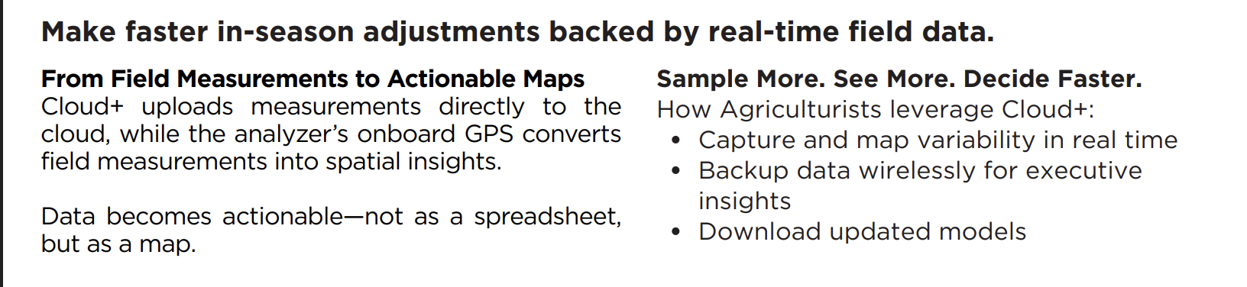 | Make faster in-season adjustments backed by real-time field data.
 | From Field Measurements to Actionable Maps
 | Cloud+ uploads measurements directly to the cloud, while the analyzer’s onboard GPS converts field measurements into spatial insights.
 | Data becomes actionable—not as a spreadsheet, but as a map.
 | Sample More. See More. Decide Faster.
 | How Agriculturists leverage Cloud+:
 | Capture and map variability in real time
 | Backup data wirelessly for executive insights
 | Download updated models
[page 2]
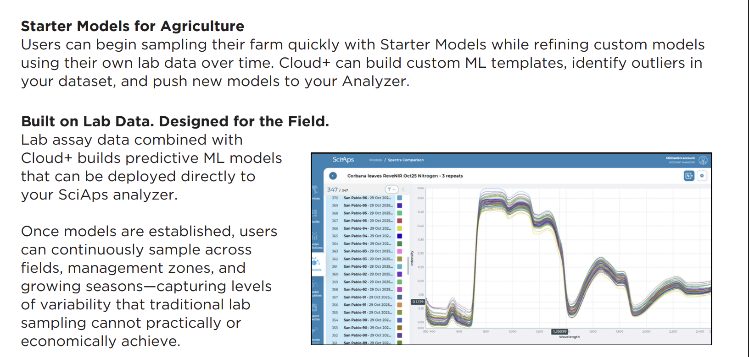 | Starter Models for Agriculture
 | Users can begin sampling their farm quickly with Starter Models while refining custom models using their own lab data over time. Cloud+ can build custom ML templates, identify outliers in your dataset, and push new models to your Analyzer.
 | Built on Lab Data. Designed for the Field.
 | Lab assay data combined with Cloud+ builds predictive ML models that can be deployed directly to your SciAps analyzer.
 | Once models are established, users can continuously sample across fields, management zones, and growing seasons—capturing levels of variability that traditional lab sampling cannot practically or economically achieve.
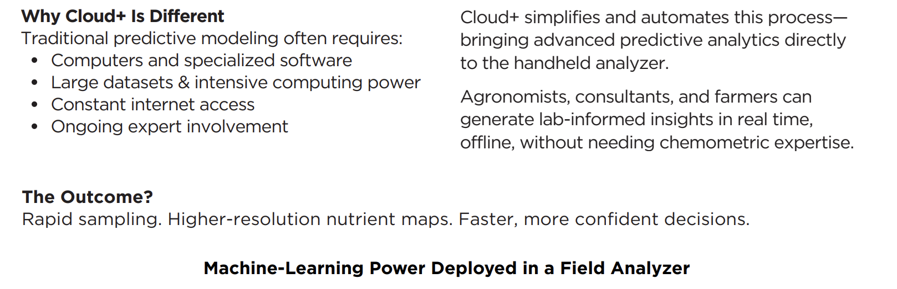 | Why Cloud+ Is Different
 | Traditional predictive modeling often requires:
 | Computers and specialized software
 | Large datasets & intensive computing power
 | Constant internet access
 | Ongoing expert involvement
 | Cloud+ simplifies and automates this process— bringing advanced predictive analytics directly to the handheld analyzer.
 | Agronomists, consultants, and farmers can generate lab-informed insights in real time, offline, without needing chemometric expertise.
 | The Outcome?
 | Rapid sampling. Higher-resolution nutrient maps. Faster, more confident decisions.
 | Machine-Learning Power Deployed in a Field Analyzer
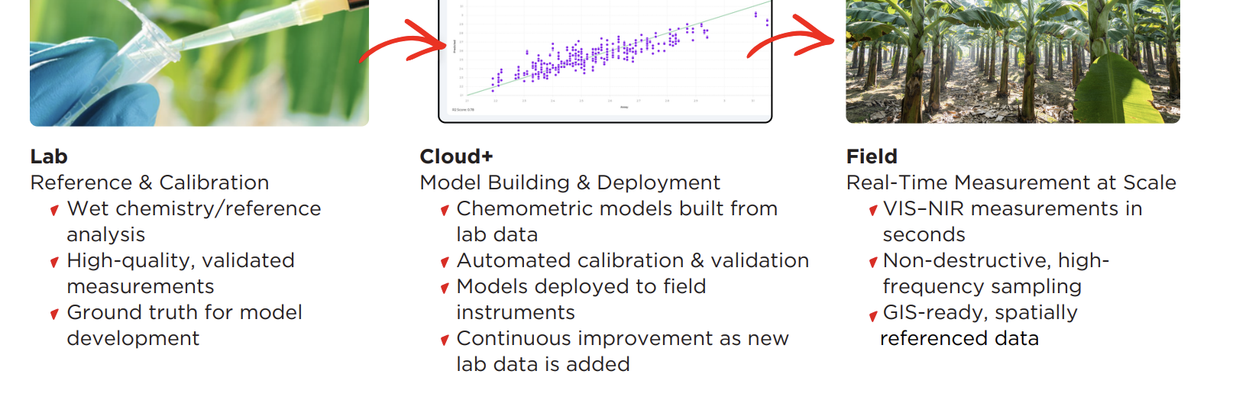 | Lab
 | Reference & Calibration
 | Wet chemistry/reference analysis
 | High-quality, validated measurements
 | High-quality, validated measurements
 | Cloud+
 | Model Building & Deployment
 | Chemometric models built from lab data
 | Automated calibration & validation
 | Models deployed to field instruments
 | Continuous improvement as new lab data is added
 | Field
 | Real-Time Measurement at Scale
 | VIS–NIR measurements in seconds
 | Non-destructive, high-frequency sampling
 | GIS-ready, spatially referenced data

