Document Title: ApNote Modern Core Logging
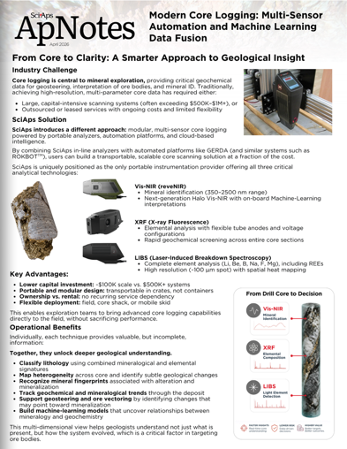
Rev Date: Sept 2026

Layout Preview | English Text | Translated Text
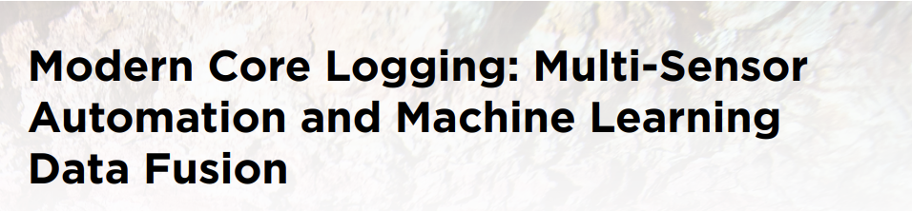 | Modern Core Logging: Multi-Sensor Automation and Machine Learning Data Fusion
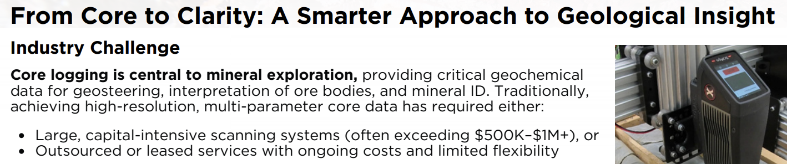 | From Core to Clarity: A Smarter Approach to Geological Insight
 | Industry Challenge
 | Core logging is central to mineral exploration, providing critical geochemical data for geosteering, interpretation of ore bodies, and mineral ID. Traditionally, achieving high-resolution, multi-parameter core data has required either:
 | Large, capital-intensive scanning systems (often exceeding $500K–$1M+), or
 | Outsourced or leased services with ongoing costs and limited flexibility
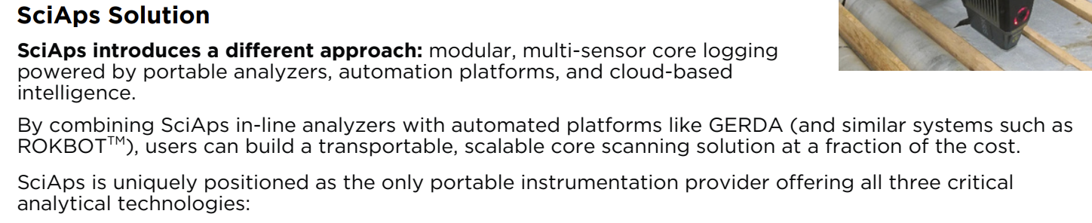 | SciAps Solution
 | SciAps introduces a different approach: modular, multi-sensor core logging powered by portable analyzers, automation platforms, and cloud-based intelligence.
 | By combining SciAps in-line analyzers with automated platforms like GERDA (and similar systems such as ROKBOTTM), users can build a transportable, scalable core scanning solution at a fraction of the cost.
 | SciAps is uniquely positioned as the only portable instrumentation provider offering all three critical analytical technologies:
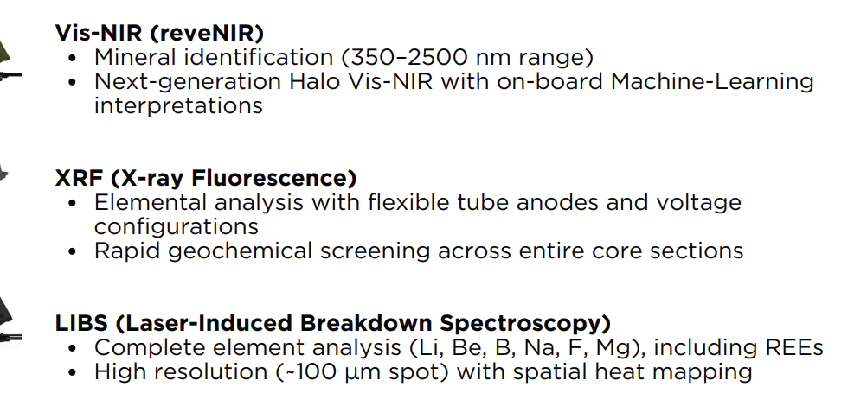 | Vis-NIR (reveNIR)
 | Mineral identification (350–2500 nm range)
 | Next-generation Halo Vis-NIR with on-board Machine-Learning interpretations
 | XRF (X-ray Fluorescence)
 | Elemental analysis with flexible tube anodes and voltage configurations
 | Rapid geochemical screening across entire core sections
 | LIBS (Laser-Induced Breakdown Spectroscopy)
 | Complete element analysis (Li, Be, B, Na, F, Mg), including REEs
 | High resolution (~100 µm spot) with spatial heat mapping
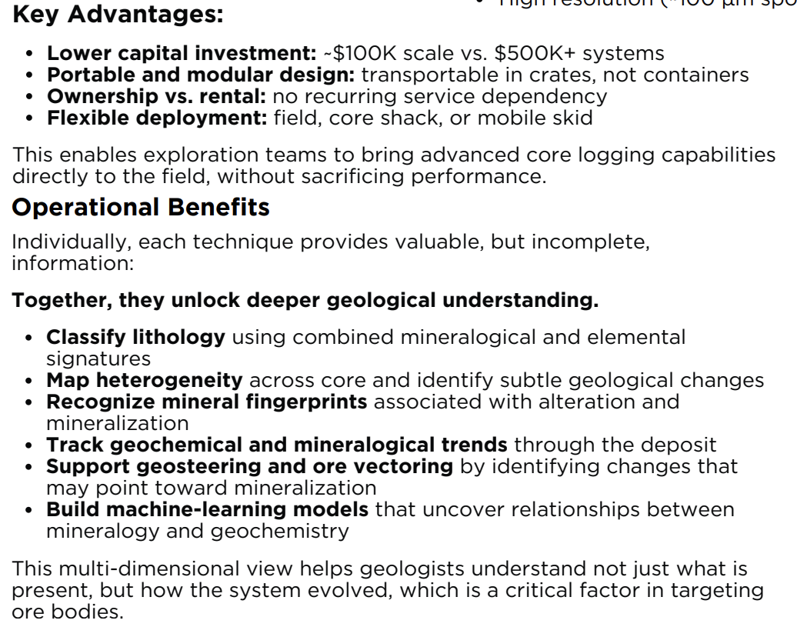 | Key Advantages:
 | Lower capital investment: ~$100K scale vs. $500K+ systems
 | Portable and modular design: transportable in crates, not containers
 | Ownership vs. rental: no recurring service dependency
 | Flexible deployment: field, core shack, or mobile skid
 | This enables exploration teams to bring advanced core logging capabilities directly to the field, without sacrificing performance.
 | Operational Benefits
 | Individually, each technique provides valuable, but incomplete, information:
 | Together, they unlock deeper geological understanding.
 | Classify lithology using combined mineralogical and elemental signatures
 | Map heterogeneity across core and identify subtle geological changes
 | Recognize mineral fingerprints associated with alteration and mineralization
 | Track geochemical and mineralogical trends through the deposit
 | Support geosteering and ore vectoring by identifying changes that may point toward mineralization
 | Build machine-learning models that uncover relationships between mineralogy and geochemistry
 | This multi-dimensional view helps geologists understand not just what is present, but how the system evolved, which is a critical factor in targeting ore bodies.
(BACK)
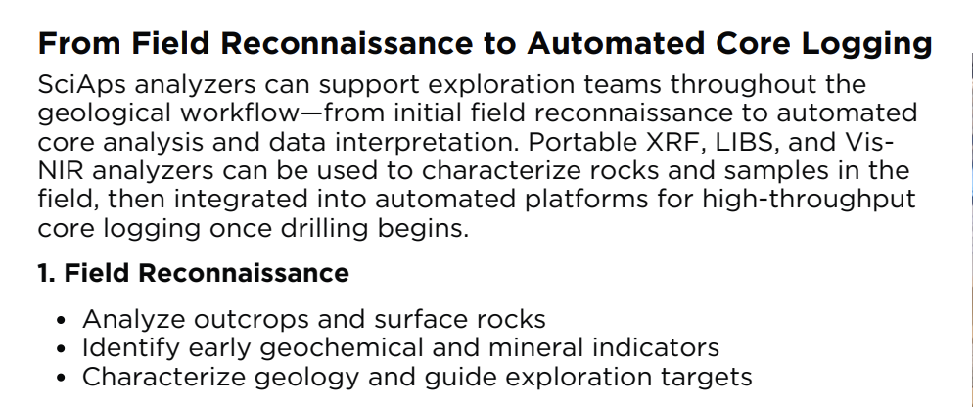 | From Field Reconnaissance to Automated Core Logging
 | SciAps analyzers can support exploration teams throughout the geological workflow—from initial field reconnaissance to automated core analysis and data interpretation. Portable XRF, LIBS, and Vis- NIR analyzers can be used to characterize rocks and samples in the field, then integrated into automated platforms for high-throughput core logging once drilling begins.
 | Field Reconnaissance
 | Analyze outcrops and surface rocks
 | Identify early geochemical and mineral indicators
 | Characterize geology and guide exploration targets
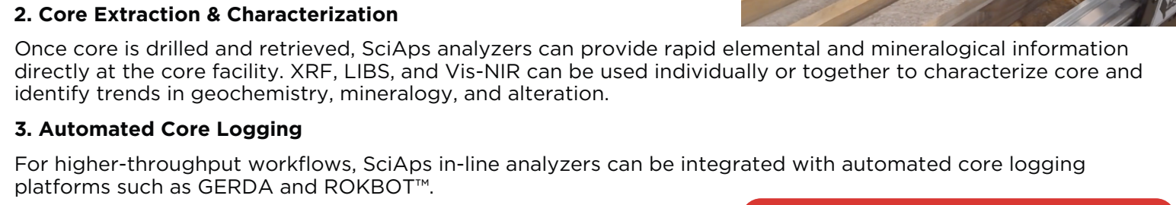 | Core Extraction & Characterization
 | Once core is drilled and retrieved, SciAps analyzers can provide rapid elemental and mineralogical information directly at the core facility. XRF, LIBS, and Vis-NIR can be used individually or together to characterize core and identify trends in geochemistry, mineralogy, and alteration.
 | Automated Core Logging
 | For higher-throughput workflows, SciAps in-line analyzers can be integrated with automated core logging platforms such as GERDA and ROKBOT™.
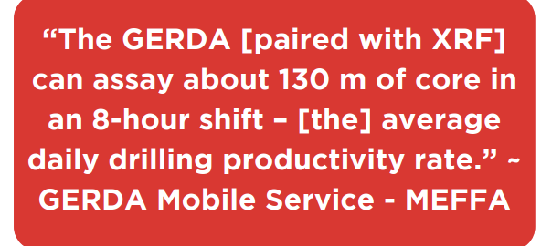 | “The GERDA [paired with XRF] can assay about 130 m of core in an 8-hour shift – [the] average daily drilling productivity rate.” ~ GERDA Mobile Service - MEFFA
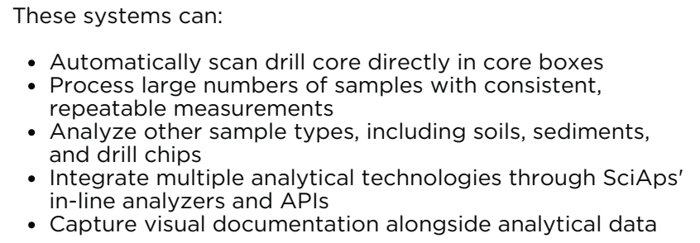 | These systems can:
 | Automatically scan drill core directly in core boxes
 | Process large numbers of samples with consistent, repeatable measurements
 | Analyze other sample types, including soils, sediments, and drill chips
 | Integrate multiple analytical technologies through SciAps' in-line analyzers and APIs
 | Capture visual documentation alongside analytical data
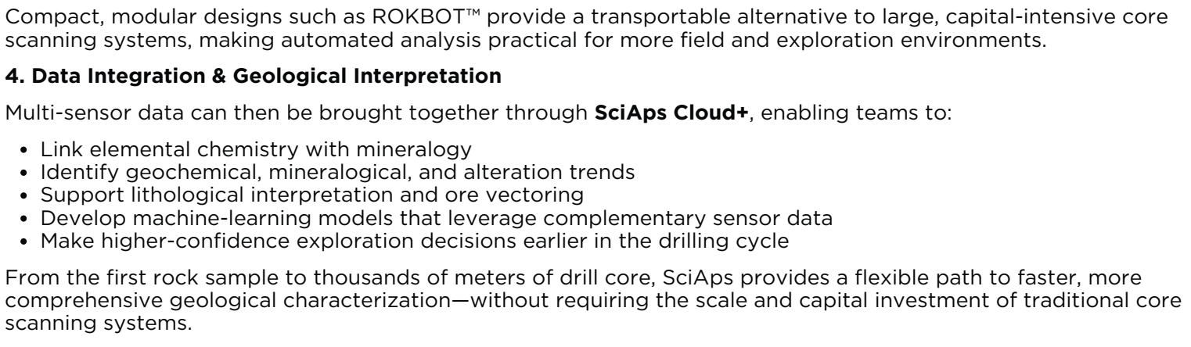 | Compact, modular designs such as ROKBOT™ provide a transportable alternative to large, capital-intensive core scanning systems, making automated analysis practical for more field and exploration environments.
 | Data Integration & Geological Interpretation
 | Multi-sensor data can then be brought together through SciAps Cloud+, enabling teams to:
 | Link elemental chemistry with mineralogy
 | Identify geochemical, mineralogical, and alteration trends
 | Support lithological interpretation and ore vectoring
 | Develop machine-learning models that leverage complementary sensor data
 | Make higher-confidence exploration decisions earlier in the drilling cycle
 | From the first rock sample to thousands of meters of drill core, SciAps provides a flexible path to faster, more comprehensive geological characterization—without requiring the scale and capital investment of traditional core scanning systems.
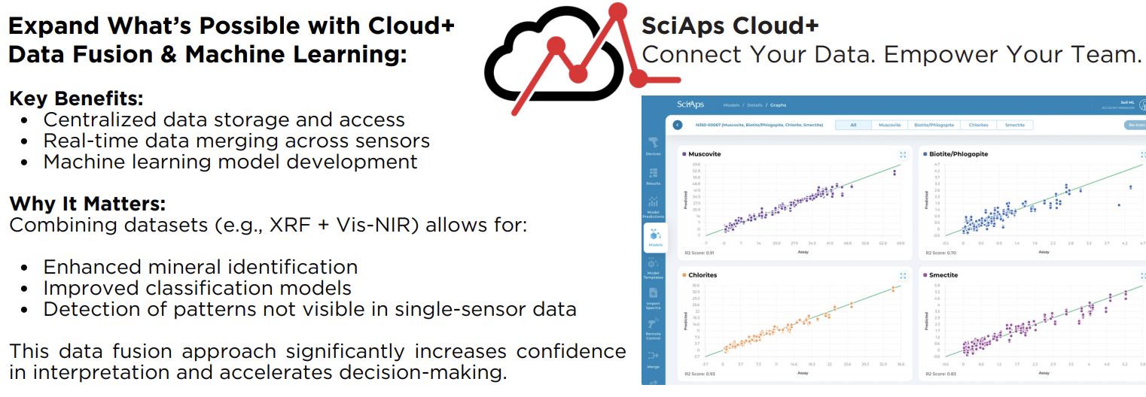 | Expand What’s Possible with Cloud+ Data Fusion & Machine Learning:
 | Key Benefits:
 | Centralized data storage and access
 | Real-time data merging across sensors
 | Machine learning model development
 | Why It Matters:
 | Combining datasets (e.g., XRF + Vis-NIR) allows for:
 | Enhanced mineral identification
 | Improved classification models
 | Detection of patterns not visible in single-sensor data
 | This data fusion approach significantly increases confidence in interpretation and accelerates decision-making.
 | Connect Your Data. Empower Your Team.

