Document Title: Technology Brief: The Advantages of Non-Isotope XRF for Lead Paint Analysis
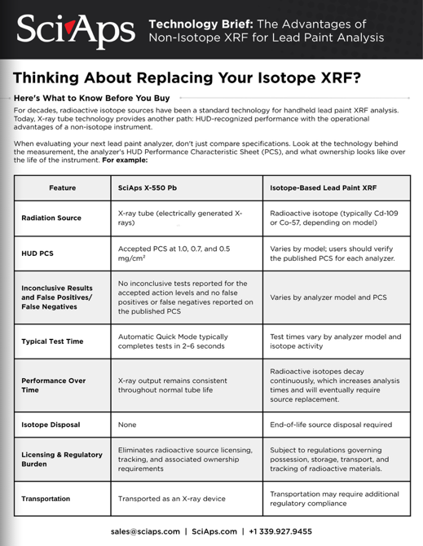
Rev Date: September 2026

Layout Preview | English Text | Translated Text
 | Technology Brief: The Advantages of Non-Isotope XRF for Lead Paint Analysis
 | Thinking About Replacing Your Isotope XRF?
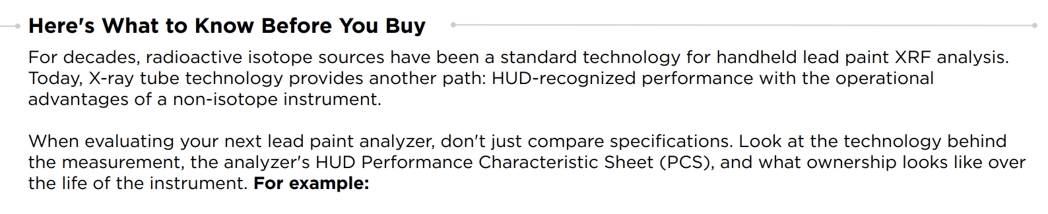 | Here's What to Know Before You Buy
 | For decades, radioactive isotope sources have been a standard technology for handheld lead paint XRF analysis. Today, X-ray tube technology provides another path: HUD-recognized performance with the operational advantages of a non-isotope instrument.
 | When evaluating your next lead paint analyzer, don't just compare specifications. Look at the technology behind the measurement, the analyzer's HUD Performance Characteristic Sheet (PCS), and what ownership looks like over the life of the instrument. For example:
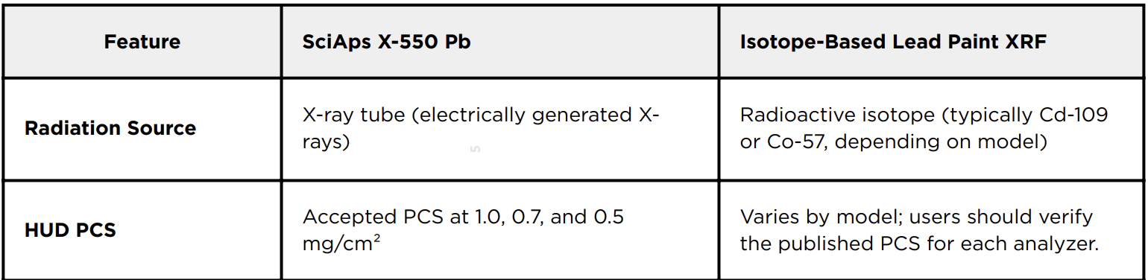 | Feature
 | SciAps X-550 Pb
 | Isotope-Based Lead Paint XRF
 | Radiation Source
 | X-ray tube (electrically generated X-rays)
 | Radioactive isotope (typically Cd-109 or Co-57, depending on model)
 | HUD PCS
 | Accepted PCS at 1.0, 0.7, and 0.5 mg/cm²
 | Varies by model; users should verify the published PCS for each analyzer.
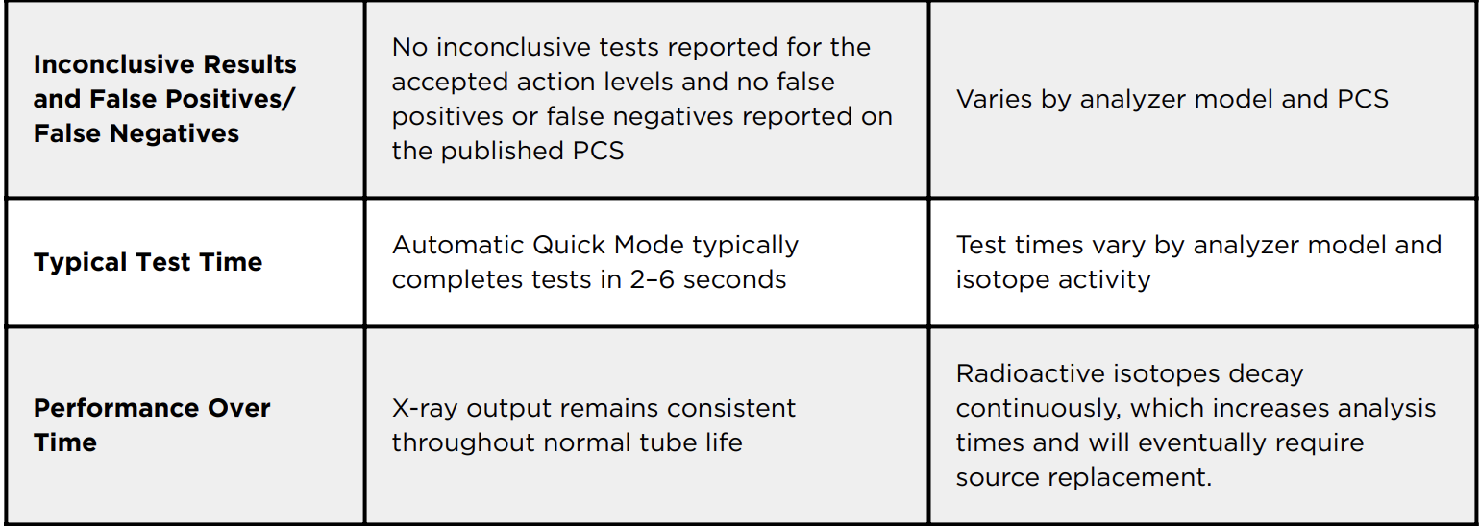 | Inconclusive Results and False Positives/ False Negatives
 | No inconclusive tests reported for the accepted action levels and no false positives or false negatives reported on the published PCS
 | Varies by analyzer model and PCS
 | Typical Test Time
 | Automatic Quick Mode typically completes tests in 2–6 seconds
 | Test times vary by analyzer model and isotope activity
 | Performance Over Time
 | X-ray output remains consistent throughout normal tube life
 | Radioactive isotopes decay continuously, which increases analysis times and will eventually require source replacement.
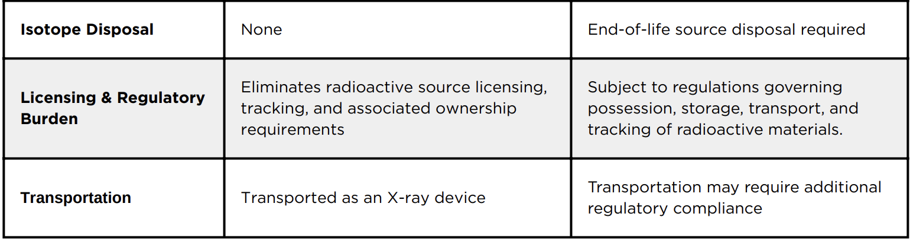 | Isotope Disposal
 | None
 | End-of-life source disposal required
 | Licensing & Regulatory Burden
 | Eliminates radioactive source licensing, tracking, and associated ownership requirements
 | Subject to regulations governing possession, storage, transport, and tracking of radioactive materials.
 | Transportation
 | Transported as an X-ray device
 | Transportation may require additional regulatory compliance
(BACK)
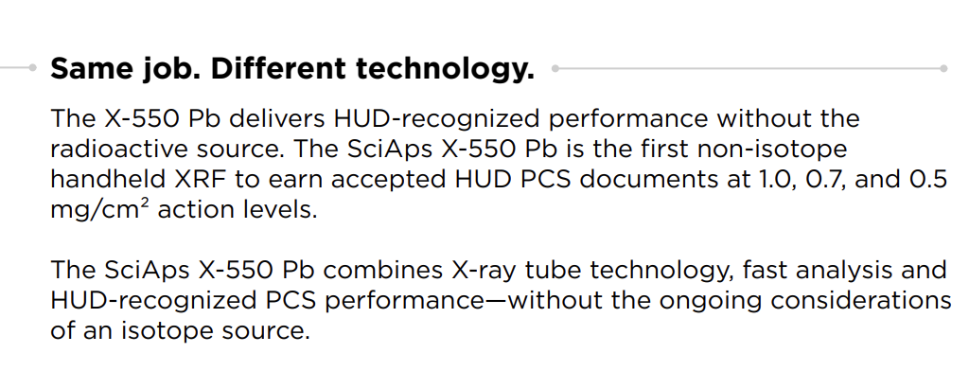 | Same job. Different technology.
 | The X-550 Pb delivers HUD-recognized performance without the radioactive source. The SciAps X-550 Pb is the first non-isotope handheld XRF to earn accepted HUD PCS documents at 1.0, 0.7, and 0.5 mg/cm² action levels.
 | The SciAps X-550 Pb combines X-ray tube technology, fast analysis and HUD-recognized PCS performance—without the ongoing considerations of an isotope source.
 | Five Questions to Ask Before You Buy
 | 1.Does the analyzer have a HUD-recognized PCS?
 | 2.What action levels are covered?
 | 3.What are the inconclusive results and test times?
 | 4.Does the analyzer use a radioactive source?
 | 5.What will ownership require 18 months from now?
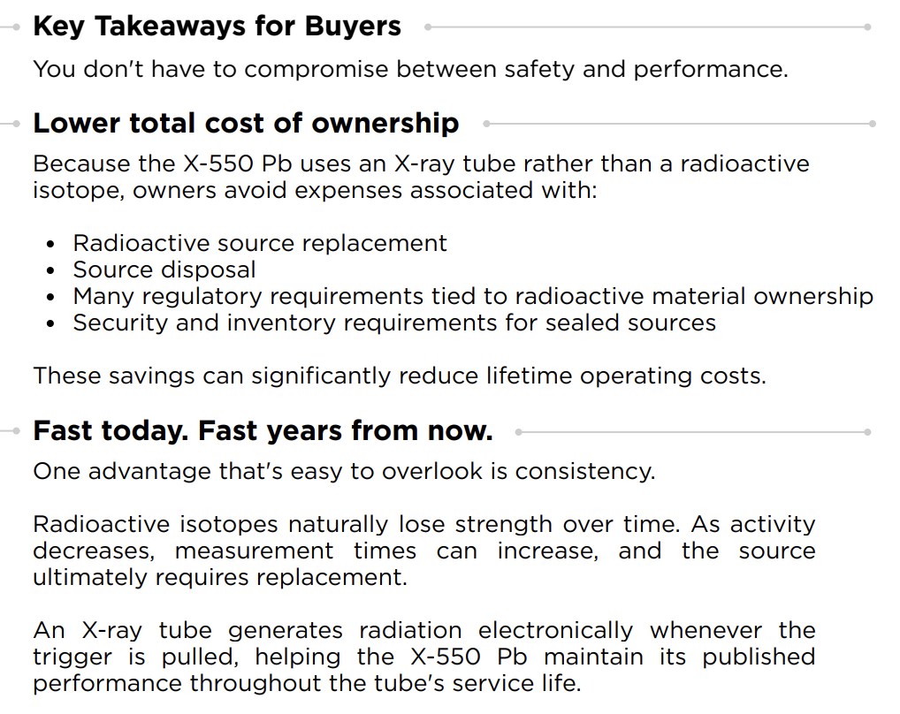 | Key Takeaways for Buyers
 | You don't have to compromise between safety and performance.
 | Lower total cost of ownership
 | Because the X-550 Pb uses an X-ray tube rather than a radioactive isotope, owners avoid expenses associated with:
 | Radioactive source replacement
 | Source disposal
 | Many regulatory requirements tied to radioactive material ownership
 | Security and inventory requirements for sealed sources
 | These savings can significantly reduce lifetime operating costs.
 | Fast today. Fast years from now.
 | One advantage that's easy to overlook is consistency.
 | Radioactive isotopes naturally lose strength over time. As activity decreases, measurement times can increase, and the source ultimately requires replacement.
 | An X-ray tube generates radiation electronically whenever the trigger is pulled, helping the X-550 Pb maintain its published performance throughout the tube's service life.
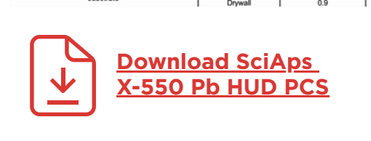 | Download SciAps X-550 Pb HUD PCS
 | Performance shouldn't come with radioactive material.

