Document Title: ASD FieldSpec4 Specifications
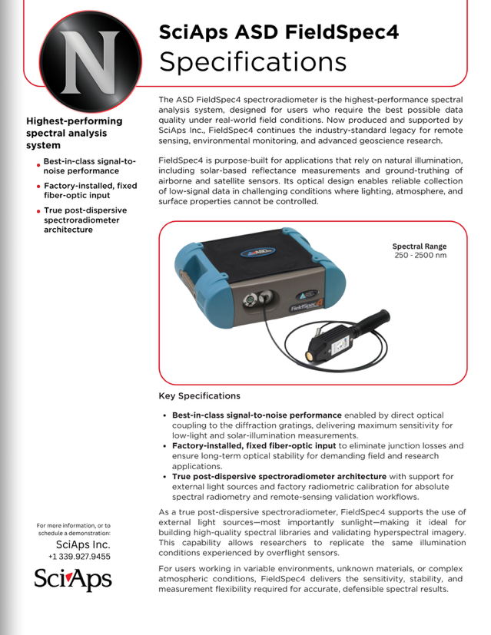
Rev Date: October 2025

Layout Preview | English Text | Translated Text
 | Specifications
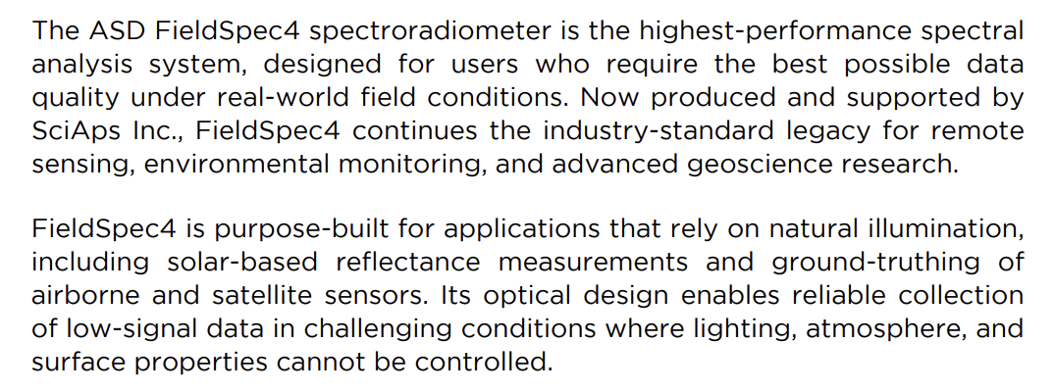 | The ASD FieldSpec4 spectroradiometer is the highest-performance spectral analysis system, designed for users who require the best possible data quality under real-world field conditions. Now produced and supported by SciAps Inc., FieldSpec4 continues the industry-standard legacy for remote sensing, environmental monitoring, and advanced geoscience research.
 | FieldSpec4 is purpose-built for applications that rely on natural illumination, including solar-based reflectance measurements and ground-truthing of airborne and satellite sensors. Its optical design enables reliable collection of low-signal data in challenging conditions where lighting, atmosphere, and surface properties cannot be controlled.
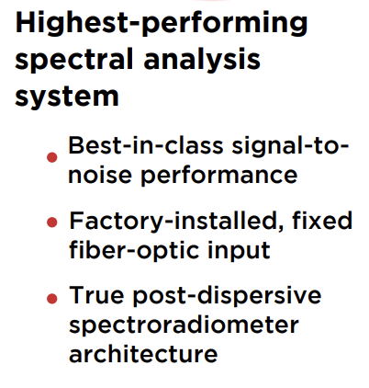 | Highest-performing spectral analysis system
 | Best-in-class signal-tonoise performance
 | Factory-installed, fixed fiber-optic input
 | True post-dispersive spectroradiometer architecture
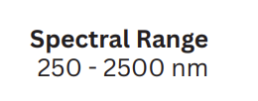 | Spectral Range
 | 250 - 2500 nm
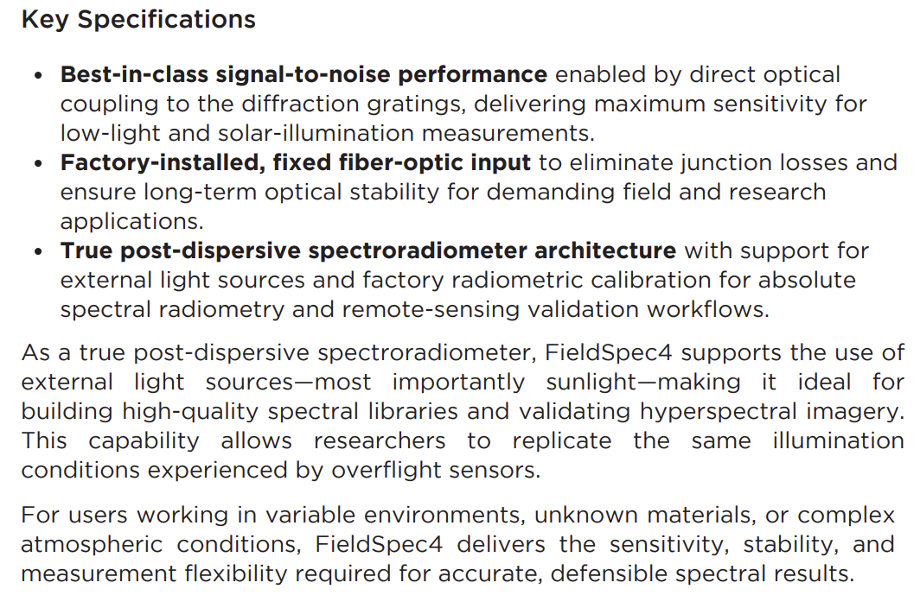 | Key Specifications
 | Best-in-class signal-to-noise performance enabled by direct optical coupling to the diffraction gratings, delivering maximum sensitivity for low-light and solar-illumination measurements.
 | Factory-installed, fixed fiber-optic input to eliminate junction losses and ensure long-term optical stability for demanding field and research applications.
 | True post-dispersive spectroradiometer architecture with support for external light sources and factory radiometric calibration for absolute spectral radiometry and remote-sensing validation workflows.
 | As a true post-dispersive spectroradiometer, FieldSpec4 supports the use of external light sources—most importantly sunlight—making it ideal for building high-quality spectral libraries and validating hyperspectral imagery. This capability allows researchers to replicate the same illumination conditions experienced by overflight sensors.
 | For users working in variable environments, unknown materials, or complex atmospheric conditions, FieldSpec4 delivers the sensitivity, stability, and measurement flexibility required for accurate, defensible spectral results.
 | For more information, or to schedule a demonstration:
(BACK)
 | Specifications
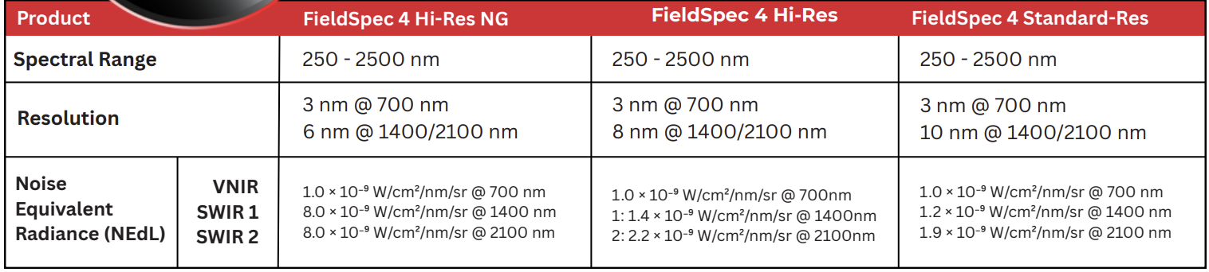 | Product
 | Spectral Range
 | Resolution
 | Noise Equivalent Radiance (NEdL)
VNIR
SWIR 1
SWIR 2
 | FieldSpec 4 Hi-Res NG
 | 250 - 2500 nm
3 nm @ 700 nm
6 nm @ 1400/2100 nm
1.0 × 10⁻⁹ W/cm²/nm/sr @ 700 nm
8.0 × 10⁻⁹ W/cm²/nm/sr @ 1400 nm
8.0 × 10⁻⁹ W/cm²/nm/sr @ 2100 nm
 | FieldSpec 4 Hi-Res
 | 250 - 2500 nm
3 nm @ 700 nm
8 nm @ 1400/2100 nm
1.0 × 10⁻⁹ W/cm²/nm/sr @ 700nm
1: 1.4 × 10⁻⁹ W/cm²/nm/sr @ 1400nm
2: 2.2 × 10⁻⁹ W/cm²/nm/sr @ 2100nm
 | FieldSpec 4 Standard-Res
 | 250 - 2500 nm
3 nm @ 700 nm
10 nm @ 1400/2100 nm
1.0 × 10⁻⁹ W/cm²/nm/sr @ 700 nm
1.2 × 10⁻⁹ W/cm²/nm/sr @ 1400 nm
1.9 × 10⁻⁹ W/cm²/nm/sr @ 2100 nm
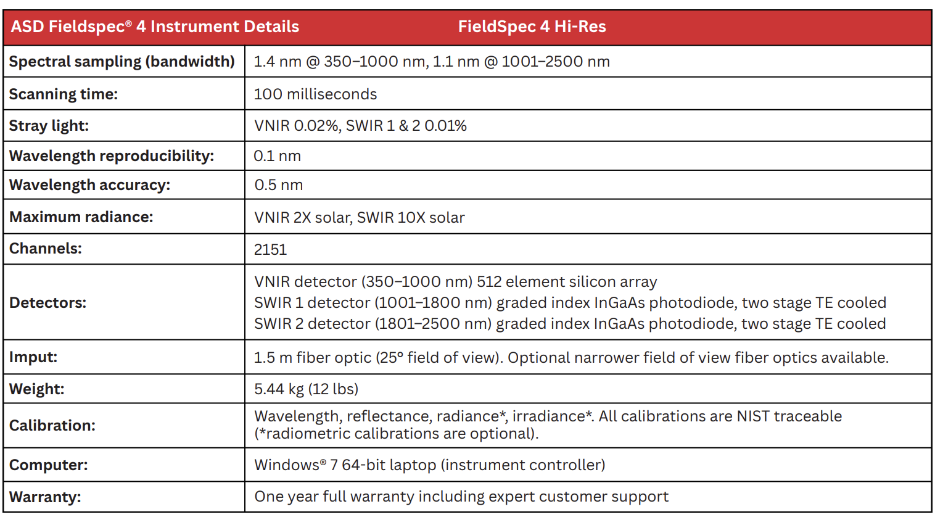 | ASD Fieldspec® 4 Instrument Details
 | FieldSpec 4 Hi-Res
 | Spectral sampling (bandwidth)
 | 1.4 nm @ 350–1000 nm, 1.1 nm @ 1001–2500 nm
 | Scanning time:
 | 100 milliseconds
 | Stray light:
 | VNIR 0.02%, SWIR 1 & 2 0.01%
 | Wavelength reproducibility:
 | 0.1 nm
 | Wavelength accuracy:
 | 0.5 nm
 | Maximum radiance:
 | VNIR 2X solar, SWIR 10X solar
 | Channels:
 | 2151
 | Detectors:
VNIR detector (350–1000 nm) 512 element silicon array
SWIR 1 detector (1001–1800 nm) graded index InGaAs photodiode, two stage TE cooled
SWIR 2 detector (1801–2500 nm) graded index InGaAs photodiode, two stage TE cooled
 | Imput:
 | 1.5 m fiber optic (25° field of view). Optional narrower field of view fiber optics available.
 | Weight:
 | 5.44 kg (12 lbs)
 | Calibration:
 | Wavelength, reflectance, radiance*, irradiance*. All calibrations are NIST traceable (*radiometric calibrations are optional).
 | Computer:
 | Windows® 7 64-bit laptop (instrument controller)
 | Warranty:
 | One year full warranty including expert customer support
 | For service of ASD products, contact
 | ASD NOW PART OF THE SCIAPS FAMILY OF PORTABLE ANALYZERS.

