Document Title: SciAps Cloud+ Brochure
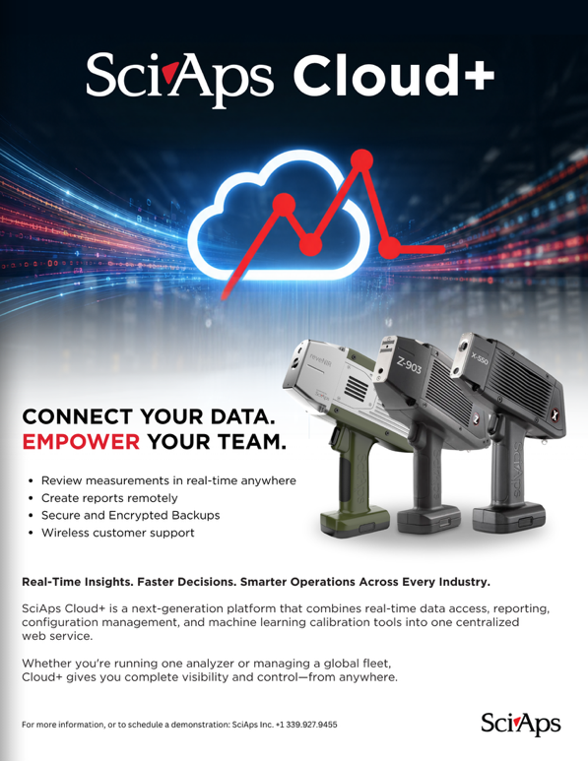
Rev Date: June 2026

Layout Preview | English Text | Translated Text
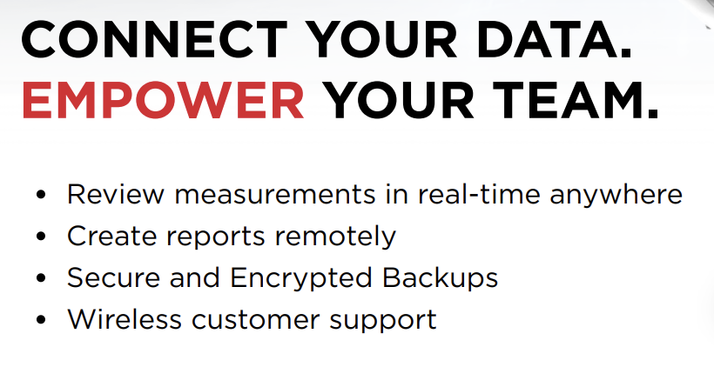 | CONNECT YOUR DATA. EMPOWER YOUR TEAM.
 | Review measurements in real-time anywhere
 | Create reports remotely
 | Secure and Encrypted Backups
 | Wireless customer support
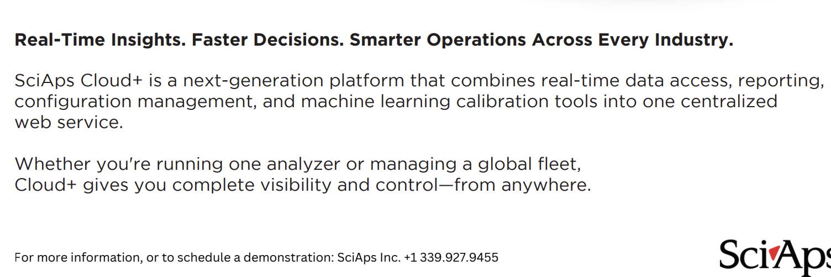 | Real-Time Insights. Faster Decisions. Smarter Operations Across Every Industry.
 | SciAps Cloud+ is a next-generation platform that combines real-time data access, reporting, configuration management, and machine learning calibration tools into one centralized web service.
 | Whether you're running one analyzer or managing a global fleet, Cloud+ gives you complete visibility and control—from anywhere.
 | For more information, or to schedule a demonstration:
[page 2]
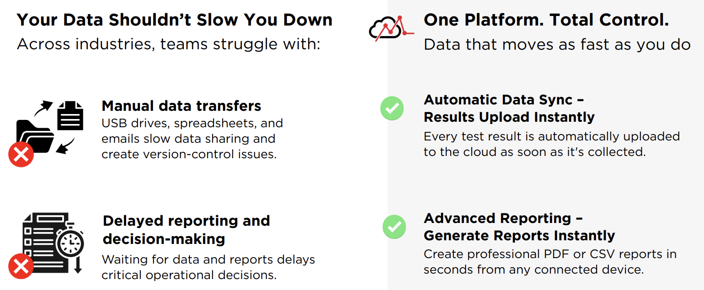 | Your Data Shouldn’t Slow You Down
 | Across industries, teams struggle with:
 | One Platform. Total Control.
 | Data that moves as fast as you do
 | Manual data transfers
 | USB drives, spreadsheets, and emails slow data sharing and create version-control issues.
 | Automatic Data Sync – Results Upload Instantly
 | Every test result is automatically uploaded to the cloud as soon as it's collected.
 | Delayed reporting and decision-making
 | Waiting for data and reports delays critical operational decisions.
 | Advanced Reporting – Generate Reports Instantly
 | Create professional PDF or CSV reports in seconds from any connected device.
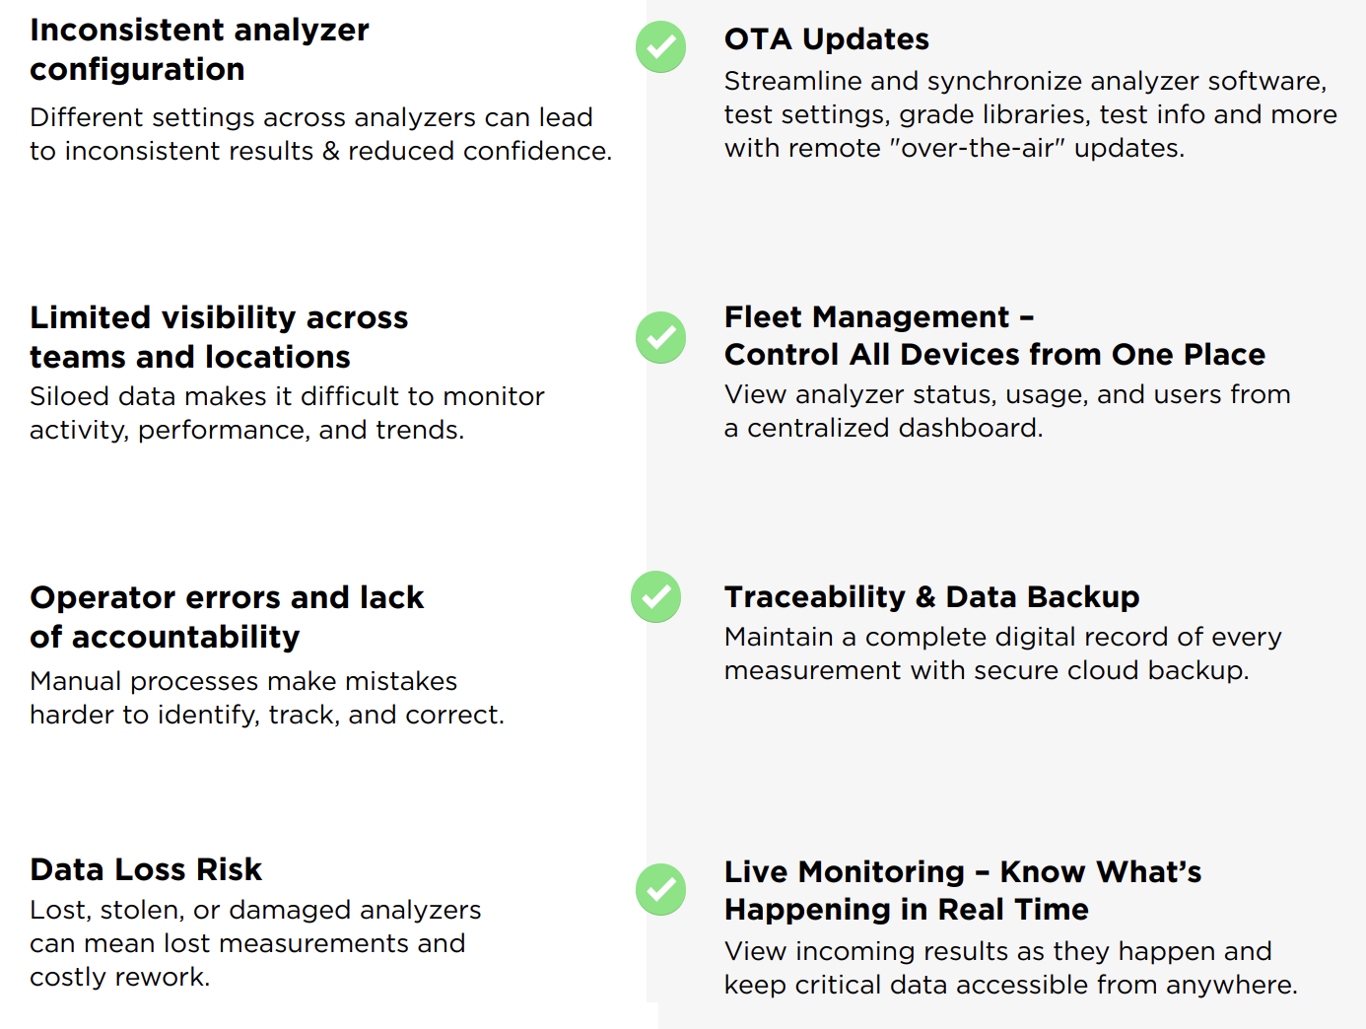 | Inconsistent analyzer configuration
 | Different settings across analyzers can lead to inconsistent results & reduced confidence.
 | OTA Updates
 | Streamline and synchronize analyzer software, test settings, grade libraries, test info and more with remote "over-the-air" updates.
 | Limited visibility across teams and locations
 | Siloed data makes it difficult to monitor activity, performance, and trends.
 | Fleet Management – Control All Devices from One Place
 | View analyzer status, usage, and users from a centralized dashboard.
 | Operator errors and lack of accountability
 | Manual processes make mistakes harder to identify, track, and correct.
 | Traceability & Data Backup
 | Maintain a complete digital record of every measurement with secure cloud backup.
 | Data Loss Risk
 | Lost, stolen, or damaged analyzers can mean lost measurements and costly rework.
 | Live Monitoring – Know What’s Happening in Real Time
 | View incoming results as they happen and keep critical data accessible from anywhere.
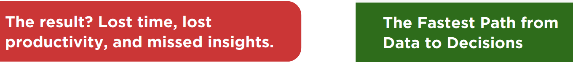 | The result? Lost time, lost productivity, and missed insights.
 | The Fastest Path from Data to Decisions
[page 3]
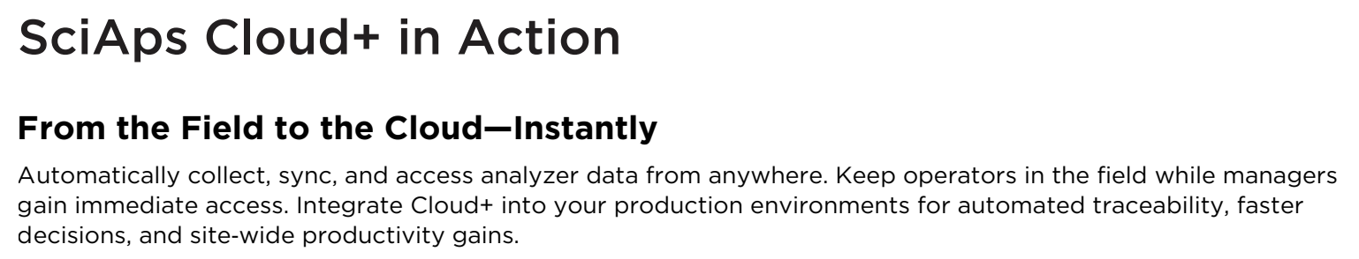 | SciAps Cloud+ in Action
 | From the Field to the Cloud—Instantly
 | Automatically collect, sync, and access analyzer data from anywhere. Keep operators in the field while managers gain immediate access. Integrate Cloud+ into your production environments for automated traceability, faster decisions, and site-wide productivity gains.
 | One Report. All Your Data.
 | Combine results from multiple analyzers and add supporting documents for a complete inspection report.
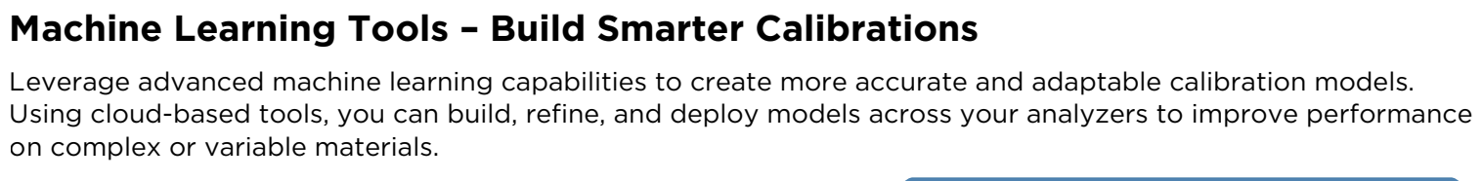 | Machine Learning Tools – Build Smarter Calibrations
 | Leverage advanced machine learning capabilities to create more accurate and adaptable calibration models. Using cloud-based tools, you can build, refine, and deploy models across your analyzers to improve performance on complex or variable materials.
[page 4]
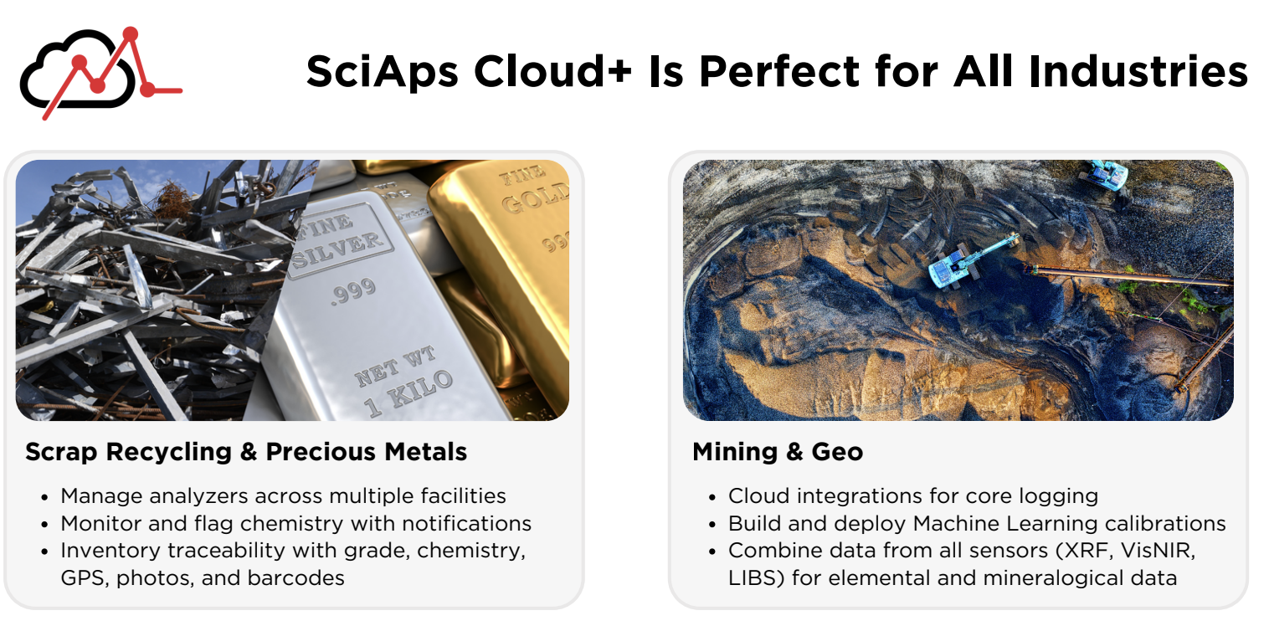 | SciAps Cloud+ Is Perfect for All Industries
 | Scrap Recycling & Precious Metals
 | Manage analyzers across multiple facilities
 | Monitor and flag chemistry with notifications
 | Inventory traceability with grade, chemistry, GPS, photos, and barcodes
 | Mining & Geo
 | Cloud integrations for core logging
 | Build and deploy Machine Learning calibrations
 | Combine data from all sensors (XRF, VisNIR, LIBS) for elemental and mineralogical data
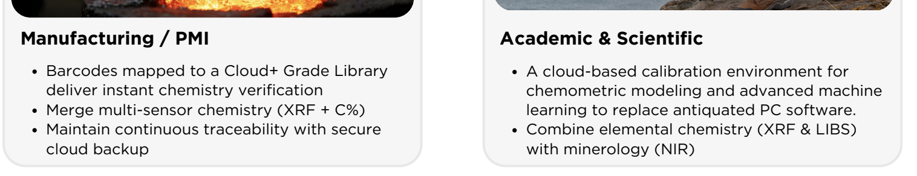 | Manufacturing / PMI
 | Barcodes mapped to a Cloud+ Grade Library deliver instant chemistry verification
 | Merge multi-sensor chemistry (XRF + C%)
 | Maintain continuous traceability with secure cloud backup
 | Academic & Scientific
 | A cloud-based calibration environment for chemometric modeling and advanced machine learning to replace antiquated PC software.
 | Combine elemental chemistry (XRF & LIBS) with minerology (NIR)
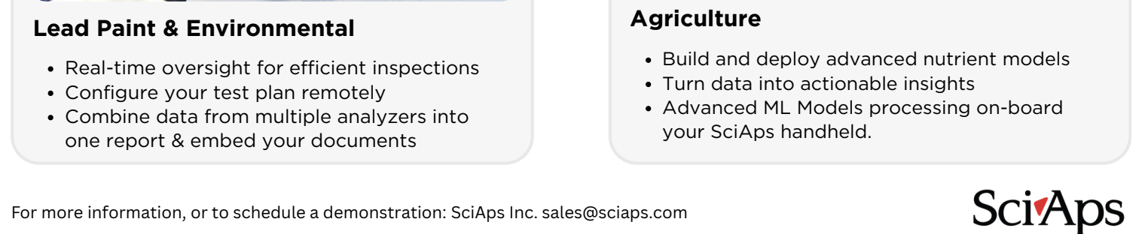 | Lead Paint & Environmental
 | Real-time oversight for efficient inspections
 | Configure your test plan remotely
 | Combine data from multiple analyzers into one report & embed your documents
 | Agriculture
 | Build and deploy advanced nutrient models
 | Turn data into actionable insights
 | Advanced ML Models processing on-board your SciAps handheld.
 | For more information, or to schedule a demonstration:

