Document Title: SciAps Cloud+ Specifications
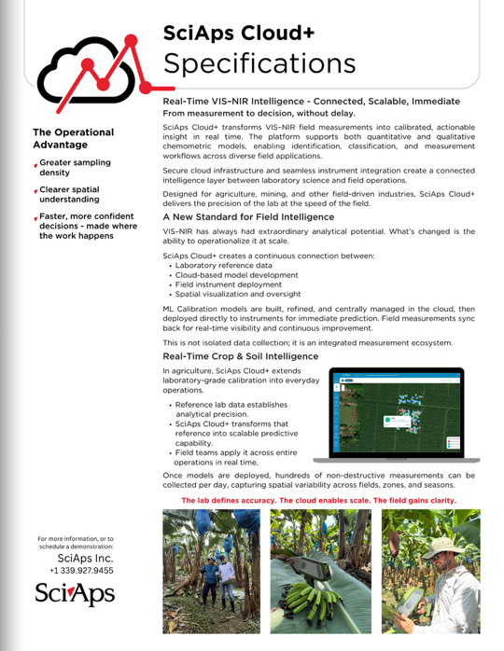
Rev Date:

Layout Preview | English Text | Translated Text
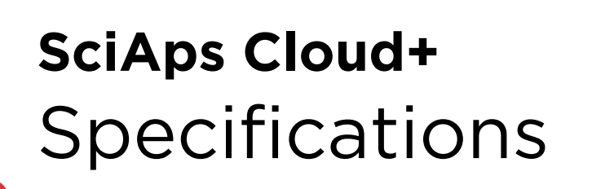 | Specifications
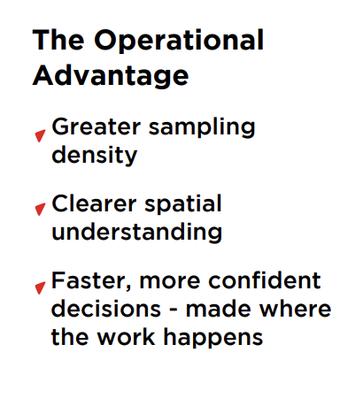 | The Operational Advantage
 | Greater sampling density
 | Clearer spatial understanding
 | Faster, more confident decisions - made where the work happens
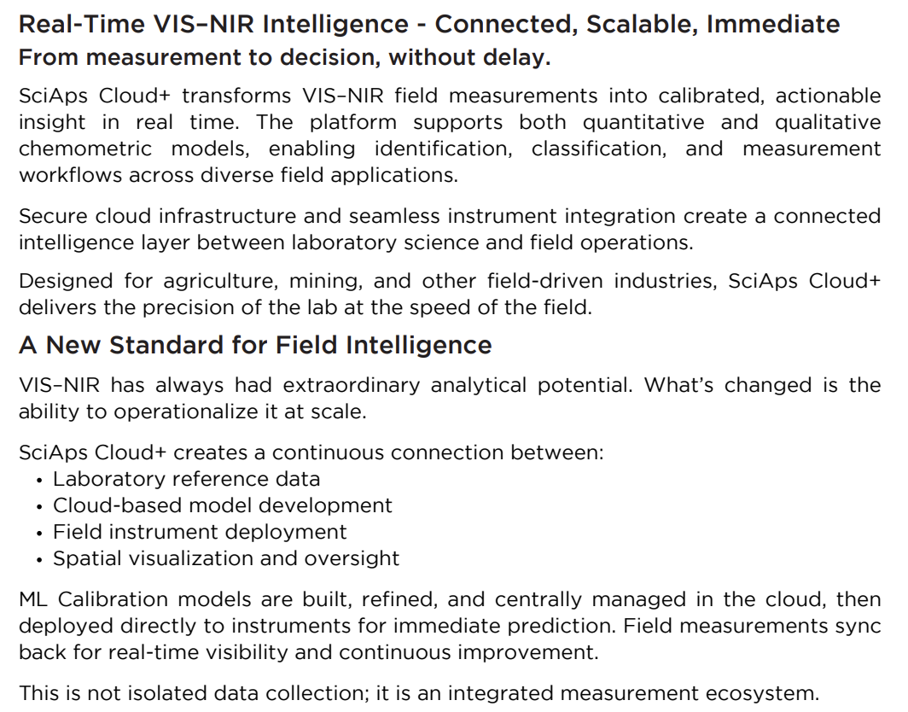 | Real-Time VIS–NIR Intelligence - Connected, Scalable, Immediate From measurement to decision, without delay.
 | SciAps Cloud+ transforms VIS–NIR field measurements into calibrated, actionable insight in real time. The platform supports both quantitative and qualitative chemometric models, enabling identification, classification, and measurement workflows across diverse field applications.
 | Secure cloud infrastructure and seamless instrument integration create a connected intelligence layer between laboratory science and field operations.
 | Designed for agriculture, mining, and other field-driven industries, SciAps Cloud+ delivers the precision of the lab at the speed of the field.
 | A New Standard for Field Intelligence
 | VIS–NIR has always had extraordinary analytical potential. What’s changed is the ability to operationalize it at scale.
 | SciAps Cloud+ creates a continuous connection between:
 | Laboratory reference data
 | Cloud-based model development
 | Field instrument deployment
 | Spatial visualization and oversight
 | ML Calibration models are built, refined, and centrally managed in the cloud, then deployed directly to instruments for immediate prediction. Field measurements sync back for real-time visibility and continuous improvement.
 | This is not isolated data collection; it is an integrated measurement ecosystem.
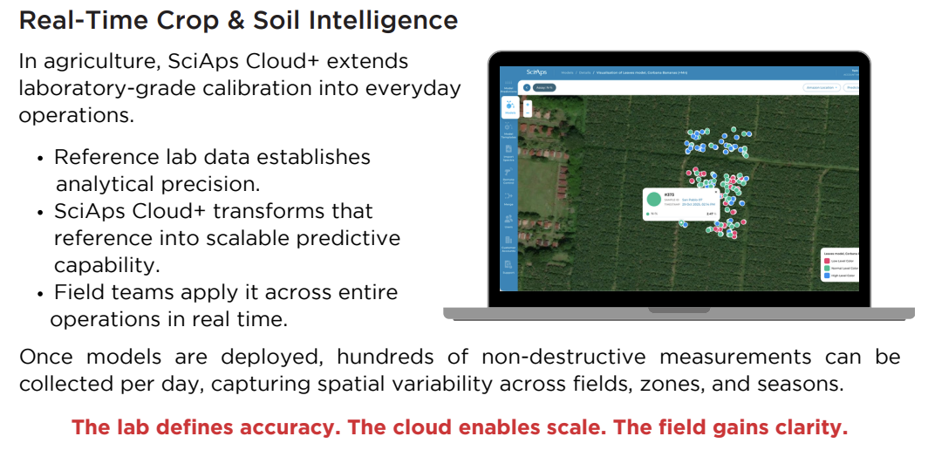 | Real-Time Crop & Soil Intelligence
 | In agriculture, SciAps Cloud+ extends laboratory-grade calibration into everyday operations.
 | Reference lab data establishes analytical precision.
 | SciAps Cloud+ transforms that reference into scalable predictive capability.
 | Field teams apply it across entire operations in real time.
 | Once models are deployed, hundreds of non-destructive measurements can be collected per day, capturing spatial variability across fields, zones, and seasons.
 | The lab defines accuracy. The cloud enables scale. The field gains clarity.
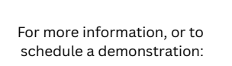 | For more information, or to schedule a demonstration:
(BACK)
 | Specifications
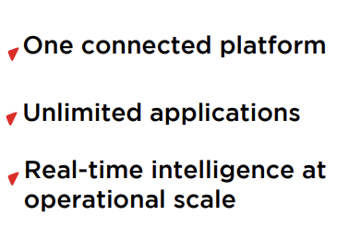 | One connected platform
 | Unlimited applications
 | Real-time intelligence at operational scale
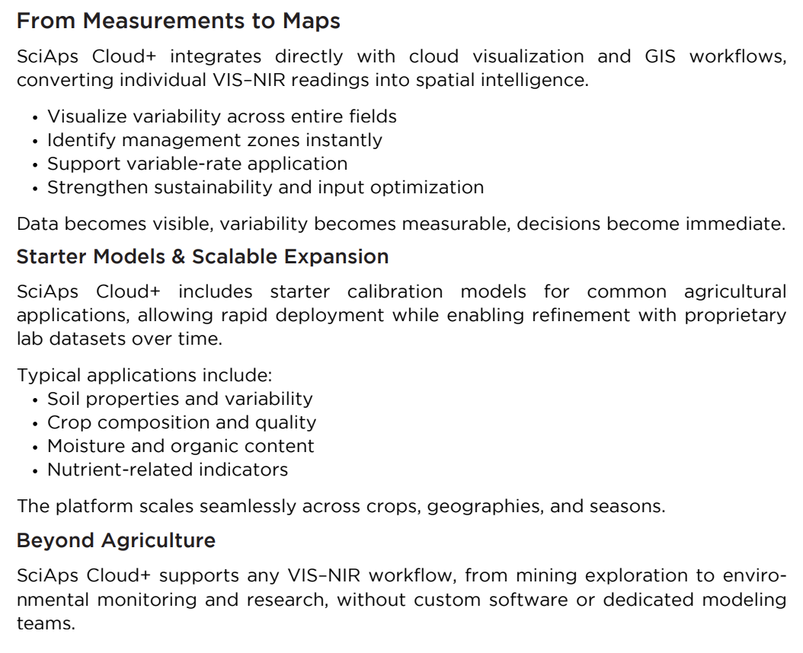 | From Measurements to Maps
 | SciAps Cloud+ integrates directly with cloud visualization and GIS workflows, converting individual VIS–NIR readings into spatial intelligence.
 | Visualize variability across entire fields
 | Identify management zones instantly
 | Support variable-rate application
 | Strengthen sustainability and input optimization
 | Data becomes visible, variability becomes measurable, decisions become immediate.
 | Starter Models & Scalable Expansion
 | SciAps Cloud+ includes starter calibration models for common agricultural applications, allowing rapid deployment while enabling refinement with proprietary lab datasets over time.
 | Typical applications include:
 | Soil properties and variability
 | Crop composition and quality
 | Moisture and organic content
 | Nutrient-related indicators
 | The platform scales seamlessly across crops, geographies, and seasons.
 | Beyond Agriculture
 | SciAps Cloud+ supports any VIS–NIR workflow, from mining exploration to environmental monitoring and research, without custom software or dedicated modeling teams.
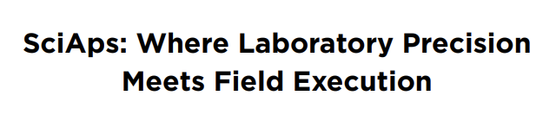 | SciAps: Where Laboratory Precision Meets Field Execution

