Document Title: ApNote Selecting the Right Field Spectrometer for Field and Laboratory Applications, A Practical Comparison: FieldSpec 4 and reveNIR
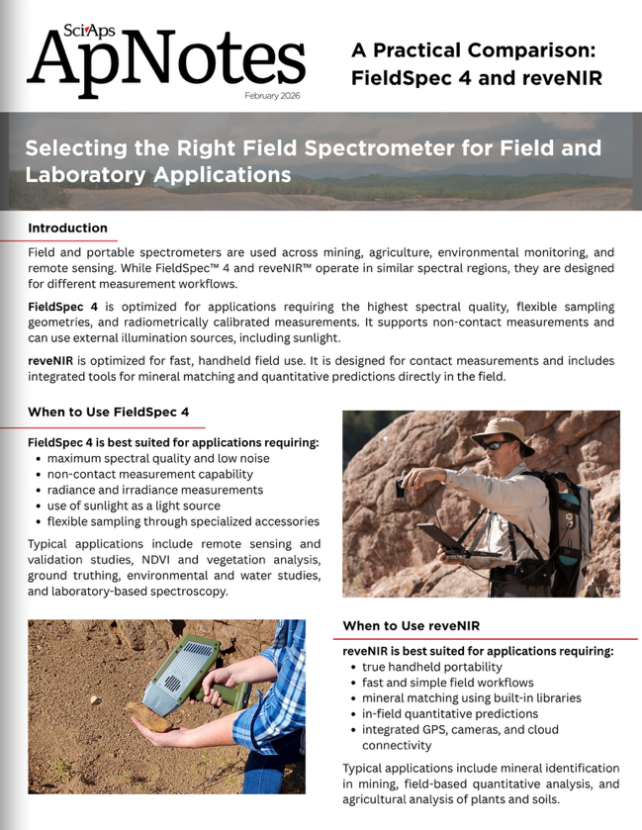
Rev Date: February 2026

Layout Preview | English Text | Translated Text
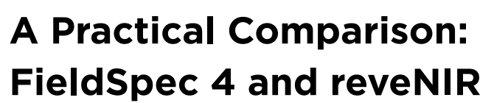 | A Practical Comparison: FieldSpec 4 and reveNIR
 | Selecting the Right Field Spectrometer for Field and Laboratory Applications
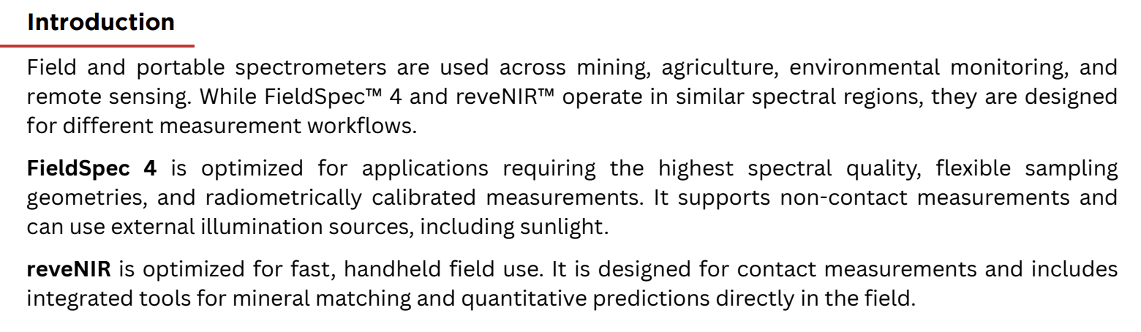 | Introduction
 | Field and portable spectrometers are used across mining, agriculture, environmental monitoring, and remote sensing. While FieldSpec™ 4 and reveNIR™ operate in similar spectral regions, they are designed for different measurement workflows.
 | FieldSpec 4 is optimized for applications requiring the highest spectral quality, flexible sampling geometries, and radiometrically calibrated measurements. It supports non-contact measurements and can use external illumination sources, including sunlight.
 | reveNIR is optimized for fast, handheld field use. It is designed for contact measurements and includes integrated tools for mineral matching and quantitative predictions directly in the field.
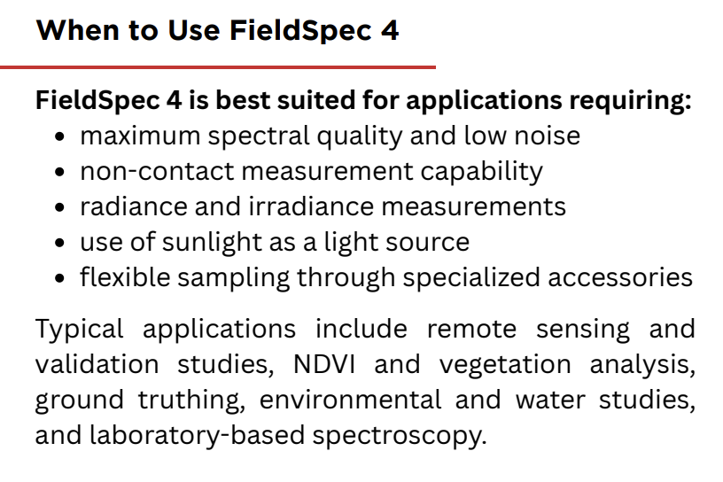 | When to Use FieldSpec 4
 | FieldSpec 4 is best suited for applications requiring:
 | maximum spectral quality and low noise
 | non-contact measurement capability
 | radiance and irradiance measurements
 | use of sunlight as a light source
 | flexible sampling through specialized accessories
 | Typical applications include remote sensing and validation studies, NDVI and vegetation analysis, ground truthing, environmental and water studies, and laboratory-based spectroscopy.
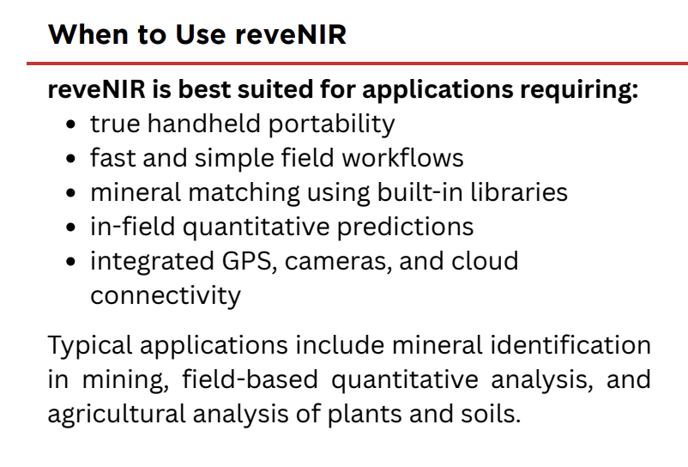 | When to Use reveNIR
 | reveNIR is best suited for applications requiring:
 | true handheld portability
 | fast and simple field workflows
 | mineral matching using built-in libraries
 | in-field quantitative predictions
 | integrated GPS, cameras, and cloud connectivity
 | Typical applications include mineral identification in mining, field-based quantitative analysis, and agricultural analysis of plants and soils.
(BACK)
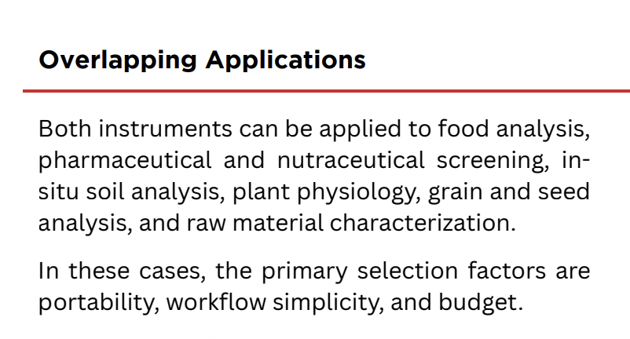 | Overlapping Applications
 | Both instruments can be applied to food analysis, pharmaceutical and nutraceutical screening, insitu soil analysis, plant physiology, grain and seed analysis, and raw material characterization.
 | In these cases, the primary selection factors are portability, workflow simplicity, and budget.
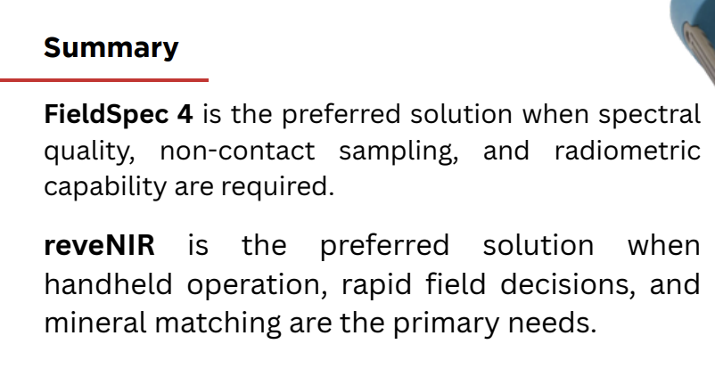 | Summary
 | FieldSpec 4 is the preferred solution when spectral quality, non-contact sampling, and radiometric capability are required.
 | reveNIR is the preferred solution when handheld operation, rapid field decisions, and mineral matching are the primary needs.
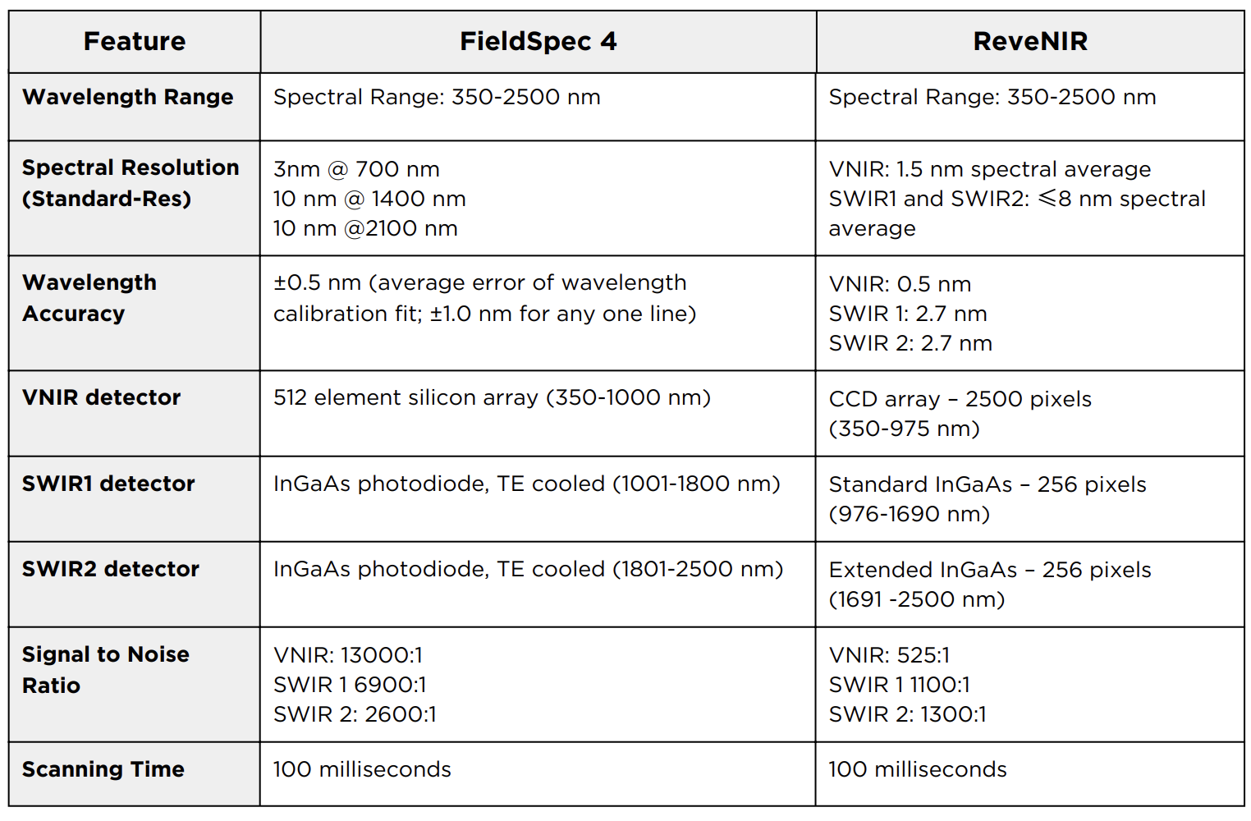 | Feature
 | Wavelength Range
 | Spectral Range: 350-2500 nm
 | Spectral Range: 350-2500 nm
 | Spectral Resolution (Standard-Res)
3nm @ 700 nm
10 nm @ 1400 nm
10 nm @2100 nm
VNIR: 1.5 nm spectral average
SWIR1 and SWIR2: ≤8 nm spectral average
 | Wavelength Accuracy
 | ±0.5 nm (average error of wavelength calibration fit; ±1.0 nm for any one line)
VNIR: 0.5 nm
SWIR 1: 2.7 nm
SWIR 2: 2.7 nm
 | VNIR detector
 | 512 element silicon array (350-1000 nm)
 | CCD array – 2500 pixels (350-975 nm)
 | SWIR1 detector
 | InGaAs photodiode, TE cooled (1001-1800 nm)
 | Standard InGaAs – 256 pixels (976-1690 nm)
 | SWIR2 detector
 | InGaAs photodiode, TE cooled (1801-2500 nm)
 | Extended InGaAs – 256 pixels (1691 -2500 nm)
 | Signal to Noise Ratio
VNIR: 13000:1
SWIR 1 6900:1
SWIR 2: 2600:1
VNIR: 525:1
SWIR 1 1100:1
SWIR 2: 1300:1
 | Scanning Time
 | 100 milliseconds
 | 100 milliseconds

