Document Title: SciAps PowerHouse RoHS
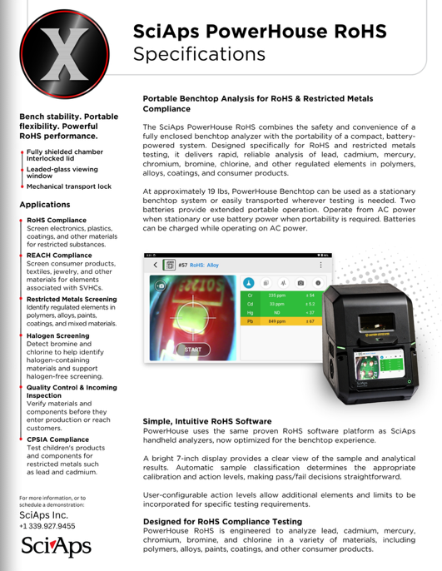
Rev Date: September 2026

Layout Preview | English Text | Translated Text
 | SciAps PowerHouse RoHS
 | Specifications
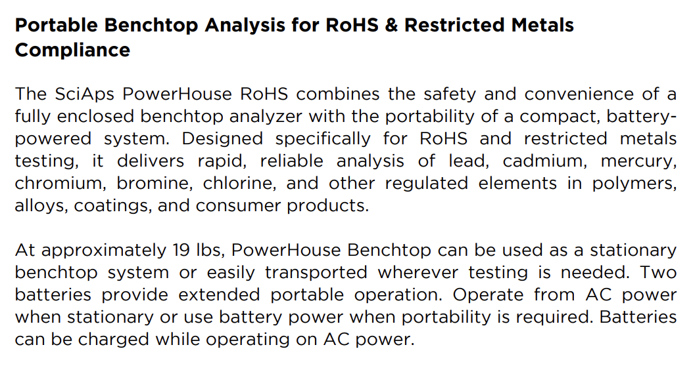 | Portable Benchtop Analysis for RoHS & Restricted Metals Compliance
 | The SciAps PowerHouse RoHS combines the safety and convenience of a fully enclosed benchtop analyzer with the portability of a compact, batterypowered system. Designed specifically for RoHS and restricted metals testing, it delivers rapid, reliable analysis of lead, cadmium, mercury, chromium, bromine, chlorine, and other regulated elements in polymers, alloys, coatings, and consumer products.
 | At approximately 19 lbs, PowerHouse Benchtop can be used as a stationary benchtop system or easily transported wherever testing is needed. Two batteries provide extended portable operation. Operate from AC power when stationary or use battery power when portability is required. Batteries can be charged while operating on AC power.
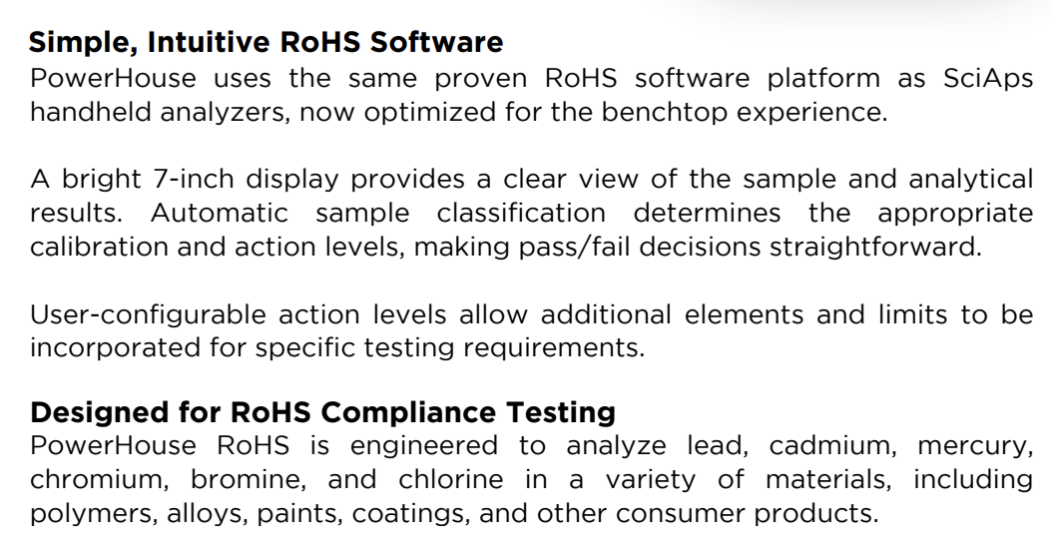 | Simple, Intuitive RoHS Software
 | PowerHouse uses the same proven RoHS software platform as SciAps handheld analyzers, now optimized for the benchtop experience.
 | A bright 7-inch display provides a clear view of the sample and analytical results. Automatic sample classification determines the appropriate calibration and action levels, making pass/fail decisions straightforward.
 | User-configurable action levels allow additional elements and limits to be incorporated for specific testing requirements.
 | Designed for RoHS Compliance Testing
 | PowerHouse RoHS is engineered to analyze lead, cadmium, mercury, chromium, bromine, and chlorine in a variety of materials, including polymers, alloys, paints, coatings, and other consumer products.
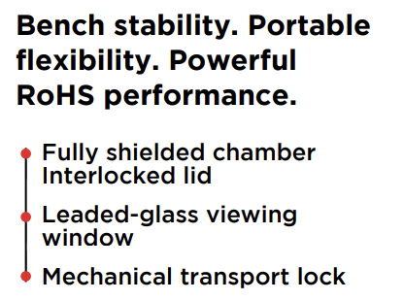 | Bench stability. Portable flexibility. Powerful RoHS performance.
 | Fully shielded chamber Interlocked lid
 | Leaded-glass viewing window
 | Mechanical transport lock
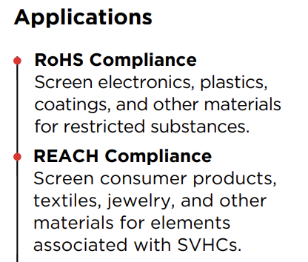 | Applications
 | RoHS Compliance
 | Screen electronics, plastics, coatings, and other materials for restricted substances.
 | REACH Compliance
 | REACH Compliance Screen consumer products, textiles, jewelry, and other materials for elements associated with SVHCs
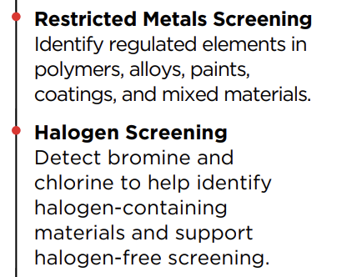 | Restricted Metals Screening
 | Identify regulated elements in polymers, alloys, paints, coatings, and mixed materials.
 | Halogen Screening
 | Detect bromine and chlorine to help identify halogen-containing materials and support halogen-free screening.
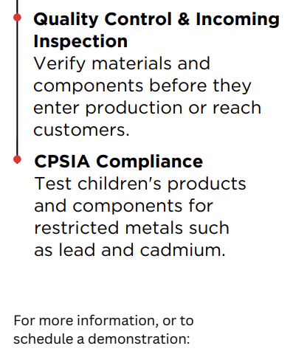 | Quality Control & Incoming Inspection
 | Verify materials and components before they enter production or reach customers.
 | CPSIA Compliance
 | Test children's products and components for restricted metals such as lead and cadmium.
 | For more information, or to schedule a demonstration:
(BACK)
 | SciAps PowerHouse RoHS
 | Specifications
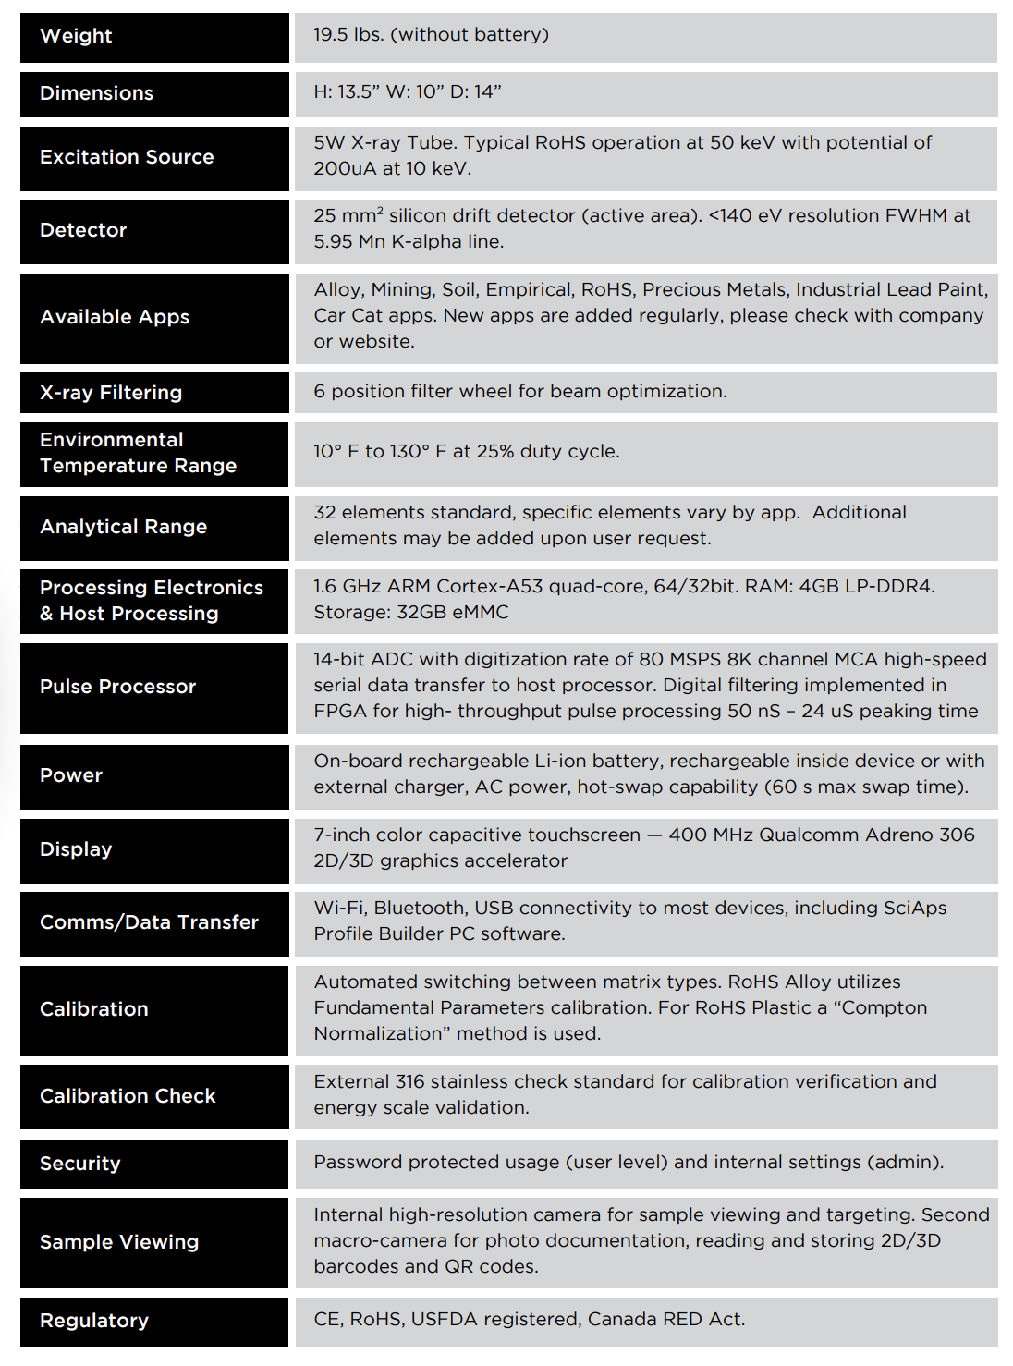 | Weight
 | 19.5 lbs. (without battery)
 | Dimensions
 | H: 13.5” W: 10” D: 14”
 | Excitation Source
 | 5W X-ray Tube. Typical RoHS operation at 50 keV with potential of 200uA at 10 keV.
 | Detector
 | 25 mm² silicon drift detector (active area). <140 eV resolution FWHM at 5.95 Mn K-alpha line.
 | Available Apps
 | Alloy, Mining, Soil, Empirical, RoHS, Precious Metals, Industrial Lead Paint, Car Cat apps. New apps are added regularly, please check with company or website.
 | X-ray Filtering
 | 6 position filter wheel for beam optimization.
 | Environmental Temperature Range
 | 10° F to 130° F at 25% duty cycle
 | Analytical Range
 | 32 elements standard, specific elements vary by app. Additional elements may be added upon user request.
 | Processing Electronics & Host Processing
 | 1.6 GHz ARM Cortex-A53 quad-core, 64/32bit. RAM: 4GB LP-DDR4. Storage: 32GB eMMC
 | Pulse Processor
 | 14-bit ADC with digitization rate of 80 MSPS 8K channel MCA high-speed serial data transfer to host processor. Digital filtering implemented in FPGA for high- throughput pulse processing 50 nS – 24 uS peaking time
 | Power
 | On-board rechargeable Li-ion battery, rechargeable inside device or with external charger, AC power, hot-swap capability (60 s max swap time).
 | Display
 | 7-inch color capacitive touchscreen — 400 MHz Qualcomm Adreno 306 2D/3D graphics accelerator
 | Comms/Data Transfer
 | Wi-Fi, Bluetooth, USB connectivity to most devices, including SciAps Profile Builder PC software.
 | Calibration
 | Automated switching between matrix types. RoHS Alloy utilizes Fundamental Parameters calibration. For RoHS Plastic a “Compton Normalization” method is used.
 | Calibration Check
 | External 316 stainless check standard for calibration verification and energy scale validation.
 | Security
 | Password protected usage (user level) and internal settings (admin).
 | Sample Viewing
 | Internal high-resolution camera for sample viewing and targeting. Second macro-camera for photo documentation, reading and storing 2D/3D barcodes and QR codes.
 | Regulatory
 | CE, RoHS, USFDA registered, Canada RED Act.
 | For more information, or to schedule a demonstration:

