Document Title: ApNote Cloud+ for Metal Recyclers
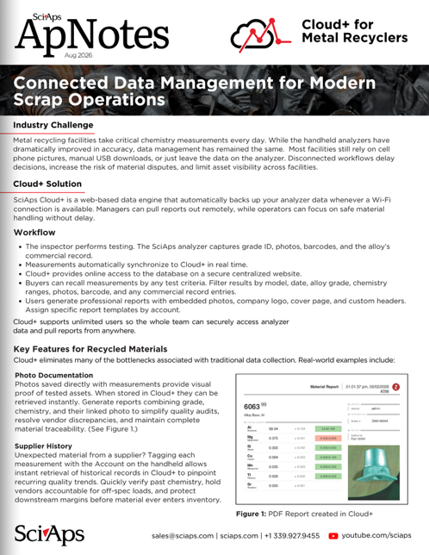
Rev Date: September 2026

Layout Preview | English Text | Translated Text
 | Cloud+ for Metal Recyclers
 | Connected Data Management for Modern Scrap Operations
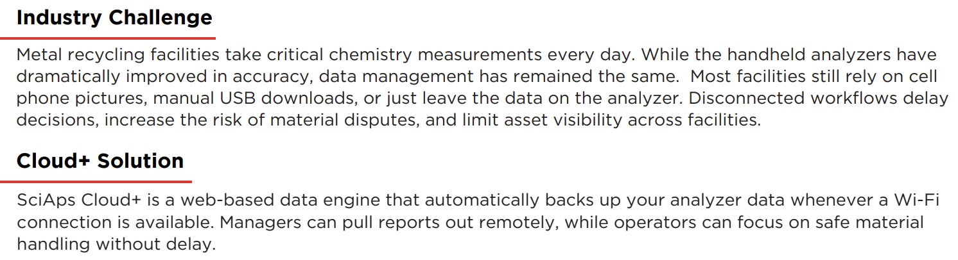 | Industry Challenge
 | Metal recycling facilities take critical chemistry measurements every day. While the handheld analyzers have dramatically improved in accuracy, data management has remained the same. Most facilities still rely on cell phone pictures, manual USB downloads, or just leave the data on the analyzer. Disconnected workflows delay decisions, increase the risk of material disputes, and limit asset visibility across facilities.
 | Cloud+ Solution
 | SciAps Cloud+ is a web-based data engine that automatically backs up your analyzer data whenever a Wi-Fi connection is available. Managers can pull reports out remotely, while operators can focus on safe material handling without delay.
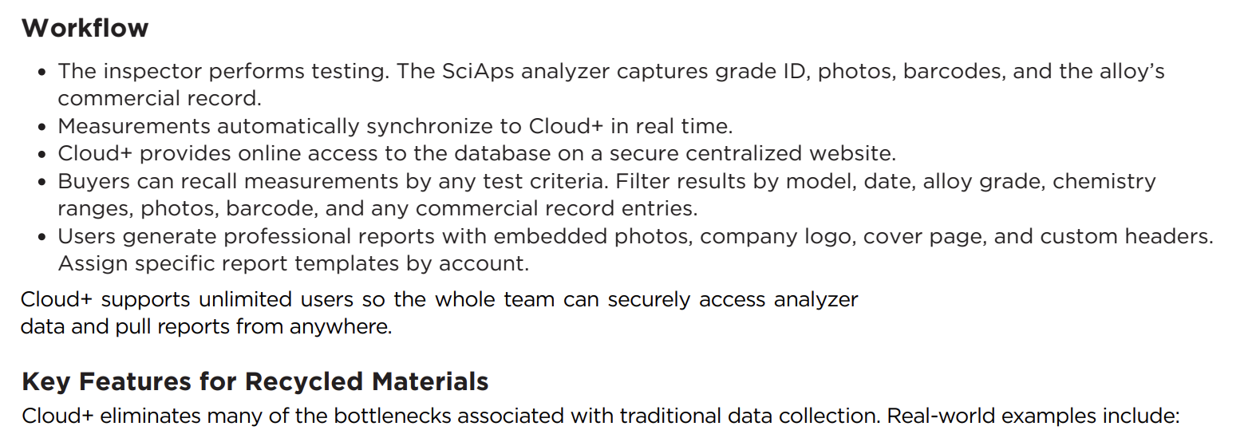 | Workflow
 | The inspector performs testing. The SciAps analyzer captures grade ID, photos, barcodes, and the alloy’s commercial record.
 | Measurements automatically synchronize to Cloud+ in real time.
 | Cloud+ provides online access to the database on a secure centralized website.
 | Buyers can recall measurements by any test criteria. Filter results by model, date, alloy grade, chemistry ranges, photos, barcode, and any commercial record entries.
 | Users generate professional reports with embedded photos, company logo, cover page, and custom headers. Assign specific report templates by account.
 | Cloud+ supports unlimited users so the whole team can securely access analyzer data and pull reports from anywhere.
 | Key Features for Recycled Materials
 | Cloud+ eliminates many of the bottlenecks associated with traditional data collection. Real-world examples include:
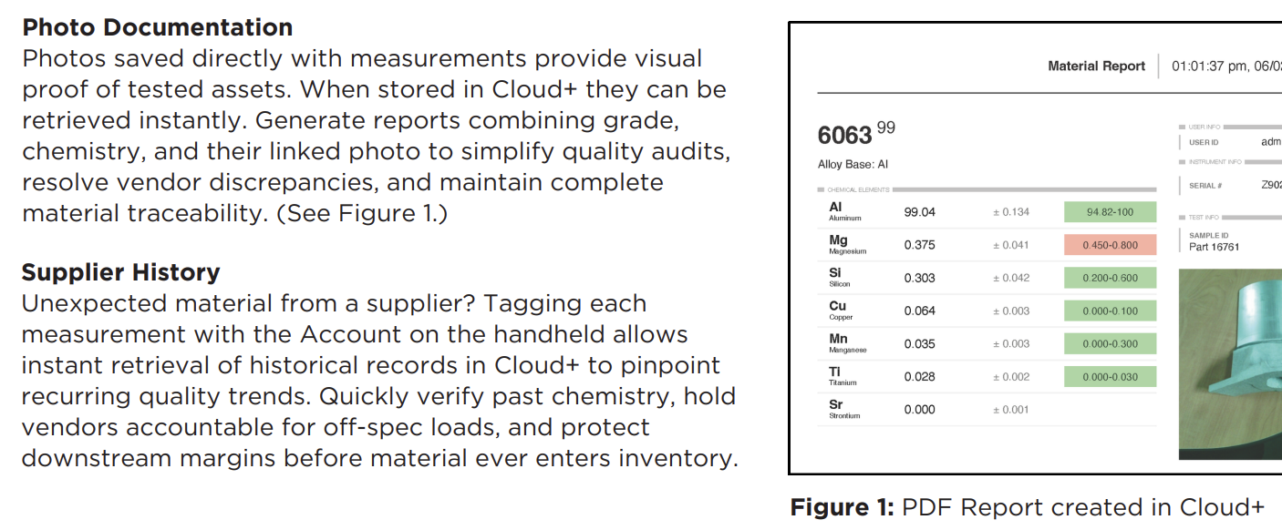 | Photo Documentation
 | Photos saved directly with measurements provide visual proof of tested assets. When stored in Cloud+ they can be retrieved instantly. Generate reports combining grade, chemistry, and their linked photo to simplify quality audits, resolve vendor discrepancies, and maintain complete material traceability. (See Figure 1.)
 | Supplier History
 | Unexpected material from a supplier? Tagging each measurement with the Account on the handheld allows instant retrieval of historical records in Cloud+ to pinpoint recurring quality trends. Quickly verify past chemistry, hold vendors accountable for off-spec loads, and protect downstream margins before material ever enters inventory.
 | Figure 1: PDF Report created in Cloud+
(BACK)
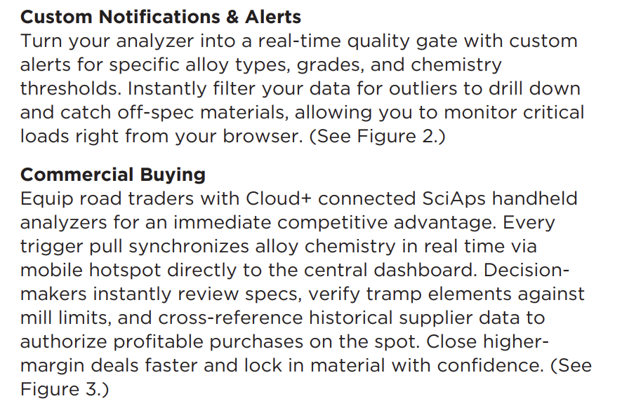 | Custom Notifications & Alerts
 | Turn your analyzer into a real-time quality gate with custom alerts for specific alloy types, grades, and chemistry thresholds. Instantly filter your data for outliers to drill down and catch off-spec materials, allowing you to monitor critical loads right from your browser. (See Figure 2.)
 | Commercial Buying
 | Equip road traders with Cloud+ connected SciAps handheld analyzers for an immediate competitive advantage. Every trigger pull synchronizes alloy chemistry in real time via mobile hotspot directly to the central dashboard. Decisionmakers instantly review specs, verify tramp elements against mill limits, and cross-reference historical supplier data to authorize profitable purchases on the spot. Close highermargin deals faster and lock in material with confidence. (See Figure 3.)
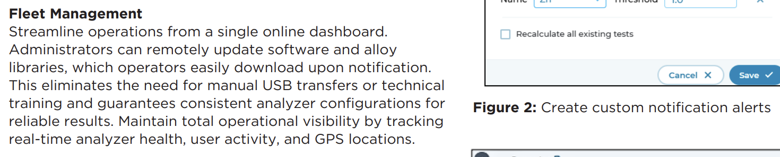 | Fleet Management
 | Streamline operations from a single online dashboard. Administrators can remotely update software and alloy libraries, which operators easily download upon notification. This eliminates the need for manual USB transfers or technical training and guarantees consistent analyzer configurations for reliable results. Maintain total operational visibility by tracking real-time analyzer health, user activity, and GPS locations.
 | Figure 2: Create custom notification alerts
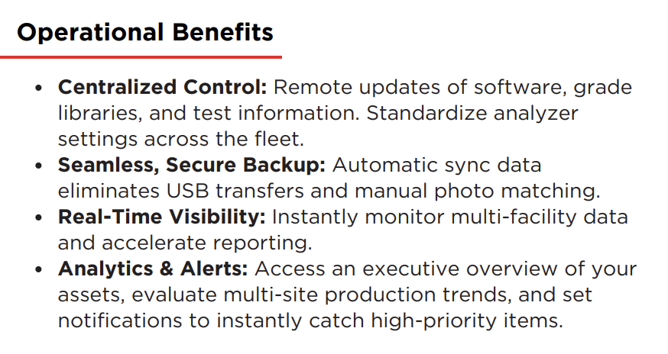 | Operational Benefits
 | Centralized Control: Remote updates of software, grade libraries, and test information. Standardize analyzer settings across the fleet.
 | Seamless, Secure Backup: Automatic sync data eliminates USB transfers and manual photo matching.
 | Real-Time Visibility: Instantly monitor multi-facility data and accelerate reporting.
 | Analytics & Alerts: Access an executive overview of your assets, evaluate multi-site production trends, and set notifications to instantly catch high-priority items.

