


A Guide to Reviewing
M14 - General Terms and Conditions

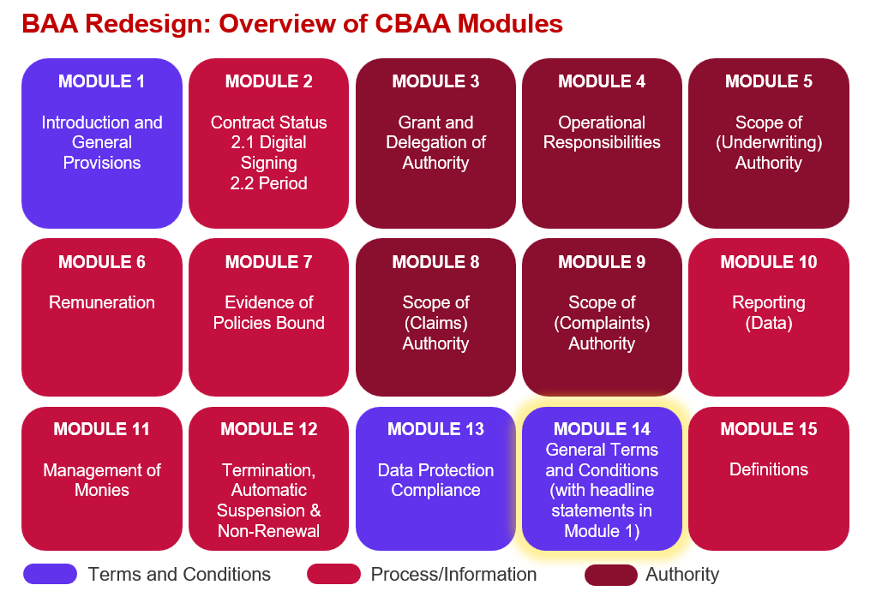

Key features:
- Many areas of differentiation that are addressed in territory specific endorsements today are now included as standard but have been made more generic to apply across the board. However, there are still some territory specific clauses that will be included when applicable.

- Many provisions have been mutualised to make this a fairer contract for the coverholder.

- There are new optional clauses for various types of coverholder insurance, and the user can also choose whether to include minimum limits.

- Enhanced provisions for confidentiality, confidential information and intellectual property.

- New standard clauses for modern slavery and duty to prevent sexual harassment.

- Business continuity and disaster recovery now included in a new ‘operational resilience’ section – with the key terms of ‘disruption’, ‘recovery capabilities’ and ‘recovery timescales’ being defined (proposed definitions included in comments on the first use of the term).

- Includes a new ‘ongoing oversight’ section covering audit/inspection, maintenance of processes and procedures and sharing of due diligence type information with insurers.

- Includes new sub-contracting / sub-delegation and survivorship clauses.

- Preventing breaches of the agreement and informing insurers of them are covered in provisions found in Module 1 along with provisions for following any direction of a regulatory body, the right of insurers to audit / inspect and that the coverholder is acting on behalf of / as an agent of the insurers.

Improvements we know are needed but have not yet been addressed:
- The module is 95% complete, there are a few things our legal counsel needs to check regarding the particular wording of a couple of clauses.

- There is also the caveat that some changes may be needed once we review the whole agreement end-to-end in Q2 2026.

- Definitions and guidance need to be finalised and are not included in this draft (except for the proposed definitions mentioned above).

