

A Guide to Reviewing M6
Remuneration

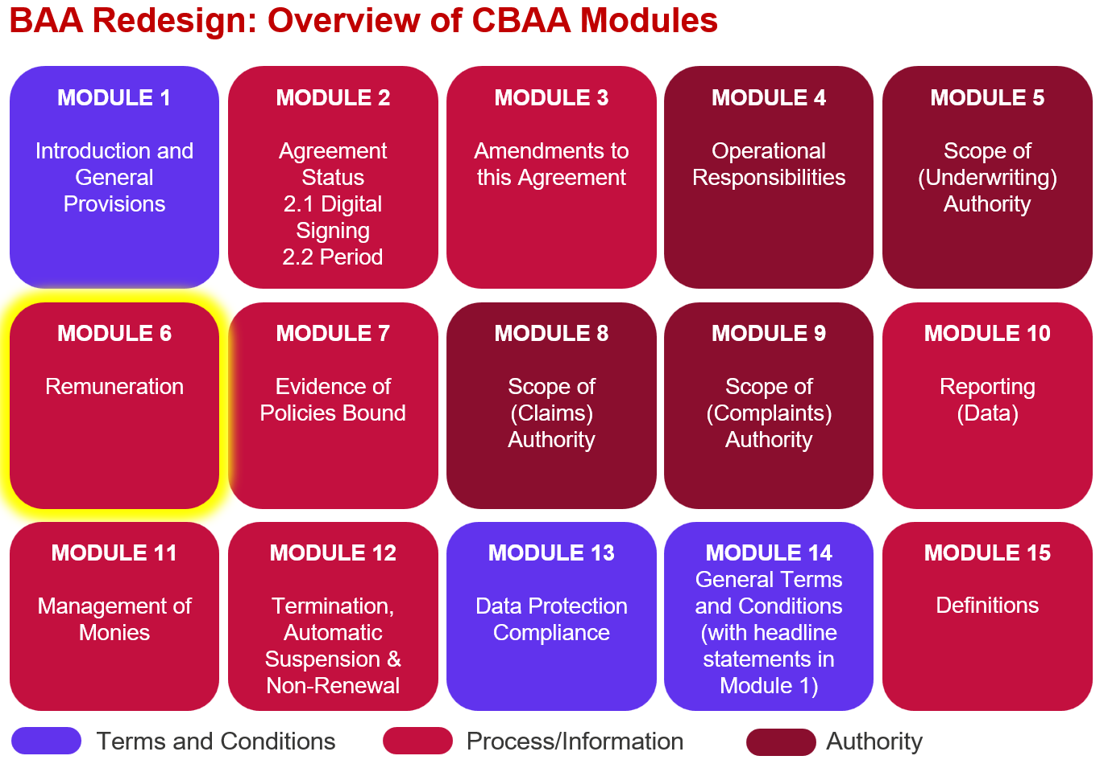

Key features:

- The Module allows for a lot more detail about remuneration to be specified, it is not just about percentage point Coverholder Commission.

- Remuneration, Commission, Producing Intermediary, Profit Commission, Fees, Expenses, Charges & Brokerage will all be newly defined terms.

- The Module details whether or not Commissions can be paid to Producing Intermediaries.

- The Module details whether or not the Coverholder can charge policyholders Fees in addition to premium.

- (London) Brokerage currently detailed in the Subscription Agreement has been moved into this module.

Improvements we know are needed but have not yet been addressed:

- Splitting out Expenses and Charges so they are dealt with separately.

- Drafting definitions for defined terms and any other guidance required.

Feedback that we would particularly welcome:

- Within the Authorised Fees Charged to the Policyholder Table we are proposing to use a ‘list of Fee types’ that the Contract Creator can select from – please let us know of any Fee types that are allowed under your current binders so we can expand the options available appropriately.

Although yet not fully defined Fee will be any charge to the policyholder, that is not premium and that is retained as a form of remuneration by the Coverholder.

- Any additional options that should be included for Embedded Variables 6.6, 6.7, 6.9 or 6.13.

