

A Guide to Reviewing M9
Complaints

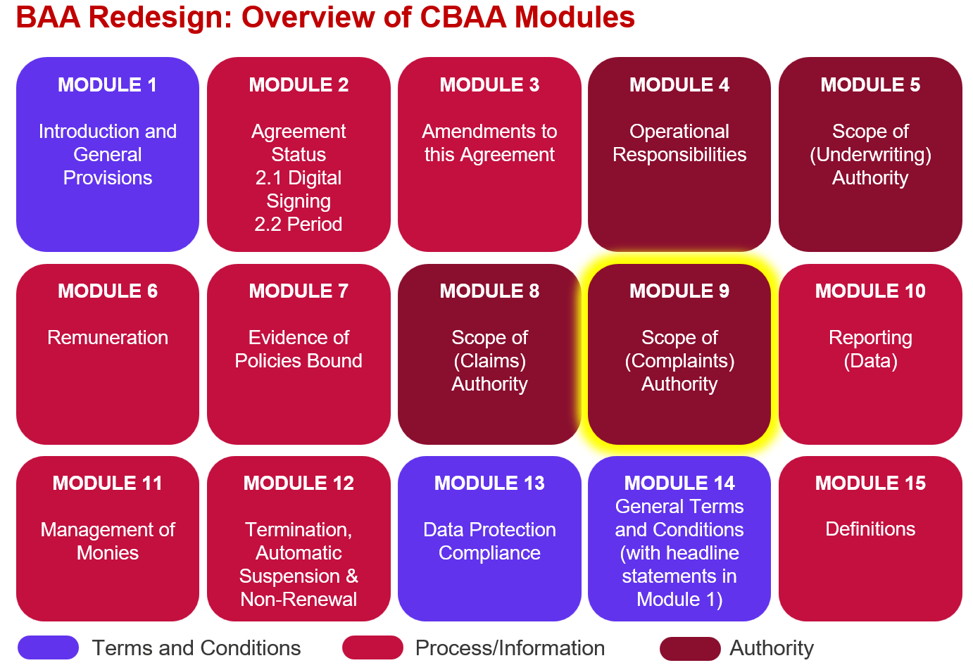

Context for Module 9 - Complaints
Following an extensive review of the complaint's wordings used in the delegated authority community it became clear that although the language used was quite often different, the subjects being addressed were often the same and the actual language used was rarely materially different. It also became evident most of the variations were driven by jurisdictional differences as regulators around the world sought to impose different ways of managing a complaint.

As a result, a new, consistent structure was developed and agreed with the Delegated Authority Wordings Group (DAWG), which has allowed for a standard consistent language to be developed for certain parts of Module 9, whilst also allowing for variations driven by local requirements.

Complaints Module Standard Structure

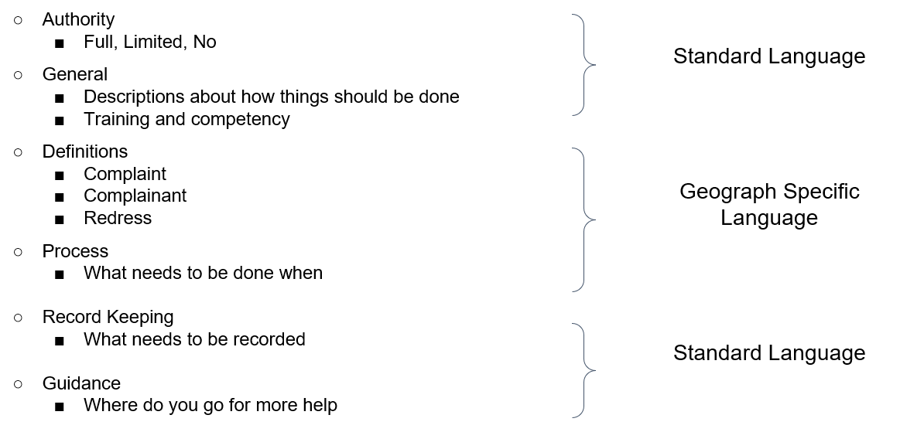

Following agreement of the foregoing structure, further analysis was undertaken to establish whether there was uniformity in the definitions and processes imposed by the regulators around the world. It was decided that definitions should be left broadly untouched, however the processes lent themselves to improved and consistent structuring. Like the Complaints endorsements themselves although language differed and time frames differed, a structure emerged that could be adopted, into which every country process that was analysed could be fitted.

Complaints Process Standard Structure
The full extent of this structure does not apply to every country we analysed. The UK is the most prescriptive, at the other end of the scale the US is the least. However, Spain, Italy and Canada, although not requiring every element of the UK process does add their own elements or versions of specific steps such as ‘data sampling’ and ‘regulator prior approval in certain circumstances’ as part of the complaints ‘process’.

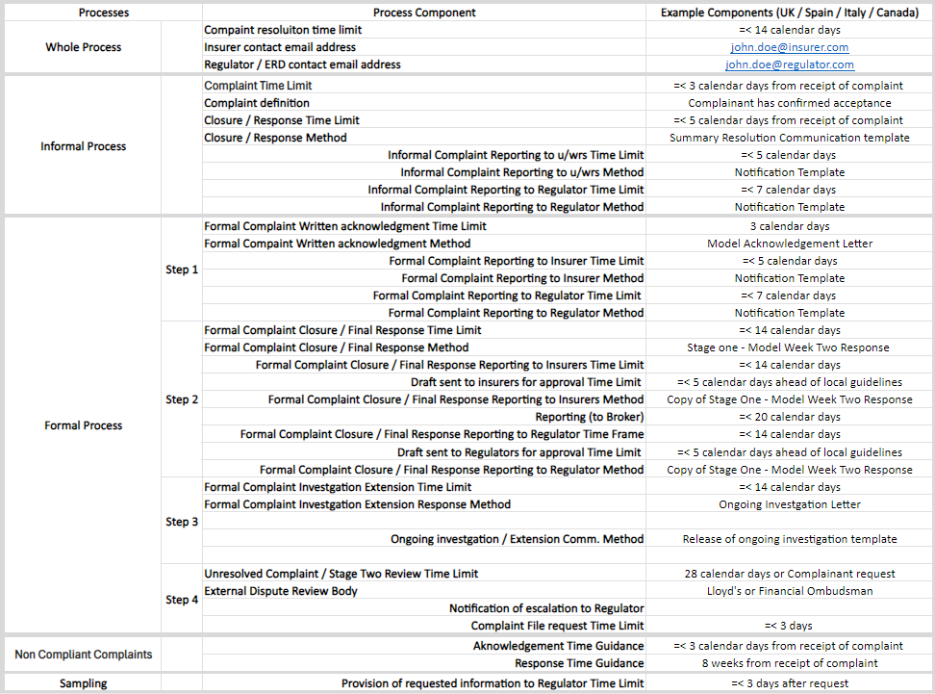

The ‘all variations’ version of M9 filed on the website shows how differing levels of authority (full authority / restricted authority – prior submit / restricted authority – SRC / no authority) impact the language to be included. Within the ‘all variations’ version we have used an example of a UK only binder, but definitions and process for other territories such as Canada and Australia will be dratted in due course.
So, there are 2 factors that effect the language within M9, level of authority the Coverholder is granted and the territories they are doing business in from which a complaint could arise.

