


A Guide to Reviewing M12
Termination / Automatic Suspension and Non-Renewal

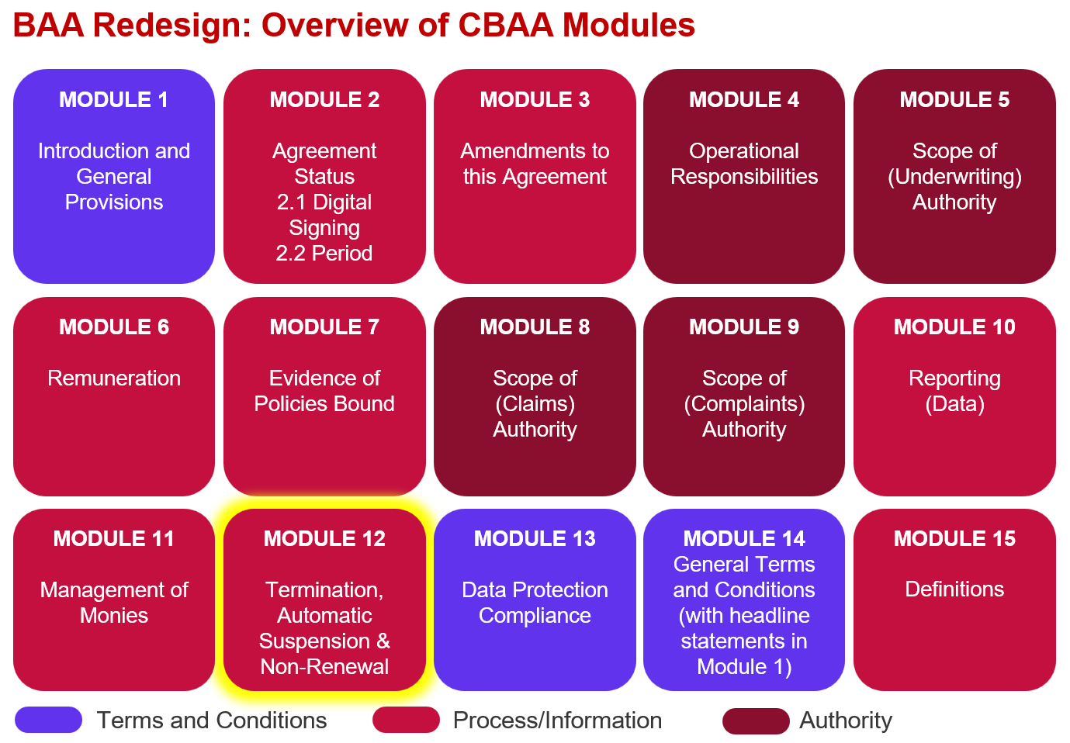

Key features:
- The module has been completely overhauled (6,000 words vs 1,400 in today’s LMA3113a).
- There has been a move to ‘Automatic Suspension’ rather than ‘Automatic Termination’.
- The module still includes the ‘Right to Immediate Termination’ and ‘Termination with Notice’.
- A revised structure provides improved clarity on ‘What happens during any notice period’ and ‘What happens once the Agreement has ended’.
- There is a brand new ‘Non-Renewal’ section for when the Agreement is fixed term (not applicable for continuous contracts).
- The ‘Non-Renewal’ section repeats some of the ‘Termination’ language but is designed to be fully informative in the event of non-renewal.
- There is a new look ‘Communication’ section that is designed to be relevant for all scenarios.
- Some key provisions have been mutualised to create a fairer Agreement for the Coverholder.
- There are more robust survivorship provisions.
- ‘Amendment to the Agreement’ (including any change of participating Insurer) is dealt with in M3 – Amendment.

Improvements we know are needed but have not yet been addressed:
- The module is 95% complete, there are a few things our legal counsel needs to check in terms of the particular wording of a couple of clauses.

- There is also the caveat that some changes may be needed once we review the whole agreement end-to-end in Q1 2026.

- Definitions and guidance need to be finalised.

