


A Guide to Reviewing M2
Agreement Status

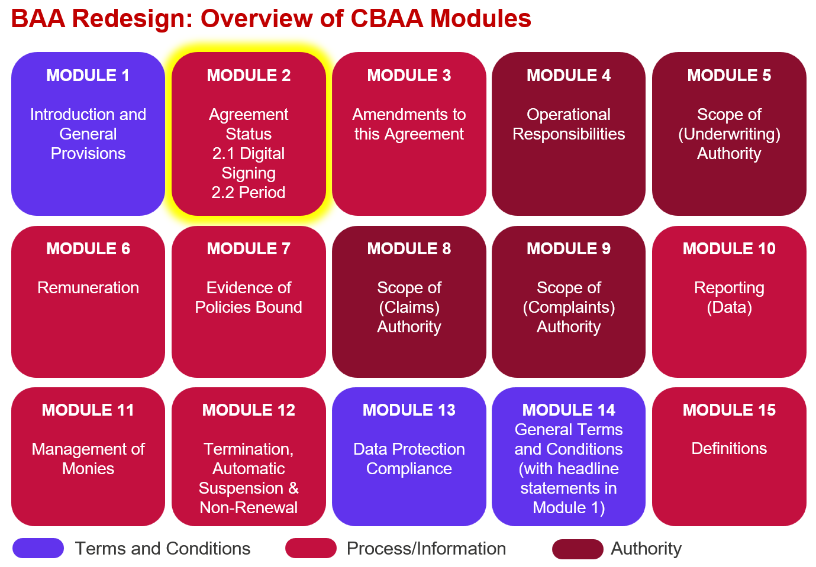

Key features:
- Details the Agreement commencement date and time and for fixed term Agreements the end date and time.
- Incudes a new section for dates on which terms have been accepted by agreement parties – linked to dates of signing – and which indicate the date on which the Agreement takes effect.
- The date on which the Agreement takes effect is purposefully separated from the date of commencement.
- ‘Amendment to the Agreement’ (including any change of participating Insurer) is dealt with in M3 – Amendment but the acceptance of the amended terms is dealt with in this M2.
- There is a new Lloyd’s Annual Transfer section for continuous agreements and fixed term agreements that run for more than a year, where there is Lloyd’s capacity.
- There are options provided for situations where there are multiple Coverholder entities who are party to the Agreement.

Improvements we know are needed but have not yet been addressed:
- The module is 95% complete, there are a few things our legal counsel needs to check in terms of the particular wording of a couple of clauses.

- There is also the caveat that some changes may be needed once we review the whole agreement end-to-end in Q2 2026.

- Definitions and guidance need to be finalised.

- This module is for use in digital form, and some small amendments will be needed for anyone wishing to use it in analogue form.

- An example ‘Insurer Capacity Table’ will be available with Module 1.

