


A Guide to Reviewing M3
Amendments to this Agreement

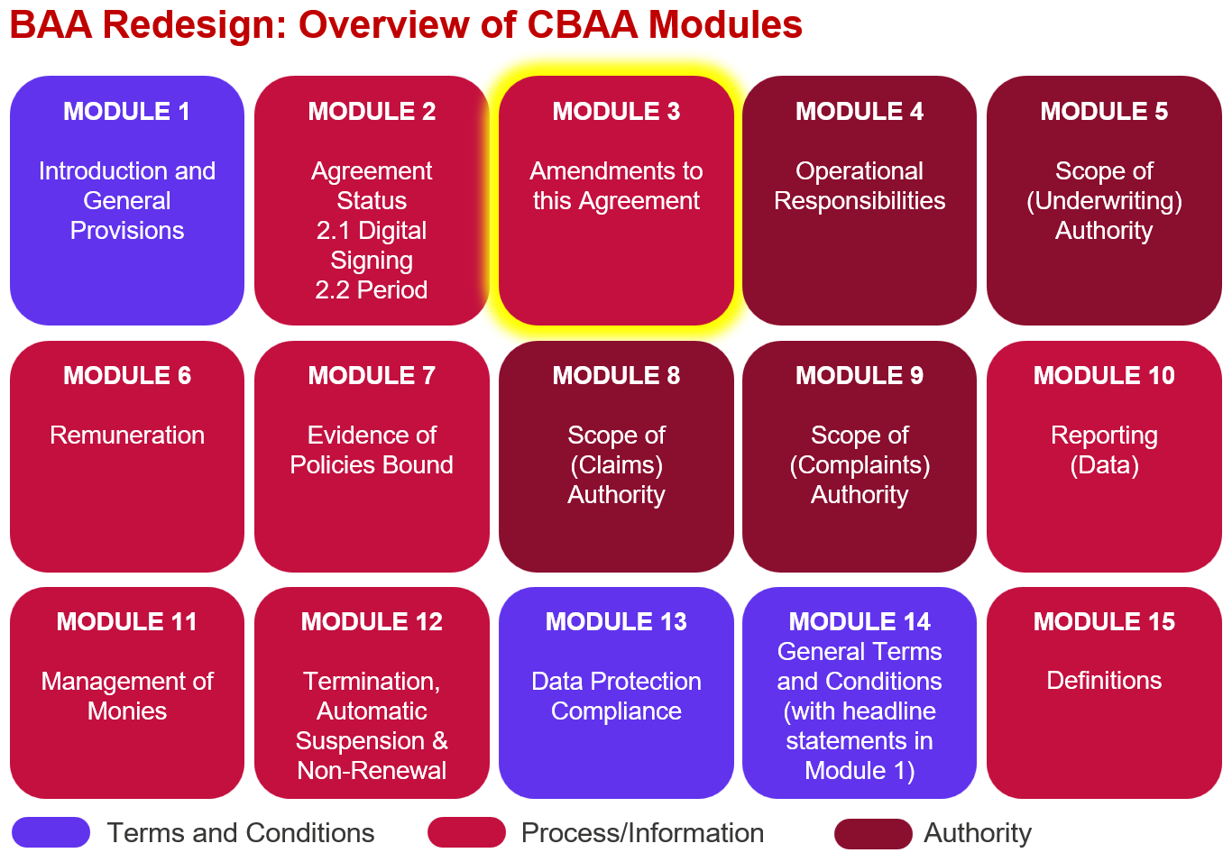

Key features:
- This module was originally planned to cover ‘Grant and Delegation of Authority’, as an overview of the regulated activities the Coverholder is authorised to undertake but the DAWG concluded it was duplicative and that M5, M7, M8, M9 and M11 adequately dealt with the more detailed scope of authority in the relevant areas. Therefore, the module has been repurposed to deal with Amendments to the Agreement.
- There is no ability to amend the Lead Insurer or Coveholder Legal Entity as changes of this nature would constitute a new Agreement.
- Any amendment to the Agreement will result in a new version of the Agreement, with previous versions being archived but a full audit trail of amendments being available in the ‘Agreement Amendments Summary’.
- 3 ‘Insurer Agreement Amendments Roles’ have been introduced to simplify the electronic agreement process and follows can pick the most appropriate role for them:
- All Agreement Amendments
- Material Agreement Amendments Only
- Capacity Follow – No Agreement Amendments
- Material Amendments are defined in the Agreement and any ‘digital object’ defined as material will be flagged as such so that the applicable Insurers are included in the electronic Agreement amendments process if those objects are ever amended.
- Acceptance of any amended terms/a new Agreement version is recorded in M2 Agreement Status.
- There are provisions for ‘Exceptional Amendments’ which due to unforeseen circumstances prevent the regular amendment process from operating.

Improvements we know are needed but have not yet been addressed:
- The module is 95% complete, there are a few things our legal counsel needs to check in terms of the particular wording of a couple of clauses.

- There is also the caveat that some changes may be needed once we review the whole agreement end-to-end in Q2 2026.

- Definitions and guidance need to be finalised.

