


A Guide to Reviewing M10
Reporting (Data)

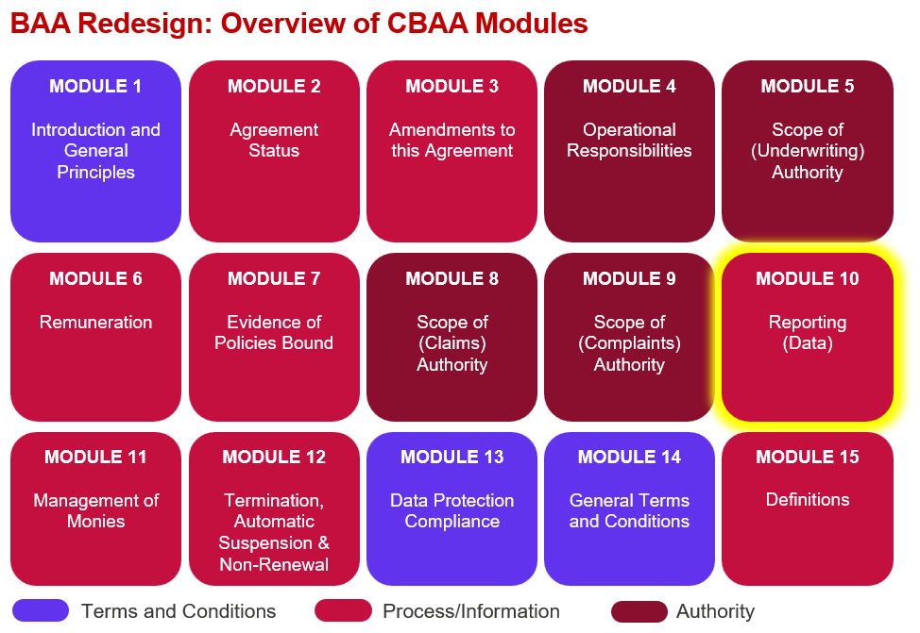

Key features:
- This Module is entirely different from what we have today.

- Policy Data considerations are divided into 4 main categories - Capture & Storage, Transfer, Formatting & Secondary Transfer.

- The Module allows for a single reporting arrangement for the entire Agreement or for multiple arrangements, for example in the event of different section leads, via a Multiple Reporting Arrangements Table.

- There is a choice for who the Coverholder sends data to initially either the broker, lead insurer or all insurers, if to the broker or lead insurer they will then have the responsibility to send on to all insurers. This makes the requirement to get data to the follows markets mandatory.

- If the Coverholder sends directly to all insurers ‘secondary data transfer’ is not required.

- Embedded Variables (in red) allow for complete flexibility for the method (e.g bordereau, DDM, Coverholder portal, API etc.) and frequency of reporting.

- There is a requirement for the specific data items the Coverholder must report on to be listed in the Module, this is via a ‘Data Specification’ of type

- In the ‘all variations’ version 10.4.1C has a link to an example ‘Risk Written and Premium Paid Data Specification Table’ this is essentially a more user-friendly version of CRS v5.2 that will be tailored to each Agreement instance based on the authorised territories and insurable interests (aka classes) authorised. Please see comments in the ‘all variations’ version for further detail.

Improvements we know are needed but have not yet been addressed:
- Some changes may be needed once we have conducted the external legal review over summer 2026.

- Definitions, guidance and list of values & names for embedded variables (anything in red) need to be finalised.

- Please ignore numbering this will be dynamic within contract builders as numbering will vary based on which clauses are included/excluded, it is merely used at this juncture to give a point of reference.

