


A Guide to Reviewing M1
Introduction and General Principles

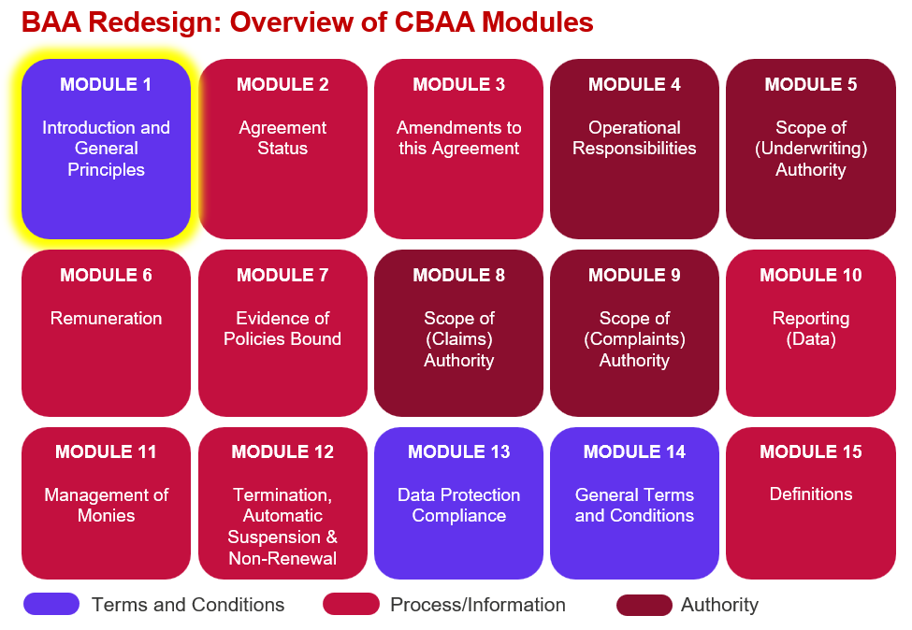

Key features:
- Sets out the contracting parties and defines the overarching principles of the Agreement.

- Allows for multiple coverholder entities to be named in the Agreement with authorised trading locations specified.

- The ‘Table of Security’ is replaced by the ‘Insurer Capacity Table’ which includes all key information about every participating Insurer. An example of what information can be found in this table is provided in the attached Excel ‘Insurer Capacity Table 060726’.

Improvements we know are needed but have not yet been addressed:
- Some changes may be needed once we have conducted the external legal review over summer 2026.

- Definitions, guidance and list of values & names for embedded variables need to be finalised.

- Some tweaks may be needed to cater for multiple brokers on a single Agreement.

- More information may need to be added to the Insurer Capacity Table and it needs to be validated against the CDR.

