


A Guide to Reviewing M5
Scope of (Underwriting) Authority

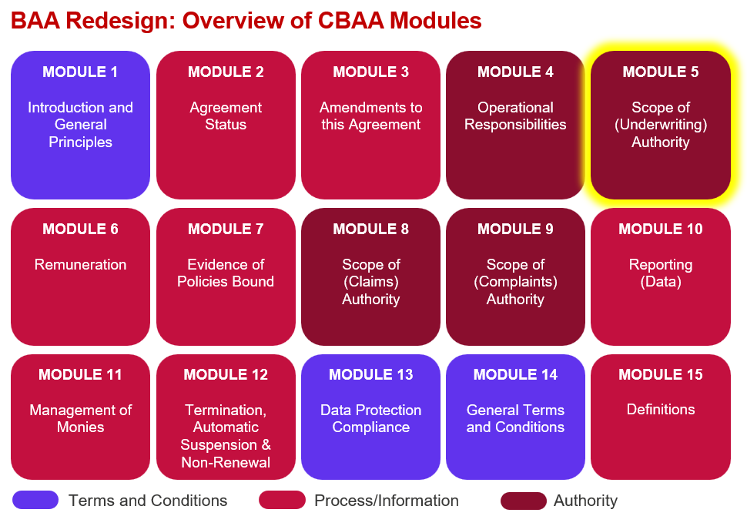

Key features:
- Backbone of the entire Agreement containing many of the variables found in today’s ‘Schedule’ and many of the variables used in rules for including/excluding clauses.

- Key Module of interest for Underwriters.

- Authority to write Insurance and / or Reinsurance is clearly segmented.

- The Module has been designed to cater for multi-section Agreements (to be known as ‘Segments’).

- A ‘data heavy’ Module with 2 important Tables (digital versions of the ‘Schedule’) and fewer Text Objects:

Territory Table(s)
- The Territories detailed in the Table must be applicable to all Insurable Interests (or classes) authorised, otherwise an additional Territory Table must be created
- Separate Territory Tables must be created where any capacity is provided by Lloyd’s Europe (effectively creating a ‘twin binder’)
- Separate Territory Tables must be created for Insurance and Reinsurance if both are authorised
- Reinsurance Territory Table includes additional details on type of Reinsurance authorised and no ‘Risk Location’
- Where separate Territory Tables are required, they can both / all be linked to a single Scope of Underwriting Authority Table

Scope of Underwriting Authority Table(s)
- ‘Insurable Interest(s)’ rather than ‘Class(es)’ will be used to set the types of risks authorised under the Agreement
- High-level ‘Insurable Interest Type’ groupings from the CDR will be used in conjunction with ‘free text descriptors’

- The ‘Territory’ & ‘Scope of Underwriting Authority’ Tables are created from a schema which means they are flexible and can be adapted to the needs of any given Agreement.

- Underwriting Basis Tables automatically pull in many territorial requirements from Crystal+ – with company market able to self-populate the tables with their own licensing requirements.

- Approach has been taken to clarify when the Coverholder does not have authority in key areas (e.g. automatic/tacit renewal).

- New section on ‘Use of the Capacity Granted under this Agreement’ covering what the Coverholder can do in regard to co-insurance, master policies, broker lines lips, other binders & consortiums and global policies.

- New section on ‘Territory or Insurable Interest Special Requirements for the Scope of Underwriting Authority’ – to automatically include relevant checks from PBQA/6.1.

- Option to add bespoke ‘Additional Requirements for the Scope of Underwriting Authority’ – localised 6.1

Improvements we know are needed but have not yet been addressed:
- Some changes may be needed once we have conducted the external legal review over summer 2026.

- Definitions, guidance and list of values & names for embedded variables need to be finalised.

