


A Guide to Reviewing M4
Operational Responsibilities

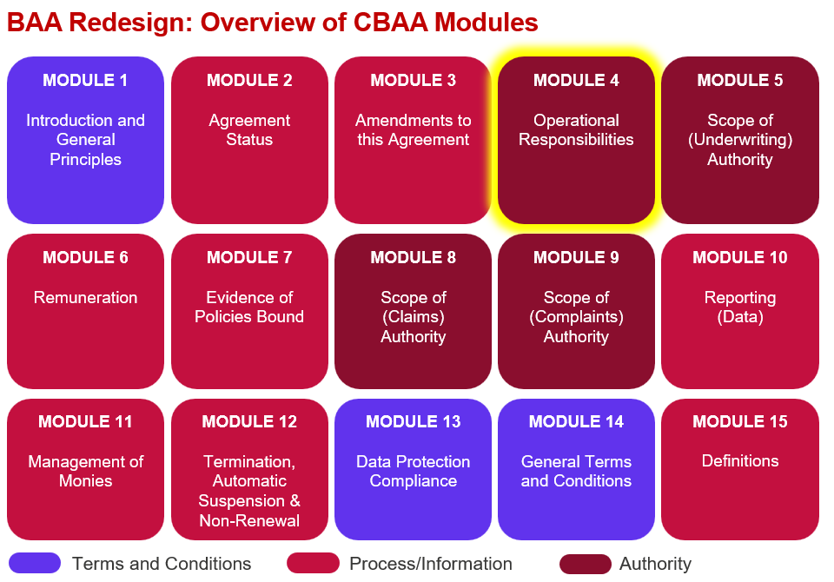

Key features:
- Coverholder persons responsible for key (regulated) activities authorised under the Agreement are recorded in the Coverholder Responsibilities Table, including options to name all individuals or only some/key persons – see example Excel table attached.

- Includes section for additional activities for which the Coverholder is responsible for that are Territory/Class/Insurable Interest specific and not covered anywhere else in this Agreement.
- Includes new sections for broker and Lead Insurer responsibilities which includes activities currently addressed in the non-schedule agreement and which are not otherwise covered in another module.
- Includes LMA9116 and 5312B/proposed C.

Improvements we know are needed but have not yet been addressed:
- Some changes may be needed once we have conducted the external legal review over summer 2026.

- Definitions, guidance and lists of values & names for embedded variables need to be finalised.

- Territory/Class/Insurable Interest specific requirements need to be verified with Lloyd’s regulatory team to see if they still stand or can be removed because of the more robust general provisions that may not negate the need for some of these clauses.

- Following a full end to end review some other responsibilities within other modules may need to be picked up and reinforced in M4.

