

A Guide to Reviewing M9
Complaints

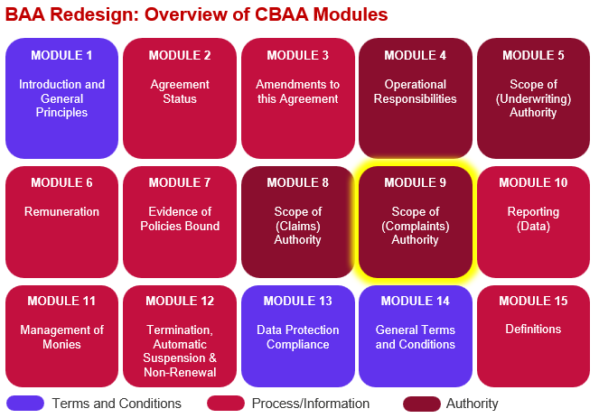

Key Features
- A new consistent structure for complaints language where territorial differences can be detailed using a standard approach. Complaints components are:

- Authority (Full, Restricted, No)
- General
- Definitions
- Process
- Record Keeping
- Guidance

- Authority has been set at 3 levels full, restricted – prior submit and no. Restricted is essentially full authority but where all communications have to be submitted to the nominated party (normally Lead Insurer) for agreement before issuance. Clause 9.2.11 is included to require this referral step.

- Most General Complaints Provisions are standard across all territories and all levels of authority but a few at the end of the section are conditional – see comments on ‘All Variations’ version for further detail.

- The territory specific complaints Definitions and Processes are held in Excel ‘All Territories Definitions and Process’ and NOT in the ‘all variations’ Word document. When viewing the territory specific details on the Excel the first tab shows a comparison between all territories and all authority levels, the following tabs show each territory for each authority level as it will look without the gaps!

- The Module includes all detail in the body of the wording where there is a single territory and for multiple territories, where those territories have specific complaints procedures, links to those territory specific procedures will open in a new window.

- If an authorised territory doesn’t have a specific complaints procedure, then the ‘International’ process will be included still with the option to select full, restricted or no authority.

- To drive consistency the records coverholders will be required to keep are the same across the board but will vary depending on authority level.

- A contact at the Lead Insurer will always be provided for further assistance and details of other useful guidance can be added if the user chooses.

- The Module caters for a single level of authority granted across multiple territories or for varying levels of authority across those territories.

Improvements we know are needed but have not yet been addressed:
- Some changes may be needed once we have conducted the external legal review over summer 2026.

- Definitions, guidance and list of values & names for embedded variables (anything in red) need to be finalised.

- Please ignore numbering this will be dynamic within contract builders as numbering will vary based on which clauses are included/excluded, it is merely used at this juncture to give a point of reference. Numbers in examples are not sequential but keep the ‘all variations’ numbering.

- Complaints Module reflects the endorsements used today and not any changes to Australian process or removal of stage one process by Lloyd’s that are coming in the next few months. We will be working with Lloyd’s compliants team in September to update the module to reflect the changes.

