

A Guide to Reviewing M6
Remuneration

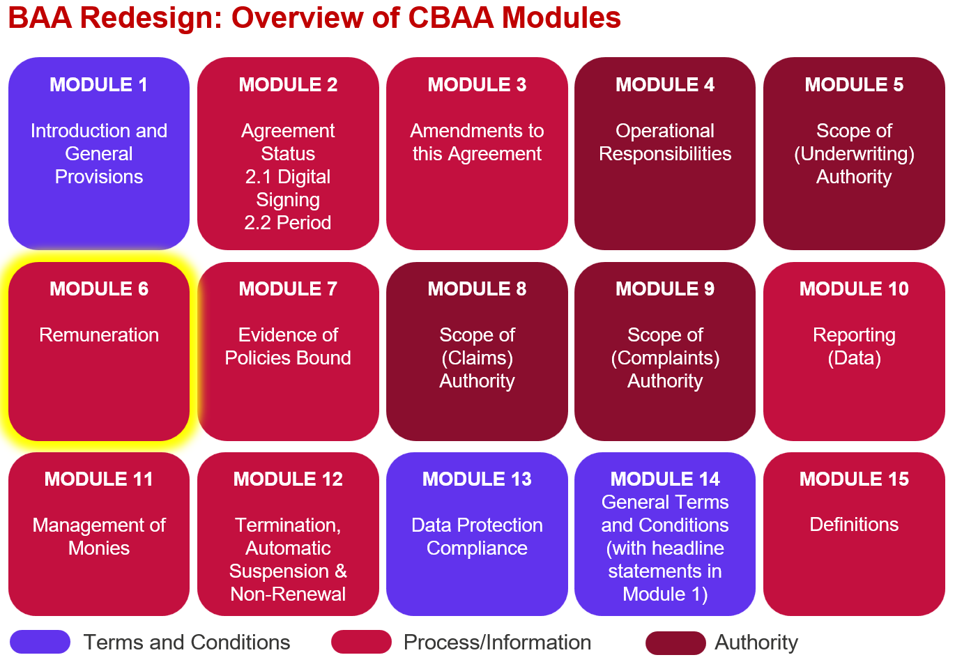

Key features:

- The Module allows significantly more detail on remuneration to be captured than is possible today. It is not limited to Coverholder commission percentages.

- As well as detailing Coverholder Commission the Module details whether or not Commissions can be paid to Producing Intermediaries.

- The Module details whether or not the Coverholder can charge policyholders Fees in addition to premium. If they can a table must be included that details the fees authorised, an example table is attached.

- (London) Brokerage currently detailed in the Subscription Agreement has been moved into this module. If it is a direct binder the brokerage section will not be included.

- There is a new optional section to address Leader Fees should they be applicable to the binder.

- The Module is all about variation and flexibility, while there are lots of options for how/what each entity is remunerated you will only ever select a single variation per entity, so a completed Module will be much shorter than the ‘all variations’ module. See simple and complex examples attached.

- You will find an explanation of when each variation is suitable in the comments added to variation A.

- Remuneration, Coverholder Commission, Producing Intermediary Commission, Profit Commission, Fees, Expenses & Charges, Brokerage and Leader Fees will all be newly defined terms – a first draft of most of these definitions is included via comments.

- Note – following the M6 deep dive a slight tweak was made to the variants for percentage point remuneration by adding in the ability to remunerate using a ‘fixed amount per policy’ - this is applicable to Coverholder & Producing Intermediary Commission as well as Brokerage and it provides greater flexibility. Therefore, the version on the recording will be ever so slightly different to the version attached but this doesn’t really change any of the points covered in the recording.

Improvements we know are needed but have not yet been addressed:
- None at this time – all comments raised under the 2024 consultation of this module have been appropriately addressed.
Feedback that we would particularly welcome:
- Within the Authorised Fees Charged to the Policyholder Table we are proposing to use a ‘list of Fee types’ that the Contract Creator can select from – please let us know of any Fee types that are allowed under your current binders so we can expand the options available appropriately.
- Any additional options that should be included for Embedded Variables relating to ‘Basis 2’

