Year 2 Home Learning 25th January 2024
English  Last week we were reading Traction Man.  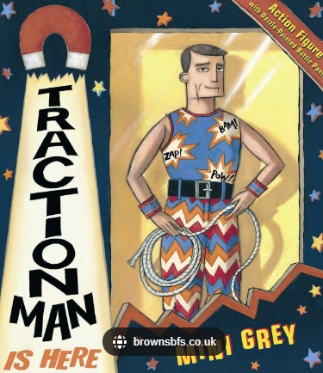  - Tell the story to as many family and friends as you can!  - Can you create a model of traction man or scrubbing brush from what you have at home. | 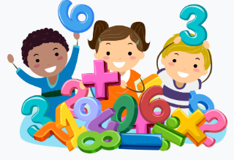  Maths  Complete the task that has been set for you on My Maths.
Spellings
We have taken these words from the Year 2 common exception word list. We would like you to practise writing these words at home so you can apply them to your writing in class.

door poor gold
floor because hold

Remember to read for at least 20 mins every day (including Bug Club)

