Year 6 Home Learning 27.06.24
Geography  This term, we have been looking at the imaginary lines, which divide our Earth! One of those lines is the Equator. For home learnig, choose one of the 13 countries (Ecuador, Colombia, Brazil, Sao Tome & Principe, Gabon, Republic of the Congo, Democratic Republic of the Congo, Uganda, Kenya, Somalia, Maldives, Indonesia or Kiribati) that sit on the Equator and create a factfile about it!  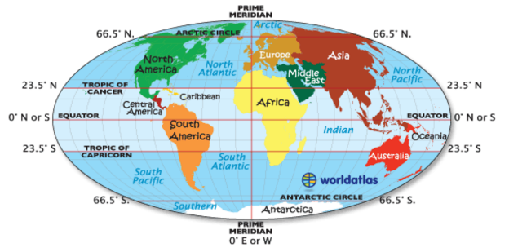  it’s showtime!!  On Wednesday, we will perform our Y6 Leavers’ Production of Aladdin! In school we will support you with creating a costume, but we need you to bring in the following:  - brightly coloured t-shirt  - brightly coloured shorts or leggings  Many thanks, Mr Greaves and Miss Wright | Maths
My Maths
Please log in to your My Maths account to see this week’s activities.

Times Tables Rockstars
Practise your times tables on Times Tables Rockstars!

Spelling
Learn these Y5/6 spellings
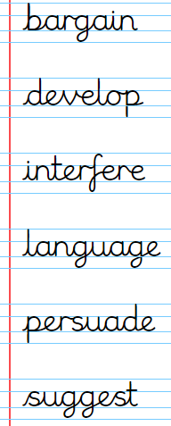
Remember to read for at least 20mins every day. Have a brilliant weekend!

