Year 2 Home Learning 4th July 2024
Seaside Crafts  This week, we have been learning a lot about Whitstable. Can you remember what we have learnt so far? If so, can you share this with your family and friends?  You can also make a paper plate seaside scene using recycled materials!  Click on the file in the year 2 blog for an idea on what you need and an idea on how to create one.  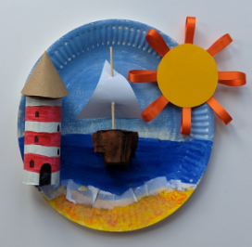 | Maths  This week we have been learning about time. We would like you to log on to My Maths and complete the tasks allocated.  The first task is ‘Introducing Clock’ and your tasks are to tell the time on the hour, half and quarter hour. Use analogue and digital clocks.  The second task is ‘Telling the time 1’ and your tasks are to read the time on analogue clocks, read the time on digital clocks, and convert analogue times to digital times and visa versa.  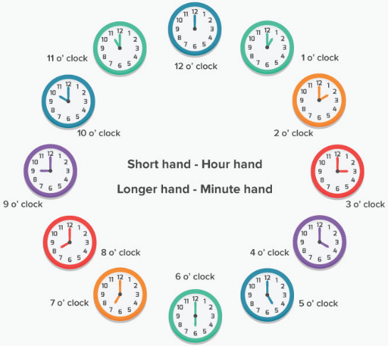
We have taken these words from the Year 2 Spelling Appendix. We would like you to practise writing these words at home so you can apply them to your writing in class.

pencil nostril dry
try July cry
Remember to read for at least 20 mins every day

