Year 6 Home Learning 11/09/25
English | Maths
For home learning this week, we would like you to sketch the view from a window in your home!  This is linked to our new English text: Belonging  Spend plenty of time looking at the scene before you draw and try to record as much detail in your drawing as possible.  If you need some help with resources (pencils, paper), let your teacher know!  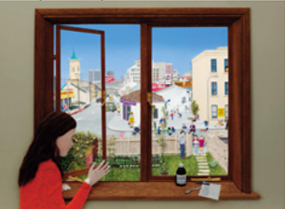 | My Maths    Times Tables Rockstars  Practise your times tables on Times Tables Rockstars!  
Spellings
Can you learn these spellings for our quiz next week? Practise by writing a sentence for each word.

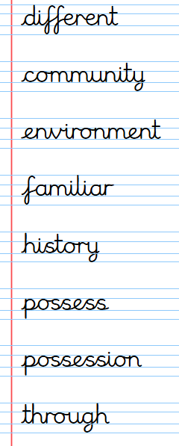
Remember to read for at least 20 minutes every day!

Year 6 Home Learning 11/09/25
English | Maths
For home learning this week, we would like you to sketch the view from a window in your home!  This is linked to our new English text: Belonging  Spend plenty of time looking at the scene before you draw and try to record as much detail in your drawing as possible.  If you need some help with resources (pencils, paper), let your teacher know! | My Maths  Times Tables Rockstars  Practise your times tables on Times Tables Rockstars!
Spellings
Can you learn these spellings for our quiz next week? Practise by writing a sentence for each word.

Remember to read for at least 20 minutes every day!

